# CS 428/528 Computer Networks

# Spring 2020

# Final

Name: Baptiste Saliba

Email: bsaliba1@binghamton.edu

Signature BSaliba

* Use your time wisely—make sure to answer the questions you know first.
* **Total points: 50 points**
* **Read the questions carefully.**

1. Determine the shortest path using Dijkstra’s algorithm from node z to all other nodes in the network. You need to draw a table similar to the one shown in class and clearly illustrate all the steps. You will not get credit for just writing the final answer. **(10 points)**

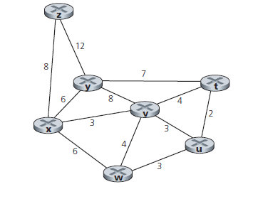

|  |  |  |  |  |  |  |  |
| --- | --- | --- | --- | --- | --- | --- | --- |
| Step | N’ | D(t), p(t) | D(u), p(u) | D(v), p(v) | D(w), p(w) | D(x), p(x) | D(y), p(y) |
| 0 | z | ∞ | ∞ | ∞ | ∞ | 8, z | 12, z |
| 1 | zx | ∞ | ∞ | 11, x | 14, w |  | 12, z |
| 2 | zxv | 15, v | 14, v |  | 14, w |  | 12, z |
| 3 | zxvy | 15, v | 14, v |  | 14, w |  |  |
| 4 | zxvyu | 15, v |  |  | 14, w |  |  |
| 5 | zxvyuw | 15, v |  |  |  |  |  |
| 6 | zxvyuwt |  |  |  |  |  |  |

2. Consider the network given below. Execute the distance vector algorithm until it converges and show the tables at each node in the network. Please show all the steps of the algorithm. You will not get credit for just writing the final answer. **(10 points)**

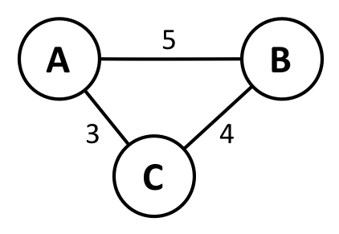

|  |  |  |  |
| --- | --- | --- | --- |
| A table | A | B | C |
| A | 0 | 5 | 3 |
| B | ∞ | ∞ | ∞ |
| C | ∞ | ∞ | ∞ |

|  |  |  |  |
| --- | --- | --- | --- |
| A table | A | B | C |
| A | 0 | 5 | 3 |
| B | 5 | 0 | 4 |
| C | 3 | 4 | 0 |

|  |  |  |  |
| --- | --- | --- | --- |
| B table | A | B | C |
| A | ∞ | ∞ | ∞ |
| B | 5 | 0 | 4 |
| C | ∞ | ∞ | ∞ |

|  |  |  |  |
| --- | --- | --- | --- |
| A table | A | B | C |
| A | 0 | 5 | 3 |
| B | 5 | 0 | 4 |
| C | 3 | 4 | 0 |

|  |  |  |  |
| --- | --- | --- | --- |
| C table | A | B | C |
| A | ∞ | ∞ | ∞ |
| B | ∞ | ∞ | ∞ |
| C | 3 | 4 | 0 |

|  |  |  |  |
| --- | --- | --- | --- |
| A table | A | B | C |
| A | 0 | 5 | 3 |
| B | 5 | 0 | 4 |
| C | 3 | 4 | 0 |

3. Consider the scenario below in which three hosts, with private IP addresses 10.0.1.12, 10.0.1.17, 10.0.1.22 are in a local network behind a NATted router that sits between these three hosts and the larger Internet. IP datagrams being sent from, or destined to, these three hosts must pass through this NAT router. The router’s interface on the LAN side has IP address 10.0.1.27, while the router’s address on the Internet side has IP address 135.122.197.209.

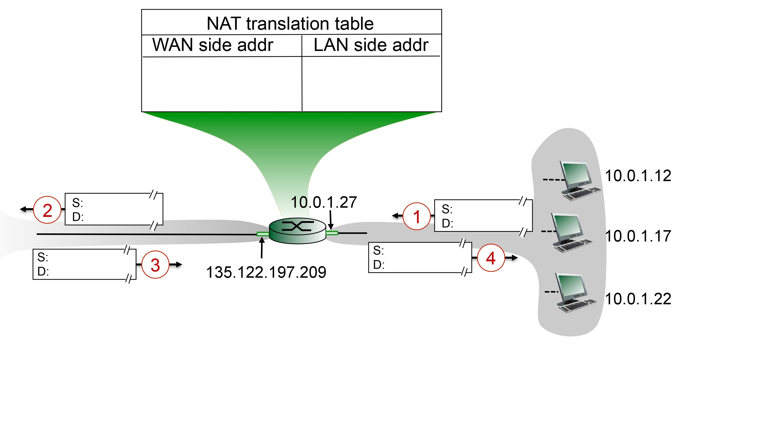

Suppose that the host with IP address 10.0.1.17 sends an IP datagram destined to host 128.119.179.184. The source port is 3373, and the destination port is 80.

(a) Consider the datagram at step 1, after it has been sent by the host but before it has reached the NATted router. What are the source and destination IP addresses for this datagram? What are the source and destination port numbers for the TCP segment in this IP datagram?

**Answer)**  
Source IP: 10.0.1.17  
Destination IP: 128.119.179.184  
Source Port: 3373  
Destination Port: 80  
  
(b) Now consider the datagram at step 2, after it has been transmitted by the NATted router. What are the source and destination IP addresses for this datagram? What are the source and destination port numbers for the TCP segment in this IP datagram? Identify the differences in datagram's IP addresses and port numbers between step 1 and step 2. Specify the entry that has been made in the router's NAT table.  
  
**Answer)**  
Source IP: 135.122.197.209  
Destination IP: 128.119.179.184  
Source Port: 5000  
Destination Port: 80  
  
The destination IP address and port remain the same because the network needs to know where the intended datagram is going. The source IP changes to the router’s NATted IP and the router generates a new source port number 5000 and replaces the original port number 3373 with that new port number. Additionally, the router creates a mapping for that new entry as shown below.  
  
135.122.197.209, 5000 🡪 10.0.1.17, 3373

(c) Now consider the datagram at step 3, just before it is received by the NATted router. What are the source and destination IP addresses for this datagram? What are the source and destination port numbers for the TCP segment in this IP datagram?

**Answer)**  
Source IP: 128.119.179.184  
Destination IP: 135.122.197.209  
Source Port: 80   
Destination Port: 5000

(d) Last, consider the datagram at step 4, after it has been transmitted by the NATted router but before it has been received by the host. What are the source and destination IP address for this datagram? What are the source and destination port numbers for the TCP segment in this IP datagram? Identify the differences in datagram's IP addresses and port numbers between step 3 and step 4. Has a new entry been made in the router's NAT table, or removed from the NAT table? Explain your answer. **(10 points)**

**Answer)**  
Source IP: 128.119.179.184  
Destination IP: 10.0.1.17  
Source Port: 80   
Destination Port: 3373

The router simply indexes into the NAT table using 135.122.197.209, 5000 then finds the mapping that was created in part ‘b’:   
  
135.122.197.209, 5000 🡪 10.0.1.17, 3373  
  
and then changes the destination IP to the mapped destination IP and the destination port to the mapped destination port.

4. Suppose that TCP's current estimated values for the round trip time (estimatedRTT) and deviation in the RTT (DevRTT) are 280 msec and 48 msec, respectively. Suppose that the next two measured values of the RTT are 400 and 240 respectively.

Compute TCP's new value of estimatedRTT, DevRTT, and the TCP timeout value after each of these two measured RTT values is obtained.Use the values of α = 0.125 and β = 0.25. For your benefit, the DevRTT formula is given here.

DevRTT = (1-β)*DevRTT + β*|SampleRTT-EstimatedRTT| **(6 points)**  
**Answer)**  
SampleRTT1 = 400msec  
SampleRTT2 = 240msec  
  
EstimatedRTT0 = 280msec  
EstimatedRTT1 = (1- α)*EstimatedRTT0 + α*SampleRTT1  
= (1-0.125)*280+0.125*400   
= 295msec  
EstimatedRTT2 = (1- α)*EstimatedRTT1 + α*SampleRTT2   
= (1-0.125)*295+0.125*240   
= 288msec  
  
DevRTT0 = 48msec  
DevRTT1 = (1-β)*DevRTT0 + β*|SampleRTT1-EstimatedRTT1|  
= (1-0.25)*48+0.25*|400-295|  
= 62.25msec  
DevRTT2 = (1-β)*DevRTT1 + β*|SampleRTT2-EstimatedRTT2|  
= (1-0.25)*62.25+0.25*|240-288|  
= 58.68msec

5. Suppose that a packet’s payload consists of 10 eight-bit values (e.g., representing ten ASCII-encoded characters) shown below. (Here, we have arranged the ten eight-bit values as five

Compute the two-dimensional parity bits for each of the five rows and sixteen columns assuming even parity. Assume that the parity bit in the lower right corner is computed so that the parity of the row parity bits in the last row has even parity. **(4 points)  
  
Answer)**

01001010 11010001 | 1   
11110000 11101100 | 1  
10011000 01000101 | 0  
01010101 01101001 | 0  
01111101 01101101 | 1  
-----------------------------  
00001010 01111100 | 1

6. Consider the figure below. The IP and MAC addresses are shown for nodes A, B, C and D, as well as for the router's interfaces.

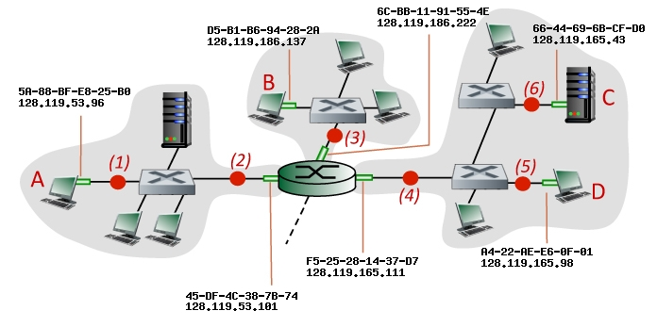

Consider an IP datagram being sent from node **B** to node **D**. Give the source and destination Ethernet addresses, as well as the source and destination addresses of the IP datagram encapsulated within the Ethernet frame at points  *(3),(4)*, and *(5)* in the figure above. **(8 points)**

**Answer)**(3)Source IP: 128.119.186.137  
Destination IP: 128.119.165.98  
Source MAC: D5-B1-B6-94-28-2A  
Destination MAC: 6C-BB-11-91-55-4E  
  
(4)  
Source IP: 128.119.186.137  
Destination IP: 128.119.165.98  
Source MAC: F5-25-28-14-37-D7  
Destination MAC: A4-22-AE-E6-0F-01

(5)  
Source IP: 128.119.186.137  
Destination IP: 128.119.165.98  
Source MAC: F5-25-28-14-37-D7  
Destination MAC: A4-22-AE-E6-0F-01

7. Consider the scenario shown below, with four different servers connected to four different clients over four three-hop paths. The four pairs share a common middle hop with a transmission capacity of R = 100 Mbps. The four links from the servers to the shared link have a transmission capacity of RS = 70 Mbps. Each of the four links from the shared middle link to a client has a transmission capacity of RC = 10 Mbps per second. What is the maximum achievable end-end throughput (in Mbps) for each of four client-to-server pairs, assuming that the middle link is fair-shared (i.e., divides its transmission rate equally among the four pairs). Which link is the bottleneck link for each session? **(4 points)**

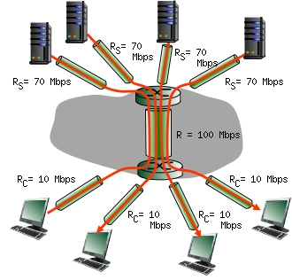  
**Answer)**  
R/4 = 25Mbps  
min(Rc, R/4, Rs) = min(10Mbps, 25Mbps, 70Mbps) = 10Mbps  
  
The bottleneck for all of the client-to-server pairs is the Rc link, limiting the end-to-end maximum throughput to 10Mbps

8. Consider the figure below, in which a single router is transmitting packets, each of length *L* bits, over a single link with transmission rate *R*Mbps to another router at the other end of the link.

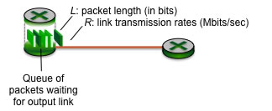

Suppose that the packet length is *L*= 4000 bits, and that the link transmission rate along the link to router on the right is *R* = 1 Mbps. Assume that the length of the wire is D = 1000 Km. Speed of propagation is 2*108 m/sec.

(a) What is the transmission delay (the time needed to transmit all of a packet's bits into the link)?

**Answer)**Transmission Delay = Packet Size/ Transmission Rate = L/R = 4000/10^6 = 0.004s

(b) What is the propagation delay (the time needed for the bits to travel from one router to the other)?

**Answer)**Propagation Delay = Distance/Propagation Rate = D/Propagation Speed = 10^6/2*10^8 = 0.005s

(c) What is the maximum number of packets per second that can be transmitted by the link? **(6 points)**

**Answer)**Total Transmission Time = 1sTransmission Delay*Number of Packets = Total Transmission Time  
0.004*N = 1  
N = 1/0.004  
N = 250 packets

9. Convert the following IP address to binary and underline the subnet part 223.112.70.16/23. How many IP addresses are available to an organization that owns this subnet? **(4 points)**

**Answer)** 223 112 70 16  
 11011111 01110000 01000110 00010000  
 11011111 01110000 01000110 00010000  
  
The remaining 9 bits can be used to assign an IP to a different host on this subnet. So this organization has a total of 2^9 IP addresses available for different hosts 223.112.70.0 – 223.112.71.255

10. Consider the TCP window evolution as shown below. Identify the slow start and congestion avoidance phases in the figure below. **(4 points)**

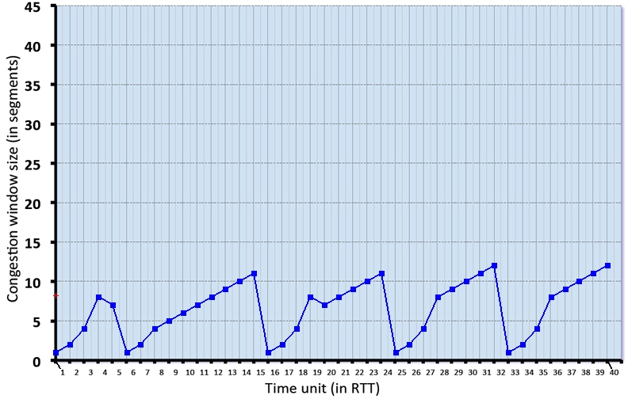

**Answer)**

Slow Start: 1 – 4, 6 – 8, 16 – 19, 25 – 28, 33 – 36  
Congestion Avoidance: 9 – 15, 20 – 24, 29 – 32, 37 – 40

11. What is the difference between routing and forwarding? **(2 points)**

**Answer)**

Routing: algorithm to figure out how to reach any other node and populates the forwarding table

Forwarding: algorithm determines local forwarding at that individual router, meaning which datagram should be sent to which port.

12. Describe the main difference between the TDMA and FDMA protocols. **(2 points)**

**Answer)**

Both are protocols to allow for multiple access of a radio spectrum but the solutions are different. FDMA divides channel spectrum into frequency bands  
TDMA divides access to the channel into rounds

13. Alice wants to communicate with Bob while ensuring confidentiality. Therefore, they decide to use public key cryptography and Bob generates the private-key, public-key pair. How will Alice obtain Bob’s public key? **(2 points)**

**Answer)**

1. Gets Bob’s certificate
2. Apply certification authorities’ public key to Bob’s certificate, get Bob’s public key

14. Describe the primary function of DHCP. **(2 points)**

**Answer)**

DHCP is connectionless so the primary task is to allocate IP’s to host’s dynamically.

15. Describe the primary function of NAT. **(2 points)**

**Answer)**

The primary function is to translate a datagram’s internal IP (LAN) to external (WAN)

16. What is the main difference between non-persistent and persistent HTTP? **(2 points)**

**Answer)**

Persistent HTTP connections keep the TCP connection alive, eliminating the need to establish a new TCP connection for each sent item. Non-persistent connections do not keep the TCP connection alive and need to establish a new TCP connection for every sent item.

17. How big is the MAC address space? Compare it against the IPv4 address space? **(4 points)**

**Answer)**

MAC address consists of 48 bits  
IPv4 address consists of 32 bits  
  
The MAC address space is larger than the IPv4 address space.

18. Why is an ARP query sent within a broadcast frame? Why is an ARP response sent within a frame with a specific destination MAC address? **(4 points)**

**Answer)**

The ARP query is sent in a broadcast frame because then that frame is sent to all hosts in that LAN to see if any of those hosts have that IP to MAC address mapping. The ARP response is sent to the specific destination MAC address that sent out this ARP query with the intension of sharing it’s IP to MAC mapping to the requesting host that needs it

19. Write the largest possible subnet mask if three routers 223.2.7.7, 223.2.7.1 and 223.2.7.5 are all in the same subnet. **(2 points)**

**Answer)**

223.2.7.7 🡪 11011111 00000010 00000111  
All these bits must remain the same and only the remaining 8 bits can change so /24 is the largest possible subnet mask

20. Describe the role of beacon frames in 802.11 (i.e., WiFi). What is the difference between active scanning and passive scanning? **(4 points)**

**Answer)**

When a host wants to associate with an access point it passively scans for beacon frame (which are constantly being sent) from nearby access points, which tell the host what access points are nearby. Then both the access point and host procede to set up the connection.  
  
With active scanning however, the access point is not constantly sending beacon frames but rather it is waiting for the host to send probe request frames, and then it sends probe response frames. Then both the access point and host procede to set up the connection.

21. What is the main difference from the infrastructure perspective between 2G and 3G networks? **(2 points)**

**Answer)**

3G introduced the ability for cellular data to be handled by the network in parallel with cellular voice. Whereas in 2G only cellular voice could be handled.

22. State the important drawbacks of symmetric key cryptography? **(2 points)**

**Answer)**

The important drawback is how do the sender and receiver agree upon this symmetric key. There is no way to ensure that you can send this key without it getting compromised.

23. Consider the two 16-bit words (shown in binary) below. Compute the Internet checksum value for these two 16-bit words. **(2 points)**

01000011 11100100

01010101 01000011  
-------------------------

Sum: 10011001 00100111

Checksum: 01100110 11011000

24. Describe the main features of the CSMA/CD protocol. **(2 points)**

**Answer)**  
- collisions *detected* within short time  
- colliding transmissions aborted, reducing channel wastage