# CST 428/528 Introduction to Computer Networks

# Spring 2020

# Midterm

Name: Baptiste Saliba

Email: bsaliba1@binghamton.edu

* Do not start until told to do so.
* Use your time wisely—make sure to answer the questions you know first.
* **Total points = 30**
* **Total time = 1hr 20 minutes.**
* **Read the questions carefully.**

1. Suppose that TCP's current estimated values for the round trip time (estimatedRTT) and deviation in the RTT (DevRTT) are 280 msec and 30 msec, respectively. Suppose that the next measured value of the RTT is 290 msec.

Compute TCP's new value of estimatedRTT, DevRTT, and the TCP timeout value after each of these this measured RTT value is obtained. Use the values of α = 0.125 and β = 0.25. **(3 points)**

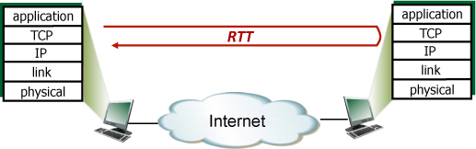

α = 0.125  
ß = 0.25  
EstimatedRTT0 = 280ms  
DevRTT0 = 30ms

EsimatedRTT = (1- α) * EstimatedRTT0 + α*SampleRTT  
= (1- 0.125) * 280 + 0.125*290  
= 281.25ms

DevRTT = (1- ß) * DevRTT0 + ß| SampleRTT – EstimatedRTT |  
= (1-0.25)*30 + 0.25 | 290 – 281.25 |  
= 24.6875ms

Time Interval = EstimatedRTT + 4*DevRTT  
= 380ms

2. Why do HTTTP, FTP and SMTP run on top of TCP rather than on UDP? **(1 point)**

They run on TCP because it allows for reliable data transfer and they cannot afford for data loss which UDP cannot guarantee.

3. Consider an e-commerce website that wants to keep a purchase record for each of its customers. Describe how this is done with cookies. **(1 point)**

With cookies this is relatively easy. The client makes the purchase request and sends an HTTP request to the server. The server creates a client ID for the user and replies with a set-cookie header set in the http response along with the client ID. That cookie is then set in the clients browser and that cookie will be sent to the server anytime that cite is accessed.

4. Why is it said that FTP sends control information “out-of-band”? **(1 point)**

It is said it sends control information out of band because it is not in-band lol

5. While designing a reliable data transfer protocol why is it necessary to include sequence numbers and timers? **(2 points)**

Sequence Numbers: These are used to make sure that packets are received in the correct order at the receiver. If we had no sequence numbers and two packets arrived at the exact same time then how would we know which one is intended to go first?

Timer: Timers are used to prevent the client from indefinitely waiting if a packet or acknowledgement is lost. The timer is used to indicated when a packet is lost. The timer is set to a value which is considered a reasonable round-trip time and if an acknowledgement for that packet is not received by the time that the timer runs out then the packet or acknowledgement is assumed to be lost.

6. Suppose a process in Host C has UDP socket with port number 6789. Suppose both Host A and Host B send UDP segment to Host C with destination port number 6789. Will both of these segments be directed to the same socket at Host C? If so, how you think the process at Host C know that these two segments originated at different host? **(1 point)**

Yes, both of these segments will be directed to the same socket. Host C will know these two segments originated from two different hosts because the source IP for both of these segments will be different.

7. Consider the figure below, with three links, each with the specified transmission rate and link length.

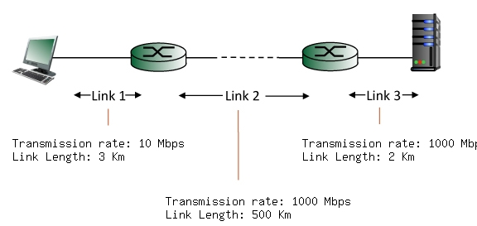

Find the end-to-end delay (including the transmission delays and propagation delays on each of the three links, but ignoring queuing delays and processing delays) from when the left host begins transmitting the first bit of a packet to the time when the last bit of that packet is received at the server at the right. The speed of propagation on each link is **2x108 m/sec**. Note that the transmission rates are in Mbps and the link distances are in Km. Assume a packet length of **8000**bits. Give your answer in milliseconds. **(3 points)**

Transmission delay = bits/transmission rate

Transmission delay1 = 8000/10Mbps = 8000/10^7 = 0.008s = 0.008ms

Transmission delay2 = 8000/1000Mbps = 8000/1000*10^6 = 0.000008s = 0.008ms

Transmission delay3 = Transmission delay2 = 0.008ms

Propagation rate = 2*10^8 m/s

Packet length = 8000 bits

Propagation delay = distance/propagation rate

Propagation delay1 = 3*10^3/2*10^8 = 1.5*10^-5s = 0.015ms

Propagation delay2 = 500*10^3/2*10^8 = 0.0025s = 2.5ms

Propagation delay3 = 2*10^3/2*10^8 = 1*10^-5= 0.01ms

End-to-end = Propagation delay + Transmission delay

= 0.015 + 2.5 + 0.01 + 0.8 + 0.008 + 0.008

= 3.341ms

8. State two important differences between packet switched and circuit switched networks. **(2 points)**

Packet switched is better for the average case but can get deadlocked with a lot of traffic whereas circuit switched is better with a lot of traffic and cannot get deadlocked.

9. State one important function of the Top-level domain servers and Authoritative DNS servers? **(1 point)**

Domain name resolution

10. Suppose Host A wants to send a large file to Host B. The path from Host A to Host B has three links R1 = 10000 Kbps, R2 = 2Mbps and R3 = 1 Mbps. **(1 point)**

a) Assuming no other traffic in the network what is the throughput for the file transfer?

Min(10000Kbps, 2000Kbps, 1000 Kbps) = 1000Kbps

b) Repeat a) assuming R2 = 100 Kbps

Min(1000Kbps, 100Kbps, 1000 Kbps) = 100Kbps

11. Below is a screenshot of an HTTP response from a wireshark capture. Answer the following questions. **(1 point)**

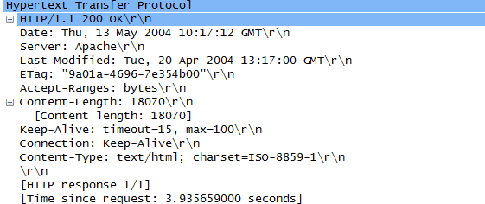

1. When was the last update made to this file?

Last-Modified Header ‘Tue, 20 Apr 2004 13:17:00 GMT’

1. The HTTP request had asked for a persistent connection. Did the server agree to a persistent connection?

Yes, the connection indicates it is ‘Keep-Alive’ which means persistent.

12. Consider the two 16-bit words (shown in binary) below. Recall that to compute the Internet checksum of a set of 16-bit words, we compute the one's complement of the sum of the two words. Compute the Internet checksum value for these two 16-bit words: **(2 points)**

1110110001011101               
0111111101110000

Sum: 10110111111011101   
Carry the One: 0110111111011110  
Checksum: 1001000000100001

13. Describe two main differences between the Go-back-N protocol and the selective repeat protocol. **(1 point)**

Go-back-N uses cumulative ACK whereas selective repeat uses individual ACK for each segment

Go-back-N maintains timer for oldest unacked packet whereas selective repeat maintains timer for each unacked segment

14. Suppose within your Web browser you click on a link to obtain a Web page. The IP address for the associated URL is not cached in your local host, so a DNS lookup is necessary to obtain the IP address. Suppose that four DNS servers are visited before your host receives the IP address from DNS. The first DNS server visited is the local DNS cache, with an RTT delay of RTT0 = 2 msecs. The second, third and fourth DNS servers contacted have RTTs of 13, 28, and 16 msecs, respectively. Initially, let's suppose that the Web page associated with the link contains a small amount of HTML text that is present in the base html file itself. Suppose the RTT between the local host and the Web server containing the object is RTTHTTP = 74 msecs.

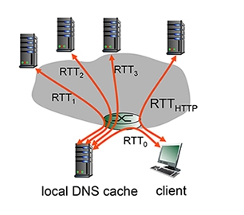

1. Assuming zero transmission time for the base html file, how much time elapses from when the client clicks on the link until the client receives the object? **(2 points)**

End-to-end = RTT0+RTT1+RTT2+RTT3+RTThttp = 2+13+28+16+74=133msec

1. Now suppose the base html references 9 very small objects on the same web server. Neglecting transmission times, how much time elapses from when the client clicks on the link until the base object and all 9 additional objects are received from web server at the client, assuming non-persistent HTTP and no parallel TCP connections? **(2 points)**

End-to-end = RTT0+RTT1+RTT2+RTT3+num_objects*(RTThttp) = 2+13+28+16+10*(74) = 799msec

15. Consider the figure below in which TCP a sender and receiver communicate over a connection in which the sender-to-receiver segments may be lost. The TCP sender sends initial window of four segments at t=1,2,3,4, respectively. Suppose the initial value of the sender-to-receiver sequence number is 108 and the first four segments *each*contain 556 bytes. The delay between the sender and the receiver is 7 time units, and so the first segment arrives at the receiver at t=8. As shown in the figure, two of the four segment(s) are lost between the sender and the receiver.

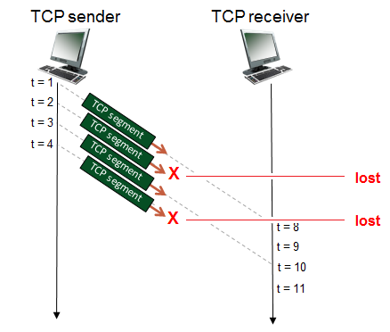

Answer the following questions:

1. Give the sequence numbers associated with each of the four segments sent by the sender. **(2 points)**

SequenceNum1= 108

SequenceNum2= 664

SequenceNum3= 1220

SequenceNum4= 1776

1. List the sequence of acknowledgements transmitted by the TCP receiver in response to the receipt of the segments actually received. In particular, give the value in the acknowledgement field of each receiver-to-sender acknowledgement, and give a brief explanation as to why that particular acknowledgement number value is being used. **(2 points)**

AckNum1 = 664, it sends this because it has received the first 556 bytes of the first segment so 108+556 = 664.

AckNum2 = 664, it sends this because it has received the first and third segments but segment 2 was never received so it sends the ack value of the last acknowledged byte which is byte 664.

16. Consider the scenario shown below, with four different servers connected to four different clients over four three-hop paths. The four pairs share a common middle hop with a transmission capacity of R = 400 Mbps. The four links from the servers to the shared link have a transmission capacity of RS = 10 Mbps. Each of the four links from the shared middle link to a client has a transmission capacity of RC = 20 Mbps per second.

1. What is the maximum achievable end-end throughput (in Mbps) for each of four client-to-server pairs, assuming that the middle link is fair-shared (i.e., divides its transmission rate equally among the four pairs)? **(1 point)**

min(10Mbps, 400/4 Mbps, 20Mbps) = min(10Mbps, 100Mbps, 20Mbps) = 10 Mbps

1. Which link is the bottleneck link for each session? **(1 point)**

Rs is the bottleneck link.

