**CS 428/528**

**Instructor: Anand Seetharam**

**Quiz 1**

1. Name the five layers of the protocol stack. (**2 points)**

**Answer)  
1. Application layer  
2. Transport layer  
3. Network layer  
4. Link layer  
5. Physical layer**

2. In this figure, 3 clients are simultaneously downloading a file from a server. The capacity of the bottleneck link is R. What is the throughput received by each client (assume Rc > R)? (**2 points)**

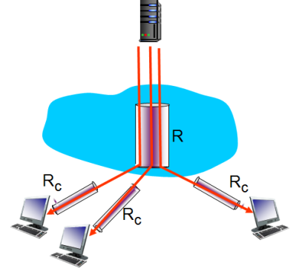

**Answer) The throughput for each client is the min(R/3, Rc) = R/3.**

3. Application and Transport layers of the Internet protocol stack are implemented in the end systems but not in the routers in the network core. True or False? **(1 point)**

**Answer) True**

4. Two hosts A and B are connected by a 100 Mbps link. A is sending a packet of size 1000 KBytes to B. What is transmission delay for the packet? (**2 points)**

**Answer)  
  
Packet Size = 1000Kbytes = 8000Kbits = 8Mbits**

**Transmission Rate = 100Mbps  
  
Transmission Delay = Packet Size/ Transmission rate  
  
8Mbits/100Mbps  
🡺 0.08s**

5. Write one important difference between circuit-switched and packet-switched networks. (**1 point)**

**Answer)**

**Packet switching is not optimal at max capacity, whereas circuit switching is. However, in the average case packet switching works best.**

6. Two hosts A and B are connected by an optical fiber 3000 Km long. The speed of light is 3*108 m/sec. What is the propagation delay? (**2 points)**

**Answer)**

**Propagation Speed = 3*10^8**

**Distance = 3000km = 3*10^6**

**Propagation Delay = Distance/Propagation Speed**

**(3*10^6)/(3*10^8) = 1/10^2  
🡺 0.01s**