**CS 428/528**

**Instructor: Anand Seetharam**

**Quiz 2**

**Baptiste Saliba**

1. What is the primary function of DNS? **(1 point)  
  
Answer)**

**To translate a url into an IP address**

2. Cookies can be used by a website to store shopping cart information. True or False? **(1 point)  
   
Answer)**

**True, cookies store user information to remember session details like shopping carts**

3. What is the difference between persistent and non-persistent HTTP connections? **(1 point)**

**Answer)**

**Persistent HTTP connections keep the TCP connection alive, eliminating the need to establish a new TCP connection for each sent item. Non-persistent connections do not keep the TCP connection alive and need to establish a new TCP connection for every sent item.**

4. What are the port numbers used by the server and client in an HTTP connection? **(2 points)**

**Answer)**

**The server will use port 80 as a welcome port and the client can use any port that is not reserved.**

5. Which of these network applications is not time sensitive (there could be multiple correct options)? **(1 point)**

**a) E-mail** b) Video Streaming c) Internet telephony (e.g., skype) **d) Web Documents**

**Answer)**

**A & D**

6. Two hosts A and B are connected by a 10 Mbps link and the distance between then is 300 Km. A is sending a packet of size 1000 KB to B. What is transmission delay and propagation delay for the packet? Speed of propagation is 3*108 m/sec. **(2 points)**

**Answer)**

**1 byte = 8 bits**

**Distance = 300Km = 3*10^5**

**Propagation Rate = 3*10^8**

**Packet Size = 1000 KB = 8000 Kb = 8 Mb**

**Transmission Rate = 10Mbps**

**Transmission Delay = Packet Size/ Transmission Rate**

**🡺 1000KB/1Mbps = 8Mb/10Mbps = 0.8 seconds**

**Propagation Delay = Distance/Propagation Rate**

**🡺 (3*10^5)/(3*10^8) = 1/10^3 = 0.001 seconds**

7. Consider the scenario shown below, with four different servers connected to four different clients over four three-hop paths. The four pairs share a common middle hop with a transmission capacity of R = 300 Mbps. The four links from the servers to the shared link have a transmission capacity of RS = 90 Mbps. Each of the four links from the shared middle link to a client has a transmission capacity of RC = 40 Mbps per second. What is the maximum achievable end-end throughput (in Mbps) for each of four client-to-server pairs, assuming that the middle link is fair-shared (i.e., divides its transmission rate equally among the four pairs). Which link is the bottleneck link for each session? **(2 points)**

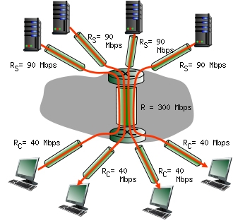

**Answer)**

**min( Rc, R, Rs) = min(40, 300/4, 90) = min(40, 75, 90)**

**🡺 40**

**Rc is the bottleneck link. So the end-to-end maximum throughput is 40 Mbps.**