**CS 428/528**

**Instructor: Anand Seetharam**

**Quiz 5**

**Baptiste Saliba**

1. Which of the following is always possible with single bit parity check (there can be multiple correct answers)? **(1 point)**

a) Correct single bit error

**b) Detect only single bit error**

c) Detect multiple bit errors but correct only single bit error

d) None of the above  
  
**Reasoning:** Single bit parity tells you whether there are an even number of 1’s in that line or not. This allows us to detect single bit errors because if the parity bit is 0 (meaning there are supposed to be an even number of 1s); however, we in the received line there are an odd number of 1s then it means that one of the bits was corrupted. We don’t know which bit it is but we do know there is a single bit error.  
  
If there are two bits that are two bits that are switched then we cannot detect that error because if there were an even number of 1s before then there will still be an even number of 1s after.

2. What is the primary function of ARP? **(1 point)**

**Answer)**

**The primary function of ARP (Address Resolution Protocol) is to map IP addresses to MAC addresses, as well as remembering that mappings time-to-live within the ARP table.**

3. In CSMA/CD after n collisions, a node chooses a value of K at uniformly at random from {0, 1, 2, ……. 2n -1}. After the 5th collision, a value of K = 4 is chosen. The result K = 4 corresponds to how many seconds of delay on a 10 Mbps Ethernet (For Ethernet, the actual time a node waits is K*512 bit times)? **(2 points)**

**Answer)**

**K*512 = 4*512 = 2048 bit times**

**Time to wait = bit times/ rate = 2048/10,000,000**

**🡺 0.0002048s**

4. What is *the* main difference between ALOHA and slotted ALOHA protocols? **(1 point)**

**Answer)**

**There is no synchronization in the unslotted ALOHA protocol whereas in the slotted ALOHA protocol there is clock synchronization. This means that there is higher collision probability in unslotted ALOHA.**

5. What is *the* main difference between the CSMA and CSMA/CD protocols? **(1 point)**

**Answer)**

**The main difference is that CSMA/CD has collision detection whereas CSMA does not. CSMA can have collisions due to propagation delay, which is why we need CSMA/CD in the first place.**

6. Switches are self-learning. True or False? **(1 point)**

**Answer)**

**True. The term that is typically used is ‘plug and play’.**

7. Consider the figure below. The IP and MAC addresses are shown for nodes A, B, C and D, as well as for the router's interfaces. Consider an IP datagram being sent from node **B** to node **A**.

Give the source and destination Ethernet addresses, as well as the source and destination addresses of the IP datagram encapsulated within the Ethernet frame at points *(3)*, *(2),* and *(1)* in the figure above. **(3 points)**

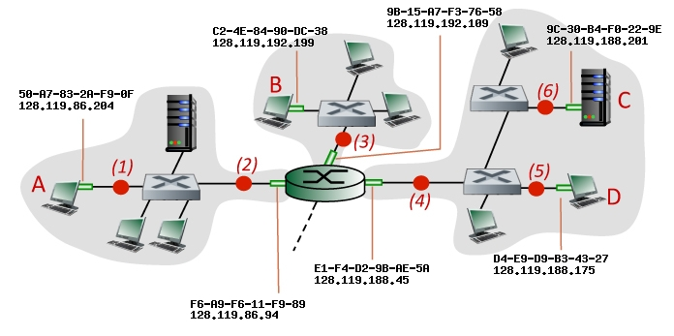

**Answer)**

(3)

MAC src: C2-4E-84-90-DC-38  
MAC dest: 9B-15-A7-F3-76-58  
IP src: 128.119.192.199  
IP dest: 128.119.86.204  
  
(2)

MAC src: F6-A9-F6-11-F9-89  
MAC dest: 50-A7-83-2A-F9-0F  
IP src: 128.119.192.199  
IP dest: 128.119.86.204

(1)

MAC src: F6-A9-F6-11-F9-89  
MAC dest: 50-A7-83-2A-F9-0F  
IP src: 128.119.192.199  
IP dest: 128.119.86.204