**PART-A**

# STAR- AIRLINES DATABASE:

This database is about airlines which consist of flight details, airlines details, employee details, passengers' details and reservations details as well as payment details.

# BACKGROUND

*STAR-AIRLINES* is a start-up company which manages flights, the certified airlines employees and passengers and their reservations as well as corresponding payment details. We started the company by buying the airlines which are affordable and which have average cruising range. We collected four airlines. Next we hired employees for the respective airlines accorfding to their certifications. We hired employees with more number of certification so that there is flexibility with the airlines and flights schedules. Next we prepared for the flights with dates and time. The start and destination was figured out and the departure date and time were scheduled. Then we opened the market for the reservations of flights. In no time we got reservations from all around the world. There were passengers who wish to fly with us. Payments were made and reservations of their respective flights were made.

# Mission Statement

The mission of the STAR-AIRLINES DATABASE is to manage the data of the airlines. To make sure that the details are entered correctly and customers are given their flights details without any errors. To make sure that the allotted employees are available for their respective flights and time is managed in organized way. Another Mission of this database is providing customers with varieties of flights with various time slots and airlines so that they have different options of flying. Lastly, maintaining the payment details with respect to the passengers and their reservations.

# DBMS Selection

Mysql is a widely used open-source relational database system. It most popular database system available and is very easy to use and understand as well. It is perfect for small as well as big companies. MySQL works very efficiently and works well even with large data sets. There many other advantages in using mysql that's why I chose to work with mysql for this project.

# ER-Diagram:

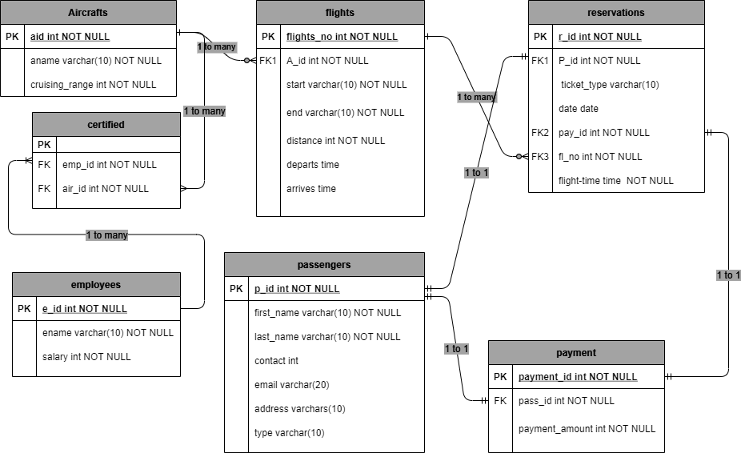

The figure shows the Entity-Relationship diagram of Star-Airlines database.

# STAR-AIRLINES Database Schema

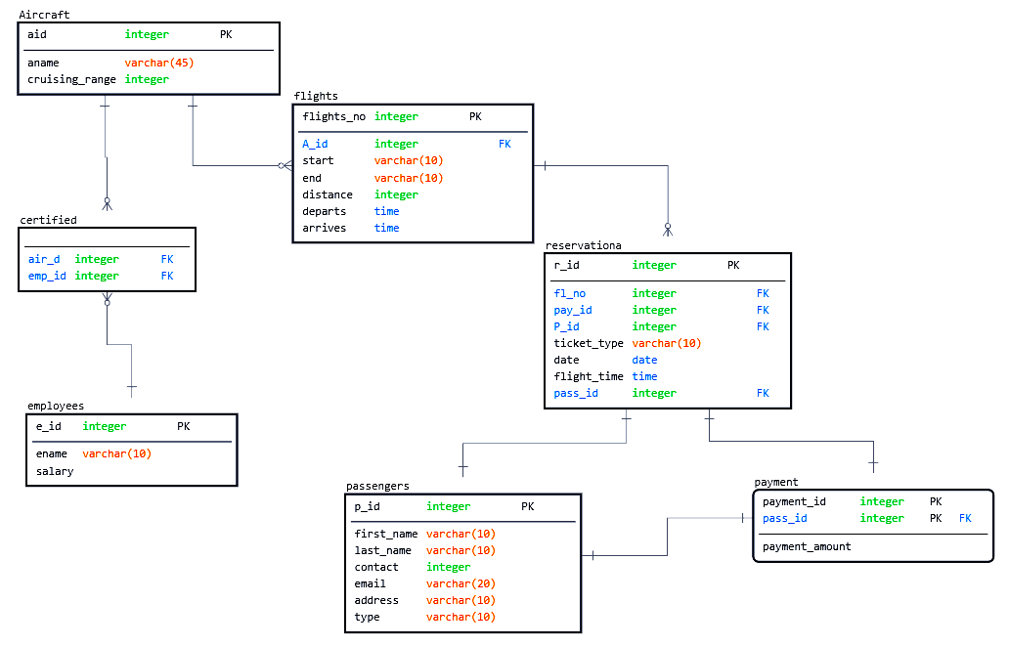

The figure shows star airlines database schema. It gives a certain idea about the structure of database.

# TABLE STRUCTURES AND SAMPLE DATA

There are total seven tables in Star Airlines database. Following are the tables:

# Airlines: It consist of its unique id called "aid" and airlines names as "aname" and the cruising range that the airline can travel.

|  |
| --- |
| ***mysql> desc Airlines;*** |
| +----------------+-------------+------+-----+---------+-------+  | Field | Type | Null | Key | Default | Extra |  +----------------+-------------+------+-----+---------+-------+  | aid | int(11) | NO | PRI | NULL | |  | aname | varchar(10) | YES | | NULL | |  | cruising_range | int(11) | YES | | NULL | |  +----------------+-------------+------+-----+---------+-------+  3 rows in set (0.41 sec) |
| ***mysql> select * from Airlines;*** |
| +-----+------------+----------------+  | aid | aname | cruising_range |  +-----+------------+----------------+  | 1 | BOEING123 | 13670 |  | 2 | BOEING777 | 20000 |  | 3 | AIRBUS-A23 | 30000 |  | 4 | AIRBUS-342 | 23000 |  +-----+------------+----------------+  4 rows in set (0.15 sec) |

# Flights: This table is for the flight details like start and destination of the flight, Departure and arrival time, and a primary key as flights_no and a foreign key which references table airlines.

|  |
| --- |
| ***mysql> desc flights;*** |
| +------------+-------------+------+-----+---------+-------+  | Field | Type | Null | Key | Default | Extra |  +------------+-------------+------+-----+---------+-------+  | flights_no | int(11) | NO | PRI | NULL | |  | start | varchar(10) | NO | | NULL | |  | end | varchar(10) | NO | | NULL | |  | distance | int(11) | NO | | NULL | |  | departs | time | YES | | NULL | |  | arrives | time | YES | | NULL | |  | A_id | int(11) | NO | MUL | NULL | |  +------------+-------------+------+-----+---------+-------+  7 rows in set (0.49 sec) |
| ***mysql> select * from flights;*** |
| +------------+-----------+--------+----------+----------+----------+------+  | flights_no | start | end | distance | departs | arrives | A_id |  +------------+-----------+--------+----------+----------+----------+------+  | 11 | newyork | london | 12000 | 00:00:12 | 00:00:13 | 1 |  | 12 | delhi | dhaka | 10000 | 00:12:00 | 00:13:00 | 2 |  | 13 | melbourne | xyz | 15000 | 08:00:00 | 10:00:00 | 1 |  | 14 | sydney | paris | 25000 | 05:00:00 | 08:00:00 | 2 |  | 15 | mexico | rome | 20000 | 14:00:00 | 22:00:00 | 3 |  +------------+-----------+--------+----------+----------+----------+------+  5 rows in set (0.00 sec) |

# Employees: This table is for the employees working in the airlines. It consist of e_id(primary key), Ename( employee names) and salary of each employees.

|  |
| --- |
| ***mysql>desc employees;*** |
| +--------+-------------+------+-----+---------+-------+  | Field | Type | Null | Key | Default | Extra |  +--------+-------------+------+-----+---------+-------+  | e_id | int(11) | NO | PRI | NULL | |  | Ename | varchar(10) | YES | | NULL | |  | salary | int(11) | YES | | NULL | |  +--------+-------------+------+-----+---------+-------+  3 rows in set (0.11 sec) |
| ***mysql> select * from employees;*** |
| +------+----------+--------+  | e_id | Ename | salary |  +------+----------+--------+  | 101 | John | 50000 |  | 102 | Margeret | 40000 |  | 103 | Samual | 35000 |  | 104 | Mary | 50000 |  | 105 | Ola | 30000 |  +------+----------+--------+  5 rows in set (0.00 sec) |

# Certified: This table shows those employees who are certified to which airlines. It has two foreign keys emp_id referencing employees table and air_id referencing airlines.

|  |
| --- |
| ***mysql> desc certified;*** |
| +--------+---------+------+-----+---------+-------+  | Field | Type | Null | Key | Default | Extra |  +--------+---------+------+-----+---------+-------+  | emp_id | int(11) | NO | PRI | NULL | |  | air_id | int(11) | YES | MUL | NULL | |  +--------+---------+------+-----+---------+-------+  2 rows in set (0.03 sec) |
| ***mysql> select * from certified;*** |
| +--------+--------+  | emp_id | air_id |  +--------+--------+  | 101 | 1 |  | 103 | 1 |  | 102 | 3 |  | 104 | 2 |  | 105 | 3 |  +--------+--------+  5 rows in set (0.00 sec) |

# Passengers: This Table is for the details of passengers. It includes passengers id as p_id(primary key), first and last name of a passenger, address, contact, email and the type of the passenger(economic or first class).

|  |
| --- |
| ***mysql> desc passengers;*** |
| +------------+-------------+------+-----+---------+-------+  | Field | Type | Null | Key | Default | Extra |  +------------+-------------+------+-----+---------+-------+  | p_id | int(11) | NO | PRI | NULL | |  | first_name | varchar(10) | NO | | NULL | |  | last_name | varchar(10) | NO | | NULL | |  | contact | int(11) | YES | | NULL | |  | email | varchar(20) | YES | | NULL | |  | address | varchar(10) | YES | | NULL | |  | type | varchar(10) | YES | | NULL | |  +------------+-------------+------+-----+---------+-------+  7 rows in set (0.05 sec) |
| ***mysql> select * from passengers;*** |
| +------+------------+-----------+---------+----------------------+-----------+---------+  | p_id | first_name | last_name | contact | email | address | type |  +------+------------+-----------+---------+----------------------+-----------+---------+  | 111 | Alisha | Magar | 12345 | alisha@gmail.com | sydney | economy |  | 222 | Alex | Steves | 11111 | alex123@gmail.com | newyork | economy |  | 333 | William | Smith | 565656 | will123@gmail.com | melbourne | first |  | 444 | Chandler | Bing | 676768 | sarcasm101@gmail.com | london | first |  | 555 | Kelly | Kapowski | 67777 | Kells1@gmail.com | rome | first |  | 666 | Phil | Williams | 90907 | WillPhil@gmail.com | xyz | economy |  | 777 | Bart | Simpson | 99989 | simp12@live.com | dhaka | economy |  | 888 | Bill | Hans | 787878 | bbb@yahoo.com | mexico | economy |  +------+------------+-----------+---------+----------------------+-----------+---------+  8 rows in set (0.00 sec) |

# Payment: This table gives the payment details of each customer. There is a primary key( payment_id), a foreign key pass_id references to passengers(p_id) and payment_amount.

|  |
| --- |
| mysql> desc payment; |
| +----------------+---------+------+-----+---------+-------+  | Field | Type | Null | Key | Default | Extra |  +----------------+---------+------+-----+---------+-------+  | payment_id | int(11) | NO | PRI | NULL | |  | pass_id | int(11) | YES | | NULL | |  | payment_amount | int(11) | YES | | NULL | |  +----------------+---------+------+-----+---------+-------+  3 rows in set (0.00 sec) |
| ***mysql> select * from payment;*** |
| +------------+---------+----------------+  | payment_id | pass_id | payment_amount |  +------------+---------+----------------+  | 201 | 111 | 15000 |  | 202 | 222 | 30000 |  | 203 | 333 | 20000 |  | 204 | 444 | 30000 |  | 205 | 555 | 50000 |  | 206 | 666 | 12000 |  | 207 | 777 | 24000 |  | 208 | 888 | 23000 |  +------------+---------+----------------+  8 rows in set (0.00 sec) |

# Reservations: This table shows the reservations details it links passenger to a flight as it have foreign keys p_id anf fl_no referencing to passenger and flights tables.

|  |
| --- |
| ***mysql> desc reservations;*** |
| +-------------+-------------+------+-----+---------+-------+  | Field | Type | Null | Key | Default | Extra |  +-------------+-------------+------+-----+---------+-------+  | r_id | int(11) | NO | PRI | NULL | |  | P_id | int(11) | YES | MUL | NULL | |  | ticket_type | varchar(10) | YES | | NULL | |  | date | date | YES | | NULL | |  | pay_id | int(11) | YES | MUL | NULL | |  | fl_no | int(11) | YES | MUL | NULL | |  | flight_time | time | YES | | NULL | |  +-------------+-------------+------+-----+---------+-------+  7 rows in set (0.00 sec) |
| ***mysql> select * from reservations;*** |
| +------+------+-------------+------------+--------+-------+-------------+  | r_id | P_id | ticket_type | date | pay_id | fl_no | flight_time |  +------+------+-------------+------------+--------+-------+-------------+  | 121 | 111 | economy | 2012-12-20 | 201 | 11 | 00:00:12 |  | 122 | 222 | economy | 2001-12-20 | 202 | 12 | 12:00:00 |  | 123 | 333 | first | 2010-11-20 | 203 | 13 | 08:00:00 |  | 124 | 444 | first | 2010-11-20 | 204 | 13 | 08:00:00 |  | 125 | 555 | first | 2001-12-20 | 205 | 12 | 12:00:00 |  | 126 | 666 | economy | 2012-12-20 | 206 | 11 | 00:00:12 |  | 127 | 777 | economy | 2013-12-20 | 207 | 14 | 05:00:00 |  | 128 | 888 | economy | 2009-12-20 | 208 | 15 | 14:00:00 |  +------+------+-------------+------------+--------+-------+-------------+  8 rows in set (0.00 sec) |

**PART-B**

# QUESTION-1

|  |  |
| --- | --- |
| SQL | select distinct aname, ename  from Aircraft,employees,certified  where aid=air_id and e_id=emp_id**;** |
| OUTPUT | +------------+------------+  | aname | ename |  +------------+------------+  | BOEING123 | John |  | BOEING123 | Samual |  | BOEING123 | alex |  | BOEING777 | Mary |  | BOEING777 | jay pritch |  | AIRBUS-A23 | Margeret |  | AIRBUS-A23 | Ola |  | AIRBUS-A23 | manny dunp |  | AIRBUS-342 | gloria |  +------------+------------+  9 rows in set (0.00 sec) |

# QUESTION-2

|  |  |
| --- | --- |
| SQL | select CONCAT(first_name,' ',last_name) AS "passengers list", contact AS "Contact info ", email AS "Email Address"  from passengers  where email IS NOT NULL order by last_name ASC; |
| OUTPUT | +-----------------+---------------+----------------------+  | passengers list | Contact info | Email Address |  +-----------------+---------------+----------------------+  | Chandler Bing | 676768 | sarcasm101@gmail.com |  | Bill Hans | 787878 | bbb@yahoo.com |  | Kelly Kapowski | 67777 | Kells1@gmail.com |  | Alisha Magar | 12345 | alisha@gmail.com |  | Bart Simpson | 99989 | simp12@live.com |  | William Smith | 565656 | will123@gmail.com |  | Alex Steves | 11111 | alex123@gmail.com |  | Phil Williams | 90907 | WillPhil@gmail.com |  +-----------------+---------------+----------------------+  8 rows in set (0.08 sec) |

# QUESTION-3

|  |  |
| --- | --- |
| SQL | select max(salary) as second_highest_salary  from employees  where salary<(select max(salary) from employees); |
| OUTPUT | +-----------------------+  | second_highest_salary |  +-----------------------+  | 130000 |  +-----------------------+  1 row in set (0.03 sec) |

# QUESTION-4

|  |  |
| --- | --- |
| SQL | select flights_no, start, end  from flights  where distance >15000; |
| OUTPUT | +------------+--------+-------+  | flights_no | start | end |  +------------+--------+-------+  | 14 | sydney | paris |  | 15 | mexico | rome |  +------------+--------+-------+  2 rows in set (0.00 sec) |

# QUESTION-5

|  |  |
| --- | --- |
| SQL | select distinct p.first_name,f.flights_no  from passengers p, payment, flights f, reservations r  where p.p_id=r.P_id and pay_id=payment_id and flights_no=fl_no and payment_amount>20000; |
| OUTPUT | +------------+------------+  | first_name | flights_no |  +------------+------------+  | Alex | 12 |  | Chandler | 13 |  | Kelly | 12 |  | Bart | 14 |  | Bill | 15 |  +------------+------------+  5 rows in set (0.00 sec) |

# QUESTION-6

|  |  |
| --- | --- |
| SQL | select p.p_id, p.first_name from passengers p  **inner join** reservations ON p.p_id= reservations.P_id; |
| OUTPUT | +------+------------+  | p_id | first_name |  +------+------------+  | 111 | Alisha |  | 222 | Alex |  | 333 | William |  | 444 | Chandler |  | 555 | Kelly |  | 666 | Phil |  | 777 | Bart |  | 888 | Bill |  +------+------------+  8 rows in set (0.00 sec) |

# QUESTION-7

|  |  |
| --- | --- |
| SQL | select p.p_id, p.first_name, pay_id from ((passengers p **inner join** reservations ON p.p_id= reservations.P_id)**inner join** payment on pay_id=payment_id); |
| OUTPUT | +------+------------+--------+  | p_id | first_name | pay_id |  +------+------------+--------+  | 111 | Alisha | 201 |  | 222 | Alex | 202 |  | 333 | William | 203 |  | 444 | Chandler | 204 |  | 555 | Kelly | 205 |  | 666 | Phil | 206 |  | 777 | Bart | 207 |  | 888 | Bill | 208 |  +------+------------+--------+  8 rows in set (0.00 sec) |

# QUESTION-8

|  |  |
| --- | --- |
| SQL | select ename, aname from employees, Aircraft, certified  where e_id=emp_id and aid=air_id and aname="BOEING123"  **UNION** select ename,aname from employees, aircraft , certified  where e_id=emp_id AND aid=air_id and aname="AIRBUS-342"; |
| OUTPUT | +------------+------------+  | ename | aname |  +------------+------------+  | John | BOEING123 |  | Margeret | BOEING123 |  | jay pritch | BOEING123 |  | alex | BOEING123 |  | Samual | AIRBUS-342 |  | jay pritch | AIRBUS-342 |  | manny dunp | AIRBUS-342 |  +------------+------------+  7 rows in set (0.00 sec) |

# QUESTION-9

|  |  |
| --- | --- |
| SQL | select * from reservations where ticket_type LIKE 'e%'; |
| OUTPUT | +------+------+-------------+------------+--------+-------+-------------+  | r_id | P_id | ticket_type | date | pay_id | fl_no | flight_time |  +------+------+-------------+------------+--------+-------+-------------+  | 121 | 111 | economy | 2012-12-20 | 201 | 11 | 00:00:12 |  | 122 | 222 | economy | 2001-12-20 | 202 | 12 | 12:00:00 |  | 126 | 666 | economy | 2012-12-20 | 206 | 11 | 00:00:12 |  | 127 | 777 | economy | 2013-12-20 | 207 | 14 | 05:00:00 |  | 128 | 888 | economy | 2009-12-20 | 208 | 15 | 14:00:00 |  +------+------+-------------+------------+--------+-------+-------------+  5 rows in set (0.04 sec) |

# QUESTION-10

|  |  |
| --- | --- |
| SQL | select * from flights where end IN ("london","paris","dhaka"); |
| OUTPUT | +------------+---------+--------+----------+----------+----------+------+  | flights_no | start | end | distance | departs | arrives | A_id |  +------------+---------+--------+----------+----------+----------+------+  | 11 | newyork | london | 12000 | 00:00:12 | 00:00:13 | 1 |  | 12 | delhi | dhaka | 10000 | 00:12:00 | 00:13:00 | 2 |  | 14 | sydney | paris | 25000 | 05:00:00 | 08:00:00 | 2 |  +------------+---------+--------+----------+----------+----------+------+  3 rows in set (0.00 sec) |

# QUESTION-11

|  |  |
| --- | --- |
| SQL | select ename from employees where salary between 40000 and 100000; |
| OUTPUT | +------------+  | ename |  +------------+  | John |  | Margeret |  | Mary |  | jay pritch |  +------------+  4 rows in set (0.00 sec) |

# QUESTION-12

|  |  |
| --- | --- |
| SQL | select avg(cruising_rane) as cruising_range from Aircraft; |
| OUTPUT | +----------------+  | cruising_range |  +----------------+  | 21667.5000 |  +----------------+  1 row in set (0.00 sec) |

# QUESTION-13

|  |  |
| --- | --- |
| SQL | select count(p_id),fl_no from reservations where fl_no='11'; |
| OUTPUT | +-------------+-------+  | count(p_id) | fl_no |  +-------------+-------+  | 2 | 11 |  +-------------+-------+  1 row in set (0.02 sec) |

# QUESTION-14

|  |  |
| --- | --- |
| SQL | select sum(payment_amount) from payment, reservations where fl_no=11 and pay_id=payment_id; |
| OUTPUT | +---------------------+  | sum(payment_amount) |  +---------------------+  | 27000 |  +---------------------+  1 row in set (0.00 sec) |

# QUESTION-15

|  |  |
| --- | --- |
| SQL | select distinct aname, start, end, departs, first_name  from Aircraft, Flights, reservations, passengers  where flights_no=fl_no and flights.A_id=Aircraft.aid and passengers.p_id=reservations.p_id; |
| OUTPUT | +------------+-----------+--------+----------+------------+  | aname | start | end | departs | first_name |  +------------+-----------+--------+----------+------------+  | BOEING123 | newyork | london | 00:00:12 | Alisha |  | BOEING123 | newyork | london | 00:00:12 | Phil |  | BOEING777 | delhi | dhaka | 00:12:00 | Alex |  | BOEING777 | delhi | dhaka | 00:12:00 | Kelly |  | BOEING123 | melbourne | xyz | 08:00:00 | William |  | BOEING123 | melbourne | xyz | 08:00:00 | Chandler |  | BOEING777 | sydney | paris | 05:00:00 | Bart |  | AIRBUS-A23 | mexico | rome | 14:00:00 | Bill |  +------------+-----------+--------+----------+------------+  8 rows in set (0.00 sec) |

# PART-C

This is a brief summary about my experience and challenges that I have faced doing this assignment. I started by designing this database on paper. First I listed all the required fields then choosing suitable attributes for each field. After deciding on the entities and attributes then I started working on making ER diagram for this database. After sketching the diagram I started on the database itself. I have used mysql for this project as it is flexible, scalable and fast. I create the database as star airlines database then created the required tables and established the relationships between them. Then the data were inserted and various sql queries were used.

# Challenges and solutions

* First challenge was use of the database itself. There are various types of databases available online. It was confusing at the start which database to use. After comparing the databases available and reviewing all the databases

mysql was most suited for this project so I decided to use mysql for this project.

* Next while making the database and creating tables I encountered some errors. Like the relationships between tables and which keys to be used making the constraints were little challenging. After many trail and errors I was successful on creating the database and was able to create tables with near to perfect relationships.
* As the data increases the management becomes difficult and confusing. With increase in input data there are a lot of errors which follows it. Making sure that each and every data is correctly inserted is a bit of a challenge.
* Security is a great challenge for these types of databases. If a third party gets to know the login details then he/she can easily check the payment details and the company will be exposed to a great loss. Encryption can be used in the confidential sections such as payment and reservations areas. The payment details can be encrypted which will increase the security for the database.

Some screen captures:

