V A R N / BRAND SYSTEM
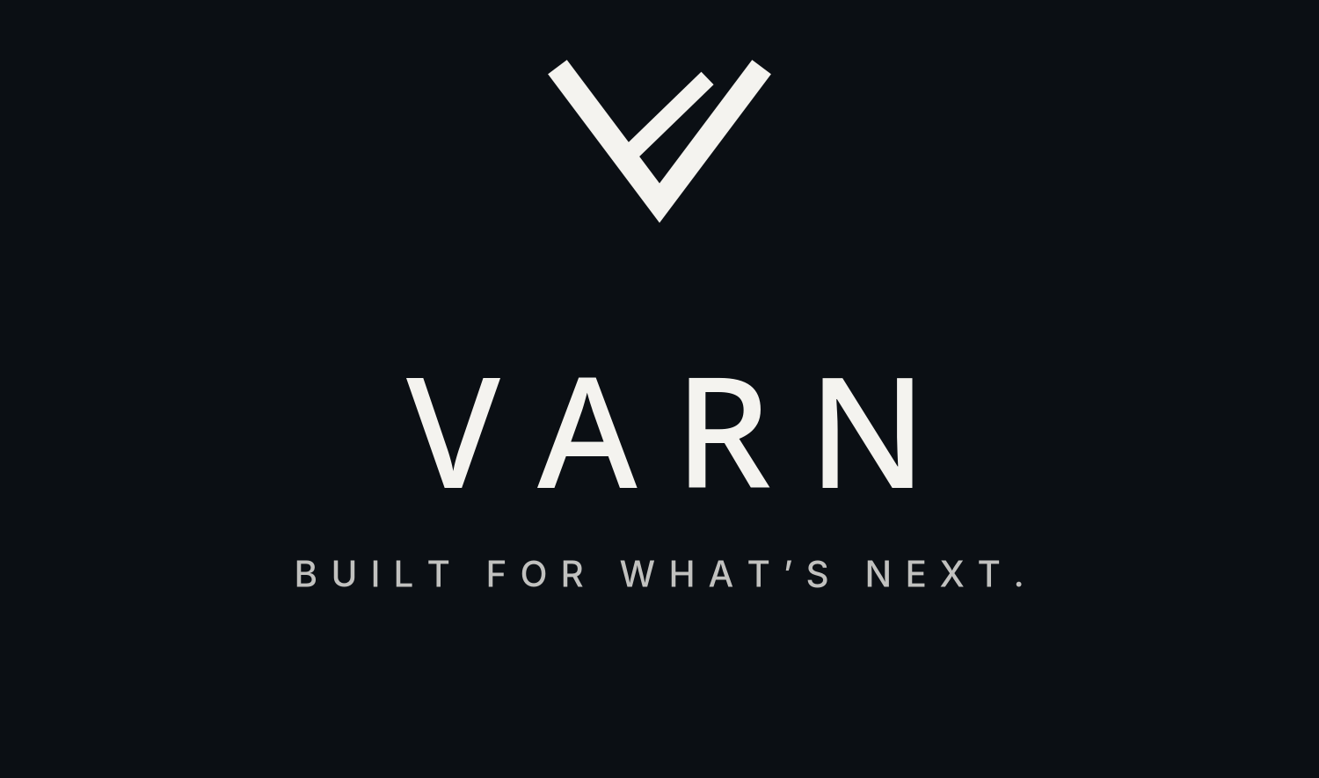
BRAND GUIDELINES / VERSION 1.0
A practical visual system for a precise, modern technology brand.

CHARCOAL | NIGHT | STEEL | FOG | BONE | SAGE

BUILT FOR WHAT’S NEXT.
A Scandinavian-inspired identity system built around restraint, precision, and strong geometry.

01 / BRAND FOUNDATION
A quiet, confident identity
VARN should feel engineered rather than decorated: deliberate geometry, calm contrast, clear hierarchy, and visual details that earn their place. The system is designed to work equally well in software, technical documents, and physical product contexts.
POSITIONING  A modern technology brand associated with awareness, reliable systems, precision, and forward motion. Keep public descriptions grounded in the actual product and its verified capabilities. | PERSONALITY  Calm, capable, exact, and quietly ambitious. Never noisy, theatrical, over-militarized, or needlessly futuristic.

Three design principles
01  PRECISION  Use aligned grids, intentional spacing, and crisp edges. Every element should have a job. | 02  RESTRAINT  Limit the palette, keep layouts spacious, and choose one focal point at a time. | 03  READINESS  Make important information easy to spot. Prioritize clarity over visual spectacle.

Identity in practice
- Let the logo be a focal point, not a repeating decoration.
- Use charcoal and bone as the main visual pairing; steel blue and sage are supporting accents.
- Keep layouts calm even when the information is dense: clear labels, visible hierarchy, and consistent spacing.

VISUAL REFERENCE / APPROVED DIRECTION
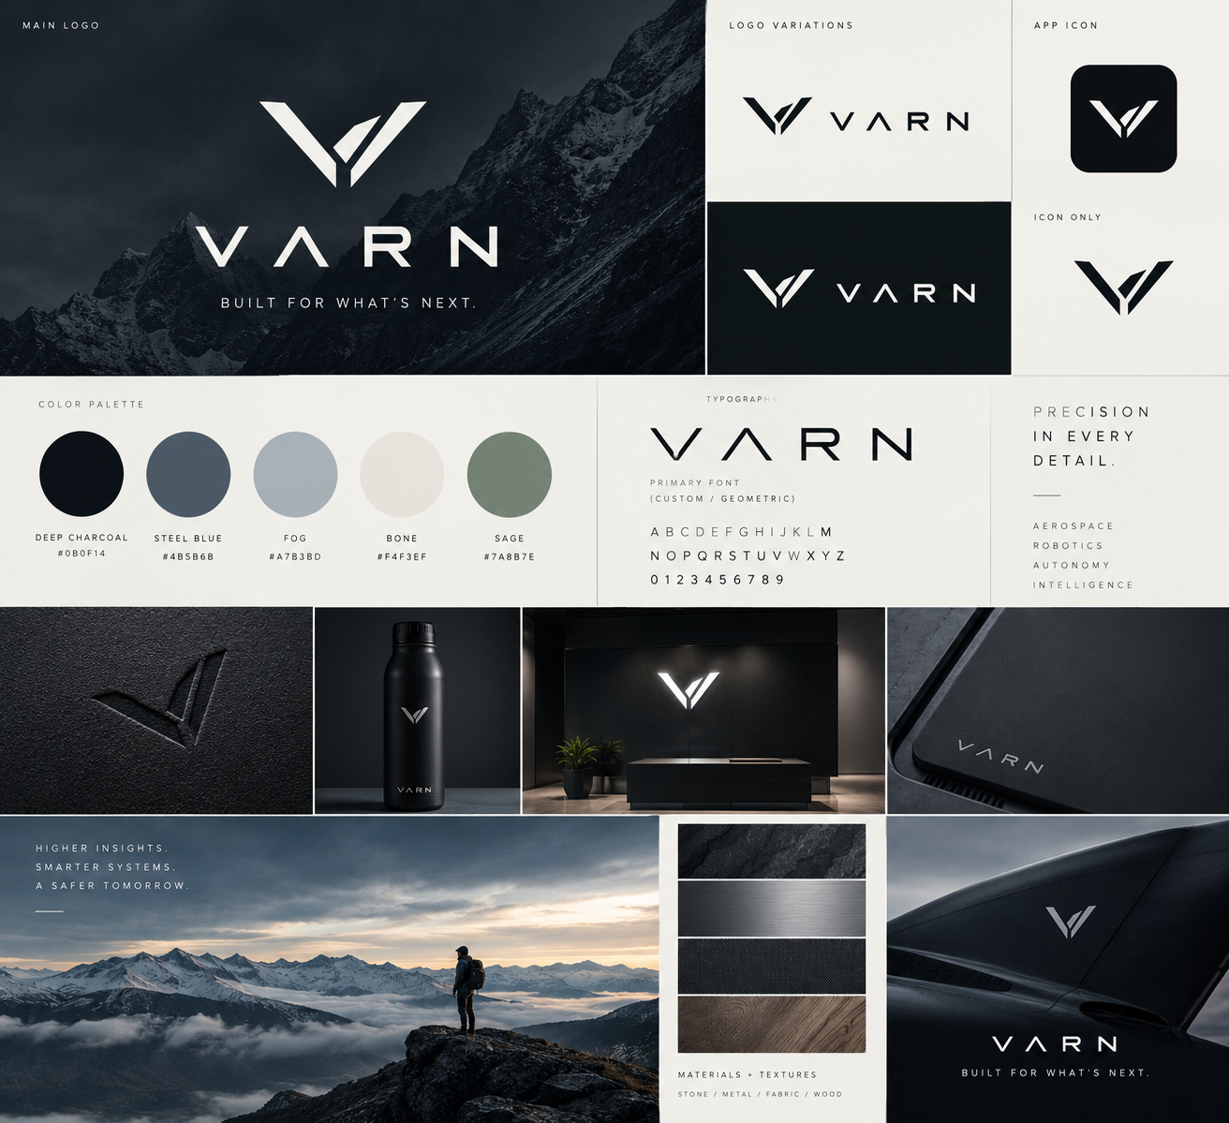
Reference moodboard: use as a direction-setting image, not as a literal specification for every future application.

02 / LOGO SYSTEM
One mark. Two primary environments.
The core identity combines the angular V mark with a widely spaced VARN wordmark. Use the stacked lockup for brand moments and the mark alone for compact applications such as app icons, avatars, and small product stamps.
PRIMARY / DARK | 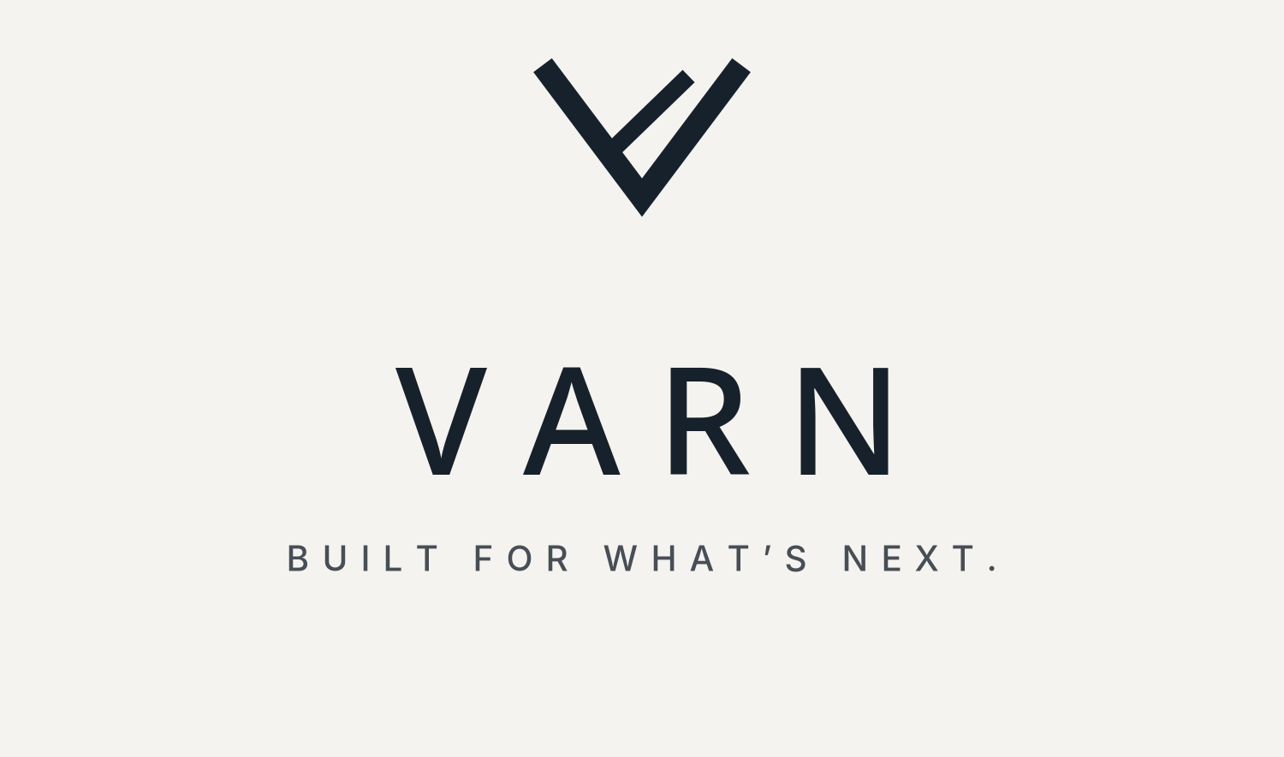  PRIMARY / LIGHT
Clear space and minimum size
CLEAR SPACE  Keep at least one mark-stem width of empty space around every side of the full lockup. When possible, leave more breathing room rather than less. | MINIMUM SIZE  Stacked lockup: 140 px wide on screen or 32 mm wide in print. Mark-only: 20 px high for UI icons; use a simplified high-contrast version at tiny sizes.

Do / do not
- Do use the supplied light logo on charcoal/night surfaces and the dark logo on bone/light surfaces.
- Do keep the mark and wordmark proportions fixed; center them as a single unit when stacked.
- Do not stretch, skew, outline, bevel, glow, or add shadows to the logo.
- Do not place the mark over high-detail photography without a calm contrast field behind it.
- Do not invent extra symbol parts or rotate the mark. Re-check tiny use for legibility.
Asset note: the included SVGs are clean starter vectors interpreting the approved concept. Compare the supplied artwork with the original reference before a final public release.

03 / COLOR SYSTEM
Muted, deliberate, high contrast
The palette starts with near-black charcoal and warm bone, then uses cool blue-gray and soft sage sparingly. Most screens should be built from charcoal/bone with steel or sage as a supporting accent.
VARN  DEEP CHARCOAL  #0B0F14  Primary dark surfaces | VARN  NIGHT  #111820  Secondary dark panels | VARN  STEEL BLUE  #4B5B6B  Links, secondary emphasis | VARN  FOG  #A7B3BD  Muted text on dark / dividers

VARN  BONE  #F4F3EF  Primary light surfaces | VARN  SAGE  #7A8B7E  Small accents, statuses, highlights | VARN  INK  #17212B  Primary text on light | VARN  WHITE  #FFFFFF  Use sparingly for contrast

Usage ratio
45% CHARCOAL | 30% BONE | 12% STEEL | 8% FOG | 5% SAGE
Ratio is a starting point, not a rule: prioritize legibility and context. Use bone text on charcoal; use ink text on bone. Avoid fog-colored body text on bone and avoid sage as a long-text color.
Contrast rule
For core reading text, favor high-contrast combinations: bone on charcoal/night and ink on bone/white. Do not rely on color alone to communicate status; pair accent colors with labels or icons.

04 / TYPOGRAPHY
Geometric display. Neutral reading.
The wordmark should remain custom artwork rather than being retyped. For all surrounding typography, use clean geometric sans-serif families with restrained tracking and clear hierarchy.
DISPLAY TYPE / SPACE GROTESK
BUILT FOR
WHAT’S NEXT.
Headlines should be compact, sharp, and short.

DISPLAY / SPACE GROTESK  Use for headlines, short callouts, and large numeric values. Suggested weight: 500 or 600. Fallback stack: “Space Grotesk”, “Inter”, Arial, sans-serif. | BODY / INTER  Use for paragraphs, interface labels, navigation, and longer reading. Suggested weights: 400 and 500. Fallback stack: “Inter”, Arial, sans-serif.

Type scale
ROLE | SIZE | WEIGHT | NOTES
Display / hero | 48-72 px | Medium | Tight line height; short phrases only
H1 | 36-44 px | Medium | Clear, editorial hierarchy
H2 | 24-30 px | Medium | Section headings
H3 | 18-22 px | Medium | Card or module headings
Body | 15-18 px | Regular | Comfortable reading line length
Caption / metadata | 11-13 px | Medium | Use uppercase + tracking sparingly
Tracking and casing
- Use letter spacing on short uppercase labels, navigation, and the wordmark. Do not apply wide tracking to long body copy.
- Prefer sentence case for readable interface labels and explanatory text. Use uppercase mainly for small section labels and selected brand moments.
- Keep line lengths comfortable: around 55-80 characters for long-form text.

05 / VISUAL LANGUAGE
Angular geometry. Quiet atmosphere.
Shape language
GEOMETRY  Use angular cuts, diagonals, and simplified V-derived forms. Prefer solid silhouettes and clean negative space to complex illustrations. Keep corners mostly crisp; use small radii only for UI containers. | LINES & GRID  Thin dividers, consistent column alignment, and generous margins create structure. Use a 4 px base spacing scale and align components to multiples of 8 where possible.

Photography direction
- Choose real-feeling, low-saturation imagery: Nordic terrain, stone, brushed metal, glass, dark technical surfaces, fog, and open skies.
- Use strong composition and negative space. A single subject or material detail is better than a crowded scene.
- Favor charcoal shadows, cool steel tones, warm off-white highlights, and restrained natural greens.
- Avoid generic stock-photo smiles, neon sci-fi effects, excessive lens flares, over-sharpening, and over-saturated color.
- When showing products or systems, represent actual capabilities accurately; avoid imagery that implies features the product does not have.
UI surfaces and components
DARK SURFACE  Main navigation, hero panels, product shell | LIGHT SURFACE  Documents, technical detail, secondary pages | ACCENT  Small emphasis, active states, selected data

Spacing tokens
4 / 8 / 12 / 16 / 24 / 32 / 48 / 64 px. Use 24-32 px inner padding for standard cards; 40-64 px for large hero sections; 64-96 px between major website sections.

06 / APPLICATIONS & VOICE
Make every touchpoint feel related
WEB / SOFTWARE  - Dark charcoal shell with bone text and steel-blue interaction accents.  - Use restrained cards, thin dividers, compact uppercase metadata, and readable data hierarchy.  - Reserve sage for a small status or confirmation accent; always pair it with text. | PRESENTATIONS / DOCUMENTS  - 16:9 slides, generous margins, one main message per slide.  - Use a charcoal title slide, bone content slides, thin rules, and a consistent footer.  - Charts should use the palette sparingly and remain readable in grayscale.
Voice and messaging
SOUND LIKE  Clear, calm, specific, direct, technically literate. State what a system does, for whom, and why it matters. Prefer facts, not superlatives. | AVOID  “Revolutionary”, “unstoppable”, “world-changing”, vague futurism, fear-based copy, or technical claims that are not substantiated.

Copy examples
PREFER | AVOID
“Clearer awareness. More confident decisions.” | “The most revolutionary system ever made.”
“Designed for reliable operation in complex environments.” | “Unstoppable technology that changes everything.”
Tagline
BUILT FOR WHAT’S NEXT.

07 / IMPLEMENTATION
Quick handoff specifications
Logo files included
- `varn_logo_on_charcoal.svg` / `.png` — stacked primary lockup on dark background.
- `varn_logo_on_bone.svg` / `.png` — stacked primary lockup on light background.
- `varn_mark_light.svg` and `varn_mark_dark.svg` — mark-only transparent vectors.
- `varn_app_icon.svg` / `.png` — square app-icon starting point.
- `varn_design_tokens.css` — copy-ready web palette, type stacks, and spacing tokens.
Design tokens
TOKEN | VALUE | USE
--varn-charcoal | #0B0F14 | Main dark background
--varn-bone | #F4F3EF | Main light background
--varn-steel-blue | #4B5B6B | Secondary accent
--varn-fog | #A7B3BD | Muted detail on dark
--varn-sage | #7A8B7E | Small accent/status
--varn-font-display | Space Grotesk / Inter | Display
--varn-font-body | Inter / Arial | Body
--varn-space-4 | 16 px | Base rhythm
Pre-launch checklist
- Confirm the vector mark matches the final approved logo exactly, then freeze a master SVG and outlined/vector-safe export.
- Check the selected wordmark and brand name with trademark counsel and verify relevant domains/social handles.
- Confirm licenses and availability for Space Grotesk and Inter; package approved font files only where licensing permits.
- Check logo contrast and minimum size on every actual background and device.
- Keep marketing descriptions accurate to real capabilities; avoid unsupported claims.
Status: design system v1.0. Visual recommendations are implementation guidance, not trademark clearance or legal advice.

