HOME SOC LAB
Build, Attack & Detect

Author: Samita Brown
Date: March 2026
Platform: VirtualBox on Kali Linux (Bare Metal)

1. Project Overview
This project documents the design, deployment, and testing of a fully functional home Security Operations Centre (SOC) lab. The lab was built to simulate a real-world enterprise environment, enabling hands-on practice with industry-standard security monitoring, log analysis, and threat detection tools.
The lab leverages Wazuh as the primary SIEM and EDR platform, with Splunk serving as the analyst-facing dashboard for log aggregation and visualization. Attack simulations were conducted from a Kali Linux host against intentionally vulnerable and standard Windows targets, with all activity monitored and alerted on by Wazuh in real time.

Field | Details
Lab Type | Home SOC / Cybersecurity Home Lab
Primary SIEM | Wazuh v4.7.5
Log Analytics | Splunk Enterprise
Virtualization | Oracle VirtualBox on Kali Linux (Bare Metal)
Network | Bridged Adapter — 192.168.15.0/24
Date Built | March 2026

2. Objectives
- Deploy and configure Wazuh SIEM with multiple endpoint agents
- Integrate Splunk as a secondary log analytics and visualization platform
- Simulate realistic attack scenarios including brute force, port scanning, and privilege escalation
- Detect, alert, and analyze security events across Windows and Linux endpoints
- Demonstrate SOC analyst workflows: alert triage, event correlation, and incident documentation
- Build a portfolio-ready project demonstrating hands-on cybersecurity skills

3. Tools & Technologies

3.1 Wazuh
Wazuh is an open-source security platform that combines SIEM, EDR, and threat intelligence capabilities. In this lab, Wazuh was deployed in an all-in-one configuration on Ubuntu Server 22.04, providing the Wazuh Manager, Indexer, and Dashboard components. Agents were installed on all monitored endpoints, enabling real-time event collection, file integrity monitoring, vulnerability detection, and active threat response.

3.2 Splunk Enterprise
Splunk is an industry-leading data analytics and SIEM platform widely used in enterprise SOC environments. Splunk Enterprise was installed on a dedicated Windows 11 laptop, with a Splunk Universal Forwarder deployed on the Ubuntu Server to stream Wazuh alerts and system logs into Splunk for indexing, searching, and dashboard visualization.

3.3 Kali Linux
Kali Linux was used as the attacker machine, running bare metal as the host OS with VirtualBox installed on top. Attack tools used included Nmap for network reconnaissance and Hydra for credential brute forcing.

3.4 Metasploitable 2
Metasploitable 2 is an intentionally vulnerable Linux VM used as a passive attack target. It was used for initial network discovery and as a secondary target for attack simulations.

4. Network Topology
All virtual machines were configured with VirtualBox Bridged Adapter networking, placing them on the same physical subnet as the host machines. This enables direct communication between all VMs and physical laptops without NAT restrictions.

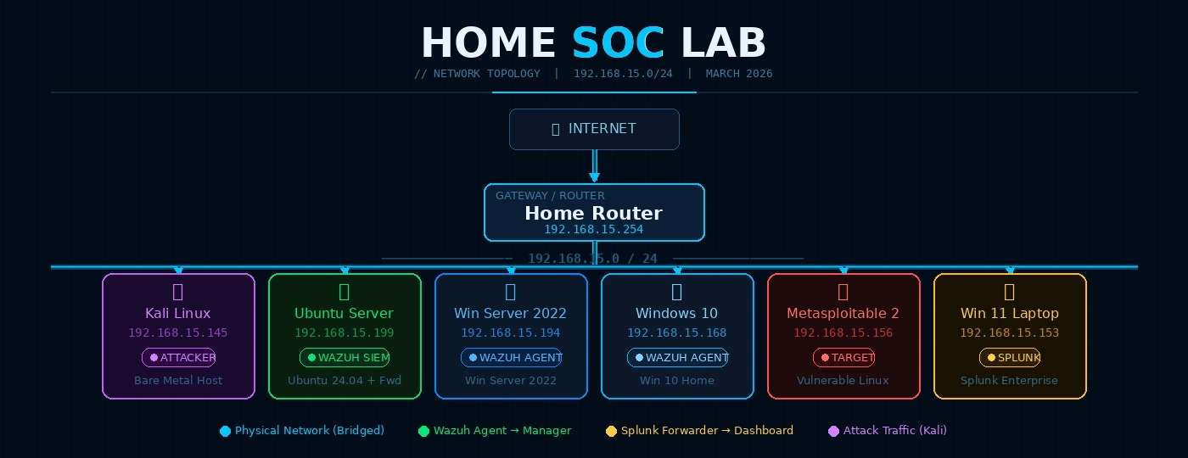

Device | Role | OS | IP Address | Status
Kali Linux (Bare Metal) | Attacker / Host Machine | Kali Linux | 192.168.15.145 | Active
Ubuntu Server VM | Wazuh SIEM Manager + Splunk Forwarder | Ubuntu 24.04.3 LTS | 192.168.15.199 | Active
Windows Server 2022 VM | Wazuh Agent / Target | Windows Server 2022 | 192.168.15.194 | Active
Windows 10 VM | Wazuh Agent / Target | Windows 10 Home | 192.168.15.168 | Active
Metasploitable 2 VM | Vulnerable Attack Target | Ubuntu (Metasploitable) | 192.168.15.156 | Active
Windows 11 Laptop | Splunk SIEM Dashboard | Windows 11 | 192.168.15.153 | Active
Home Router | Network Gateway | — | 192.168.15.254 | Active

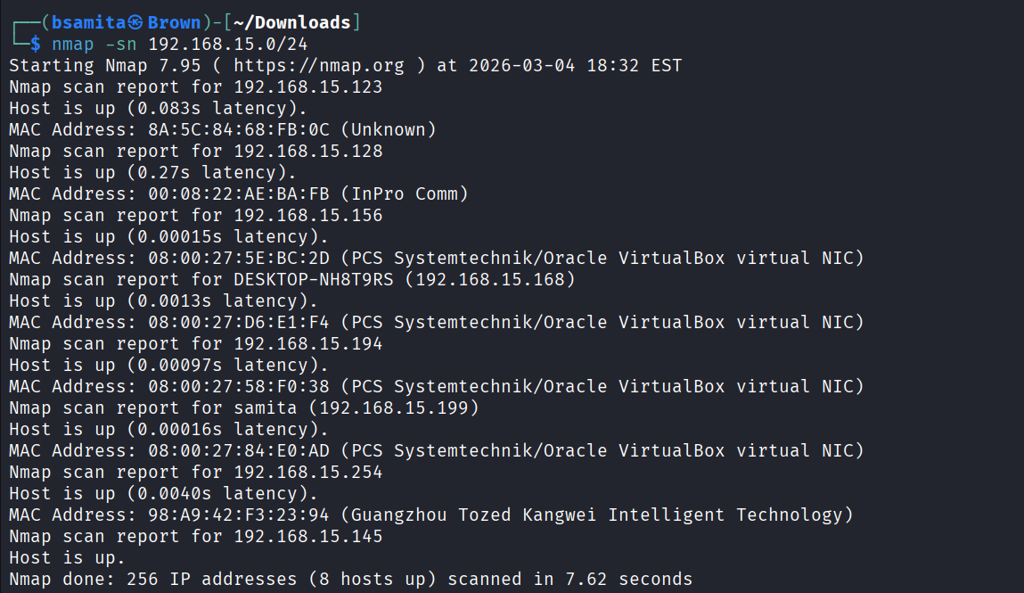
Figure 1: Nmap host discovery scan revealing all lab devices on 192.168.15.0/24

5. Lab Setup & Configuration

5.1 Wazuh Installation on Ubuntu Server
Wazuh was installed using the official all-in-one installation script on Ubuntu Server 22.04.5 LTS. This script automatically deploys and configures the Wazuh Manager, Wazuh Indexer (OpenSearch), and Wazuh Dashboard components.
curl -sO https://packages.wazuh.com/4.7/wazuh-install.sh
sudo bash wazuh-install.sh -a
Following installation, all three services were confirmed active and running:
sudo systemctl status wazuh-manager
sudo systemctl status wazuh-indexer
sudo systemctl status wazuh-dashboard
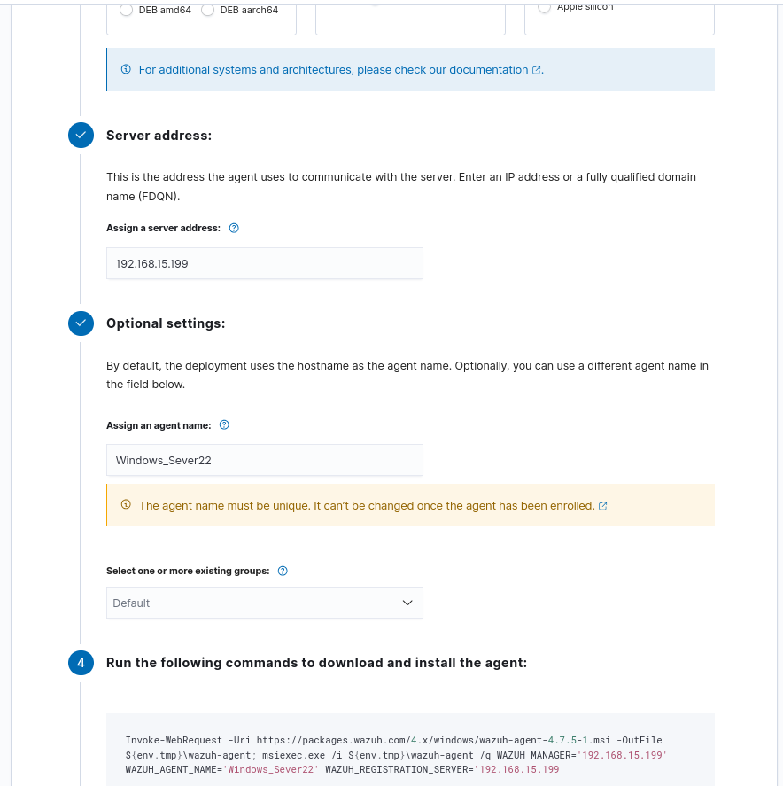
Figure 2: Wazuh dashboard showing agent deployment configuration for Windows Server 2022
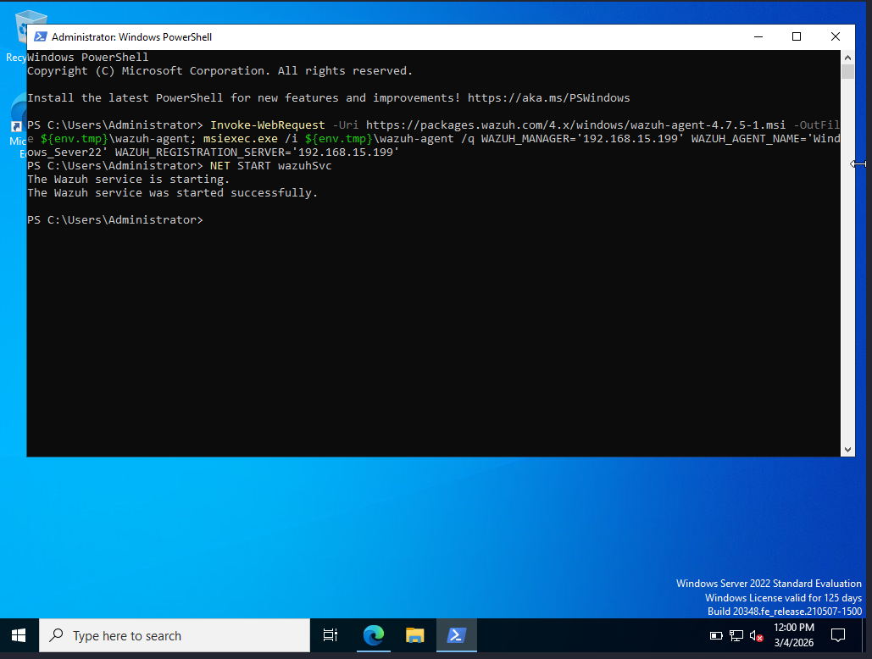
Figure 3: PowerShell installation of Wazuh agent on Windows Server 2022

5.2 Wazuh Agent Deployment
Wazuh agents were deployed on both Windows endpoints using the deploy agent wizard in the Wazuh dashboard. The following agents were successfully enrolled and confirmed active:
- Agent 001: Windows_Server22 — IP 192.168.15.194 — Status: Active
- Agent 002: TargetWindows10 — IP 192.168.15.168 — Status: Active
Agent installation on Metasploitable 2 was attempted but encountered SSL handshake failures due to the legacy nature of the OS. Metasploitable was therefore retained as a passive attack target without an agent, which is consistent with real-world scenarios where not all network hosts have EDR agents installed.

5.3 Splunk Universal Forwarder Configuration
A Splunk Universal Forwarder was installed on the Ubuntu Server (192.168.15.199) to stream logs to the Splunk Enterprise instance on the Windows 11 laptop (192.168.15.153). The forwarder was configured to monitor system logs and Wazuh alert files.
sudo /opt/splunkforwarder/bin/splunk add forward-server 192.168.15.153:9997
sudo /opt/splunkforwarder/bin/splunk add monitor /var/log/syslog
sudo /opt/splunkforwarder/bin/splunk add monitor /var/log/auth.log
sudo /opt/splunkforwarder/bin/splunk add monitor /var/ossec/logs/alerts/alerts.json
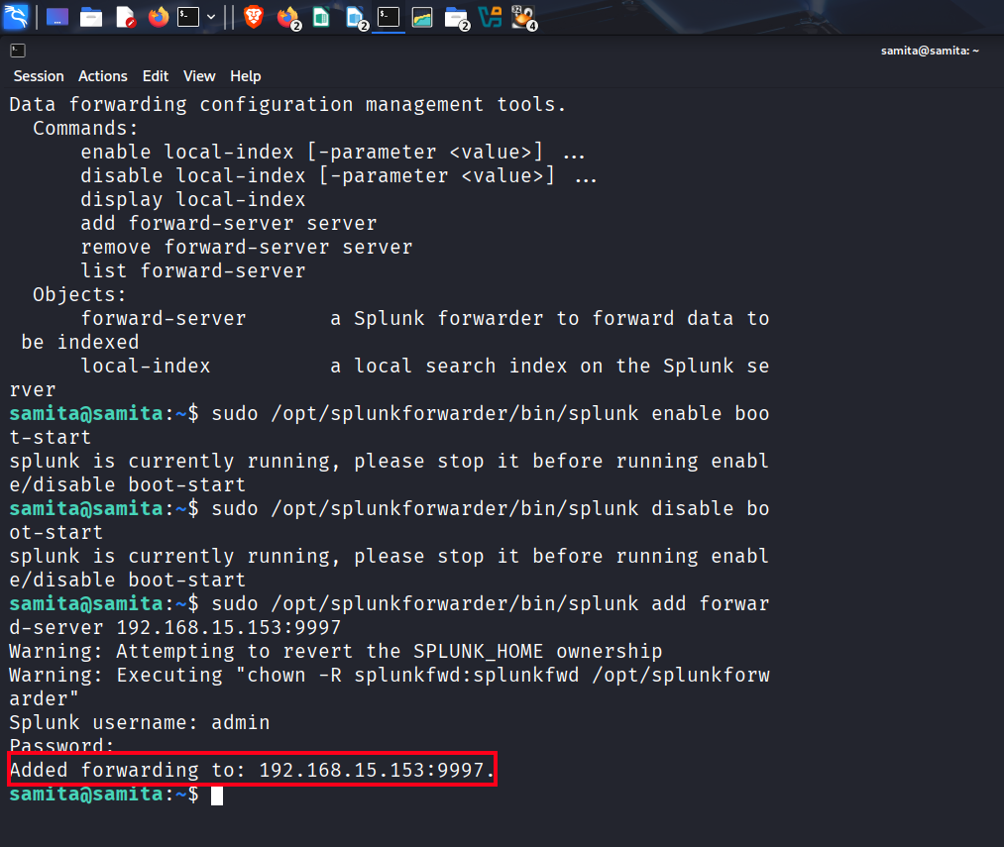
Figure 4: Splunk Universal Forwarder successfully configured to forward to 192.168.15.153:9997
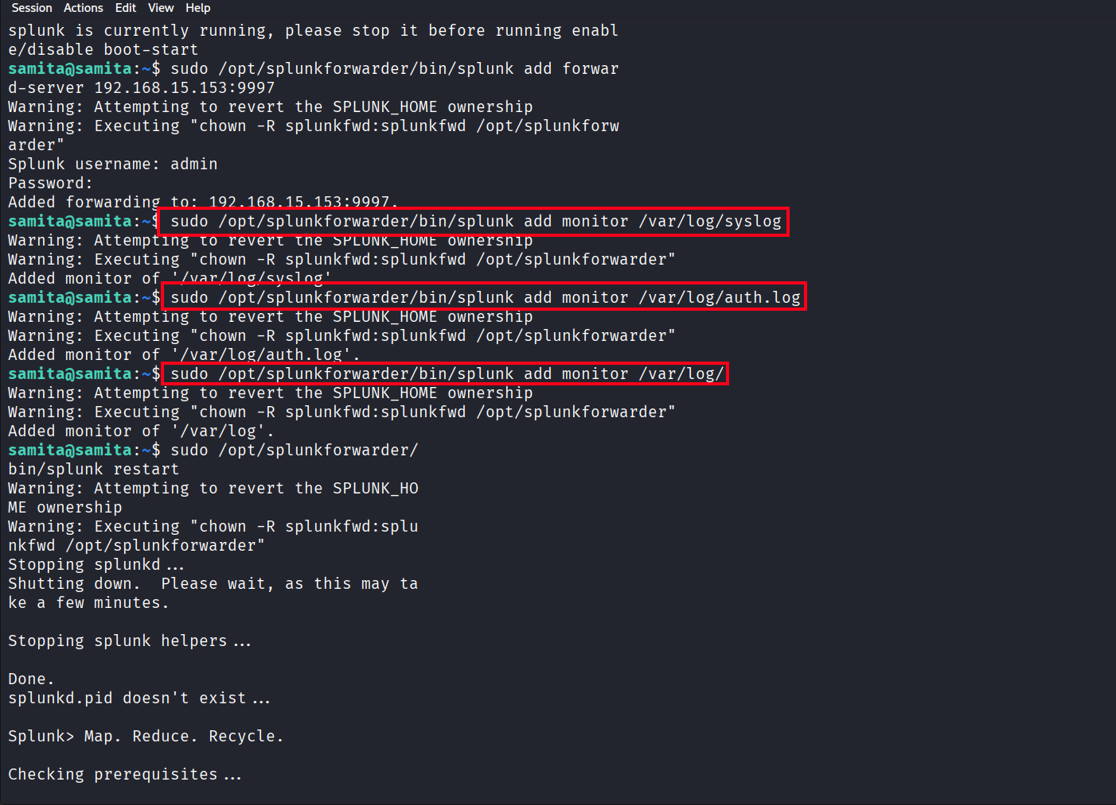
Figure 5: Splunk forwarder monitors configured for syslog, auth.log, and Wazuh alerts

6. Attack Simulations
The following attack scenarios were executed from the Kali Linux host machine against the Windows endpoints and the lab network. All attacks were monitored in real time through the Wazuh dashboard.

Attack | Tool | Target | Wazuh Rule | Severity
Network Port Scan | Nmap | All VMs | 40101, 40111 | Medium
SMB Brute Force | Hydra | Windows 10 / Win Server | 5763, 5710 | High
Failed Logins | Manual / Hydra | Windows 10 | 60122, 60204 | Medium
Privilege Escalation | CMD (net user) | Windows 10 | 60154, 60109 | Critical

6.1 Network Reconnaissance — Nmap Port Scan
An Nmap host discovery and service version scan was run across the entire 192.168.15.0/24 subnet, followed by targeted aggressive scans against the Windows endpoints. This simulates the initial reconnaissance phase of an attack, where a threat actor maps the network to identify live hosts, open ports, and running services.
nmap -sn 192.168.15.0/24
nmap -sS -sV -A 192.168.15.168
nmap -sS -sV -A 192.168.15.194
The host discovery scan confirmed all lab devices were online and reachable. Wazuh generated alerts under rule groups 40101 and 40111, flagging the port scan activity against the monitored agents.

6.2 Brute Force Attack — Hydra SMB
A credential brute force attack was executed against the Windows endpoints using Hydra targeting the SMB protocol. This simulates a common lateral movement and initial access technique used by threat actors to gain unauthorized access to Windows systems.
hydra -l Administrator -P /usr/share/wordlists/rockyou.txt smb://192.168.15.168 -t 4
hydra -l Administrator -P /usr/share/wordlists/rockyou.txt smb://192.168.15.194 -t 4
Wazuh detected the repeated authentication failures and triggered rules 5763 and 5710, classifying the activity as a brute force attack. The Windows agents reported Event ID 4625 (Logon Failure) entries to Wazuh.

6.3 Failed Windows Login Attempts
Multiple failed login attempts were generated on the Windows 10 VM by deliberately entering incorrect credentials. This tests Wazuh's ability to detect authentication anomalies through Windows Event Log monitoring.
Wazuh captured these events via the Windows agent and surfaced them under rule 60122, correlating multiple 4625 Event IDs into a brute force detection alert. The Wazuh dashboard showed 3 authentication failures recorded for the TargetWindows10 agent.

6.4 Privilege Escalation — New Admin User Creation
A privilege escalation simulation was conducted on the Windows 10 VM by creating a new local user account and adding it to the Administrators group via Command Prompt running with Administrator privileges. This simulates post-exploitation behaviour where an attacker establishes persistence and escalates privileges.
net user hacker1 Password123! /add
net localgroup administrators hacker1 /add
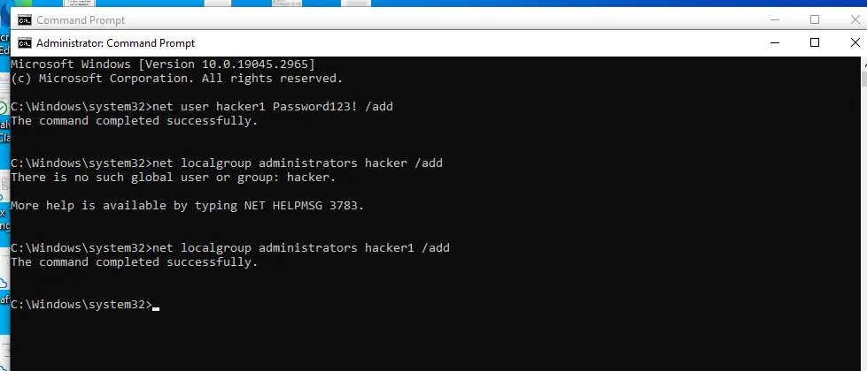
Figure 6: CMD showing successful creation of hacker1 user and addition to Administrators group
Wazuh immediately detected this activity and fired Rule 60154 at severity level 12 (Critical) — 'Administrators group changed'. Additionally, Rule 60109 fired for 'User account enabled or created', and Rule 60160 for 'Domain users group changed'. This represents exactly the type of high-severity alert a SOC analyst would prioritize for investigation.

7. Wazuh Detection Results
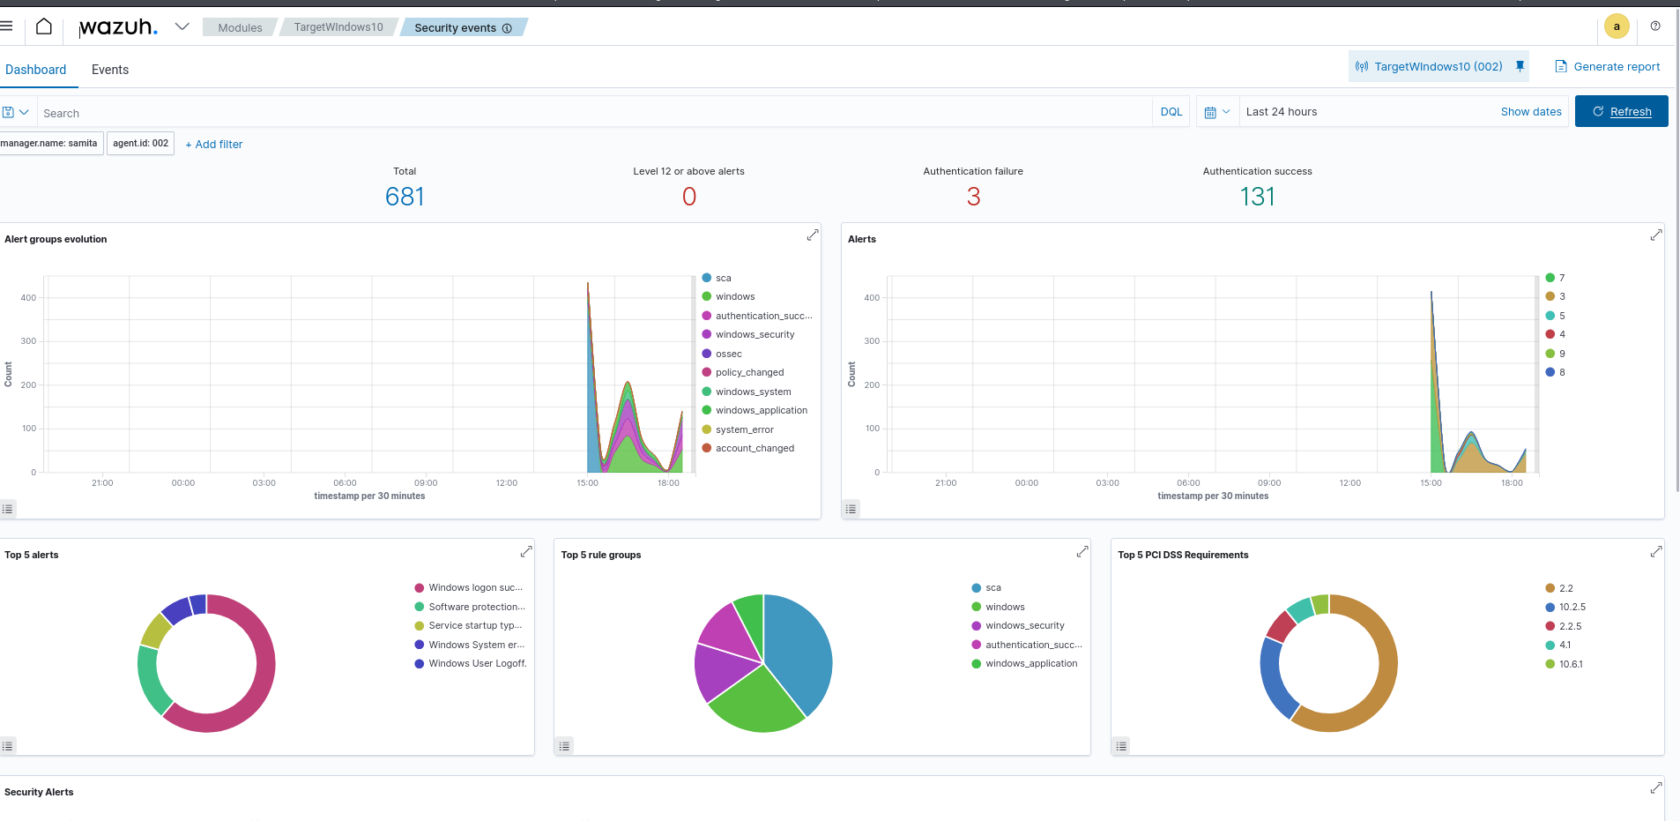
Figure 7: Wazuh Security Events dashboard for TargetWindows10 showing 681 total events
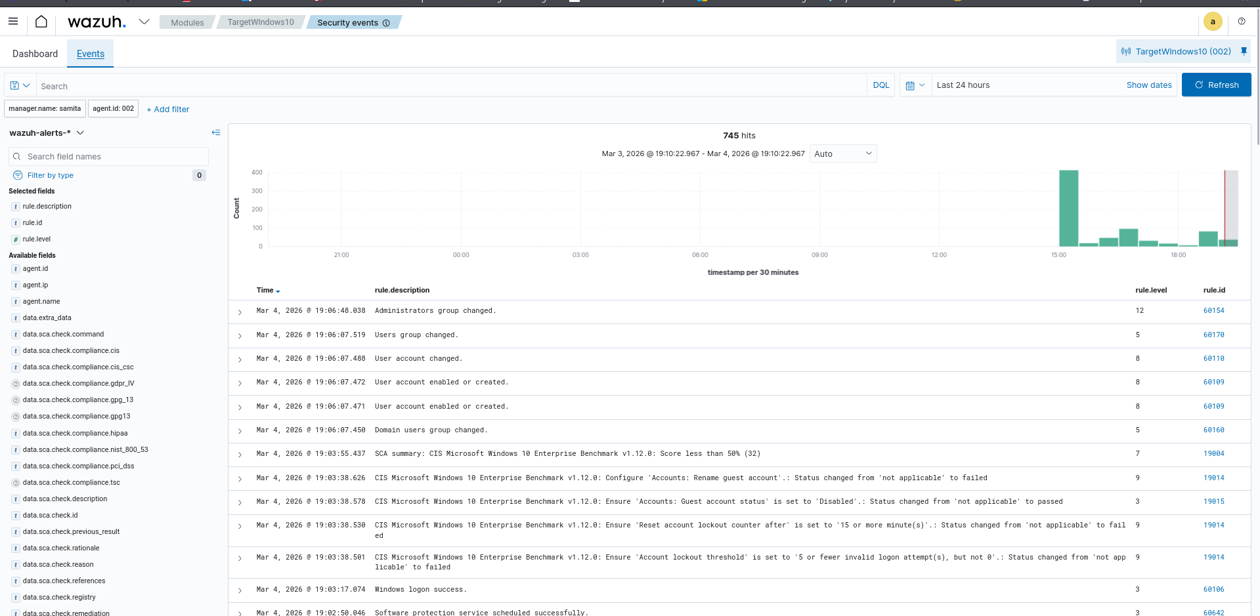
Figure 8: Wazuh Events view showing Rule 60154 Level 12 Critical alert — Administrators group changed
The Wazuh dashboard recorded the following key detections across the lab simulation period:
- 681 total security events recorded on TargetWindows10 agent
- 745 hits captured in the Wazuh events index for the simulation period
- Rule 60154 (Level 12 — Critical): Administrators group changed — triggered by hacker1 being added to admin group
- Rule 60109 (Level 8): User account enabled or created — triggered on new user creation
- Rule 60160 (Level 5): Domain users group changed — triggered during privilege escalation
- Rule 19004 (Level 7): CIS Benchmark compliance failure — Windows 10 scored below 50% on CIS Microsoft Windows 10 Enterprise Benchmark v1.12.0
- 131 Authentication successes and 3 Authentication failures recorded
- CIS compliance checks flagged misconfigurations including missing account lockout policy and guest account status

8. Key Learnings
- Deploying and managing a SIEM (Wazuh) in an all-in-one configuration on Ubuntu Server, including indexer, manager, and dashboard components
- Configuring and enrolling Wazuh agents on Windows endpoints via PowerShell and the web-based deployment wizard
- Setting up log forwarding pipelines using Splunk Universal Forwarder to stream logs from Linux to a remote Splunk instance
- Understanding the difference between endpoint detection (Wazuh agents) and network-level visibility, and how legacy systems like Metasploitable present real-world challenges
- Executing and documenting attack scenarios including network reconnaissance, brute force, and privilege escalation
- Interpreting Wazuh alert rule IDs, severity levels, and MITRE ATT&CK mappings to triage security events
- Understanding CIS Benchmark compliance checks and how Wazuh automates configuration auditing
- Correlating Windows Event IDs (4625, 4720, 4732) with SIEM alerts to trace attack activity

9. Future Improvements
- Add pfSense as a dedicated firewall/router VM to introduce network-level traffic filtering, IDS/IPS via Snort or Suricata, and firewall log forwarding to Wazuh
- Build custom Splunk dashboards to visualize attack timelines, top alert sources, and authentication failure trends
- Integrate MITRE ATT&CK framework mapping in Wazuh to categorize detected attacks by tactic and technique
- Add a threat intelligence feed to Wazuh to enrich alerts with known malicious IP data
- Introduce Wazuh Active Response to automatically block attacking IPs at the firewall level
- Simulate more advanced attack chains including lateral movement, data exfiltration, and persistence mechanisms

10. Conclusion
This home SOC lab successfully demonstrates a complete security monitoring pipeline from endpoint agent deployment through to SIEM detection and log analytics. The lab mirrors real-world SOC architecture and tooling, providing hands-on experience with Wazuh and Splunk — two platforms widely used in enterprise security operations.
The attack simulations confirmed that the detection pipeline is functioning correctly, with Wazuh generating appropriate alerts for all simulated threat scenarios. The privilege escalation attack triggered a Level 12 Critical alert within seconds of execution, demonstrating the effectiveness of agent-based endpoint monitoring.
This lab serves as a practical foundation for developing SOC analyst skills including alert triage, log analysis, threat hunting, and incident documentation — all critical competencies for a career in cybersecurity.

Built by Samita • March 2026 • Home SOC Lab

