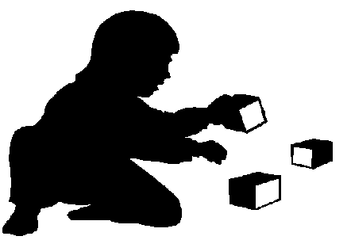
Independence Policy
At Playpals we encourage the children to learn new skills and to become as independent as appropriate for their age.
We always expect the children to “have -a-go” before offering to help them with any self-care skill.
We wait to be asked , before helping the children in the Poppy and Sunflower Rooms.
As a setting we insist on “please” and “thank you” when help is asked for and when help is given.
The following is the progression independent skills in Playpals Nursery and our expectations,
Daisy Room; Poppy Room; Sunflower (youngest); Sunflower(Eldest)
Personal Hygiene:
- Fetch a tissue when nose is running and attempt to wipe own nose
- Identify when they need a tissue, wipe their own nose.
- Wipe their own faces using a face cloth in front of the mirror
- Hand wash, with help
- Hand wash, without help, only supervision
- Hand wash without reminders after the toilet, Outdoor play and before food
Dressing/undressing:
- Find own shoes, slippers or wellies
- Find own coat or items of clothing
- Put on mittens, unaided
- Put on slippers, wellies and slip-on shoes without help,(not necessarily on the correct feet)
- Put arms in coat, whilst adult holds coat
- Put gloves on unaided
- Put slip-on shoes, slippers and wellies on the right feet
- Puts coat on unaided (not necessarily fastened)
- Pulls up/down trousers, tights and underwear when using the toilet
- Can fasten own coat
Toilet training:
- Will sit on the potty
- Can wipe themselves with help
- Uses the toilet independently, with few accidents
- Can flush the toilet
- Uses the toilet with NO accidents
Feeding:
- Feed oneself with a spoon
- Drink from a cup with a lid
- Drinks from a cup without a lid
- Uses a fork at meal times and not a spoon
- Uses a knife and fork at ALL mealtimes
- Helps to lay the table (counting knives, forks plates etc)
- Beginning to learn how to cut their own food using the knife
General chores:
- Help to put toys away when singing the “tidy up song” or as part of the routine.
- Helps to put their bedding away after sleep time, in their bed bags
- Pour their own drink from the jug/bottle
- Serve themselves at mealtimes using a serving spoon

