SENTINEL-S3
Cloud Honeypot Simulation & Intrusion Dashboard
Week 10 Project Deliverable

Bradley Sanchez & Alonzo Izzo
Cloud Computing Capstone Project

1. Project Overview

Project Title
Sentinel-S3: An Educational Cloud Honeypot Simulation and Intrusion Analysis Platform

Problem Statement
Cyber attacks targeting cloud infrastructure are increasing in both frequency and sophistication. Many organizations and students lack hands-on exposure to how attackers behave when they encounter real systems. Traditional security education relies heavily on theoretical concepts without providing learners an opportunity to observe live attack patterns in a controlled, safe environment.

Sentinel-S3 addresses this gap by deploying a deliberately vulnerable SSH honeypot in the cloud that attracts and logs real unauthorized access attempts. The collected data is automatically processed and displayed through a secure, authenticated web dashboard, giving users direct visibility into attacker behavior, credential brute-forcing, and command execution patterns , all without risk to production systems.

Target Users
- Students studying cloud security and threat analysis
- Instructors and professors looking for real world attack data to support cloud computing coursework
- Cloud computing students seeking hands-on experience with AWS services in a meaningful project context

Objectives of the System
- Deploy a Cowrie SSH honeypot on AWS EC2 to attract and log unauthorized login attempts from the public internet
- Automatically ingest and store attack data (IP addresses, usernames, passwords, commands) in Amazon DynamoDB
- Provide a secure, authenticated web dashboard protected by Amazon Cognito that displays live intrusion data
- Enable security analysis through filtering, and searching of thousands of attack events
- Demonstrate practical use of core AWS services (EC2, S3, Lambda, API Gateway, CloudFront, Cognito, DynamoDB) within a single integrated system
- Complete all of the objectives listed above whilst complying with all AWS Free Tier limitations and $100 dollar credit allowance

2. System Architecture

High-Level Architecture
The Sentinel-S3 system is divided into two pipelines: a data ingestion pipeline that captures honeypot events and stores them in DynamoDB, and a web presentation pipeline that serves a secure dashboard to authenticated users.

Data Ingestion Pipeline
Cowrie Honeypot (EC2) → cowrie.json log file → IAM Role (CowrieEC2toS3Role) → S3 Bucket (cowrie-logs-sentinel3) → Lambda (cowrie-s3-ingest) → DynamoDB (cowrieEvents) → SNS Notification (CowrieNotification) → Admin Email
Web Presentation Pipeline
Web Browser → CloudFront (sentinel-s3 website) → S3 (sentinel-s3-bucket-1234) → Amazon Cognito (SentinelUserPool) → Lambda Function URL (sentinel-get-events) → DynamoDB (cowrieEvents)


Explanation of System Components
- Cowrie Honeypot (EC2): A medium-interaction SSH honeypot running on an Amazon EC2 instance in a public subnet. It simulates a real Linux environment and records all connection attempts, login credentials, and commands executed by attackers.
- Amazon S3 (cowrie-logs-sentinel3): The honeypot periodically uploads its cowrie.json log file to this S3 bucket, triggering the ingestion Lambda.
- AWS Lambda (cowrie-s3-ingest): Triggered by S3 upload events. Parses the Cowrie JSON logs and writes structured records to DynamoDB.
- Amazon DynamoDB (cowrieEvents): NoSQL database storing all honeypot events. Each record contains a source IP, timestamp, username, password, session ID, event type, and optional command input.
- Amazon SNS (CowrieNotification): Sends email alerts to administrators when new log data is successfully uploaded and processed.
- Amazon S3 (sentinel-s3-bucket-1234): Hosts the static website files including HTML, CSS, JavaScript, and configuration.
- Amazon CloudFront: CDN distribution that serves the website over HTTPS globally with low latency.
- Amazon Cognito (SentinelUserPool): Manages user authentication using the OAuth 2.0 authorization code grant with PKCE. Protects the dashboard from unauthorized access.
- AWS Lambda Function URL (sentinel-get-events): Reads all events from DynamoDB and returns them as JSON to the authenticated dashboard.

How Cloud Services Interact
When an attacker connects to the honeypot EC2 instance, Cowrie logs the session to a local JSONand LOG file. A scheduled upload transfers this file to S3, which triggers the ingestion Lambda code via an S3 event notification. The Lambda parses and writes records to DynamoDB and publishes an SNS notification to the SNS topic which sends off emails to the admins.

On the web side, a user visits the CloudFront URL and is redirected to the Cognito Hosted UI to log in. After authentication, the user's browser receives a JWT (JSON Web Token). The dashboard JavaScript uses this token to call the Lambda Function URL, which scans DynamoDB and returns all events. The dashboard renders the data in a searchable table.

3. Technology Stack

Frontend
Framework | Plain HTML5, CSS3, and vanilla JavaScript — no frontend framework required
UI Template | Dimension by HTML5 UP — a responsive single-page layout with animated article panels
Fonts & Icons | Font Awesome 4 icon library, Source Sans Pro via Google Fonts
Hosting | Amazon S3 (static website) served via Amazon CloudFront (HTTPS )
Auth Client | Custom PKCE OAuth2 flow implemented in auth.js using the Web Crypto API — no SDK required

Backend
Runtime | Python 3.12 on AWS Lambda
Data Ingestion | Lambda function triggered by S3 events — parses Cowrie JSON logs and writes to DynamoDB
Data API | Lambda Function URL (sentinel-get-events) — scans DynamoDB and returns all events as JSON
Notifications | Amazon SNS — publishes email alerts when new honeypot data is ingested

Database
Service | Amazon DynamoDB — serverless NoSQL key-value and document database
Table name | cowrieEvents
Partition key | pk (String) — format: IP#<source_ip>
Sort key | sk (String) — format: <timestamp>#<eventid>#<session_id>
Key attributes | src_ip, timestamp, username, password, input, eventid, session, sensor, message
Capacity mode | On-demand (pay per request) Free Tier eligible,
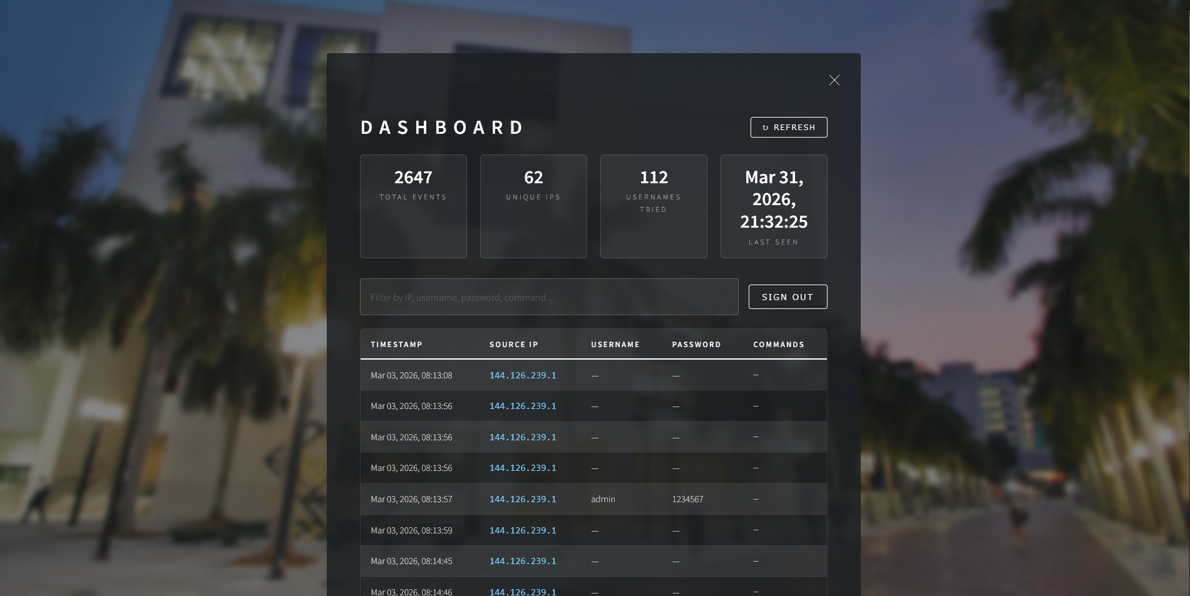

Cloud Provider and Services
Provider | Amazon Web Services (AWS)
Compute | EC2 (honeypot), Lambda (ingestion + API)
Storage | S3 (logs + website hosting)
Database | DynamoDB (event storage)
CDN | CloudFront (website delivery)
Auth | Amazon Cognito (user pool + hosted login UI)
Notifications | Amazon SNS (email alerts)
IAM | IAM roles and policies controlling all service-to-service permissions
Networking | VPC with public subnet for EC2 honeypot instance

4. Current Implementation Progress

Core Features ———— Fully Implemented
- SSH honeypot actively running on EC2, attracting and logging real attack attempts from the public internet
- Automated log ingestion pipeline from EC2 → S3 → Lambda → DynamoDB with SNS email notifications
- Live intrusion dashboard showing 2,000+ events with stats, search/filter, and pagination
- All data columns populated: Timestamp, Source IP, Username, Password, Commands
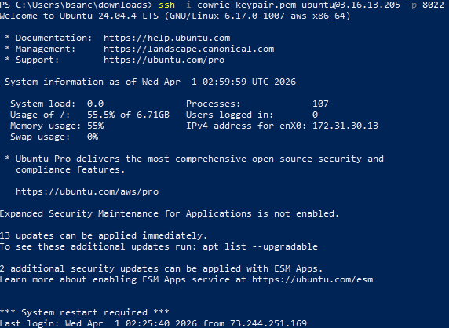

Cloud Environment Setup ———— Fully Implemented
- VPC with public subnet configured for EC2 honeypot deployment
- IAM roles configured: CowrieEC2toS3Role (EC2 → S3) and Cowrie-S3-ingest-role (Lambda → DynamoDB)
- S3 buckets created for log storage and static website hosting
- CloudFront distribution deployed with Origin Access Control securing the S3 origin
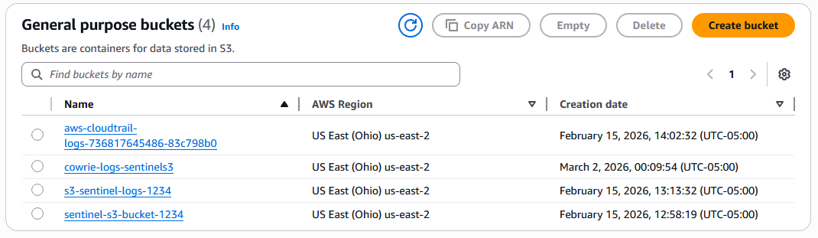

Backend Services————Fully Implemented
- “cowrie-s3-ingest Lambda”: parses incoming Cowrie JSON logs from S3 and writes structured records to DynamoDB
- “sentinel-get-events Lambda”: scans all records from DynamoDB using internal pagination and returns the full dataset as JSON
- Lambda Function URL configured with CORS allowing the CloudFront origin
- Lambda timeout set to 30 seconds with 256 MB memory to handle full dataset scans
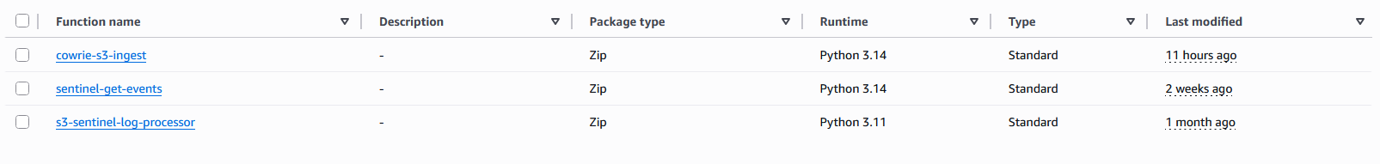

Database Integration————Fully Implemented
The info found below is from research compiled up until Wednesday March 4th from Sentinel S3’s website
- DynamoDB table cowrieEvents contains 2,009 records collected from live honeypot traffic
- Records span multiple attacker IPs- 38 unique IP addresses in total
- Attackers have tried 112 unique usernames including admin, root, user, and es
- Common passwords captured include 123456, 12345, admin, and password
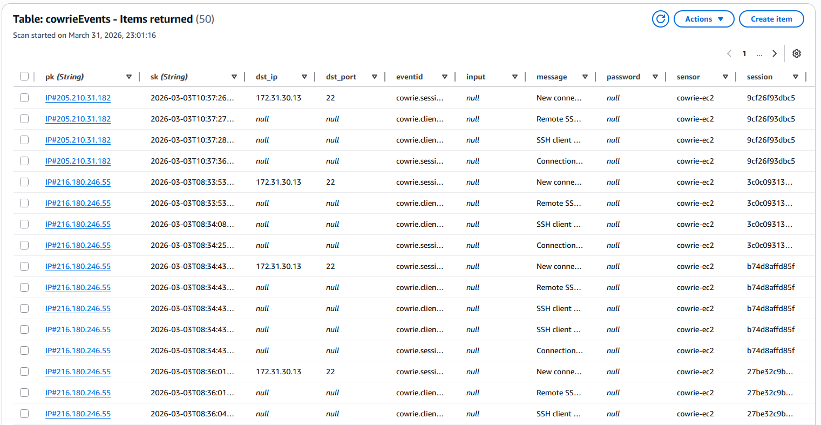

Working Frontend Components————Partially Implemented
- Homepage with animated navigation panels (GitHub, Info, Login, Contact)
- Login panel with Cognito-powered Sign In button and authenticated user display
- Dashboard panel with 4 stat cards (Total Events, Unique IPs, Usernames Tried, Last Seen)
- Searchable, paginated events table with 10 rows per page
- Refresh button for live data reload
- Sign Out functionality clearing session tokens and redirecting to Cognito logout


5. User Interface

Application Pages
Page / Panel | Description
Homepage | Full-screen background with animated header showing project title, subtitle, and navigation buttons. Users can access GitHub, Info, Login, and Contact panels from this view.
GitHub Panel | Links directly to the Sentinel-S3 GitHub repository where the full project source code is available.
Info Panel | Describes the project purpose, goals, and the AWS services used. Provides educational context for visitors unfamiliar with honeypots.
Login Panel | Displays a Sign In with AWS Cognito button. After authentication, the panel updates to show the logged-in user's email and a button to open the Dashboard. The nav button changes from Login to Dashboard.
Dashboard Panel | The core feature of the application. Shows 4 stat cards at the top, a search/filter bar, and a paginated table of all honeypot intrusion events with Timestamp, Source IP, Username, Password, and Commands columns.
Contact Panel | A contact form for visitors to reach the project team.
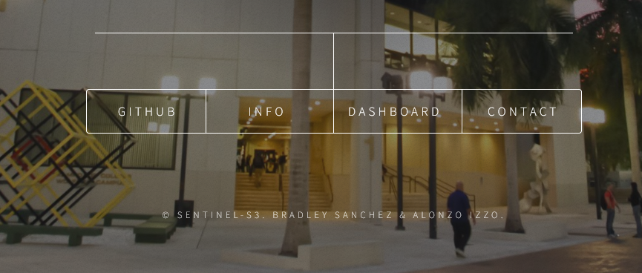
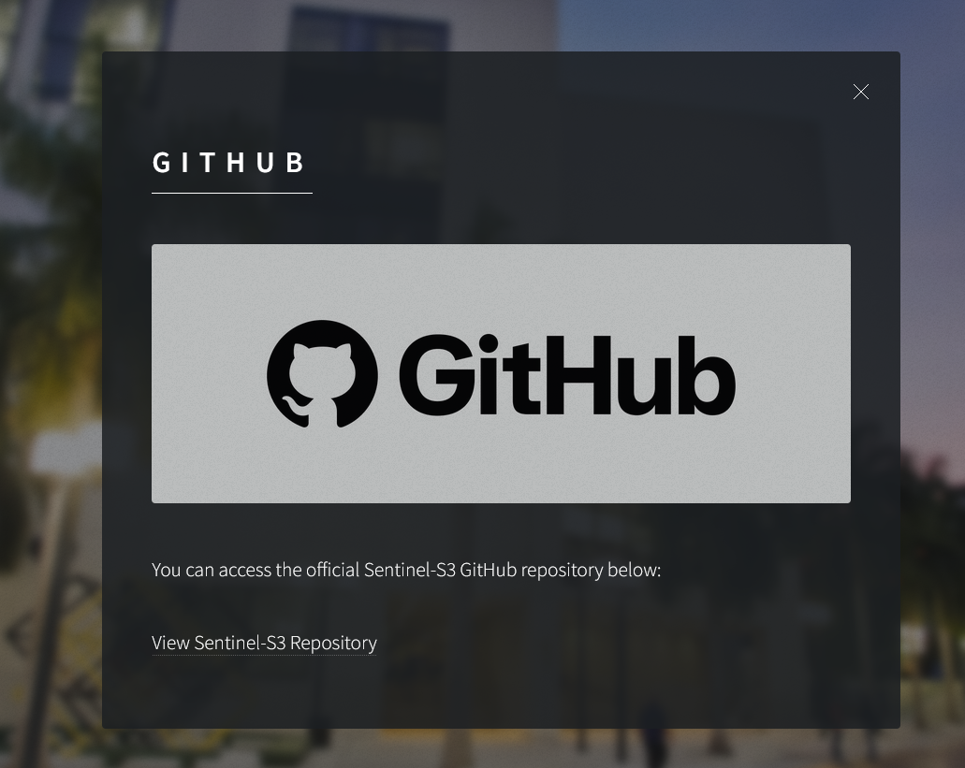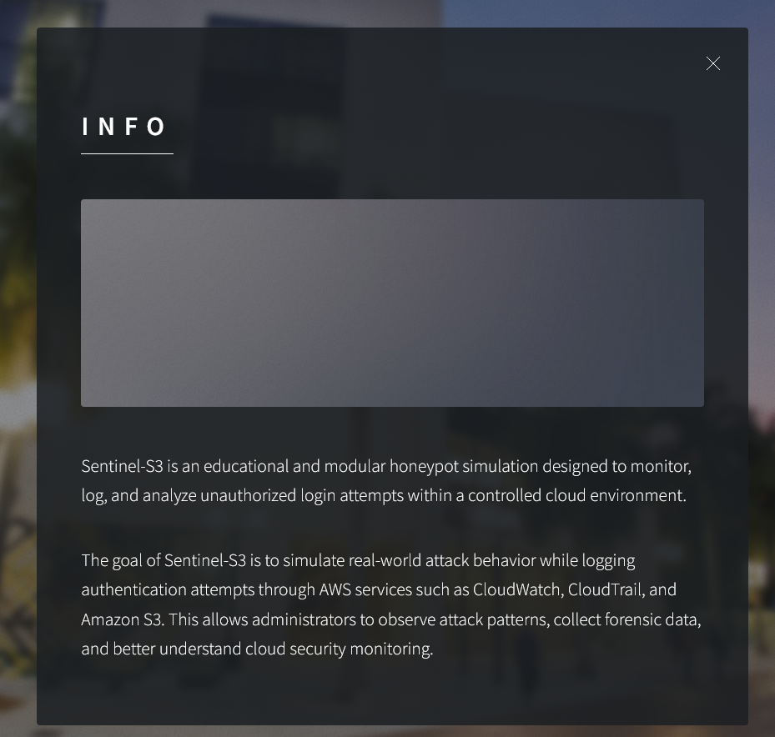
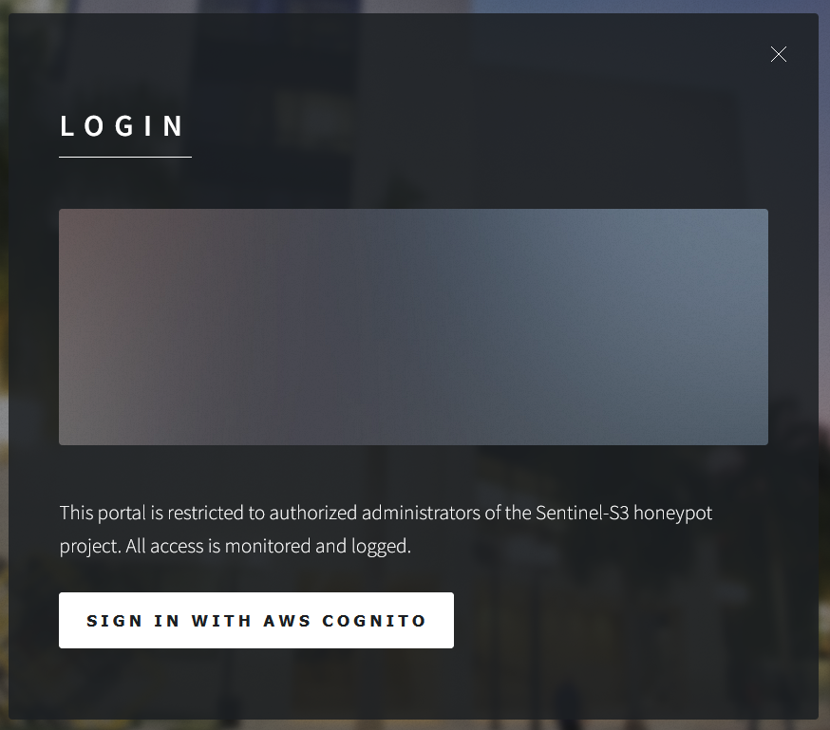


How Users Interact with the System
- A user visits the CloudFront URL (https://d1lntby3a9gmd4.cloudfront.net) and sees the animated Sentinel-S3 homepage
- Clicking Login opens the login panel where the user clicks Sign In with AWS Cognito
- The user is redirected to the Cognito Hosted UI, enters credentials, and is redirected back to the site
- The nav bar updates to show Dashboard and the user's email is displayed
- Clicking Dashboard opens the intrusion data panel which automatically loads all events
- Users can type in the search bar to filter events by IP address, username, password, or command
- Users can page through results using the Prev and Next pagination buttons
- Clicking Refresh reloads the latest data from DynamoDB
- Clicking Sign Out clears the session and logs the user out via Cognito

6. Cloud Functionality

Compute Services
- Amazon EC2 (t2.micro - Free Tier): Hosts the Cowrie SSH honeypot in a public subnet. Configured with a security group allowing inbound SSH traffic on port 22 from the public internet to attract attackers.
- AWS Lambda (sentinel-get-events): Serverless function that scans the DynamoDB table and returns all events as JSON. Configured with a 30-second timeout and 256 MB memory. Invoked only on demand when the dashboard loads.
- AWS Lambda (cowrie-s3-ingest): Serverless function triggered by S3 PutObject events. Parses Cowrie JSON logs and writes structured records to DynamoDB.

Storage
- Amazon S3 (cowrie-logs-sentinel3): Receives periodic uploads of cowrie.json log files from the EC2 honeypot. Triggers the ingestion Lambda via S3 event notifications.
- Amazon S3 (sentinel-s3-bucket-1234): Hosts all static website assets including HTML, CSS, JavaScript, fonts, and images. Access is restricted to CloudFront only via Origin Access Control.

APIs
- Lambda Function URL (sentinel-get-events): A dedicated HTTPS endpoint attached directly to the Lambda function. Configured with CORS to allow requests from the CloudFront origin. Returns the full DynamoDB dataset as JSON.
- Amazon Cognito OAuth2 Endpoints: The Hosted UI login page and token exchange endpoint handle user authentication. The PKCE flow ensures no client secret is required in the browser.

Databases
- Amazon DynamoDB (cowrieEvents): On-demand NoSQL table storing all honeypot events. Holds 2,000+ records with 38 unique attacker IPs (as of March 4th 2026). Queried by Lambda using a full table scan with internal pagination to return all records.

Deployment Approach
- All infrastructure was provisioned manually through the AWS Management Console
- The static website is deployed by uploading files directly to S3 and creating CloudFront invalidations to clear cached versions
- Lambda functions are deployed through the AWS Console inline code editor
- All services operate within the AWS Free Tier limits , no ongoing costs are incurred for normal usage

7. Current Challenges
The following technical challenges were encountered during development and resolved through systematic debugging and iterative problem-solving.

Challenge | How We Solved It
CORS preflight blocking | API Gateway's built-in CORS handling conflicted with the CORS headers returned by Lambda, causing all preflight OPTIONS requests to fail with Status code: null. Resolved by switching from API Gateway to a Lambda Function URL, which has its own independent CORS configuration that does not conflict with Lambda response headers.
Lambda timeout on full scan | The Lambda function timed out at 3 seconds when scanning the full DynamoDB table of 2,000+ records. Resolved by increasing the timeout to 30 seconds and memory to 256 MB, and rewriting the function to handle internal DynamoDB pagination automatically.
CloudFront cache serving stale files | After uploading updated JavaScript files, CloudFront continued serving old cached versions. Resolved by creating CloudFront cache invalidations using the /* path after every file upload to force distribution of the latest versions.
Incorrect API Gateway invoke URL | The API Gateway invoke URL contained the character 'l' which was misread as the number '1' (cjlxltcizd vs cj1x1tcizd), causing all API calls to fail with Server Not Found. Resolved by copying the URL directly from the API Gateway Stages page rather than transcribing it manually.

8. Next Development Steps
The following improvements are planned before the final project presentation:

Website Enhancements
- Refine the visual design of the dashboard panel including improved stat card styling and table formatting
- Add color-coded event type indicators to the table (e.g. red for login failures, yellow for command execution, green for session connect/close)
- Add a summary chart or graph showing attack frequency over time to give a visual representation of attack patterns

Database Enhancements
- Expand the DynamoDB item schema to capture additional Cowrie fields that are currently not displayed, including:
  - dst_ip and dst_port — the destination IP and port of the honeypot that the attacker connected to
  - sensor — the identifier of the Cowrie sensor instance that logged the event
  - session — the unique session ID grouping all events from a single attacker connection
  - message — the human-readable Cowrie event description
- Update the dashboard table to display these additional columns with column visibility toggles so users can customize their view

Sentinel-S3 Cloud Computing Capstone • Bradley Sanchez & Alonzo Izzo

