ASSIGNMENT 4

Sashidhar Bezawada

2022-09-21

# Markdown Basics

## Favorite Foods

1. Pizza
2. Breakfast skillets
3. French Fries

## Images

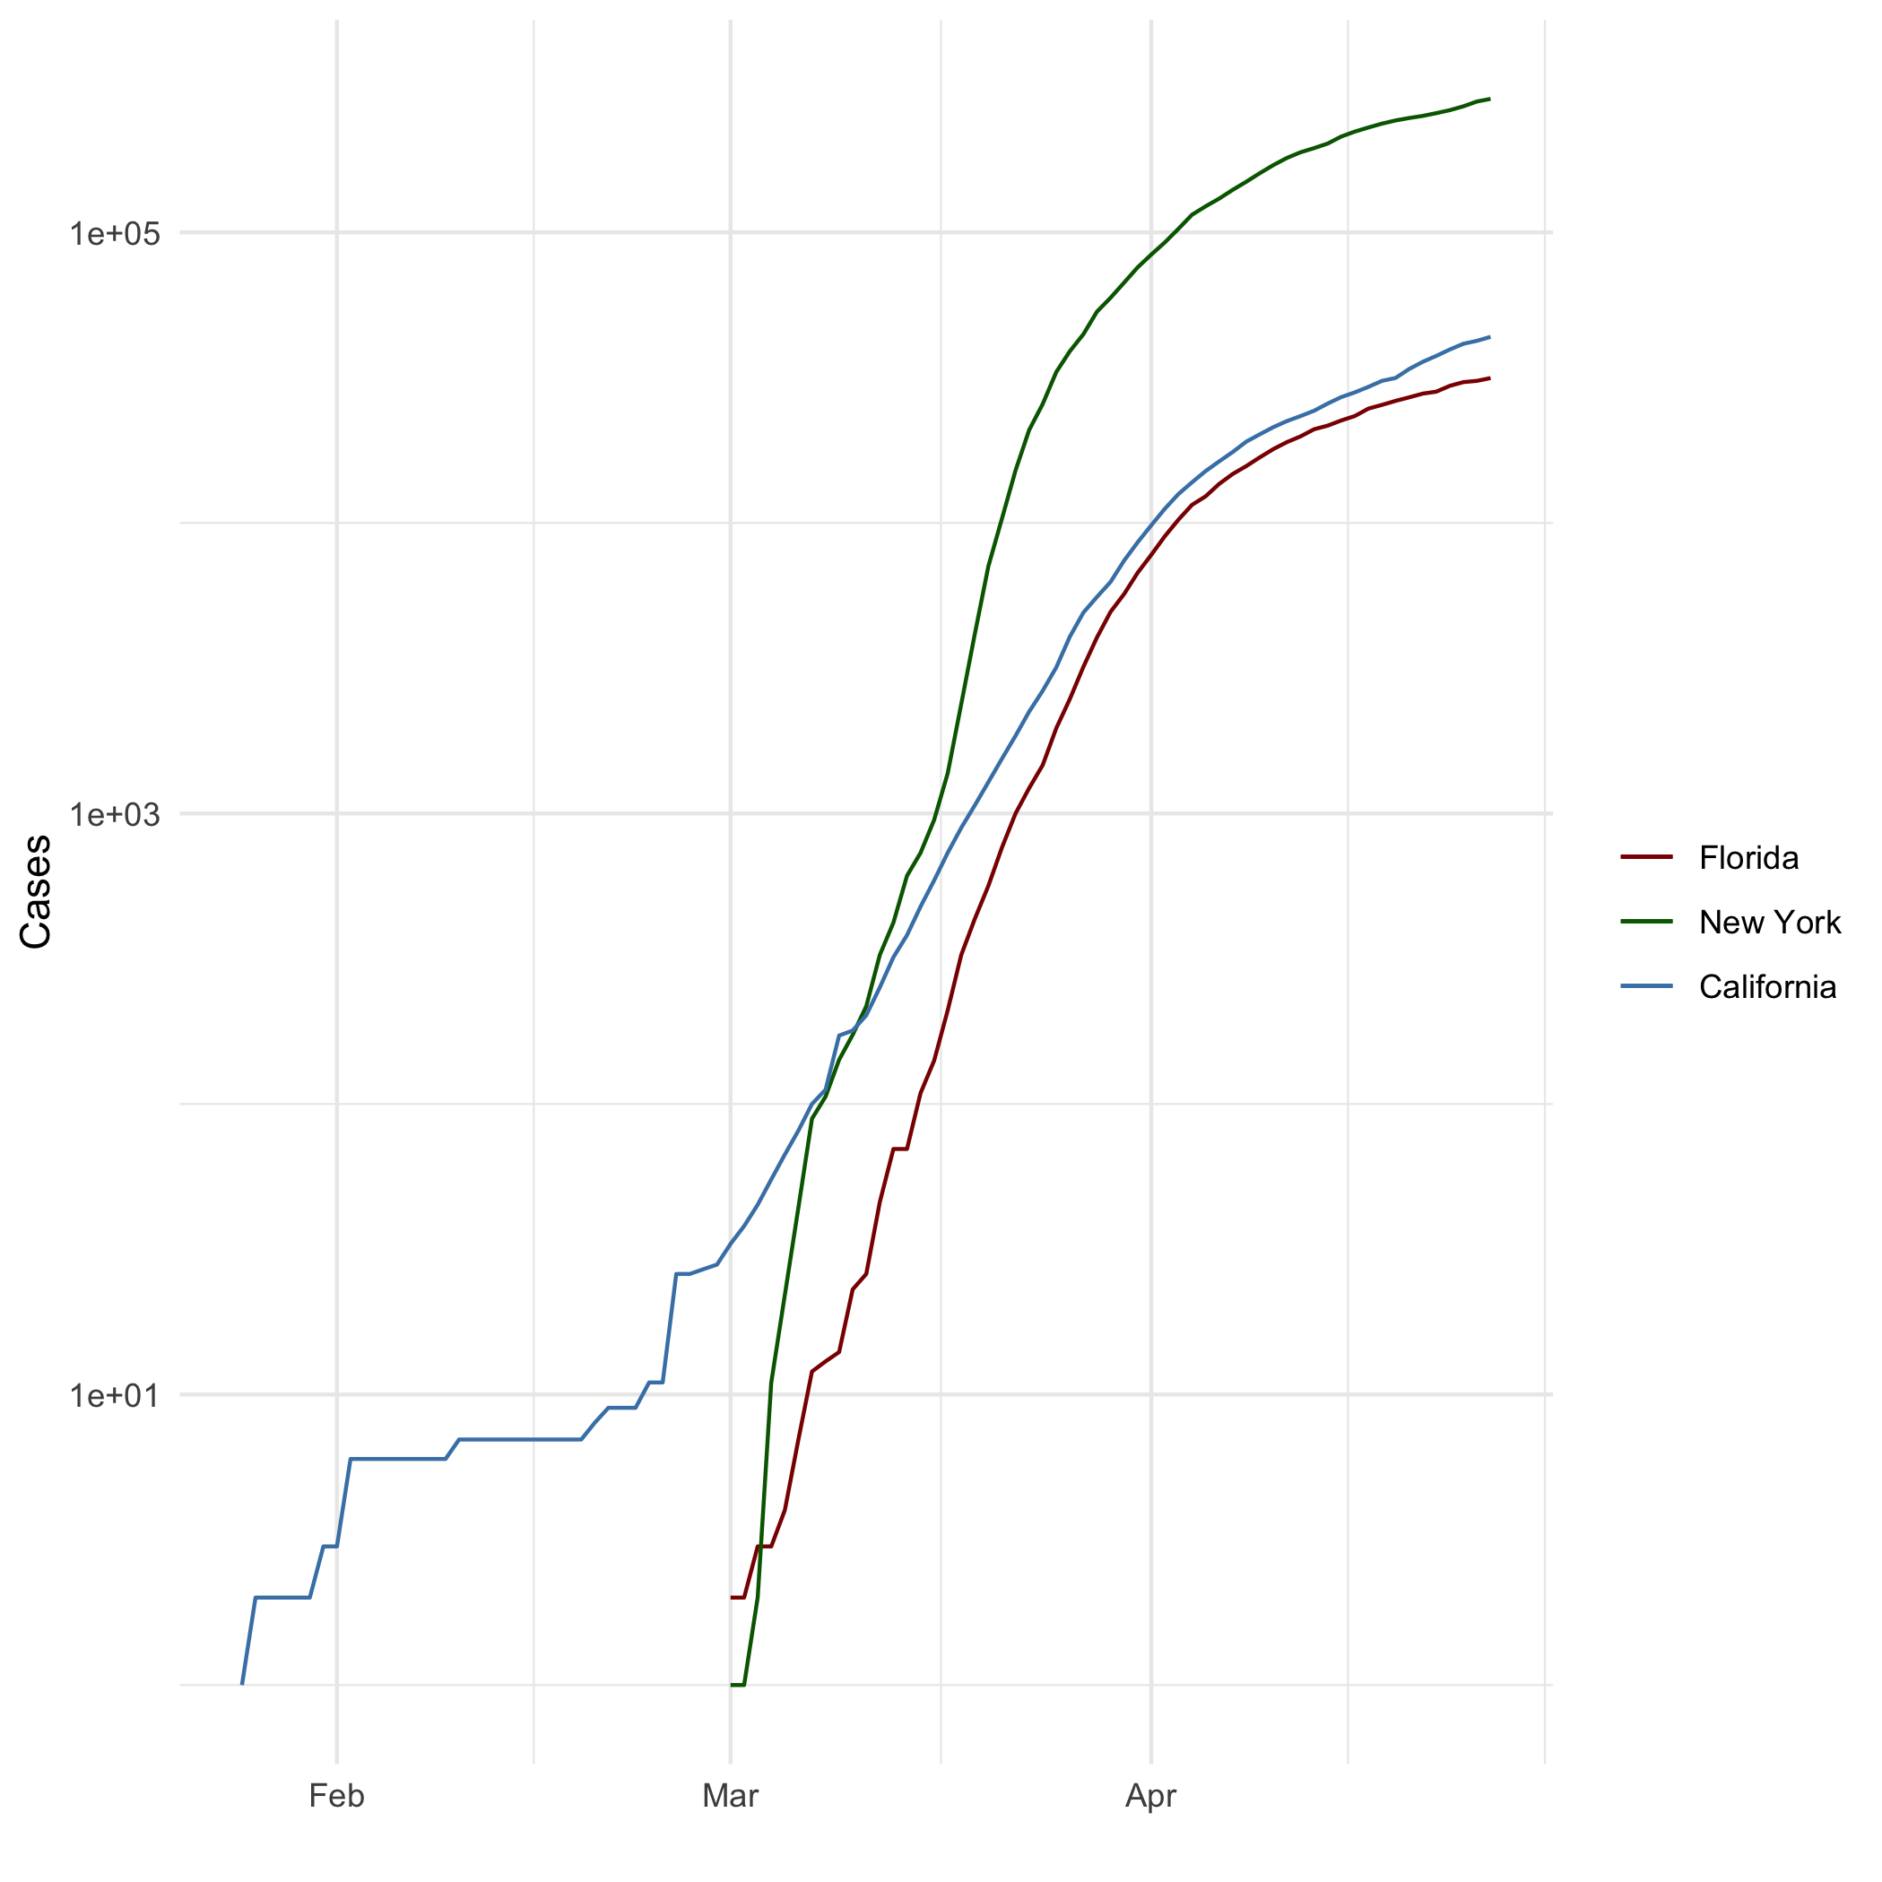

All Cases (Log Plot)

## Add a Quote

“Happiness can be found even in the darkest of times, if one only remembers to turn on the light.”

— Dumbledore

## Add an Equation

$$E=mc^{2}$$

## Add a Footnote

[1].

## Add Citations

* R for Everyone
* Discovering Statistics Using R

(Lander 2014; Field, Miles, and Field 2012)

# Inline Code

## NY Times COVID-19 Data

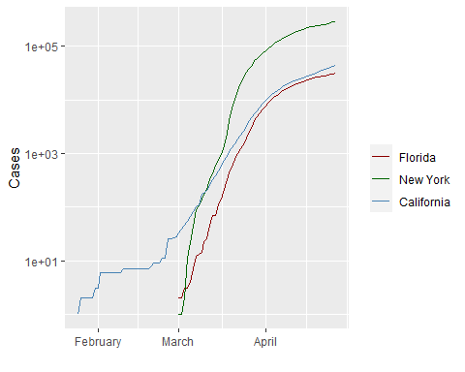

## R4DS Height vs Earnings

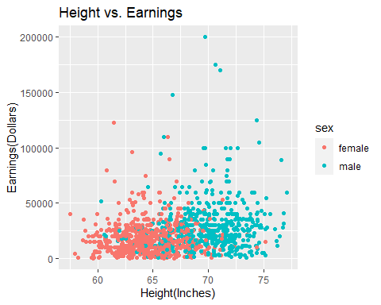

# Tables

## Knitr Table with Kable

## Create a dataframe called characters_df using the following information from LOTR  
name <- c("Aragon", "Bilbo", "Frodo", "Galadriel", "Sam", "Gandalf", "Legolas", "Sauron", "Gollum")  
race <- c("Men", "Hobbit", "Hobbit", "Elf", "Hobbit", "Maia", "Elf", "Maia", "Hobbit")  
in_fellowship <- c(TRUE, FALSE, TRUE, FALSE, TRUE, TRUE, TRUE, FALSE, FALSE)  
ring_bearer <- c(FALSE, TRUE, TRUE, FALSE, TRUE, TRUE, FALSE, TRUE, TRUE)  
age <- c(88, 129, 51, 7000, 36, 2019, 2931, 7052, 589)  
  
characters_df <- data.frame(name,race,in_fellowship,ring_bearer, age)  
  
#Creation of table using knitr::kable  
knitr::kable(characters_df,caption = "One Ring to Rule Them All")

One Ring to Rule Them All

| name | race | in_fellowship | ring_bearer | age |
| --- | --- | --- | --- | --- |
| Aragon | Men | TRUE | FALSE | 88 |
| Bilbo | Hobbit | FALSE | TRUE | 129 |
| Frodo | Hobbit | TRUE | TRUE | 51 |
| Galadriel | Elf | FALSE | FALSE | 7000 |
| Sam | Hobbit | TRUE | TRUE | 36 |
| Gandalf | Maia | TRUE | TRUE | 2019 |
| Legolas | Elf | TRUE | FALSE | 2931 |
| Sauron | Maia | FALSE | TRUE | 7052 |
| Gollum | Hobbit | FALSE | TRUE | 589 |

## Pandoc Table

#install.packages('pander')  
#install.packages('Rcpp')  
colnames(characters_df) <- c("Name","Race","In Fellowship?","Is Ring Bearer?","Age")  
characters_df$`In Fellowship?` <- ifelse(characters_df$`In Fellowship?`=='TRUE','Yes','No')  
characters_df$`Is Ring Bearer?` <- ifelse(characters_df$`Is Ring Bearer?`=='TRUE','Yes','No')  
pandoc.table(head(characters_df,5),style="grid")

##   
##   
## +-----------+--------+----------------+-----------------+------+  
## | Name | Race | In Fellowship? | Is Ring Bearer? | Age |  
## +===========+========+================+=================+======+  
## | Aragon | Men | Yes | No | 88 |  
## +-----------+--------+----------------+-----------------+------+  
## | Bilbo | Hobbit | No | Yes | 129 |  
## +-----------+--------+----------------+-----------------+------+  
## | Frodo | Hobbit | Yes | Yes | 51 |  
## +-----------+--------+----------------+-----------------+------+  
## | Galadriel | Elf | No | No | 7000 |  
## +-----------+--------+----------------+-----------------+------+  
## | Sam | Hobbit | Yes | Yes | 36 |  
## +-----------+--------+----------------+-----------------+------+

# References

output: pdf_document: default html_document: default word_document: default

Field, A., J. Miles, and Z. Field. 2012. *Discovering Statistics Using r*. SAGE Publications. <https://books.google.com/books?id=wd2K2zC3swIC>.

Lander, J. P. 2014. *R for Everyone: Advanced Analytics and Graphics*. Addison-Wesley Data and Analytics Series. Addison-Wesley. <https://books.google.com/books?id=3eBVAgAAQBAJ>.

1. This is a footnote.