**CHAPTER 1**

**INTRODUCTION**

This chapter gives an introduction about the project, its scope, features and necessity of the project. It also gives details about the configuration and a brief overview of the tools and technologies used to develop and deploy the project.

**1.1 SYSTEM CONFIGURATION**

The Hardware and Software configurations that are availed during the course of the project are stated below.

**1.1.1 Hardware Specification**

Processor : Intel Core i5

RAM : 8 GB

Hard disk : 1 TB

**1.1.2 Software Specification**

Operating System : Windows 10 Professional 64-bit OS

Database : Microsoft SQL Server

Language Used : HTML/CSS

JavaScript

PHP

MySQL

Development Tools : Visual Studio Code (IDE)

XAMPP

MySQL Workbench 8.0 CE

**1.2 TOOLS AND TECHNOLOGIES USED**

A programming tool is a computer program that software developers use to create, debug, maintain, or otherwise support other programs and applications. Technology is the collection of techniques, skills, methods and processes used in the production of goods or services or in the accomplishment of objectives. The tools and technologies used in the concerned projects are detailed in this section.

**1.2.1** **XAMPP**

XAMPP is a free and open-source cross-platform web server solution stack package developed by Apache Friends, consisting mainly of the Apache HTTP Server, MariaDB database, and interpreters for scripts written in the PHP and Perl programming languages. Since most actual web server deployments use the same components as XAMPP, it makes transitioning from a local test server to a live server possible.

The most obvious characteristic of XAMPP is the ease at which a WAMP webserver stack can be deployed and instantiated.

Officially, XAMPP's designers intended it for use only as a development tool, to allow website designers and programmers to test their work on their own computers without any access to the Internet. To make this as easy as possible, many important security features are disabled by default. XAMPP has the ability to serve web pages on the World Wide Web. A special tool is provided to password-protect the most important parts of the package.

XAMPP also provides support for creating and manipulating databases in MariaDB and SQLite among others. Once XAMPP is installed, it is possible to treat a localhost like a remote host by connecting using an FTP client. It is also possible to connect to localhost via FTP with an HTML editor.

**1.2.2 Visual Studio Code**

Visual Studio Code is a source-code editor developed by Microsoft for Windows, Linux and macOS. It includes support for debugging, embedded Git control, syntax highlighting, intelligent code completion, snippets, and code refactoring. It is also customizable, so users can change the editor's theme, keyboard shortcuts, and preferences. The source code is free and open source and released under the permissive MIT License. The compiled binaries are freeware and free for private or commercial use.

Visual Studio Code is based on Electron, a framework which is used to deploy Node.js applications for the desktop running on the Blink layout engine. Although it uses the Electron framework, the software does not use Atom and instead employs the same editor component (codenamed "Monaco") used in Azure DevOps (formerly called Visual Studio Online and Visual Studio Team Services).

Visual Studio Code is a source code editor that can be used with a variety of programming languages. It supports a number of programming languages and a set of features that differs per language. Unwanted files and folders can be excluded from the project tree via the settings. Many of Visual Studio Code features are not exposed through menus or the user interface, but can be accessed via the command palette.

Visual Studio Code can be extended via plug-ins, available through a central repository. This includes additions to the editor and language support. A notable feature is the ability to create extensions that add support for new languages, themes, debuggers, perform static code analysis, add code linters, using the Language Server Protocol and connect to additional services.

Visual Studio Code includes multiple extensions for FTP, allowing the software to be used as a free alternative for web development. Code can be synced between the editor and the server, without downloading any extra software.

Visual Studio Code allows users to set the code page in which the active document is saved, the newline character for Windows/Linux, and the programming language of the active document. This allows it to be used on any platform, in any locale, and for any given programming language.

Visual Studio Code has out-of-the-box support for almost every major programming language. Several are included by default, for example, JavaScript, TypeScript, CSS, and HTML but other language extensions can be found and downloaded for free from the VS Code Marketplace.

**1.2.3 MySQL Workbench**

SQL is a language of the structured queries. This language allows managing and manipulating the relational types of databases. MySQL act as the SQL Dev-Tool by using visual editor SQL is implemented in MySQL Workbench.

Due to the SQL editor, developers can create, edit and send queries through the MySQL server databases. The numerous sent queries and their results are demonstrated in different tables. Everything is carried out automatically. All queries are stored in the history panel for further their searching and launching.

Besides this, the row highlighter by various colors is available for the MySQL Workbench syntaxes. This significantly simplifies the SQL writing and debugging process for developers.

Executing security testing, the specialists pay special attention to the server administration. Many aspects should be considered for the corporate data safety. It includes user management, server configuration, its logs, and etc. Software testing will be less difficult if one uses MySQL server for data management.

Features that simplify the MySQL Server Administration are User administration – a visual user management tool. The server configuration ensures the setting of the optimal performance.

The backup and database recovery – a visual tool for the file import and export of the MySQL dump. These files contain scripts for creating tables, bases, data inputs, and so on. The server logs – a visual tool of the MySQL logs review (error logs, binary logs, InnoDB logs).

MySQL Workbench provides prominent features such as Database Connection & Instance Management, Wizard driven action items, SQL Editor features such as Schema object browsing, inspection, and search, SQL syntax highlighter and statement parser, SQL code completion and context sensitive help, Multiple and editable result sets, unicode support.

It’s used for monitoring performance such as performance schema metrics, MySQL instance dashboard, Query statistics and in database migration with any ODBC compliant database.

Native support: Microsoft SQL Server, PostgreSQL, SQL Anywhere, SQLite, and Sybase ASE.

**1.2.4 HTML 5**

Hypertext Markup Language (HTML) is the standard markup language for creating web pages and web applications. With Cascading Style Sheets (CSS) and JavaScript, it forms a triad of cornerstone technologies for the World Wide Web.

Web browsers receive HTML documents from a web server or from local storage and render the documents into multimedia web pages. HTML describes the structure of a web page semantically and originally included cues for the appearance of the document.

HTML elements are the building blocks of HTML pages. With HTML constructs, images and other objects such as interactive forms may be embedded into the rendered page. HTML provides a means to create structured documents by denoting structural semantics for text such as headings, paragraphs, lists, links, quotes and other items. HTML elements are delineated by tags, written using angle brackets. Tags such as <img /> and <input /> directly introduce content into the page. Other tags such as <p> surround and provide information about document text and may include other tags as sub-elements. Browsers do not display the HTML tags, but use them to interpret the content of the page.

In practical terms, it adds support for (among other things): a standard canvas tag that lets Javascript draw arbitrary shapes, audio and video tags as an alternative to Flash for media players, handy tags like article, nav, and footer for common page elements, and a nice new date-picker. The new APIs let us do things like play music, work with local files, and get the user's physical location in the world. CSS3 features like animations and transitions sometimes get lumped in there too.

**1.2.5 CSS**

Cascading Style Sheets (CSS) is a style sheet language used for describing the presentation of a document written in a markup language like HTML. CSS is a cornerstone technology of the World Wide Web, alongside HTML and JavaScript.

CSS is designed to enable the separation of presentation and content, including layout, colors, and fonts. This separation can improve content accessibility, provide more flexibility and control in the specification of presentation characteristics, enable multiple web pages to share formatting by specifying the relevant CSS in a separate .css file, and reduce complexity and repetition in the structural content.

Separation of formatting and content also makes it feasible to present the same markup page in different styles for different rendering methods, such as on-screen, in print, by voice (via speech-based browser or screen reader), and on Braille-based tactile devices. CSS also has rules for alternate formatting if the content is accessed on a mobile device.

Before CSS, nearly all presentational attributes of HTML documents were contained within the HTML markup. All font colors, background styles, element alignments, borders and sizes had to be explicitly described, often repeatedly, within the HTML. CSS lets authors move much of that information to another file, the style sheet, resulting in considerably simpler HTML.

For example, headings (h1 elements), sub-headings (h2), sub-sub-headings (h3), etc., are defined structurally using HTML. In print and on the screen, choice of font, size, color and emphasis for these elements is presentational.

Before CSS, document authors who wanted to assign such typographic characteristics to, say, all h2 headings had to repeat HTML presentational markup for each occurrence of that heading type. This made documents more complex, larger, and more error-prone and difficult to maintain. CSS allows the separation of presentation from structure. CSS can define color, font, text alignment, size, borders, spacing, layout and many other typographic characteristics, and can do so independently for on-screen and printed views. CSS also defines non-visual styles, such as reading speed and emphasis for aural text readers.

**1.2.6 JavaScript**

JavaScript often abbreviated as JS, is a high-level, interpreted programming language that is characterized as dynamic, weakly typed, prototype-based and multi-paradigm.

JavaScript is a client-side scripting language, which means the source code is processed by the client's web browser rather than on the web server. This means JavaScript functions can run after a webpage has loaded without communicating with the server. For example, a JavaScript function may check a web form before it is submitted to make sure all the required fields have been filled out. The JavaScript code can produce an error message before any information is actually transmitted to the server.

Like server-side scripting languages, such as php and asp, JavaScript code can be inserted anywhere within the HTML of a webpage However, only the output of server-side code is displayed in the HTML, while JavaScript code remains fully visible in the source of the webpage. It can also be referenced in a separate .JS file, which may also be viewed in a browser.

Alongside HTML and CSS, JavaScript is one of the core technologies of the World Wide Web. JavaScript enables interactive web pages and is an essential part of web applications. The vast majority of websites use it, and major web browsers have a dedicated JavaScript engine to execute it.

As a multi-paradigm language, JavaScript supports event-driven, functional, and imperative (including object-oriented and prototype-based) programming styles. It has APIs for working with text, arrays, dates, regular expressions, and the DOM, but the language itself does not include any I/O, such as networking, storage, or graphics facilities. It relies upon the host environment in which it is embedded to provide these features.

Initially only implemented client-side in web browsers, JavaScript engines are now embedded in many other types of host software, including server-side in web servers and databases.

**1.2.7 PHP**

PHP is a general-purpose scripting language that is especially suited to server-side web development, in which case PHP generally runs on a web server. Any PHP code in a requested file is executed by the PHP runtime, usually to create dynamic web page content or dynamic images used on websites or elsewhere.

PHP code is well organized and can be easily embedded into HTML code. It works on all major operating systems like Linux, Windows, Unix and Mac OS, and it supports main web and enterprise servers like Apache, Netscape, Microsoft IIS, etc. Moreover, it is easier to troubleshoot problems in PHP when compared to other languages.

PHP is also preferred because it’s a cost effective solution and it’s capable of operating on both Linux and windows servers. Another good thing about PHP is that it is capable of operating on both Linux and windows servers. When we talk about cost-effective solutions, many people prefer using the Linux servers as they have zero licensing fees required for associating with the servers. Thus, many agencies prefer using it for their development.

Some notable advantages of PHP are collect form data, generate dynamic page content, send and receive cookies, command line scripting and developing desktop applications.

The current version of PHP is very robust which gives the choice to use whichever language would suit the needs and it also has advanced features for making the language even more robust to be helpful for using in web programming.

**1.2.8 MySQL**

MySQL is open-source relational database. MySQL is written in C and C++. The base was developed by the Swedish company in 1995. One of the main pluses of such type databases is that they are cross-platform. They may be launched on OS MAC, Linux, and Windows.

Performing web application testing, the specialists may work with various database management systems among which there are Oracle, DB2, Microsoft Access, and many others. But, rather often, software testing company faces exactly MySQL and all because of the range of advantages which this system possesses.

MySQL may support various database engines while other system types do not maintain such function. In comparison with other relational bases, It is characterized by high performance. Economically, It is a rather effective base. It is much cheaper than some other bases of relational type. Besides, the license price for the commercial version is also not so high.

MySQL is a very powerful program in its own right. It handles a large subset of the functionality of the most expensive and powerful database packages. It uses a standard form of the well-known SQL data language that works quickly even with large data sets. It is very friendly to PHP, the most appreciated language for web development that is used in this project.

MySQL supports large databases, up to 50 million rows or more in a table. The default file size limit for a table is 4GB, but it can be increased to a theoretical limit of 8 million terabytes (TB). It is customizable. The open-source GPL license allows programmers to modify the MySQL software to fit their own specific environments.

**CHAPTER 2**

**SYSTEM REQUIREMENT AND ANALYSIS**

This chapter explains the brief introduction about the system overview and also gives the detailed description about the design of the application.

**2.1 SYSTEM ANALYSIS**

System Analysis is the analysis of all aspects of a project along with the ways to collect information about the operation of its modules. It is the management exercise which helps us in designing a new system or improving the existing system. It is necessary to determine the desired end and the most efficient method of obtaining this end. It is also a systematic investigation of a real and planned system to determine the function of the system and how they relate each other and to other system.

**2.1.1 SYSTEM OVERVIEW**

Recent development in technology had led to the development of numerous number of webpages and a wide range of devices. This project provide the facility for the user to access the web application from most of the devices. A webpage is a combination of triad of three technologies where all the User-interface will be chosen. This application contains several modules and functionalities.

**2.2 FUNCTIONAL REQUIREMENTS**

This chapter deals with the functionalities and modules that is provided to end users and administrators. First, the functional requirements of end user modules are described, where user can signup, login, place order, etc. Followed by the functional requirements of administrator modules are described where administrator can manage products and its details.

**2.2.1 END USER**

* + The system verifies and validates information entered in appropriate fields during signup process. The user can view or search products either through query on search box or category wise.
* The user can add products to the cart by clicking on add to cart option on the product.
* Products added can be viewed in the cart. User can remove or modify quantity of each item from the cart.
* Here the application ensures that the user must be logged in to place the order.
* Then the user can place order and use any one of two payment methods provided to complete the process.
* On successful submitting the cart will become empty and order details will be recorded.

**2.2.2 ADMINISTRATOR**

* The administrator can needs to be logged in to access any features that is developed in order to make changes to the products.
* There is no sign up option provided for administrators for security reasons.
* The administrator can view products that is being displayed to the end users and the product details can be edited or removed.
* New products and categories can also be added to the database.
* The system ensures that only the administrator is logged in.

**2.3 NON- FUNCTIONAL REQUIREMENTS**

**2.3.1 SECURITY**

The application provides security by providing the secure paypal payment gateway for transactions.

**2.3.2 PERFORMANCE**

This application uses Ajax JS for features like search box, cart, etc. that reflects any changes to the system without the need to reload the page.

**2.3.3 RELIABILITY**

The system should provide a reliable environment to both customers and administrators. All orders should be reaching at the admin without any errors.

**2.3.4 EXTENSIBILITY**

The application can be extended in such a way to make future development feasible and new features can be added upon demands.

**2.3.5 SCALABILITY**

The application can scale to meet the expected traffic and order volume at normal and peak times since it is more adaptable to the changing needs or demands of its users or clients.

**2.3.5 ACCESSIBILITY**

This application can be accessed through wide range of devices that is connected to the internet, since the web pages are responsive, that ensures that the platform meets the basic accessibility standards throughout.

**CHAPTER 3**

**SYSTEM DESIGN**

**3.1 FLOW DIAGRAM**

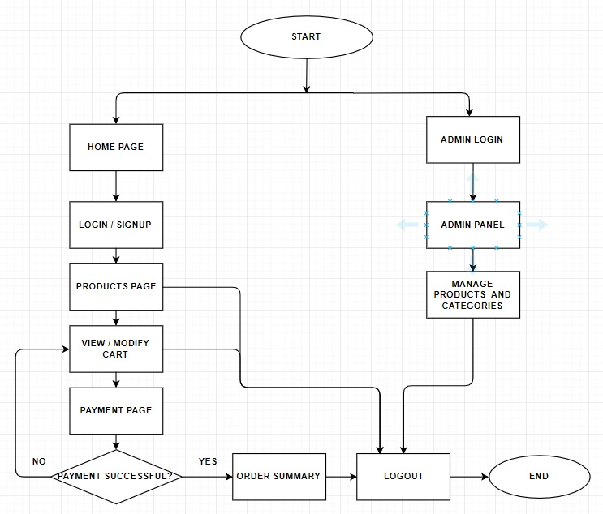

Flow diagram is a collective term for a diagram representing a flow or set of dynamic relationships in a system. The term flow diagram is also used as a synonym for flowchart.This flow diagram represents the application flow for both the end users and administrators.

The end user can visit the home page, view products, search for products, or choose categorical view. The user can add products to the cart, modify it and upto this point, the user can logout any time. Once the user has chosen paypal payment option, the user cannot logout until or unless the payment is successful or cancelled. Then the order summary will be displayed to the user upon successful payment.

Similarly, the administrator can only login to the system, since the sign up option is disabled for security reasons. The administrator can manage products and categories in the database and can logout and end the process flow.

**3.2 ENTITY RELATIONSHIP DIAGRAM**

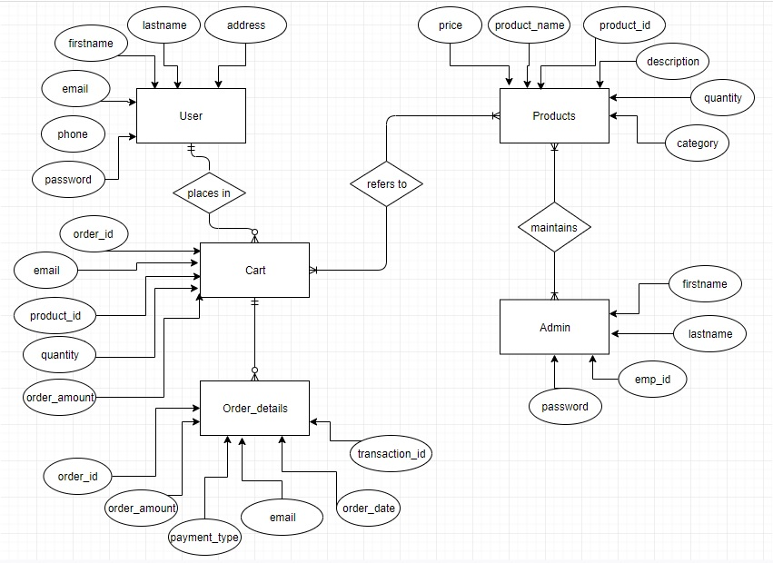

The ER or (Entity Relational Model) is a high-level conceptual data model diagram. Entity-Relation model is based on the notion of real-world entities and the relationship between them.

ER modeling helps you to analyze data requirements systematically to produce a well-designed database. So, it is considered a best practice to complete ER modeling before implementing your database.

This entity relationship diagram contains five tables totally for user, products, cart, order details and admin, which explains the relationship between the user to cart is one to many as same customer can buy multiple product, also for order details to cart is zero to many as for a single order can have different product in the cart. Then the admin to products is one to many, since an admin can manage many products. Then products to cart has many to many relationship, since many products can be added to cart and it can be different products.

**CHAPTER 4**

**SYSTEM IMPLEMENTATION**

This chapter deals with the implementation of this application which explain modules and table design that is needed to develop the system. It comprises of five tables and many modules as explained below.

**4.1 MODULES**

Modules developed in the application are explained briefly in this part. The Application contains many modules such as,

* Home Screen
* User Signup/Login
* User’s Products page
* Cart page
* Place order
* Paypal Payment page
* Admin Login
* Add product
* View product
* Add a new category
* Edit product
  + 1. **Home Screen**



Home Screen module displays the main page with menu with links and search box to navigate through the web application.

Search box is built using AJAX JS technology, which searches for products while the user types and displays the suggestion, based on the query given by the user. Once the user selects the product from the suggestion list, the product and its details will be displayed.

The user can navigate to products with categorical view through the drop down list option on top of the page. Similarly Login, signup and logout options are also provided on top of the home screen.

* + 1. **User Signup/Login**

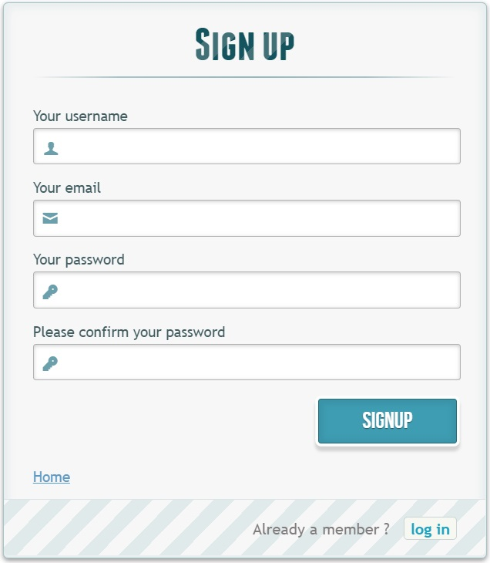

Sign up form is used to create a new account for an user. This module checks for field validations and guide the user to follow the constraints to fulfill the requirements for creating a new account.

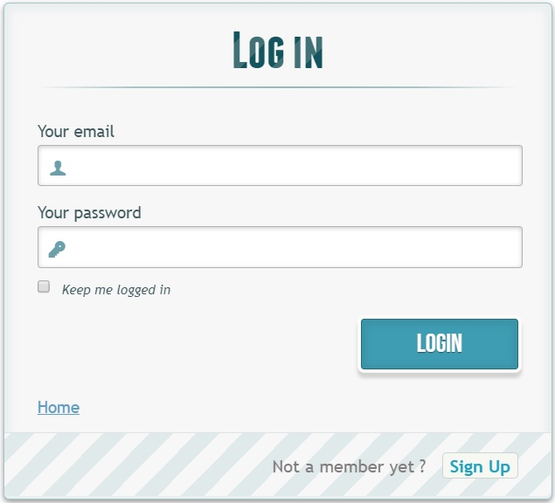

Login module is used to make the customer sign in using their account credentials provided during signup. Upon successful login, the application maintains a session until the customer logout. If there is a mismatch in credentials provided, the customer is prompted to enter the credentials again.

* + 1. **User’s Products page**

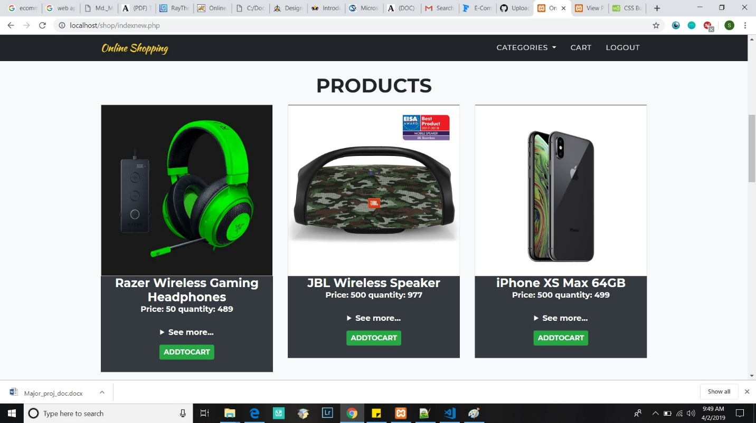

This module displays the products by categories, where it can be accessed through drop down list on top of the page. The products can be added to the cart from the products displayed in this module which narrows down the result to what customer prefers.

* + 1. **Cart page**

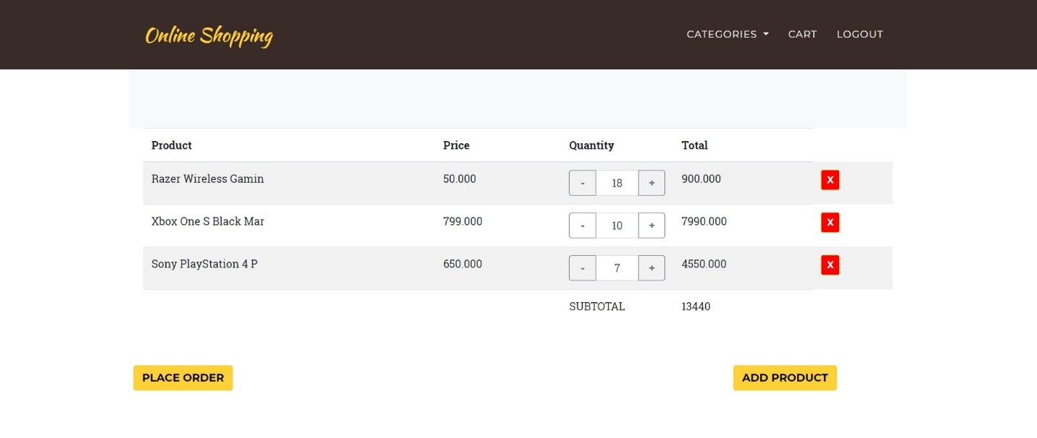

This module is a shopping cart which displays the products added by the customer to the cart. It displays a pre-order summary view with product name, price, quantity and total amount for each product. The product can be removed from the cart using the button provided to the right of each product.

After reviewing the cart, the user can add further products or proceed further to place the order.

* + 1. **Place order**

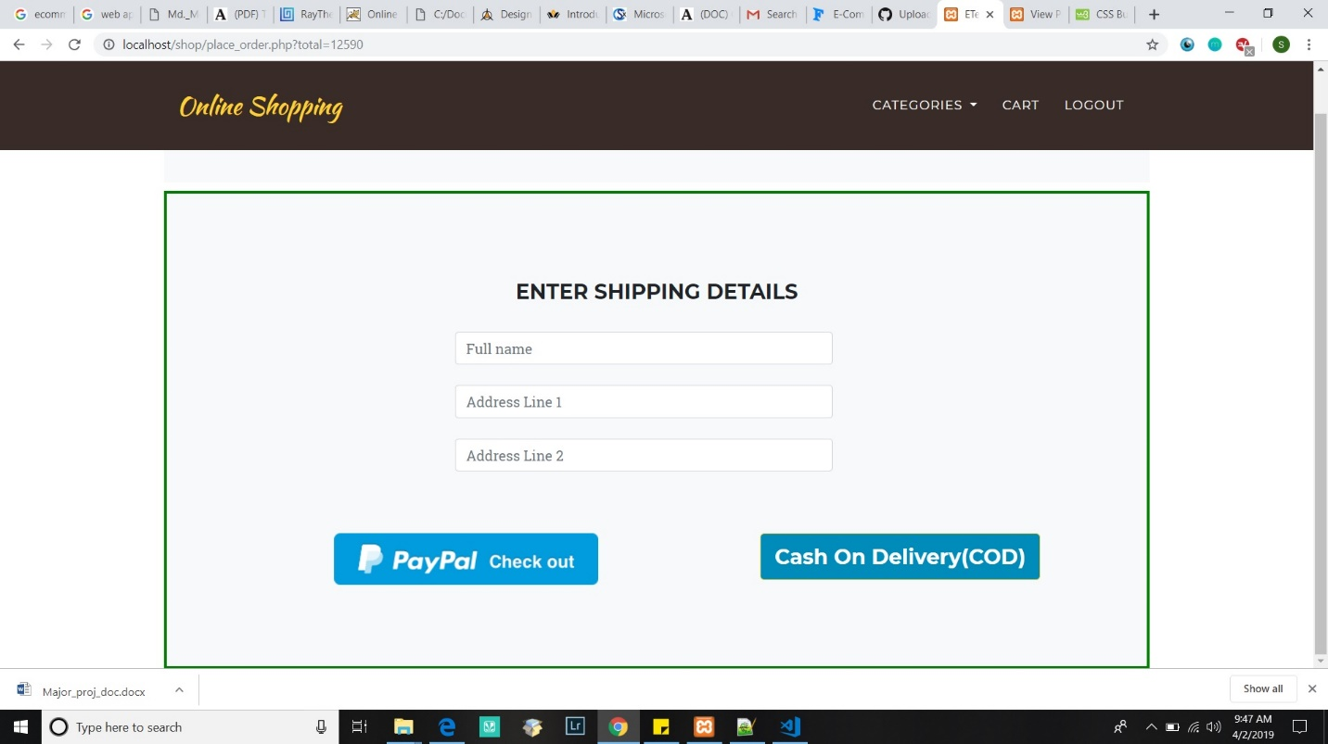

This module takes user input such as Customer name and Shipping address. The customer can opt for any one of the two payment methods, Cash On Delivery (COD) and PayPal checkout.

* + 1. **PayPal Payment page**

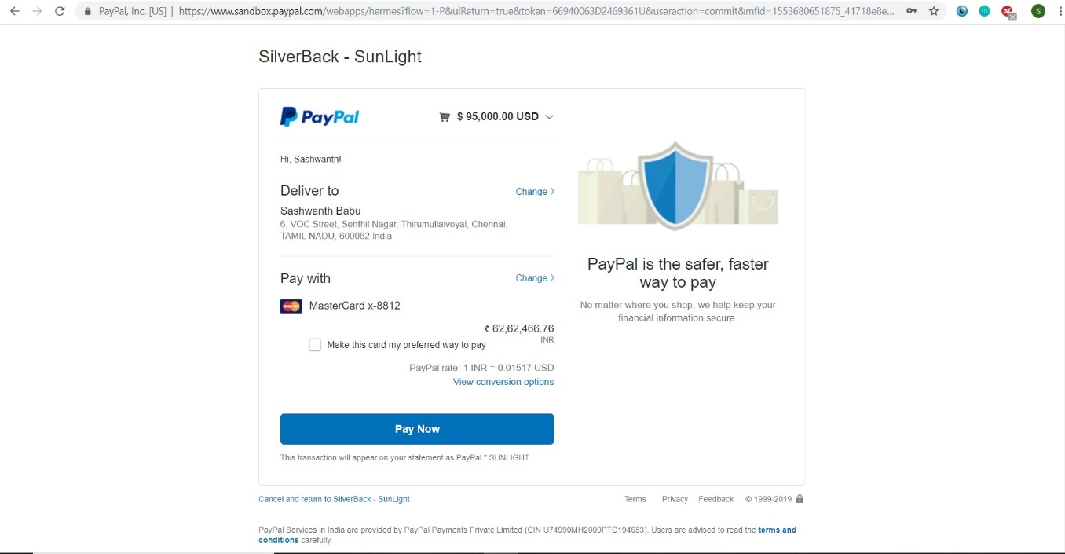

This payment module allows the customer to pay for the order using PayPal, which offers a secure gateway to make the trade by processing the payment that offers a worldwide online payments system that adds to the reliability of the application.

* + 1. **Admin Login**

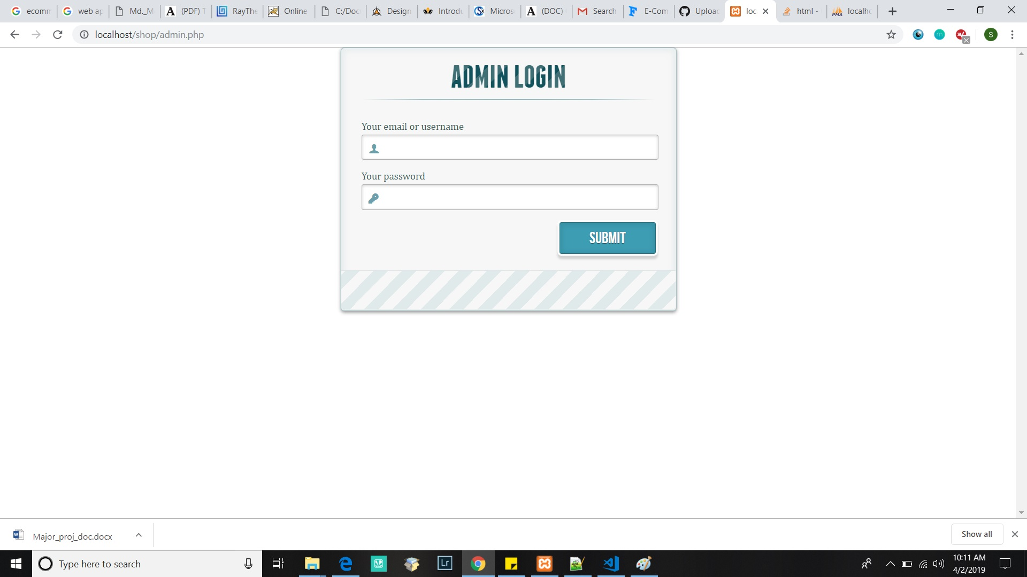

This module is similar to user login, but this is provided only for web administrators. This page cannot be accessed through any links from customer’s user interface. Upon successful login, the application maintains a session until the admin logout and will be redirected to view products page. If there is a mismatch in credentials provided, the admin is prompted to enter the credentials again.

* + 1. **Add product**

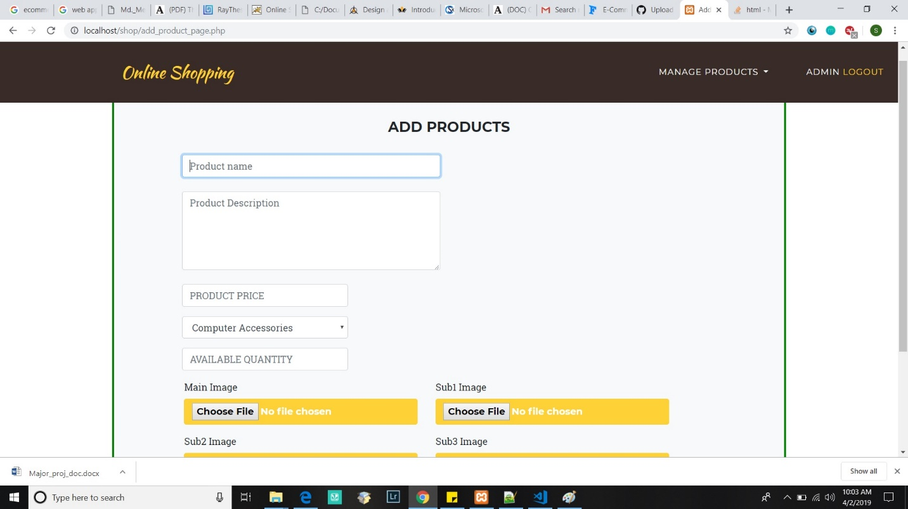

This module can be accessed only by administrators upon authorized login and while the session is maintained. It enables the administrator to add new products to the database with details such as product name, price, category, etc.

* + 1. **View product**

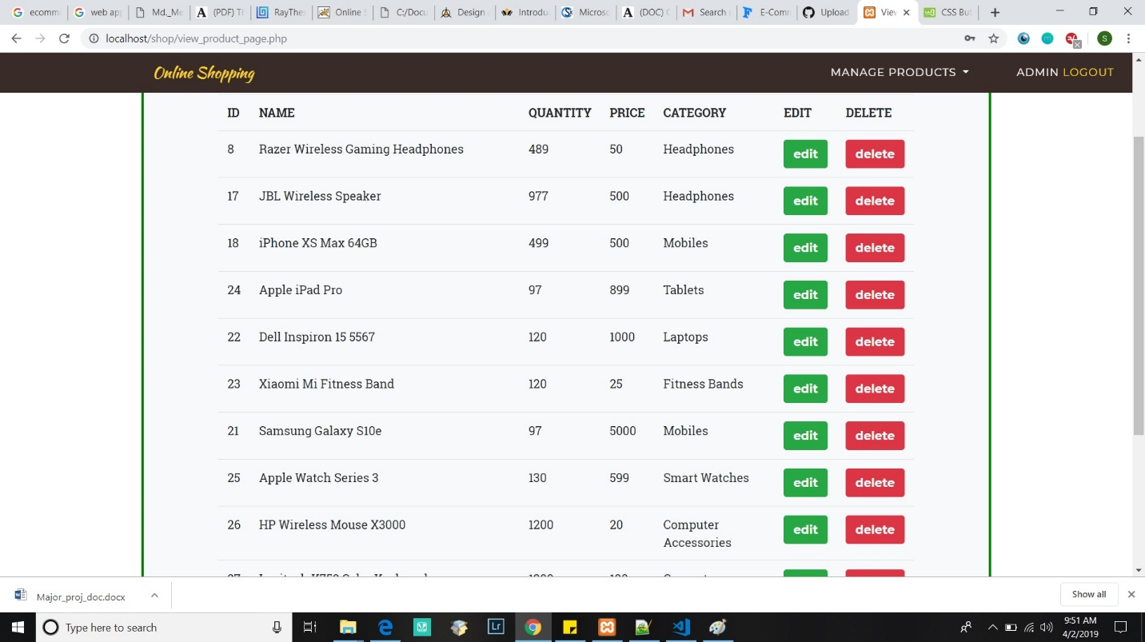

This module also can be accessed only by administrators upon authorized login and while the session is maintained. It enables the administrator to view products that is currently in the database with details such as product name, price, category, etc. The user can delete or edit products through this module.

**4.1.10 Add New Category**

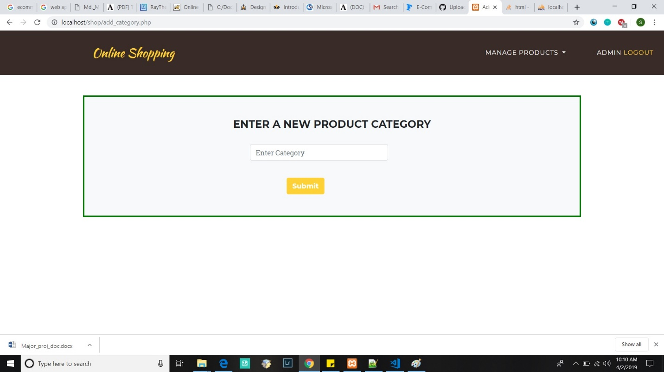

This module also can be accessed only by administrators upon authorized login. It enables the administrator to add a new category to the database.

**4.1.11 Edit product**

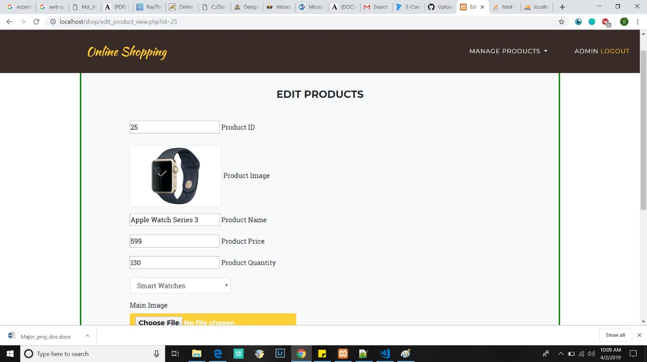

This module belongs to administrator which can be accessed upon authorized login. This can be accessed through view products page, which displays products in the database. This module allows the user to edit the product details such as image, name, price, etc.