Saunders Parking Systems
User Guide

Prepared by Bryan Saunders

Table of Contents
Table of Contents 2
User Interface 3
Menu System 4
System Menu 4
Admin Menu 4
Help Menu 4

User Interface

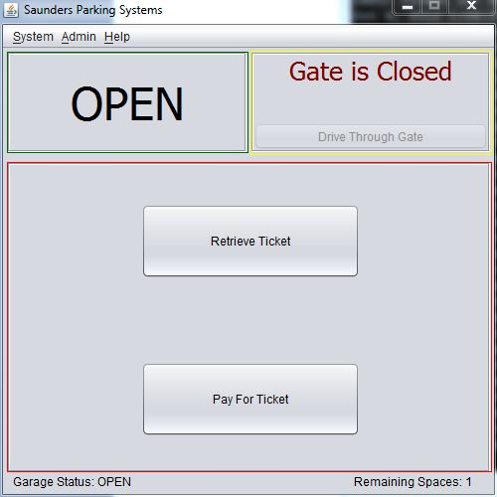
Figure 1.1 – Main User Interface

Figure 1.1 is a screen shot of the primary System User Interface. The UI has three primary sections, one menu, and one status panel. The top right section, marked in yellow, is the Gate Panel. This panel represents the gate in the garage and has controls for simulating the car driving through the gate. The top left section, marked in green, is the Sign Panel. This panel represents the sign in the garage and reflects what the sign would say. The main panel, marked in red, represents the Kiosk Panel. This panel is meant to simulate the screens that the driver would see when entering or exiting the garage. At the bottom of the screen is the Status Panel. This panel will display the garage status and the remaining spaces in the garage at all times.

Menu System

System Menu

Retrieve Ticket
Starts the simulation for the Pay for Ticket scenario

Pay for Ticket
Starts the simulation for the Pay for Ticket scenario

Admin Menu

Login
Logs in the current Attendant

Logout
Logs out the current Attendant

Set Garage Status
Sets the Garage Status to Open or Closed

Set Parking Fee
Sets the 15 minute Parking Fee

Set Maximum Spaces
Sets the Maximum Number of Spaces in the Garage

Data Tools, Open Data Viewer
Opens the Data Viewer

Data Tools, Open Report Generator
Open the Report Generation Screen

Shutdown Kiosk
Shuts down the Kiosk Simulator

Help Menu

Summon Attendant
Summons the Parking Attendant

