Saunders Parking Systems

Prepared by Bryan Saunders

Table of Contents
Table of Contents 2
Use Case Diagram 5
Actor-Goal Table 5
UC-1: Retrieve Ticket 6
Scope 6
Level 6
Primary Actor 6
Stakeholders and Interests 6
Preconditions 6
Success Guarantee 6
Main Success Scenario 6
Extensions 6
Special Requirements 7
Variations in Technology and Data 7
Frequency of Occurrence 7
Miscellaneous 7
UC-2: Pay for Ticket 8
Scope 8
Level 8
Primary Actor 8
Stakeholders and Interests 8
Preconditions 8
Success Guarantee 8
Main Success Scenario 8
Extensions 8
Special Requirements 9
Variations in Technology and Data 9
Frequency of Occurrence 9
Miscellaneous 9
UC-3: Generate Report 10
Scope 10
Level 10
Primary Actor 10
Stakeholders and Interests 10
Preconditions 10
Success Guarantee 10
Main Success Scenario 10
Extensions 10
Special Requirements 10
Variations in Technology and Data 10
Frequency of Occurrence 10
Miscellaneous 10
UC-4: Set Fee 11
Scope 11
Level 11
Primary Actor 11
Stakeholders and Interests 11
Preconditions 11
Success Guarantee 11
Main Success Scenario 11
Extensions 11
Special Requirements 11
Variations in Technology and Data 11
Frequency of Occurrence 11
Miscellaneous 11
UC-5: Set Spaces 12
Scope 12
Level 12
Primary Actor 12
Stakeholders and Interests 12
Preconditions 12
Success Guarantee 12
Main Success Scenario 12
Extensions 12
Special Requirements 12
Variations in Technology and Data 12
Frequency of Occurrence 12
Miscellaneous 12
UC-6: Authentication 13
Scope 13
Level 13
Primary Actor 13
Stakeholders and Interests 13
Preconditions 13
Success Guarantee 13
Main Success Scenario 13
Extensions 13
Special Requirements 13
Variations in Technology and Data 13
Frequency of Occurrence 13
Miscellaneous 13
Domain Model 14
Domain Concepts 15
Event 15
Ticket Description 15
Ticket 15
Driver 15
Car 15
Kiosk 15
Sign 15
Gate 15
Attendant 15
Report 15
Payment Description 15
Payment 15
Cash Payment 16
Electronic Payment 16
Payment Gateway 16
Sequence Diagrams 17
Enter Parking Garage 17
Configure Parking Spaces 17
Exit Parking Garage 18

Use Case Diagram

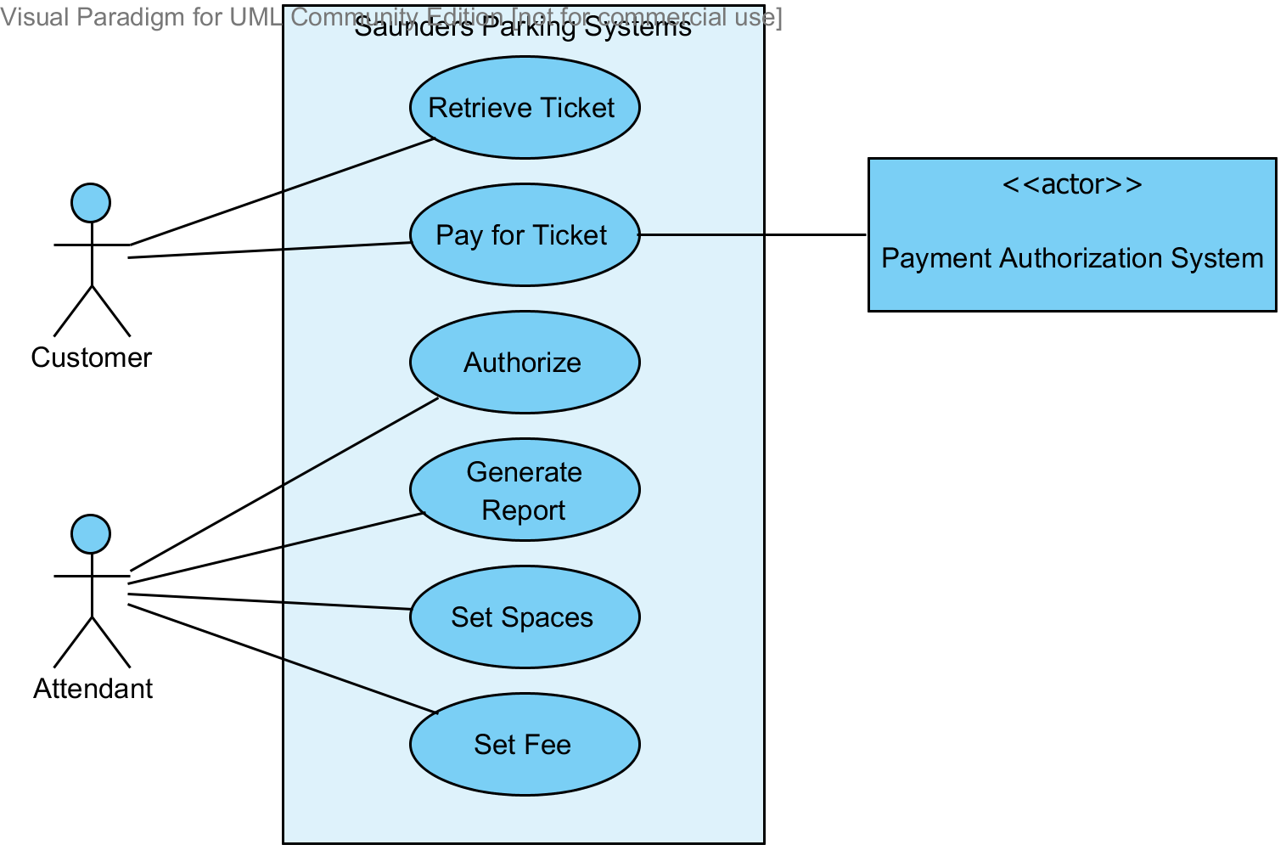

Actor-Goal Table

Actor(s) | Goal
Customer | Retrieve a Ticket
Customer | Pay for a Ticket
Attendant | Set Parking Fee
Attendant | Set Garage Spaces
Attendant | Generate Report
Payment Authorization Service | Authorize Credit Card Payments

UC-1: Retrieve Ticket

Scope
Saunders Parking Systems

Level
User Goal

Primary Actor
Customer

Stakeholders and Interests
Customer: Retrieve ticket from dispenser, enter garage
Attendant: Garage sign updated

Preconditions
None

Success Guarantee
Customer has ticket and entered garage. Garage sign updated

Main Success Scenario
- Customer requests ticket
- System receives ticket request
- System generates unique ticket ID
- System creates ticket
- System records Entrance Event information
- Customer retrieves ticket
- System opens garage gate
- Customer enters garage
- System updates garage sign
- System closes garage gate

Extensions
Step 5: Dispenser out of blank tickets (Out of Scope)
- If system can detect the error, attendant will be summoned
- Attendant will replace blank tickets
- System continues at step 6
Step 7: Gate will not open (Out of Scope)
- If system can detect the error, attendant will be summoned
- Attendant will manually open gate
- System continues at step 8
Step 9: Sign will not update (Out of Scope)
- If system can detect the error, attendant will be summoned
- Attendant will manually update the sign
- System continues at step 10
Step 10: Gate will not close (Out of Scope)
- If system can detect the error, attendant will be summoned
- Attendant will manually close gate

Special Requirements
None

Variations in Technology and Data
Step 3: Ticket ID should be universally unique
Step 4: Entrance Event information consists of time stamp & ticket id

Frequency of Occurrence
Every time a customer requires entrance into the garage, Could be nearly continuous

Miscellaneous
None

UC-2: Pay for Ticket

Scope
Saunders Parking Systems

Level
User Goal

Primary Actor
Customer

Stakeholders and Interests
Customer: Pay parking fee, exit garage
Attendant: Garage sign updated
Payment Authorization System: Authorize electronic payments
Garage Owner: Collect garage revenue

Preconditions
UC-1 completed successfully

Success Guarantee
Payment authorized, fee paid, and customer exited garage. Garage sign updated

Main Success Scenario
- Customer approaches exit gate
- System asks for Customer ticket
- Customer inserts ticket
- System reads ticket
- System computes total fee
- System presents customer with fee
- System asks for payment
- Customer provides payment
- If electronic payment, System authorizes payment
- System records Exit Event information
- System prints receipt
- Customer retrieves receipt
- System opens gate
- Customer exits garage
- System updates garage sign
- System closes gate

Extensions
Any Step: Assistance Needed
- Customer indicates assistance is needed
- System summons Attendant to provide assistance
Step 2: Customer has lost ticket
- Customer indicates ticket has been lost
- System charges lost ticket fee
- System continues as step 6
Step 4: System can not read ticket
- System returns ticket
- Customer is prompted to enter ticket id manually
- Customer enters ticket id
- System continues at step 5
Step 5: Ticket is invalid
- System indicates ticket is invalid
- System charges lost ticket fee
- System continues as step 6
Step 8: Customer does not have valid payment
- Attendant is summoned for manual resolution
Step 9: Payment authorization denied
- System indicates payment authorization failed
- System returns to step 7
Step 11: Dispenser out of paper (Out of Scope)
- If system can detect the error, attendant will be summoned
- Attendant will replace paper
- System continues at step 12
Step 13: Gate will not open (Out of Scope)
- If system can detect the error, attendant will be summoned
- Attendant will manually open gate
- System continues at step 14
Step 15: Sign will not update (Out of Scope)
- If system can detect the error, attendant will be summoned
- Attendant will manually update the sign
- System continues at step 16
Step 16: Gate will not close (Out of Scope)
- If system can detect the error, attendant will be summoned
- Attendant will manually close gate

Special Requirements
- System should accept cash (exact change only) and electronic (credit/debit card) payments.
- Credit authorization response within 30 seconds 90% of the time.

Variations in Technology and Data
None

Frequency of Occurrence
Every time a customer requires to exit the garage, Could be nearly continuous

Miscellaneous
None

UC-3: Generate Report

Scope
Saunders Parking Systems

Level
User Goal

Primary Actor
Attendant

Stakeholders and Interests
Attendant: Generate usage & revenue reports

Preconditions
UC-6 completed successfully

Success Guarantee
Reports generated

Main Success Scenario
- Attendant indicates a report should be generated
- System prompts the Attendant to select report type
- Attendant selects report type
- System presents Attendant with report options
- Attendant sets report options
- Attendant indicates report should be generated
- System generates report

Extensions
Any Step: Cancellation
- Attendant indicates the report generation should be cancelled
- System returns to pre-reporting state

Special Requirements
None

Variations in Technology and Data
Step 7: Reports will be displayed on the screen only.

Frequency of Occurrence
Daily

Miscellaneous
None

UC-4: Set Fee

Scope
Saunders Parking Systems

Level
User Goal

Primary Actor
Attendant

Stakeholders and Interests
Attendant: Adjust the parking fee for the garage
Garage Owner: Adjust fee’s to increase business and revenue

Preconditions
UC-6 completed successfully

Success Guarantee
Fee’s updated to new fee

Main Success Scenario
- Attendant indicates the parking fee should be adjusted
- System asks the Attendant for the new parking fee
- Attendant enters new parking fee
- System sets the parking fee
- System returns to pre-configuration state

Extensions
None

Special Requirements
None

Variations in Technology and Data
None

Frequency of Occurrence
Whenever parking fee’s change

Miscellaneous
None

UC-5: Set Spaces

Scope
Saunders Parking Systems

Level
User Goal

Primary Actor
Attendant

Stakeholders and Interests
Attendant: Update spaces to match garage availability

Preconditions
UC-6 complete successfully

Success Guarantee
Number of spaces updated to reflect availability

Main Success Scenario
- Attendant indicates the spaces available should be adjusted
- System asks the Attendant for the new space count
- Attendant enters new space count
- System sets the space count
- System returns to pre-configuration state

Extensions
None

Special Requirements
None

Variations in Technology and Data
None

Frequency of Occurrence
Whenever space availability changes

Miscellaneous
None

UC-6: Authentication

Scope
Saunders Parking Systems

Level
User Goal

Primary Actor
Attendant

Stakeholders and Interests
Attendant: Wants to be authorized by the system

Preconditions
None

Success Guarantee
Attendant is authorized

Main Success Scenario
- Attendant indicates they want to be authorized
- System prompts Attendant for credentials
- System verifies credentials
- System indicates the Attendant is authorized

Extensions
Step 3: Credentials invalid
- System indicates the provided credentials are invalid
- System returns to step 1

Special Requirements
None

Variations in Technology and Data
Step 2: Credentials will be provided as a user id and pin

Frequency of Occurrence
Potentially several times an hour

Miscellaneous
None

Domain Model

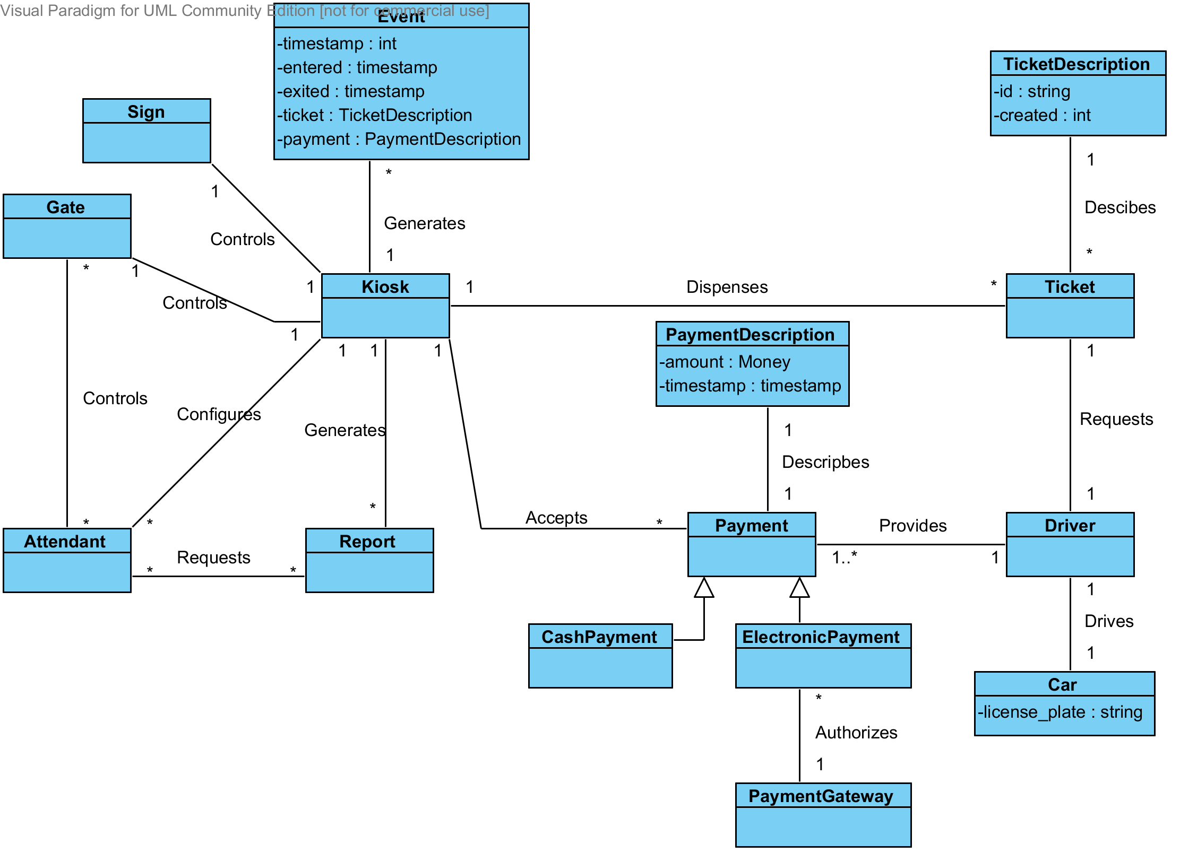

Domain Concepts

Event
Generated by the Kiosk when a Driver enters the garage and parks it is updated again when the Driver exits the garage.

Ticket Description
Describes a ticket.

Ticket
Ticket printed for a Driver.

Driver
Drives a Car into the garage and provides Payment when exiting the garage.

Car
Driven into the garage by the Driver.

Kiosk
The main interaction point for the system providing an interface for the Attendant and the Driver.

Sign
Garage sign that displays information about the status of the garage, such as number of parking spaces available.

Gate
Controls access into and out of the garage.

Attendant
Assists Drivers when they have trouble with the Kiosk. Attendants are also responsible for generating Reports, configuring the Kiosk, and manually controlling the Gates.

Report
Contains detailed information about the garage and payments.

Payment Description
Described a payment.

Payment
Provided to the Kiosk by a Driver in order to exit the garage.

Cash Payment
Type of Payment that is made with cash.

Electronic Payment
Type of Payment that is made with an electronic form, such as credit and debit cards.

Payment Gateway
Authorizes electronic payments.

Sequence Diagrams

Enter Parking Garage

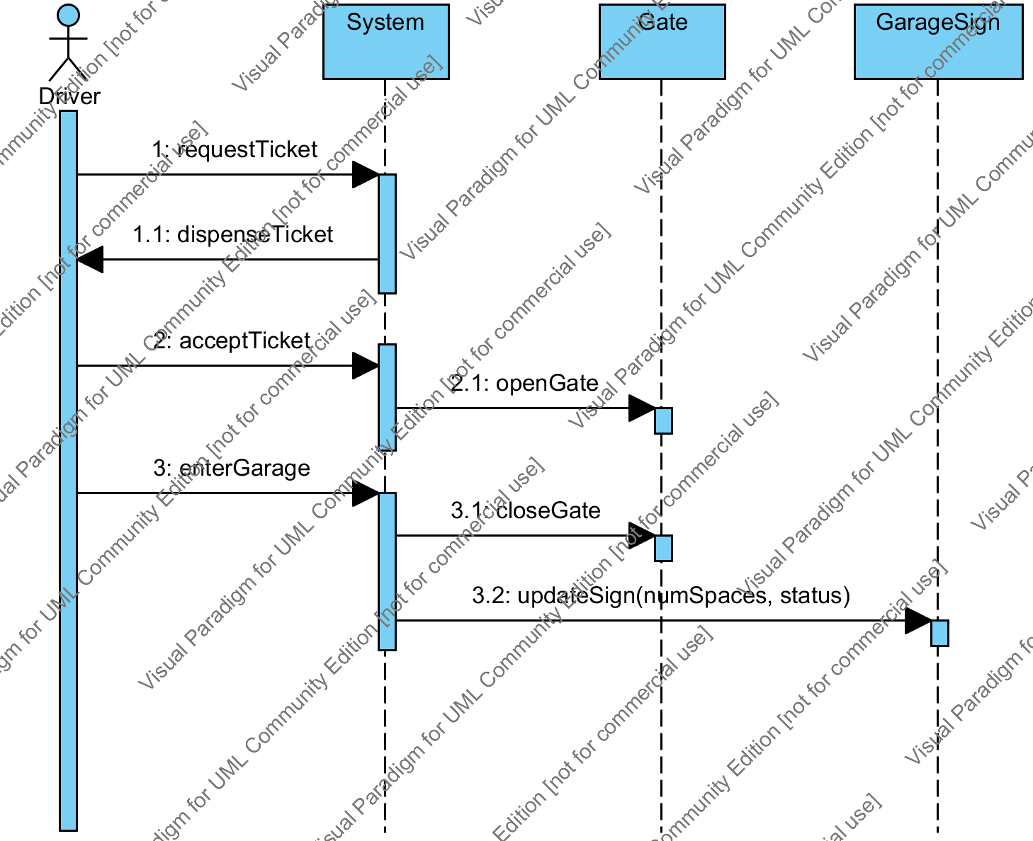

Configure Parking Spaces

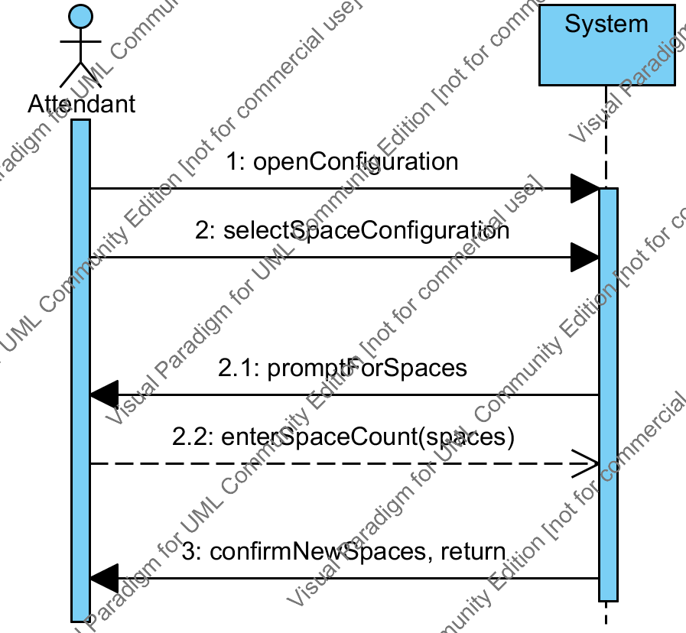

Exit Parking Garage

