CS414 – Object Oriented Design
Take Home Final Exam
Taken By: Bryan Saunders

Honor Pledge

“I have not given, received, or used any unauthorized assistance.”
Signature: Bryan Saunders
Date: 12/11/2012

Question 1

Part A

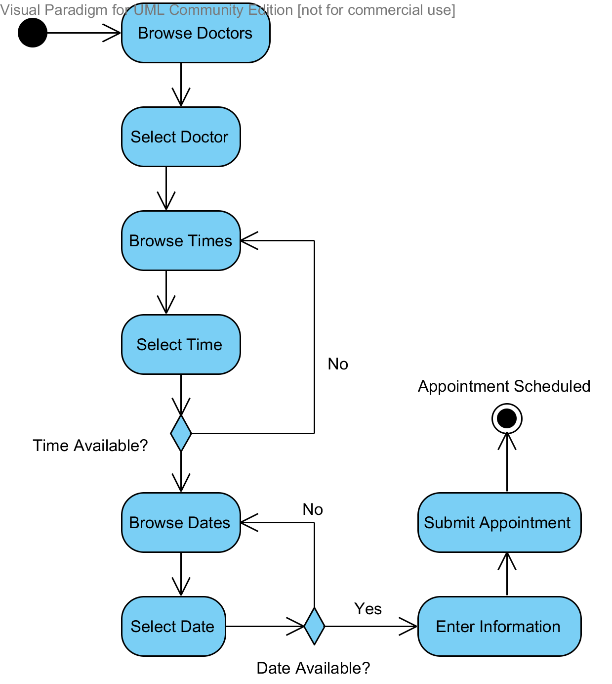

Part B

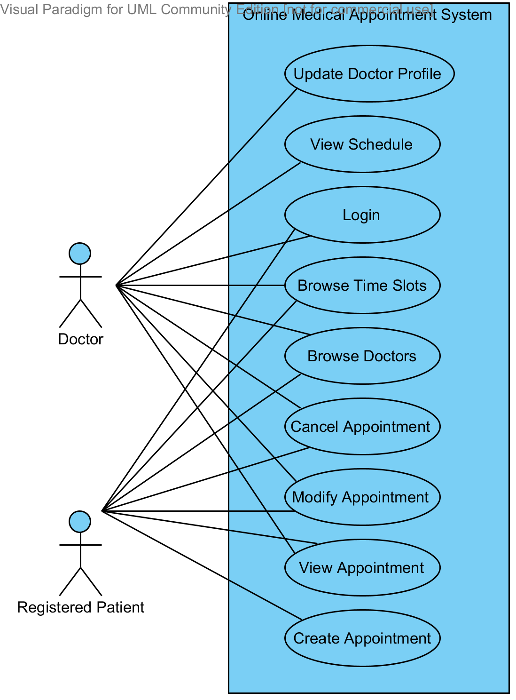

Part C

Use Case Scenario 1
Name | Modify Appointment
Scope | CS414 Online Medical Appointment Scheduling System
Level | User Goal
Primary Actor | Registered Patient
Stakeholders and Interests | Registered Patient: Change appointment information  Doctor: Provide the correct care to the patient at an appropriate time
Preconditions | Registered Patient logged in to the system
Success Guarantee | Registered Patient has modified appointment successfully
Main Success Scenario | - Registered Patient (RP) chooses “View Appointments”  - System loads list of RP’s appointments  - RP chooses appointment to modify  - System loads appointment information form  - System pre-populates form with current data  - RP changes appointment information  - RP selects “Save Appointment”  - System saves new appointment information  - System notifies Doctor and RP of appointment changes  - System redirects RP to home screen
Extensions | Step 6: Invalid information entered  - System displays appropriate error message(s)  - User corrects invalid field(s)  - System continues at step 7
Special Requirements | None
Variations in Technology & Data | Step 6: The system shall validate field data after the field is populated and without requiring form submission.
Frequency of Occurrence | Every time a patient needs to modify an appointment, infrequently.
Miscellaneous | What is the best way to notify the Doctor of appointment changes?

Use Case Scenario 2
Name | View Appointment Schedule
Scope | CS414 Online Medical Appointment Scheduling System
Level | User Goal
Primary Actor | Doctor
Stakeholders and Interests | Doctor: View all upcoming appointments
Preconditions | Doctor logged in to the system
Success Guarantee | Doctor has viewed appointment schedule
Main Success Scenario | - Doctor selects “View Schedule”  - System loads schedule selection form  - Doctor selects date  - Doctor selects “View Schedule”  - System loads schedule  - Doctor views schedule  - Doctors selects “Done”  - System redirects Doctor to home screen
Extensions | Step 6: Print Schedule  - Doctor selects “Print”  - System loads print dialog  - Doctor sets print options  - Doctor selects “Ok”  - System sends print command  - System closes print dialog  - System continues at step 7
Special Requirements | None
Variations in Technology & Data | None
Frequency of Occurrence | Daily
Miscellaneous | None

Question 2

Part A
I Used the “Replace Type Code with State/Strategy” refactoring. This refactoring is for replacing type codes with a State class and a set of TypeCode subclasses. In this case I replaced the Enum with a RentalState parent object and four subclasses.

Final Code
public class RentalStateMachine {
private RentalState currentState;

public RentalStateMachine() {
this.currentState = new ForRent();
}

public void rent() throws IllegalEventException {
RentalState newState = this.currentState.rent();
this.currentState = newState;
}

public void returnRental() throws IllegalEventException {
RentalState newState = this.currentState.returnRental();
this.currentState = newState;
}

public void setForSale() throws IllegalEventException {
RentalState newState = this.currentState.setForSale();
this.currentState = newState;
}

public void sell() throws IllegalEventException {
RentalState newState = this.currentState.sell();
this.currentState = newState;
}

public RentalState getCurrentState() {
return this.currentState;
}

public void setCurrentState(RentalState currentState) {
this.currentState = currentState;
}
}

abstract class RentalState {
RentalState sell() throws IllegalEventException {
throw new IllegalEventException();
}

RentalState setForSale() throws IllegalEventException {
throw new IllegalEventException();
}

RentalState returnRental() throws IllegalEventException {
throw new IllegalEventException();
}

RentalState rent() throws IllegalEventException {
throw new IllegalEventException();
}
}

class ForRent extends RentalState {
@Override
RentalState rent() throws IllegalEventException {
return new Rented();
}

@Override
RentalState setForSale() throws IllegalEventException {
return new ForSale();
}
}

class Rented extends RentalState {
@Override
RentalState returnRental() throws IllegalEventException {
return new ForRent();
}
}

class ForSale extends RentalState {
@Override
RentalState sell() throws IllegalEventException {
return new Sold();
}
}

class Sold extends RentalState {

}

class IllegalEventException extends Exception {
private static final long serialVersionUID = 1L;

}

Part B
public class RentalStateMachine {
private RentalState currentState;

public RentalStateMachine() {
this.currentState = new ForRent();
}

public void rent() throws IllegalEventException {
RentalState newState = this.currentState.rent();
this.currentState = newState;
}

public void returnRental() throws IllegalEventException {
RentalState newState = this.currentState.returnRental();
this.currentState = newState;
}

public void setForSale() throws IllegalEventException {
RentalState newState = this.currentState.setForSale();
this.currentState = newState;
}

public void sell() throws IllegalEventException {
RentalState newState = this.currentState.sell();
this.currentState = newState;
}

public void withdraw() throws IllegalEventException {
RentalState newState = this.currentState.withdraw();
this.currentState = newState;
}

public RentalState getCurrentState() {
return this.currentState;
}

public void setCurrentState(RentalState currentState) {
this.currentState = currentState;
}
}

abstract class RentalState {
RentalState sell() throws IllegalEventException {
throw new IllegalEventException();
}

RentalState setForSale() throws IllegalEventException {
throw new IllegalEventException();
}

RentalState returnRental() throws IllegalEventException {
throw new IllegalEventException();
}

RentalState rent() throws IllegalEventException {
throw new IllegalEventException();
}

RentalState withdraw() throws IllegalEventException {
return new Withdrawn();
}
}

class ForRent extends RentalState {
@Override
RentalState rent() throws IllegalEventException {
return new Rented();
}

@Override
RentalState setForSale() throws IllegalEventException {
return new ForSale();
}
}

class Rented extends RentalState {
@Override
RentalState returnRental() throws IllegalEventException {
return new ForRent();
}
}

class ForSale extends RentalState {
@Override
RentalState sell() throws IllegalEventException {
return new Sold();
}
}

class Sold extends RentalState {
@Override
RentalState withdraw() throws IllegalEventException {
throw new IllegalEventException();
}
}

class Withdrawn extends RentalState {
@Override
RentalState sell() throws IllegalEventException {
return new Withdrawn();
}

@Override
RentalState returnRental() throws IllegalEventException {
return new Withdrawn();
}

@Override
RentalState rent() throws IllegalEventException {
return new Withdrawn();
}

@Override
RentalState setForSale() throws IllegalEventException {
return new Withdrawn();
}
}

class IllegalEventException extends Exception {
private static final long serialVersionUID = 1L;

}

Part C
public class OriginalRentalStateMachine {
public enum RentalState {
ForRent, Rented, ForSale, Sold, Withdrawn;
}

private RentalState currentState;

public void rent() throws IllegalEventException {
if (currentState == RentalState.Withdrawn) {
currentState = RentalState.Withdrawn;
} else if (currentState == RentalState.ForRent) {
currentState = RentalState.Rented;
} else {
throw new IllegalEventException();

}
}

public void returnRental() throws IllegalEventException {
if (currentState == RentalState.Withdrawn) {
currentState = RentalState.Withdrawn;
} else if (currentState == RentalState.Rented) {
currentState = RentalState.ForRent;
} else {
throw new IllegalEventException();
}
}

public void setForSale() throws IllegalEventException {
if (currentState == RentalState.Withdrawn) {
currentState = RentalState.Withdrawn;
} else if (currentState == RentalState.ForRent) {
currentState = RentalState.ForSale;
} else {
throw new IllegalEventException();
}
}

public void sell() throws IllegalEventException {
if (currentState == RentalState.Withdrawn) {
currentState = RentalState.Withdrawn;
} else if (currentState == RentalState.ForSale) {
currentState = RentalState.Sold;
} else {
throw new IllegalEventException();
}
}

public void withdraw() throws IllegalEventException{
if (currentState != RentalState.Sold) {
currentState = RentalState.Withdrawn;
} else {
throw new IllegalEventException();
}
}
}

class IllegalEventException extends Exception {
private static final long serialVersionUID = 1L;

}

Part D
Changes made for Part B
+ 1 Class
+ 6 Methods (4 inside new class)
+ 15 Lines of Code Total

Changes made for Part C
+ 1 Enum
+ 1 New Method
+ 4 Method Updates
+ 17 Lines of Code Total

The changes to both Part B and C were about the same number of lines, however the changes to Part B left the code in a much better state. Adding a new state was much easier after applying the state pattern because I only needed to implement a new class. In the original code I had to go back and change all of the previously existing methods to account for the new state.

Question 3

Part A
I added an Abstract method to the Node class called Evaluate. I then moved the logic from each of the if branches to its appropriate sub-class and updated them where necessary to compile. Then I removed the if conditionals and replaced them with a call to the abstract evaluate method.

import java.util.HashMap;

/*** File Evaluator.java ***/
public class Evaluator {

public int evaluate(Node node) {
return node.evaluate();
}
}

/*** File Node.java ***/
abstract class Node {
abstract public int evaluate();
}

/*** File Expression.java ***/
abstract class Expression extends Node {
private Node left;
private Node right;

public Node getLeft() {
return left;
}

public Node getRight() {
return right;
}
}

/*** File Addition.java ***/
class Addition extends Expression {
@Override
public int evaluate() {
int leftOperand = getLeft().evaluate();
int rightOperand = getRight().evaluate();
return leftOperand + rightOperand;
}
}

/*** File Subtraction.java ***/
class Subtraction extends Expression {
@Override
public int evaluate() {
int leftOperand = getLeft().evaluate();
int rightOperand = getRight().evaluate();
return leftOperand - rightOperand;
}
}

/*** File Negate.java ***/
class Negate extends Expression {
@Override
public int evaluate() {
int leftOperand = getLeft().evaluate();
return (-leftOperand);
}
}

/*** File Token.java ***/
class Token extends Node {
public static final int IDENTIFIER = 1;
public static final int INTEGER_LITERAL = 2;
private HashMap<String, Integer> IdentifierToValue;
private int type;
private String text;

public String getText() {
return text;
}

public int getType() {
return type;
}

@Override
public int evaluate() {
if (type == Token.IDENTIFIER)
return IdentifierToValue.get(getText()).intValue();
else
return Integer.parseInt(getText());
}
}

Part B

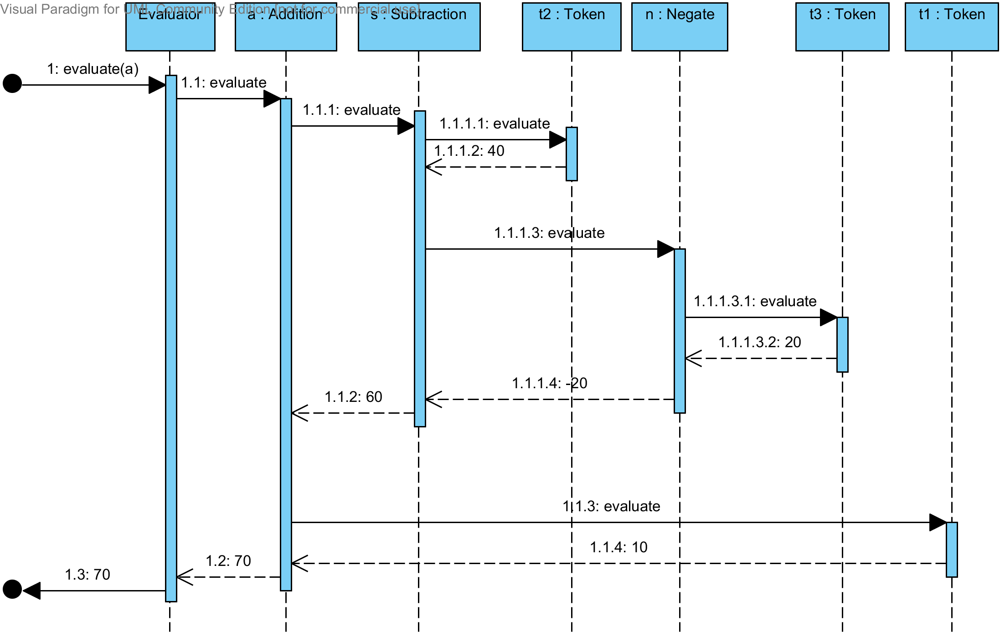

Question 4

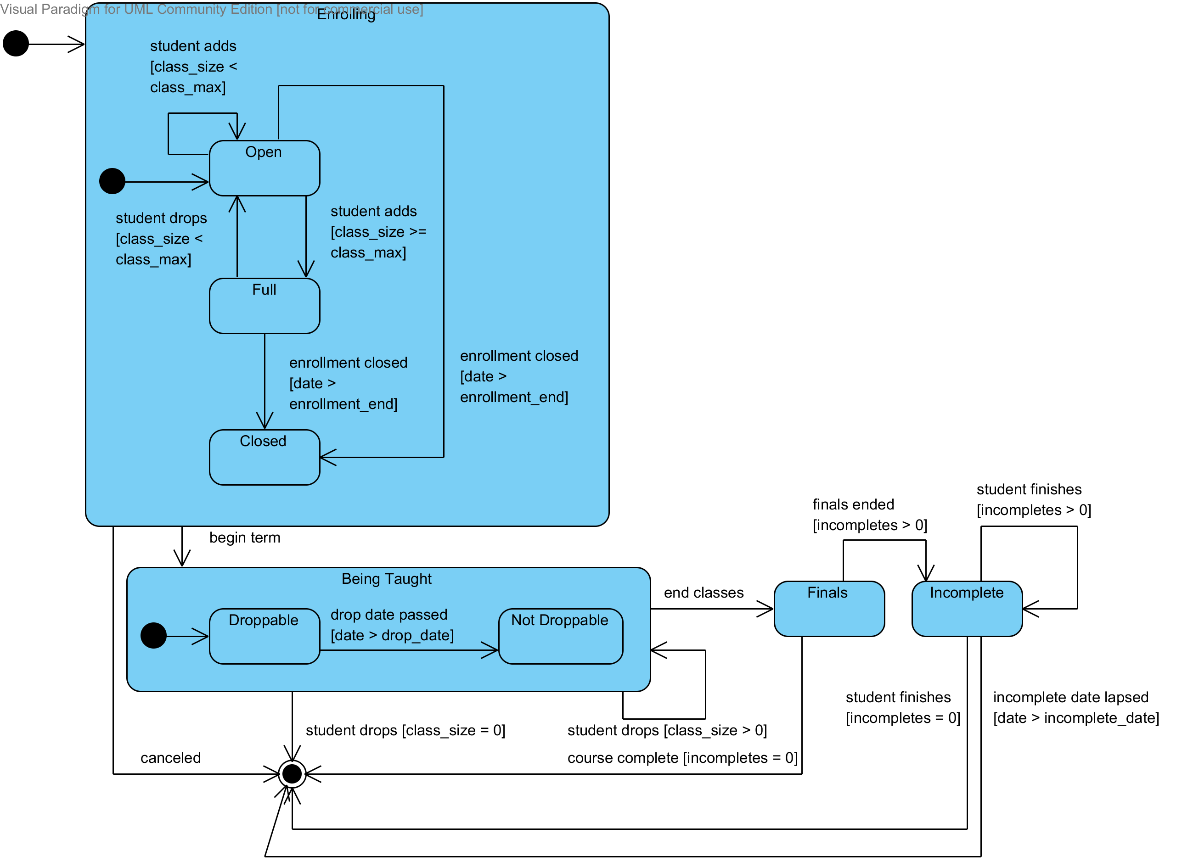

Question 5

Part A
import javax.swing.*;
import java.awt.*;
import java.awt.event.*;
import java.util.HashMap;

public class SaleFrame extends JFrame implements ActionListener {
private static final long serialVersionUID = 1L;

private JButton enterItemButton = new JButton("Enter Item");
private JTextField priceField = new JTextField(30);
private JTextField itemIDField = new JTextField(10);
private JTextField quantityField = new JTextField(10);

public SaleFrame() {
Container container = getContentPane();
container.setLayout(new FlowLayout(FlowLayout.CENTER));
container.add(new JLabel("Enter Item ID(1/2)"));

container.add(itemIDField);
container.add(new JLabel("Enter quantity of the item"));
container.add(quantityField);
container.add(enterItemButton);
container.add(new JLabel("The total price of the item"));
container.add(priceField);
priceField.setEditable(false);
enterItemButton.addActionListener(this);
}

public void actionPerformed(ActionEvent e) {
int itemID = Integer.parseInt(itemIDField.getText());
int quantity = Integer.parseInt(quantityField.getText());

SaleController controller = new SaleController();
int price = controller.computePrice(itemID, quantity);
displayPrice(price);
}

public void displayPrice(int price) {
priceField.setText("The price for the entered item is " + price);
}

public static void main(String[] args) {
SaleFrame saleframe = new SaleFrame();
saleframe.setSize(200, 200);
saleframe.setVisible(true);
}
}

class SaleController {
int computePrice(int itemID, int quantity) {
ProductCatalog productCatalog = ProductCatalog.getInstance();
ProductDescription description = productCatalog
.getProductDescription(itemID);
PriceCalculator calculator = new PriceCalculator();
int price = calculator.calculatePrice(quantity, description);
return price;
}
}

class ProductCatalog {
private HashMap<Integer, ProductDescription> itemIDtoProductDescriptionMap = new HashMap<Integer, ProductDescription>();

protected ProductCatalog() {
super();
itemIDtoProductDescriptionMap.put(1, new ProductDescription(10));
itemIDtoProductDescriptionMap.put(2, new ProductDescription(15));
}

private static ProductCatalog INSTANCE;

public static ProductCatalog getInstance() {
if (INSTANCE != null)
return INSTANCE;
else
return new ProductCatalog();
}

public ProductDescription getProductDescription(int itemID) {

return itemIDtoProductDescriptionMap.get(itemID);
}
}

class ProductDescription {
private int unitPrice;

public ProductDescription(int unitPrice) {
this.unitPrice = unitPrice;
}

public int getUnitPrice() {
return unitPrice;
}
}

class PriceCalculator {
public int calculatePrice(int quantity, ProductDescription description) {
int price = quantity * description.getUnitPrice();
return price;
}
}

Part B
import java.awt.Container;
import java.awt.FlowLayout;
import java.util.LinkedList;
import java.util.List;
import java.awt.event.ActionEvent;
import java.awt.event.ActionListener;
import java.util.HashMap;

import javax.swing.JButton;
import javax.swing.JFrame;
import javax.swing.JLabel;
import javax.swing.JTextField;

public class SaleFrame extends JFrame implements ActionListener, PriceObserver {
private static final long serialVersionUID = 1L;

private JButton enterItemButton = new JButton("Enter Item");
private JTextField priceField = new JTextField(30);
private JTextField itemIDField = new JTextField(10);
private JTextField quantityField = new JTextField(10);

private SaleController controller;

public SaleFrame() {
Container container = getContentPane();
container.setLayout(new FlowLayout(FlowLayout.CENTER));
container.add(new JLabel("Enter Item ID(1/2)"));

container.add(itemIDField);
container.add(new JLabel("Enter quantity of the item"));
container.add(quantityField);
container.add(enterItemButton);
container.add(new JLabel("The total price of the item"));
container.add(priceField);
priceField.setEditable(false);
enterItemButton.addActionListener(this);

controller = new SaleController();
controller.addObserver(this);
}

public void actionPerformed(ActionEvent e) {
int itemID = Integer.parseInt(itemIDField.getText());
int quantity = Integer.parseInt(quantityField.getText());

controller.computePrice(itemID, quantity);
}

public void displayPrice(int price) {
priceField.setText("The price for the entered item is " + price);
}

public static void main(String[] args) {
SaleFrame saleframe = new SaleFrame();
saleframe.setSize(200, 200);
saleframe.setVisible(true);
}

@Override
public void priceUpdated(int price) {
displayPrice(price);
}
}

class SaleController {

List<PriceObserver> observers;

public SaleController(){
observers = new LinkedList<PriceObserver>();
}

void addObserver(PriceObserver observer){
observers.add(observer);
}

int computePrice(int itemID, int quantity) {
ProductCatalog productCatalog = ProductCatalog.getInstance();

ProductDescription description = productCatalog
.getProductDescription(itemID);
PriceCalculator calculator = new PriceCalculator();

int price = calculator.calculatePrice(quantity, description);

firePriceUpdatedEvent(price);
return price;
}

private void firePriceUpdatedEvent(int price) {
for(PriceObserver observer : observers){
observer.priceUpdated(price);
}
}
}

interface PriceObserver {
void priceUpdated(int price);
}

class ProductCatalog {
private HashMap<Integer, ProductDescription> itemIDtoProductDescriptionMap = new HashMap<Integer, ProductDescription>();

protected ProductCatalog() {
super();
itemIDtoProductDescriptionMap.put(1, new ProductDescription(10));
itemIDtoProductDescriptionMap.put(2, new ProductDescription(15));
}

private static ProductCatalog INSTANCE;

public static ProductCatalog getInstance() {
if (INSTANCE != null)
return INSTANCE;
else
return new ProductCatalog();
}

public ProductDescription getProductDescription(int itemID) {

return itemIDtoProductDescriptionMap.get(itemID);
}
}

class ProductDescription {
private int unitPrice;

public ProductDescription(int unitPrice) {
this.unitPrice = unitPrice;
}

public int getUnitPrice() {
return unitPrice;
}
}

class PriceCalculator {
public int calculatePrice(int quantity, ProductDescription description) {
int price = quantity * description.getUnitPrice();
return price;
}
}

