Q1 - SCENARIO
A car rental company called FastCarz has a .net Web Application and Web API which are recently migrated from on-premise system to Azure cloud using Azure Web App Service
and Web API Service.
The on-premises system had 3 environments Dev, QA and Prod.
The code repository was maintained in TFS and moved to Azure GIT now. The TFS has daily builds which triggers every night which build the solution and copy the build package to drop folder.
deployments were done to the respective environment manually. The customer is planning to setup Azure DevOps service for below requirements:

1) The build should trigger as soon as anyone in the dev team checks in code to master branch.
2) There will be test projects which will create and maintained in the solution along the Web and API. The trigger should build all the 3 projects - Web, API and test.
The build should not be successful if any test fails.
3) The deployment of code and artifacts should be automated to Dev environment.
4) Upon successful deployment to the Dev environment, deployment should be easily promoted to QA and Prod through automated process.
5) The deployments to QA and Prod should be enabled with Approvals from approvers only.

Explain how each of the above the requirements will be met using Azure DevOps configuration.
Explain the steps with configuration details.

Answers:-

1) The build should trigger as soon as anyone in the dev team checks in code to master branch.

- Go to pipeline trigger
- Then enable continues integration
- Select Master branch in branch filter and save.
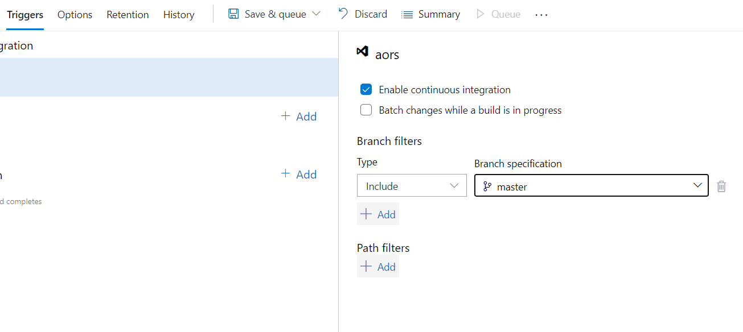

2) There will be test projects which will create and maintained in the solution along the Web and API. The trigger should build all the 3 projects - Web, API and test.

- Select a template like Asp.net core and then click Apply.
- Provide the directory to the project, along with any test projects.
Type Web/*.csproj Project to restore and build.
Type API/*.csproj Project(s) to restore and build
Type Tests/*.csproj Project(s) to test.

Steps to follow:
- task: DotNetCoreCLI@2
displayName: 'dotnet build test'
inputs:

Path to projects:
Web/*.csproj
API/*.csproj
arguments: ‘Tests/*.csproj '
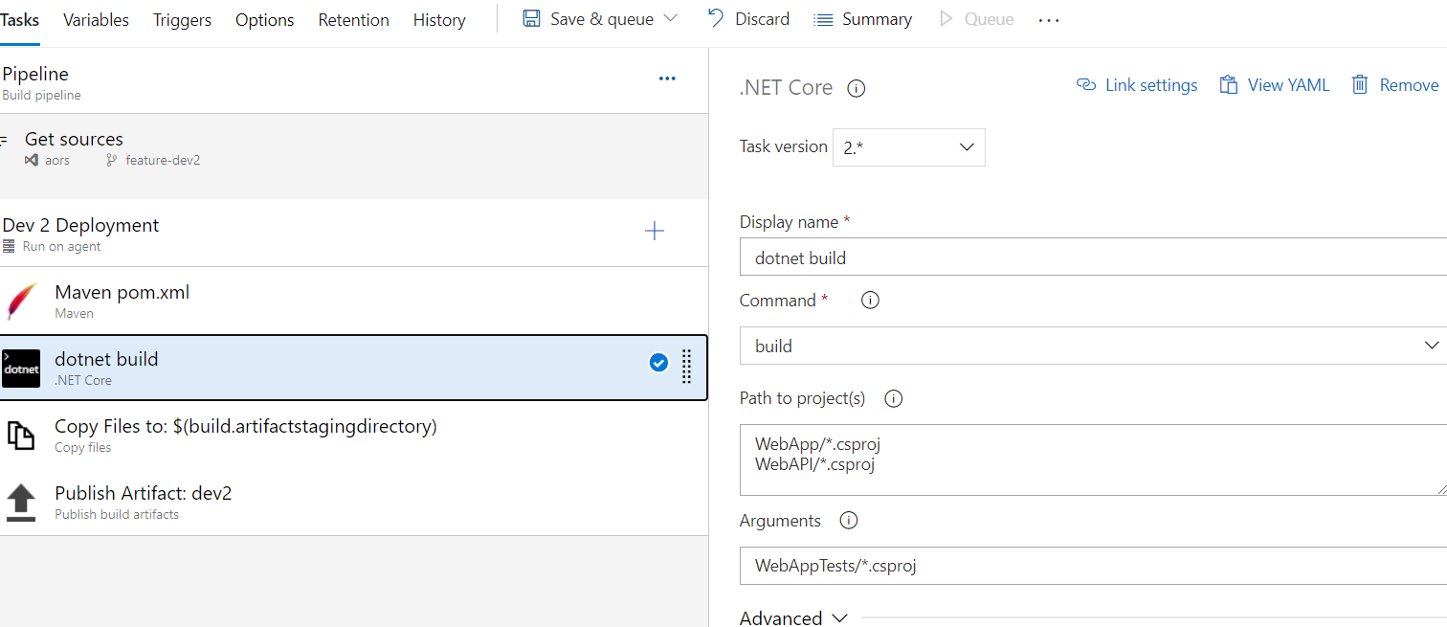

- Go to Triggers settings.

- Click Enable continuous integration.

- In Branch Filters,
- Click Add
- Add the master branch.

- In Path filters,
- Specify the paths for file changes,
- Include /App /API and /Tests.
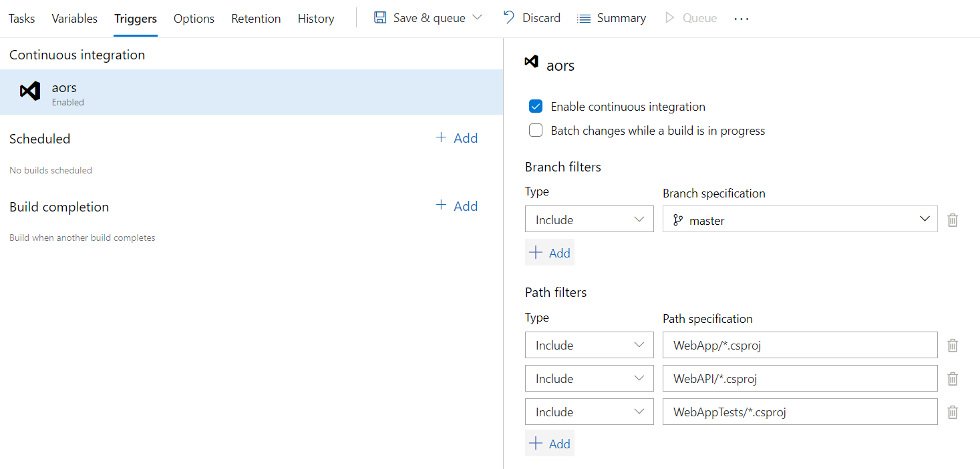
- Click Save & queue and then Save & queue.
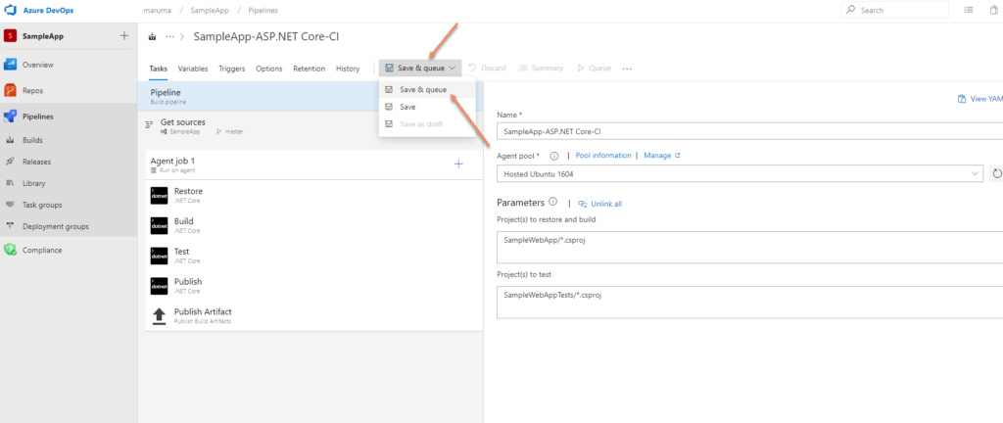

- First build is created.

The build should not be successful if any test fails.

For the condition - if the test cases fails
- Add the flag - failTaskOnFailedTests: true
steps:
- task: TestResults
displayName: ' Test Results **/TEST-*.xml'
inputs:
failTaskOnFailedTests: true

3) The deployment of code and artifacts should be automated to Dev environment.

Steps:

- In control option –
- Enabled – Only when all previous tasks have succeeded.

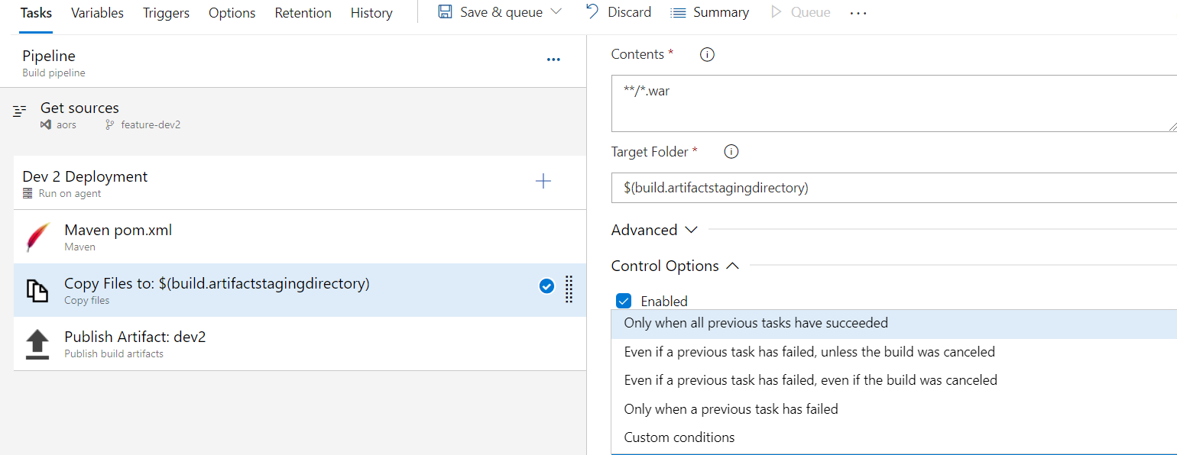

Automated Deploying Azure app services DEV

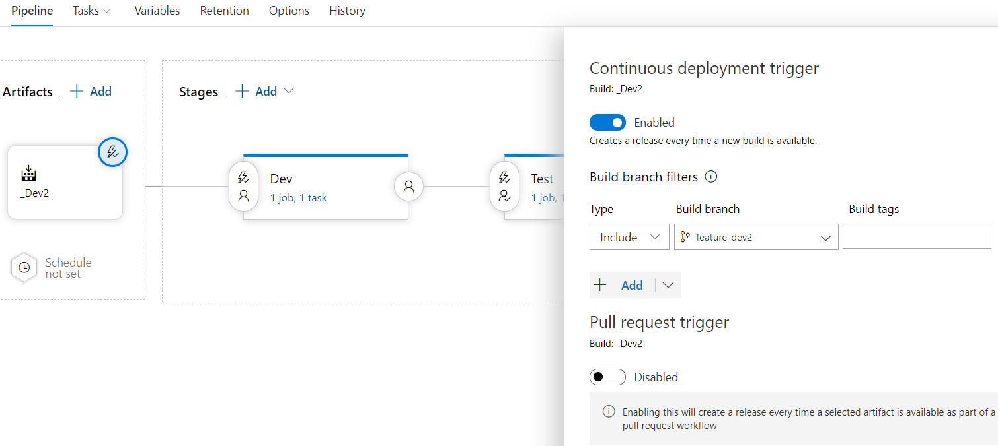

4) Upon successful deployment to the Dev environment, deployment should be easily promoted to QA and Prod through automated process.

For QA deployment.

- Need to set up an azure SPN to deploy into QA environment
- Need select azure subscription webapplinux/winows Webappname

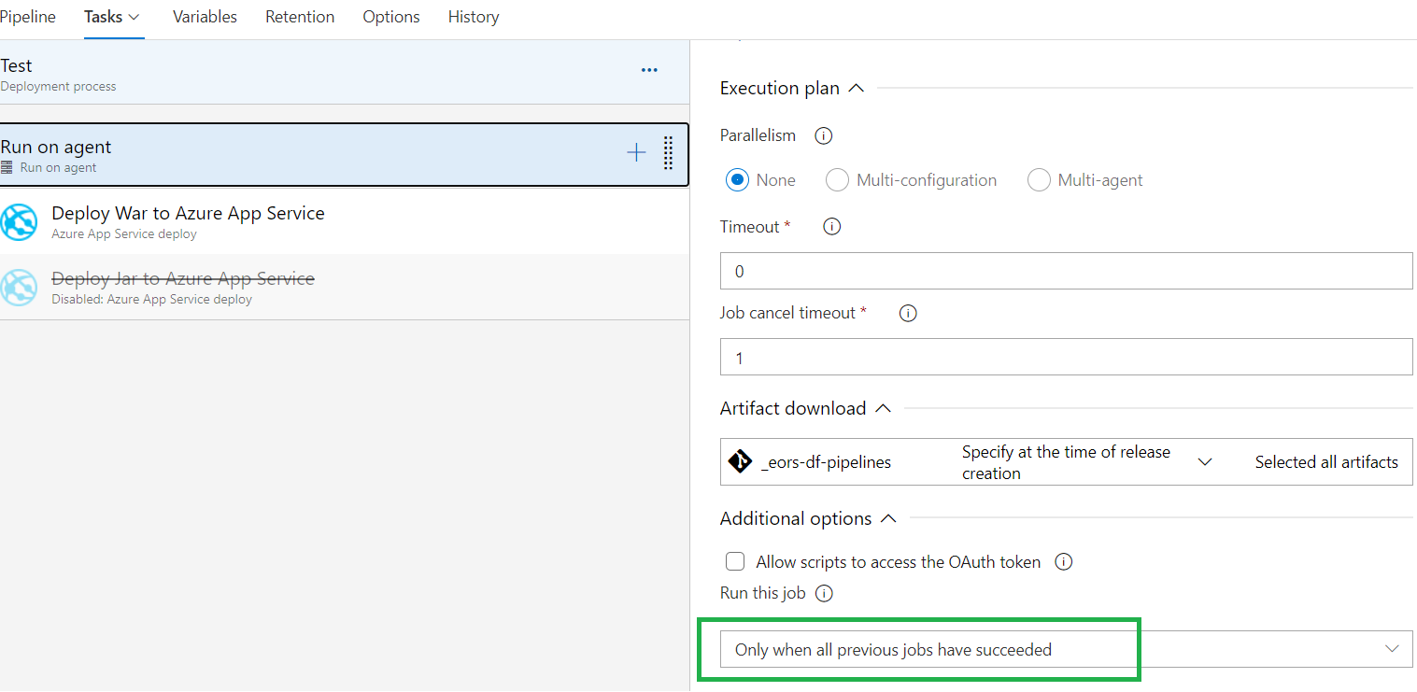

For production deployment.

- Need to set up an azure SPN to deploy into production environment
- Need select azure subscription webapplinux/winows Webappname

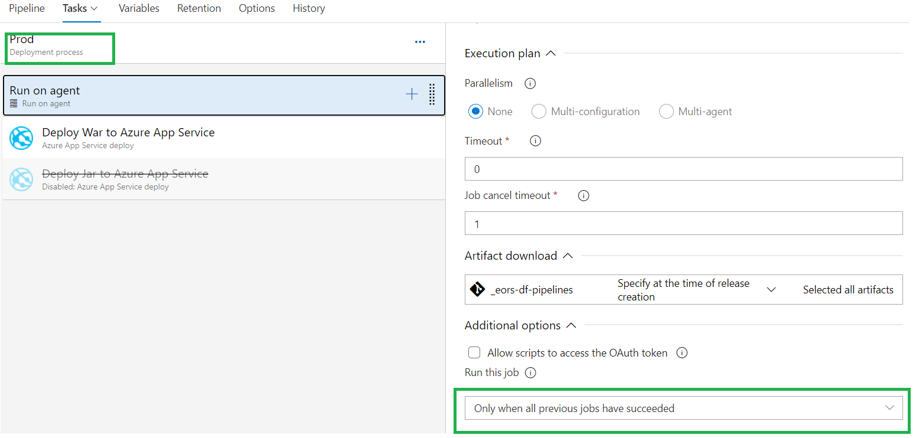

Stages

Dev -> QA -> Production

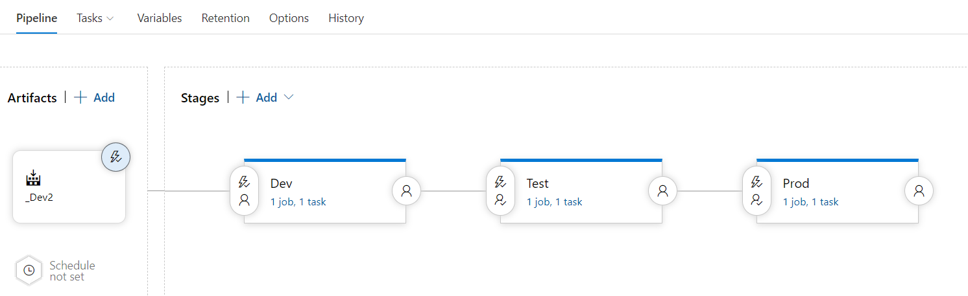

5) The deployments to QA and Prod should be enabled with Approvals from approvers only.

Steps:

- Go to Pre-deployment approvals
- Enable it
- Approvers - List the user and group names

