Note- Task is done using Terraform

Q2 - SCENARIO
Macro Life, a healthcare company has recently setup the entire Network and Infrastructure on Azure.
The infrastructure has different components such as Virtual N/W, Subnets, NIC, IPs, NSG etc.
The IT team currently has developed PowerShell scripts to deploy each component where all the properties of each resource is set using PowerShell commands.
The business has realized that the PowerShell scripts are growing over period of time and difficult to handover when new admin onboards in the IT.
The IT team has now decided to move to ARM based deployment of all resources to Azure.
All the passwords are stored in a Azure Service known as key Vault. The deployments needs to be automated using Azure DevOps using IaC(Infrastructure as Code).

1) What are different artifacts you need to create - name of the artifacts and its purpose
2) List the tools you will to create and store the ARM templates.
3) Explain the process and steps to create automated deployment pipeline.
4) Create a sample ARM template you will use to deploy a Windows VM of any size
5) Explain how will you access the password stored in Key Vault and use it as Admin Password in the VM ARM template.

Answers:-

1) What are different artifacts you need to create - name of the artifacts and its purpose

ARM template and parameter to the template are stored by Link Artifacts.

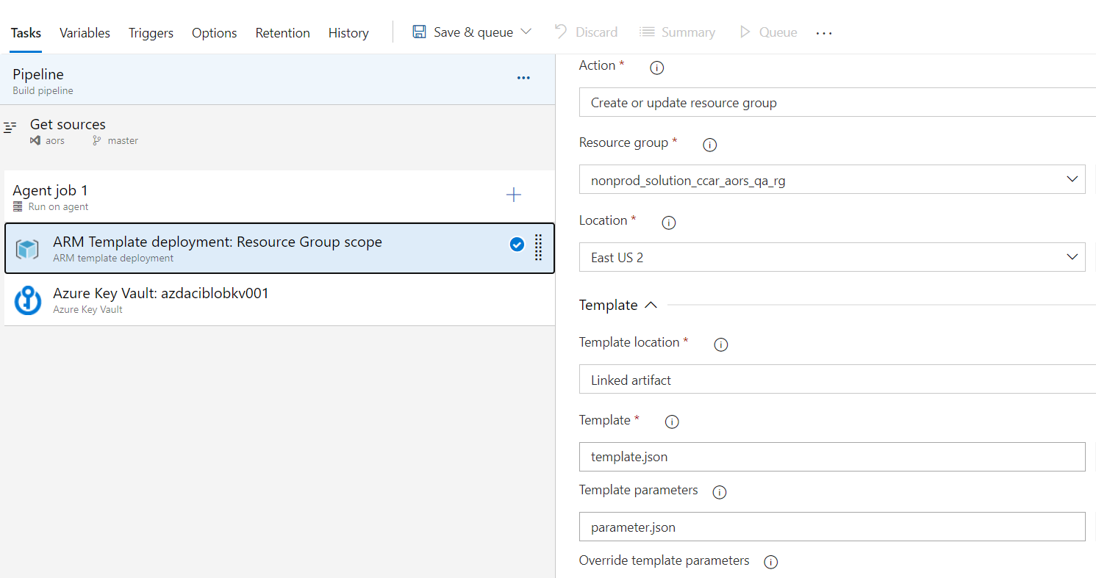

2) List the tools you will to create and store the Terraform configuration files.

- Visual studio code
- Azure cli installed in visual studio code using extensions.
- Azure storage account for storing terraform state files.
- Azure resource group
- Azure key vault

3) Explain the process and steps to create automated deployment pipeline.

- Create repository in Azure DevOps.
- Create a new branch in the repository.
- Add main.tf, terraform.tfvars, variable.tf, output.tf and backend.tf in the Azure Repository
- Create SPN to connect to Azure environment.
- Select a step in Azure pipeline to deploy the terraform configuration file.
- Create an Azure Key vault to store the password.
- Run the Azure pipeline to Deploy a Windows VM azure.

4) Create a sample Terraform configuration file you will use to deploy a Windows VM of any size

Main.tf

# this data source to access information about an existing Resource Group.
data "azurerm_resource_group" "main_rg" {
name = var.resource_group_name
}

# this data source to access information about an existing VNet Resource Group.
data "azurerm_resource_group" "vnetshared_rg" {
name = var.vnet_resource_group_name
}

# this data source to access information about an existing virtual network.
data "azurerm_virtual_network" "vnet" {
name = var.vnet_name
resource_group_name = data.azurerm_resource_group.vnetshared_rg.name
}

# this data source to access information about an existing subnet.
data "azurerm_subnet" "subnet" {
name = var.subnet_name
resource_group_name = data.azurerm_resource_group.vnetshared_rg.name
virtual_network_name = data.azurerm_virtual_network.vnet.name
}

# create a network interface for the VM
resource "azurerm_network_interface" "nic" {
name = var.nic_name
count = var.vm_count
location = var.location
resource_group_name = data.azurerm_resource_group.main_rg.name

ip_configuration {
name = "internal"
subnet_id = data.azurerm_subnet.subnet.id
private_ip_address_allocation = "dynamic"
}
}

# create a windows virtual machine
resource "azurerm_virtual_machine" "vm" {
count = var.vm_count
name = var.vm_name
location = var.location
resource_group_name = data.azurerm_resource_group.main_rg.name
network_interface_ids = [element(azurerm_network_interface.nic.*.id,count.index)]
vm_size = var.size

# this image from shared repository will be used for vm deployment
storage_image_reference {
id = var.image_reference_id
}

storage_os_disk {
name = var.vm_name
caching = "ReadWrite"
create_option = "FromImage"
managed_disk_type = var.storage_account_type
}
os_profile {
computer_name = var.vm_name
admin_username = var.administrator_login
admin_password = var.administrator_password
}
os_profile_windows_config {
provision_vm_agent = true
}
boot_diagnostics {
enabled = true
storage_uri = var.boot_diagnostics
}

# tags for the virtual machine
tags = {
Environment = var.environment
}
}

Variable.tf

variable "resource_group_name" {
description = "resource group name"
}
variable "vnet_name" {
description = "name of the azure vnet"
}
variable "nic_name" {
description = "name of the nic"
}

variable "vm_name" {
description = "name of the azure vm"
}
variable "subnet_name" {
description = "name of the azure subnet"
}
variable "ip_address" {
description = "Private ip address allocation"
default = "Dynamic"
}
variable "vnet_resource_group_name" {
description = "name of the network resource group"
}
variable "location" {
description = "location of the virtual network"
}
variable "appname" {
description = "Name of the application (the VM name will be captured based on the apllication)"
}
variable "sub_component_name" {
description = "Name of the sub-component of an application"
}
variable "administrator_login" {
description = "Name of the vm administrator login"
default = "admin"
}
variable "administrator_password" {
description = "Password for the vm administrator login"
default = "Password@1234"
}
variable "size" {
description = "vm size specification"
default = "Standard_D2_v2"
}
variable "boot_diagnostics" {
description = "boot diagnostics trorage for VMs"
}
variable "vm_count" {
description = "Number of VMs deployment"
default = 1
}
variable "image_reference_id" {
description = "storage_image_reference"
}
variable "storage_account_type" {
description = "the disk geo replication Locations type"
default = "Standard_LRS"
}
variable "environment" {
description = ""
default ="devtest"
}

Output.tf

output "vm_name" {
value = azurerm_virtual_machine.vm.*.name
}

Terraform.tfvars

resource_group_name = "rg1"
vnet_name = "vnet1"
subnet_name = "subnet1"
ip_address = "dynamic"
vnet_resource_group_name = "nonprod_shared_network_rg"
location = "East US2"
size = "Standard_B2s"
boot_diagnostics = "https://ushiprodvmosdiagnostics.blob.core.windows.net/"
vm_count = 2
image_reference_id = "/subscriptions/***********************/resourceGroups/*************/providers/Microsoft.Compute/galleries/Lowes_Golden_image_gallery/images/Windows_Server_2016_Datacenter/versions/01.10.2019"
storage_account_type = "Standard_LRS"
environment = "dev"
dept = "department"
appname = "bincytest"
administrator_login = "lowesadmin"
administrator_password = "Password@1234"
domain_user = "**********"
domain_password = "**********"
OUpath = "OU=MSB 2016,OU=DTQ,OU=Azure,OU=Windows Servers,OU=Lowes Compliance,DC=lowes,DC=com"
vm_name = "test1"
nic_name = "nic1"

Backend.tf

terraform {

backend "azurerm" {
resource_group_name = "rg1"
storage_account_name = "statefile"
container_name = "container1"
key = "***************"
access_key = "*******************”
}
}

5) Explain how will you access the password stored in Key Vault and use it as Admin Password in the VM Terraform configuration file.

data "azurerm_key_vault_secret" "secret" {
name = "admin"
vault_uri = "https://KeyVault.vault.azure.net/"
}

resource “azurerm_ Virtual_machine” “vm” {

os_profile {
computer_name = "vm1"
admin_username = "admin"
admin_password = "${data.azurerm_key_vault_secret.secret.value}"
}

}

