**HONOR CODE**

I, **Navin Kumar Singh,** with roll no. **21f1003002** declare that, I will not use any ideas, writings, code or work that is not my own or my group’s with the intention of claiming it my or my group’s work. And all the work that I will submit as part of this project I will not share that outside my group with anybody directly or indirectly or upload that on any public forums on the internet.

I acknowledge that failing in any of the above constitutes as plagiarism and in that case the institute can take appropriate disciplinary action.

**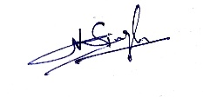  
Sign:**

**Date:** 17-02-2023