PRISON MANAGEMENT SYSTEM
Software Requirements Specification
Version 0.0.2
PAUL MONGOLA
Software Engineer

Document Approval
The following Software Requirements Specification has been accepted and approved by the following:
Title | Date

Table of Contents
Contents
Software Requirements Specification Template 1
Template Usage: 1
Acknowledgements: 1
Document Approval 2
Title Date 2
Table of Contents 3
1. Introduction 1
1.1 Purpose 1
1.2 Scope 1
1.3 Definitions, Acronyms, and Abbreviations 1
1.4 Overview 1
2. General Description 2
2.1 Product Functions 2
2.2 User Characteristics/Roles 2
2.3 External Interface Requirements 2
2.4 Functional Requirements 2
2.4.1 <Functional Requirement or Feature #1> 2
2.4.2 <Functional Requirement or Feature #2> 2
2.5 Use Cases 2
2.5.1 Use Case #1 2
2.5.2 Use Case #2 2
2.6 Non-Functional Requirements 3
3. System Architecture 3
4. General Constraints 3
4.3 References 4

Introduction

1.1 Purpose
This Software Requirements Specification (SRS) describes the requirements for the Prison Management System, a secure centralized back-end (RESTful API) developed to digitize the management of prison-related data. It is intended for use by the development team, project supervisor, and evaluators to understand what the system is required to do, and to serve as the basis for design, implementation, and testing.

1.2 Scope
The software product to be produced is the Prison Management System (PMS) Back-end API.
The system will manage inmate records (enrollment, personal details, and cell allocation), disciplinary incidents, case records, visitor records, sentence records, rehabilitation programs, inmate health records, inter-facility transfers, and daily routine checks. It will also provide user account management with role-based access control, automatic audit logging of all actions, and notifications for key events.
The system will not provide a user interface directly — it is a back-end API consumed by separate web and mobile client applications. It will also not handle court proceedings, legal case adjudication, external judicial system integration, or financial/payment processing. In addiction it will not handle the prison staff Management for instance assigning duties to each other.
The goal is to replace manual, fragmented record-keeping of inmates data with a single, secure, centralized source of truth for prison data — reducing duplication and inconsistency while enforcing accountability through role-based access control and audit logging.

2. Definitions, Acronyms, and Abbreviations
Abbreviations | Meaning
API | Application Programming Interface
REST | Representational State Transfer
JWT | JSON Web Token
RBAC | Role Based Access Control
PMS | Prison Management System
SRS | System Requirements Specification
Inmate | A person held custody in a correctional Facilities

1.4 Overview
The remainder of this SRS is organized as follows: Section 2 provides a general description of the system, its users, and its functional and non-functional requirements. Section 3 describes the system architecture. Section 4 describes general constraints affecting the design and implementation of the system, followed by references.

2.General Description
This section describes the general factors affecting the Prison Management System and its requirements, providing context before the specific requirements are detailed.

2.1 Product Functions
The Prison Management System back-end provides the following core functions: user account management with role-based access control; inmate management, imate health management, inter-facility transfer and daily routine checks.

2.2 User Characteristics/Roles
The system is intended for use by prison staff only; there is no direct inmate- or public-facing interface.
Anticipated user roles include the Super Admin (Officer), who has full administrative control over all system modules, including user accounts, roles, records, permissions, and audit logs; the Records Officer, who manages inmate enrollment, records, and cell allocations; the Disciplinary Officer, who manages incidents; the Visits Officer, who manages visitor records; the Rehabilitation Officer, who manages rehabilitation activities; and the Medical Officer, who manages inmate health records. All users are assumed to have basic computer literacy.

2.3 External Interface Requirements
The system exposes a RESTful API over HTTPS, accepting and returning data in JSON format, consumption by mobile and web-applications.

2.4 Functional Requirements

2.1.1 Module 1: User Account Management
FR-001: Create User Accounts
Description:
The system shall allow the Super Admin to create new user accounts for prison staff by entering the required information, including full name, email, username, and assigned role.
The system shall validate the submitted information, reject duplicate usernames or emails and create the account only when all required information is valid.

Acceptance Criteria: A new account is created with valid credentials and assigned a role.
Priority: High
FR-002: Assign and Modify User Roles and Permission
Description:
The system shall allow the Super Admin (Officer) to assign roles to user accounts and modify their associated permissions according to staff responsibilities.
The system shall validate and save role changes and enforce the updated permissions during subsequent access-control checks.

Acceptance Criteria: Role changes are saved and take effect immediately on next login.
Priority: High
FR-003: Deactivate and Reactivate User Accounts
Description:
The system shall allow the Super Admin (Officer) to deactivate active user accounts and reactivate previously deactivated accounts. Deactivated accounts shall be prevented from establishing new authenticated sessions, and existing sessions shall be invalidated according to the system’s session-management policy.
User Role: Super Admin (Officer)
Acceptance Criteria: Deactivated accounts cannot log in; reactivated accounts regain prior access.
Priority: High
FR-004: Enforce Role-Based Access Control
Description:
The system shall enforce role-based access control (RBAC) by verifying that users have the necessary permissions before allowing access to protected system functions, modules, and resources.
The system shall perform authorisation checks on protected server-side operations, including direct API requests, to prevent users from bypassing access restrictions.

Acceptance Criteria: Unauthorized access attempts are blocked and logged.
Priority: High

2.1.2 Module 2: Inmate Management
FR-005: Register New Inmate
Description:
The system shall allow an authorised Records Officer to register a new inmate by entering the required personal and custodial information, including full name, date of birth, gender, admission date, crime details and sentence details.
The system then shall calculate the sentence period of the inmate from the beginning to the end of their sentence.
The system shall validate the required fields, generate a unique inmate identifier for each successfully registered inmate, and store the information in the inmate’s profile.
User Role: Records Officer
Acceptance Criteria: Inmate profile is created and assigned a unique identifier.
Priority: High
FR-006: Update inmate records
Description:
The system shall allow an authorised Records Officer to retrieve an existing inmate profile and update permitted personal or custodial information when changes occur or if there was an error in recording the details .
The system shall validate the updated information, save valid changes, and preserve an audit trail of changes to relevant records, including the user responsible and the date and time of the update.

Acceptance Criteria: Updates are saved and reflected in the inmate’s profile.
Priority: Medium
FR-007: Allocate inmates to cells
Description:
The system shall allow an authorised Records Officer to assign an inmate to a cell based on the cell’s available capacity,when the inmate is being registered or enrolled into the prison and should follow the and the facility’s approved accommodation rules.
Before confirming the allocation, the system shall verify that the selected cell is suitable for the inmate and has sufficient available capacity. The system shall reject allocations that violate these conditions.

Acceptance Criteria: Inmate is assigned to a cell only if capacity rules are met.
Priority: High
FR-008: Monitor and Enforce Cell Capacity
Description:
The system shall maintain the current occupancy of each registered cell by tracking inmate allocations and transfers. Before completing an allocation or transfer into a cell, the system shall verify that the operation will not cause the cell’s occupancy to exceed its defined capacity.
The system shall reject any operation that would exceed the permitted capacity and ensure that occupancy figures remain consistent with confirmed inmate assignments.

Acceptance Criteria: Allocation is rejected when a cell is at full capacity.
Priority: High
FR-009: Transfer Inmates Between Cells
Description:
The system shall allow an authorised Records Officer to transfer an inmate from their currently assigned cell to another cell within the same facility. Before completing the transfer, the system shall verify that the inmate has a valid current assignment and that the destination cell satisfies the applicable capacity rules. Upon successful transfer, the system shall update the inmate’s current cell assignment, release capacity in the previous cell, and update occupancy in the destination cell.
User Role: Records Officer
Acceptance Criteria: Inmate’s cell record is updated, and prior cell capacity is released.
Priority: Medium

2.1.3 Module 3: Discipline and Incident Management
FR-010: Record Disciplinary Incidents
Description:
The system shall allow an authorised Disciplinary Officer to record a disciplinary incident involving one or more inmates by entering the incident date and time, incident description, location, category of misconduct, and the inmates involved. The system shall validate the required information, associate the incident with the relevant inmate profiles, and store the incident record for subsequent review and resolution.
The system shall assign a unique identifier to each incident record to facilitate retrieval and tracking.

Acceptance Criteria: Incident is recorded with date, description, and involved parties.
Priority: High
FR-011: Record Incident Outcomes and Resolutions
Description: The system shall allow users to record the outcome of a recorded incident.

Acceptance Criteria: Incident status updates to “resolved” with outcome details attached.
Priority: Medium
FR-012: View Inmate Disciplinary History
Description:
The system shall allow authorised Disciplinary Officers and Records Officers to retrieve and view an inmate’s disciplinary history from the inmate’s profile. The history shall display the disciplinary incidents associated with the inmate, including incident date, incident description, status, recorded outcome, and any disciplinary action imposed, where applicable. The system shall restrict access to this information to users with the appropriate permissions.

Acceptance Criteria: All past incidents linked to the inmate are retrievable.
Priority: Medium

2.1.5Module 4: Visit Management
FR-016: Record Prison Visits
Description:
The system shall allow an authorised Visitor Officer to record a visit by capturing the visitor’s full name, identification details where applicable, the name or unique identifier of the inmate being visited, and the date of the visit.
The system shall validate the required information, verify that the selected inmate exists in the system, and save the visit record with a unique identifier for future reference.

Acceptance Criteria: A visit record is successfully created with the visitor’s details, the correct inmate, and the visit date.
Priority: High
FR-017: Record Visit Start Time, End Time, and Duration
Description:
The system shall allow an authorised Visitor Officer to record the time a visitor begins and ends a visit with an inmate.
The system shall calculate the total duration of the visit using the recorded start and end times. The system shall validate that the end time is not earlier than the start time and associate the duration with the corresponding visit record.

Acceptance Criteria: Visit date/time is captured accurately.
Priority: Medium
FR-018: View Inmate Visit History
Description:
The system shall allow authorised Visitor Officers and Records Officers to view the visit history associated with a particular inmate.
The system shall display the visitor’s name, visit date, start time, end time, and visit duration where available. The system shall ensure that the displayed records are associated with the correct inmate and restrict access to authorised users.

Acceptance Criteria: All past visits linked to the inmate are retrievable.
Priority: Medium

2.1.5 Module 5: Rehabilitation and Activities Management
FR-019: Create and Manage Rehabilitation Programs
Description:
The system shall allow an authorised Rehabilitation Officer to create a rehabilitation program by entering its name, instructor, and any available description and schedule.

Acceptance Criteria: A program is saved with its required details, active status, and unique identifier. Authorised staff can retrieve and update the program details.
Priority: High
FR-020: Enroll an Inmate in a Rehabilitation Program
Description:
The system shall allow an authorised Rehabilitation Officer to enroll an inmate in a program by providing the inmate, program, and enrollment date.
The system shall verify that the inmate and program exist, the program is active, and the inmate does not already have an enrolled or suspended enrollment in that same program. If valid, the system shall save the enrollment with an enrolled status and a unique identifier.

Acceptance Criteria: The enrollment is saved with the correct inmate, program, enrollment date, enrolled status, and unique identifier. An enrollment cannot be created for an inactive program or duplicated while the inmate is already enrolled or suspended in that program.
Priority: High
FR-022: View and Search Rehabilitation Enrollments
Description:
The system shall allow authorised Rehabilitation Officers, Records Officers, and Super Admins to view and search enrollment record.Users shall be able to filter enrollments by inmate, inmate name, program, program name enrollement Each result shall identify the inmate and program, and show the enrollment date and status.

Acceptance Criteria: Authorised users can retrieve enrollment records and use the available filters to find a particular inmate’s or program’s enrollment.
Priority: Medium
FR-023: Record Attendance at a Rehabilitation Session
Description:
The system shall allow an authorised Rehabilitation Officer to record whether an enrolled inmate was present or absent at a program session. The record shall include the inmate, program, session date, attendance status, and optional remarks.
The system shall verify that the inmate has an active enrollment in the program, that the session date is not before the enrollment date, and that attendance has not already been recorded for that enrollment and date. Attendance may also be recorded for multiple inmates in one request, provided each inmate appears only once in that request.

Acceptance Criteria: Attendance is saved against the correct enrollment and session date with a present or absent status. Duplicate records for the same enrollment and date are rejected.
Priority: High
FR-024: View and Search Rehabilitation Attendance
Description:
The system shall allow authorised Rehabilitation Officers, Records Officers, and Super Admins to view and search attendance records.
Users shall be able to filter records by inmate, program name, attendance status, and a session date range. Results shall show the session date, attendance result, remarks where provided, and the user who recorded the attendance. Date range limits shall include records on the selected start and end dates.

Acceptance Criteria: Authorised users can retrieve attendance records and narrow results using the available filters.
Priority: Medium

2.1.6 Module 6: Inmate Health Management
FR-024: Record Inmate Medical Visit
Description:
The system shall allow an authorised Medical Officer to record an inmate’s medical visit by entering the inmate’s sickness, medication provided and medical recommendations, including a follow up date where necessary.
The system shall save each medical visit as a separate record linked to the inmate’s profile.

Acceptance Criteria: The medical visit is successfully recorded with the relevant medical details and are linked to the appropriate inmate.
FR-025: View Inmate Medical History
Description:
The system shall allow an authorised Medical Officer to search for and view a particular inmate’s medical records. The system shall display the inmate’s previous medical visits, including the dates of visits, recorded sicknesses, diagnoses, medications provided, and medical recommendations.

Acceptance Criteria: The Medical Officer can retrieve the selected inmate’s medical history and view the details of previously recorded visits.
Priority: Medium

2.1.7 Module 7: Notifications
FR-026: Notify Staff of Upcoming Sentence Completion
Description:
The system shall automatically notify authorised prison staff when an inmate's sentence is approaching its completion date, based on a predefined notification period before the expected release date.

Acceptance Criteria: Notification is sent within a defined threshold (e.g., 7 days before release).
Priority: Medium

FR-027: Inmate cell reallocation
Description:
The System shall notify the authorized staff on any reallocation of an inmate to another cell.
Acceptance Criteria: The notification is received and is clear enough

FR-028: Notify Staff of New Inmate Admission
Description:
The system shall notify authorized staff when a new inmate is admitted and assigned to a cell.

Acceptance Criteria:
A notification is sent after the inmate record and initial cell allocation are successfully created. The notification identifies the inmate and assigned cell. No notification is sent if the admission or cell allocation fails.
FR-029: Notify Staff of a Reported Incident

Description:
The system shall notify authorized staff when an incident involving one or more inmates is recorded.

Acceptance Criteria:
A notification is sent after the incident is successfully recorded.
The notification identifies the incident and its involved inmates.
Only staff authorized to access incident information can view the notification.

FR-032: Notify Medical Staff of a Recorded Medical Visit
Description:
The system shall notify authorized medical staff when a medical visit for an inmate is recorded.

Acceptance Criteria:
A notification is sent after the medical visit is successfully recorded.
The notification identifies the inmate and visit date.
The notification does not expose diagnosis, sickness, medication, or other sensitive medical details to unauthorized users

FR-033: Notify Administrators of User Access Changes
Description:
The system shall notify authorized administrators when a user account is created, deactivated, reactivated, or has its role or permissions changed.

Acceptance Criteria:
A notification is sent after the account change succeeds.
The notification identifies the affected user and the type of access change.
Only authorized administrators can view the notification.
Priority: Medium

2.1.8 Module 8: Inmate Transfer Management
FR-034: Create Inmate Transfer Request

Description:
The system shall allow an authorised Records Officer to initiate an inmate transfer request by selecting the inmate, specifying the destination prison facility, and providing the reason for the transfer. The system shall validate the required information and save the request with a unique identifier and a status of "Pending" for review by the Super Admin.

Acceptance Criteria: Transfer request is created and linked to the correct inmate, with status set to "pending."
Priority: High
FR-035: Review Inmate Transfer Requests

Description: The system shall allow the Super Admin to approve or reject a pending transfer request.

Acceptance Criteria: Transfer request status updates to "approved" or "rejected," and the requesting officer is notified.
Priority: High

2.5 Use Cases

2.1.4 Use Case #1

2.1.5 Use Case #2
…

2.6 Non-Functional Requirements

2.6.1 Performance
- The system shall display prisoner records and search results within 3 seconds under normal operating conditions.
- The system shall support at least 100 concurrent users without significant performance degradation.

2.6.2 Security
- The system shall encrypt sensitive prisoner and staff information both when stored and when transmitted.
- The system shall restrict access to information according to the user`s role, such as administrator, officer, medical staff and management.
- The system shall lock a user account after repeated unsuccessful login attempts.

2.6.3 Availability and Reliability
- The system shall be available to authorized users during prison operating hours, excluding scheduled maintenance.
- The system shall recover from a system failure within 30 minutes.

2.6.4 Usability
- The system's interface shall be simple and easy for prison staff to use with minimal training.
- The system shall be accessible using commonly supported desktop web browsers.

2.6.5 Scalability
- The system shall be able to accommodate an increase in the number of prisoners, staff, visits and records without major changes to the system.

2.6.6 Maintainability
- The system`s source code shall follow a defined coding standard to make it easier to maintain and modify.
- The system shall log errors and system activities in logs to support troubleshooting.

2.6.7 Compliance and Legal
- The system shall comply with applicable laws and regulations concerning the protection and handling of person and prisoner information.

2.6.8 Data Integrity
- The system shall prevent loss or unauthorized alteration of prisoner records during normal operation and planned maintenance.
- The system shall validate information entered by users to prevent incorrect, incomplete or inconsistent prisoner records.
- The system shall prevent duplicate prisoner identification numbers.
- The system shall maintain accurate relationships between prisoner records and related information such as visits, cell assignments and transfers.
- The system shall maintain the date and time when important records are created and modified.
- The system shall ensure that required prisoner information cannot be saved when mandatory fields are empty.

3. System Architecture
The current system is a backend application built with Spring Boot. It provides a REST API for managing prison records, including user accounts, inmates, cell allocations, cases, sentences, incidents, visitors, visits, and rehabilitation programs. The system currently has no user interface.
The API receives requests, checks the user’s identity and permissions, applies business rules, and returns responses. Users sign in to obtain a JWT access token and include it when making requests to protected operations.
The application stores records in a PostgreSQL database. It uses repositories to access the data, and Flyway applies versioned changes to the database structure. When configured, the application can send password recovery messages through an SMTP email service.
For local deployment, Docker Compose runs the API and PostgreSQL as separate containers. The API communicates with PostgreSQL over Docker’s private network. The email service is external and is used only when email delivery is configured.

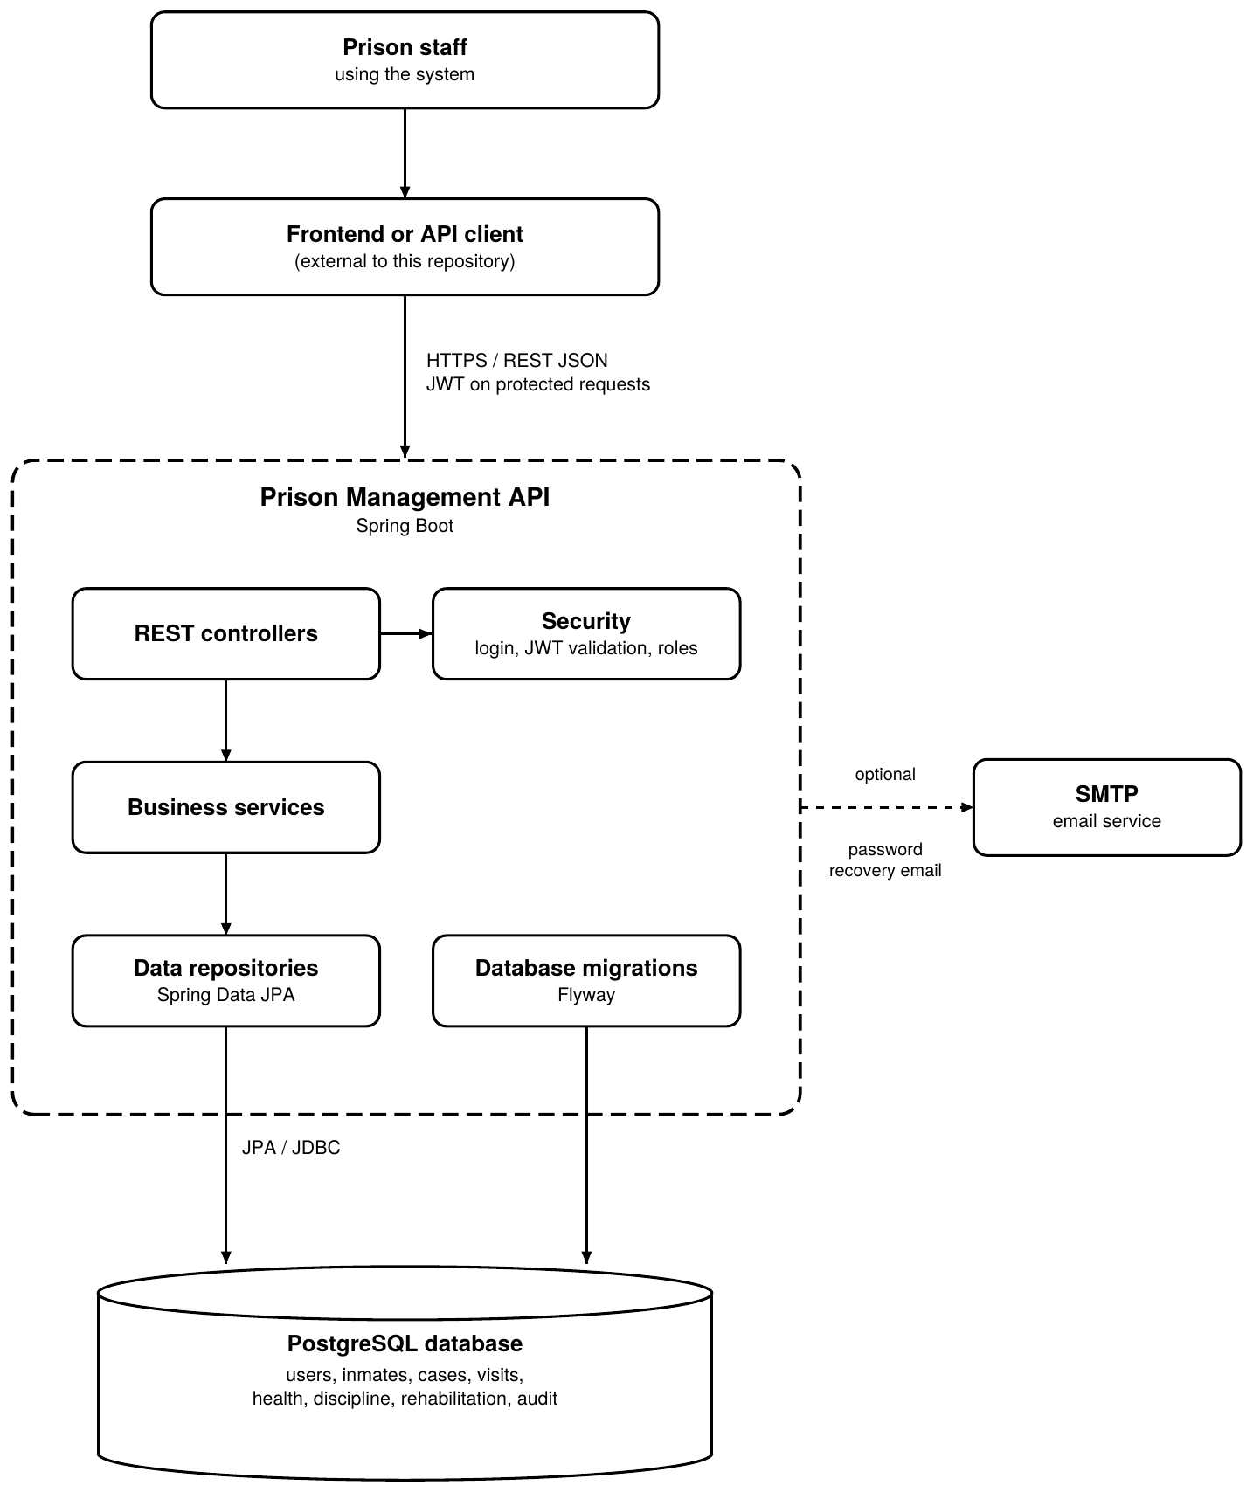

4. General Constraints
- Authorized prison staff will have user accounts.
- Users will have basic computer skills.
- The prison will provide the required computers and network infrastructure.
- Regular data backups will be performed.
- Only authorized personnel will have access to the system.

4.3 References
Functional Requirement document Group aa2, By Paul Mongola
Non-Functional Requirements document Group aa2, By Shyreen Kampani

