COMP Superscalar

User Guide
Version 1.2



1. COMP Superscalar (COMPSs) 5
2. Developing COMPSs applications 6
2.1. Main application code 6
2.2. Remote methods code 7
2.3. Java annotated interface 7
2.4. Equivalent remote methods 8
3. Running COMPSs applications 10
3.1. Compiling and Packaging the application 10
3.2. Running the application 10
3.3. Logging the execution 11
3.4. Execution results 12
3.5. Exploring the final execution graph 12
3.6. COMPSs monitoring system 12
4. Sample applications 14
4.1. Matrix multiplication 14
4.2. Sparse LU decomposition 14
4.3. BLAST Workflow 15
5. COMPSs Configuration 17
5.1. Grid/Cluster configuration (static resources) 18
5.1.1. Resources 18
5.1.2. Project 19
5.2. Shared Disks configuration 19
5.3. Cloud Provider configuration (dynamic resources) 20
5.3.1. Resources 20
5.3.2. Project 20
5.4. Connectors 21
5.4.1. Amazon EC2 21
5.4.2. rOCCI Connector 22
6. Bindings 24
6.1. C/C++ 24
6.1.1. Programming Model 24
6.1.1.1. Task Selection 24
6.1.1.2. Value and Object return 25
6.1.1.3. Main Program 25
6.1.1.4. Functions file 26
6.1.1.5. Other Source Files 26
6.1.1.6. Class Serialization 27
6.1.1.7. Method – Task 27
6.1.1.8. XML configuration files 29
6.1.2. Application Compilation 30
6.1.3. Application Environment 30
6.1.4. Application Execution 30
6.1.5. Matmul Execution Graph 31
6.2. Python 33
6.2.1. Programming Model 33
6.2.1.1. Task Selection 33
6.2.1.2. Main Program 35
6.2.1.2.1. Future Objects 36
6.2.1.3. Important Notes 37
6.2.2. Application Execution 37
6.2.2.1. Environment 37
6.2.2.2. Command 37
7. Tracing 39
7.1. Trace Command 39
7.2. Application Instrumentation 39
7.3. Trace Visualization 40
7.3.1. Trace Loading 40
7.3.2. Configuration File 41
7.3.3. View Adjustment 42
7.4. Trace Interpretation 44
7.5. Trace Analysis 45
7.5.1. Graphical Analysis 45
7.5.2. Numerical Analysis 47
7.5.3. Other Trace examples 50

COMP Superscalar (COMPSs)
COMP Superscalar (COMPSs) is a programming model which aims to ease the development of applications for distributed infrastructures, such as Clusters, Grids and Clouds. COMP superscalar also features a runtime system that exploits the inherent parallelism of applications at execution time.

For the sake of programming productivity, the COMPSs model has four key characteristics:
- Sequential programming: COMPSs programmers do not need to deal with the typical duties of parallelization and distribution, such as thread creation and synchronization, data distribution, messaging or fault tolerance. Instead, the model is based on sequential programming, which makes it appealing to users that either lack parallel programming expertise or are looking for better programmability.
- Infrastructure unaware: COMPSs offers a model that abstracts the application from the underlying distributed infrastructure. Hence, COMPSs programs do not include any detail that could tie them to a particular platform, like deployment or resource management. This makes applications portable between infrastructures with diverse characteristics.
- Standard programming languages: COMPSs is based on the popular programming language Java, but also offers language bindings for Python and C/C++ applications. This facilitates the learning of the model, since programmers can reuse most of their previous knowledge.
- No APIs: In the case of COMPSs applications in Java, the model does not require to use any special API call, pragma or construct in the application; everything is pure standard Java syntax and libraries. With regard the Python and C/C++ bindings, a small set of API calls should be used on the COMPSs applications.

Developing COMPSs applications
In this section the steps to develop a COMPSs application will be illustrated; the sequential Simple application will be used to explain an application porting to COMPSs. The user is required to select a set of methods, invoked in a sequential application, to be run as remote tasks on the available resources.
A COMPSs application is composed of three parts:
- Main application code: the code that is executed sequentially and contains the calls to the user-selected methods that will be executed on the Cloud.
- Remote methods code: the implementation of the remote tasks.
- Java annotated interface: It declares the selected methods to be run as remote tasks and metadata used to schedule the tasks.
The main application code (sequential) will have the name of the application, always starting with capital letter, in this case will be Simple.java. The Java annotated interface will be named as application name+ Itf.java in this case will be SimpleItf.java. And the code that implements the remote tasks will be called as application name + Impl.java, in this case will be SimpleImpl.java.
All code examples are in the /home/user/workspace/ folder of the development environment.

Main application code
In COMPSs the application is kept completely unchanged, i.e. no API calls need to be included in the main application code in order to run the selected tasks on the nodes.
The COMPSs runtime is in charge of replacing the invocations to the user-selected methods with the creation of remote tasks also taking care of the access to files from the main application code.
Let’s consider the Simple application example that takes an integer as input parameter and increases it by one unit.
The main application code of Simple app (Simple.java) will be executed in a sequential way except the increment() method. COMPSs, as mentioned above, will replace at execution time the call to this method generating a remote task on the remote node.

package simple;

import java.io.FileInputStream;
import java.io.FileOutputStream;
import java.io.IOException;

import simple.SimpleImpl;

public class Simple {

public static void main(String[] args) {
String counterName = "counter";
int initialValue = args[0];

/*----------------------------------------------------------
Creation of the file which will contain the counter variable
----------------------------------------------------------*/
try {
FileOutputStream fos = new FileOutputStream(counterName);
fos.write(initialValue);
System.out.println("Initial counter value is " + initialValue);
fos.close();
}catch(IOException ioe) {
ioe.printStackTrace();
}

/*------------------------------------------------
Execution of the program
------------------------------------------------*/
SimpleImpl.increment(counterName);

/*------------------------------------------------
Reading from an object stored in a File
------------------------------------------------*/
try {
FileInputStream fis = new FileInputStream(counterName);
System.out.println("Final counter value is " + fis.read());
fis.close();
}catch(IOException ioe) {
ioe.printStackTrace();
}
}
}

Remote methods code
The following code is the implementation of the remote method of the Simple application (SimpleImpl.java) that will be executed remotely by COMPSs.

package simple;

import java.io.FileInputStream;
import java.io.FileOutputStream;
import java.io.IOException;
import java.io.FileNotFoundException;

public class SimpleImpl {
public static void increment(String counterFile) {
try{
FileInputStream fis = new FileInputStream(counterFile);
int count = fis.read();
fis.close();

FileOutputStream fos = new FileOutputStream(counterFile);
fos.write(++count);
fos.close();
}catch(FileNotFoundException fnfe){
fnfe.printStackTrace();
}catch(IOException ioe){
ioe.printStackTrace();
}
}
}

Java annotated interface
The Java interface is used to declare the methods to be executed remotely along with Java annotations that specify the necessary metadata about the tasks. The metadata can be of three different types:
- For each parameter of a method, the data type (currently File type, primitive types and the String type are supported) and its directions (IN, OUT or INOUT).
- The Java class that contains the code of the method.
- The constraints that a given resource must fulfil to execute the method, such as the number of processors or main memory size.
Here follows a complete and detailed explanation of the usage of the metadata:
- Method-level Metadata: for each selected method, the following metadata has to be defined:
- @Method: Mandatory. It specifies the class that implements the method.
- @Constraints: Mandatory. The user can specify the capabilities that a resource must have in order to run a method. The COMPSs runtime will create a VM (in a cloud environment), that fits the specified requirements in order to perform the execution.
- Processor:
  - processorCPUCount: Number of required processors.
- Memory:
  - memoryPhysicalSize: Amount of GB of physical memory needed.
- Parameter-level Metadata (@Parameter): for each parameter and method, the user must define:
- Direction: Direction.IN, Direction.INOUT or Direction.OUT
- Type: COMPSs supports the following types for task parameters:
- Basic types: Type.BOOLEAN, Type.CHAR, Type.BYTE, Type.SHORT, Type.INT, Type.LONG, Type.FLOAT, Type.DOUBLE. They can only have IN direction, since primitive types in Java are always passed by value.
- String: Type.STRING. It can only have IN direction, since Java Strings are immutable.
- File: Type.FILE. It can have any direction (IN, OUT or INOUT). The real Java type associated with a FILE parameter is a String that contains the path to the file. However, if the user specifies a parameter as a FILE, COMPSs will treat it as such.
- Object: Type.Object. It can have any direction (IN, OUT or INOUT).
- Return type: Any object, a basic type or a generic class object.
- Method modifiers: the method has to be STATIC.

The Java annotated interface of the Simple app example (SimpleItf.java) declares the Increment() method that will be executed remotely. The method implementation can be found in simple.SimpleImpl class and needs a single input parameter, a string containing a path to the file counterFile. Besides, in this example there are constraints on the minimum number of processors and minimum memory size needed to run the method.

package simple;

import integratedtoolkit.types.annotations.Constraints;
import integratedtoolkit.types.annotations.Method;
import integratedtoolkit.types.annotations.Parameter;
import integratedtoolkit.types.annotations.Parameter.Direction;
import integratedtoolkit.types.annotations.Parameter.Type;

public interface SimpleItf {

@Constraints(processorCPUCount = 1, memoryPhysicalSize = 0.3f)
@Method(declaringClass = "simple.SimpleImpl")
void increment(
@Parameter(type = Type.FILE, direction = Direction.INOUT)
String file
);

}

Equivalent remote methods
Since version 1.2, the COMPSs programming model allows developers to define sets of equivalent remote methods. Thus, an invocation to any of the methods in the set might produce the execution of another method of the set in the remote resource.
The coding of the application does not change, the remote methods are implemented as regular Java methods and the main code of the application is a sequential code that contains calls to these methods. The only component of the application that changes for defining a set of equivalent methods is the Java annotated interface.
The programming model considers all the equivalent methods of a set as different implementations of the same method. Therefore, the name and parameters of all the implementations must coincide; the only difference is the class where the method is implemented. This is reflected in the attribute declaringClass of the @Method annotation. Instead of stating that the method is implemented in a single class, the programmer can define an array of declaring classes for the method.
The following code depicts an example where the developer sorts an integer array using two different methods: merge sort and quick sort that are respectively hosted in the packagepath.Mergesort and packagepath.Quicksort classes.
@Method(declaringClass = { "packagepath.Mergesort",
"packagepath.Quicksort"})
void sort(
@Parameter(type = Type.OBJECT, direction = Direction.INOUT)
int[] array
);

As independent remote methods, the sets of equivalent methods might have common restrictions to be fulfilled by the resource hosting the execution. Or even, each implementation might have specific constraints. Through the @Constraints annotation, developers can specify the common constraints for a whole set of methods. The following example states that for both sorting algorithms only one core is required to run the method.
@Constraints(processorCoreCount = 1)
@Method(declaringClass = { "packagepath.Mergesort",
"packagepath.Quicksort"})
void sort(
@Parameter(type = Type.OBJECT, direction = Direction.INOUT)
int[] array
);

However, these sorting algorithms have different memory consumption, thus each algorithm might require a specific amount of memory and that should be stated in the implementation constraints. For this purpose, the developer can add a @Multiconstraints annotation containing the specific constraints for each implementation. Since the Mergesort has a higher memory consumption than the quicksort, the following example sets a requirement of 1 core and 2GB of memory for the mergesort implementation and 1 core and 500MB of memory for the quicksort.
@Constraints(processorCoreCount = 1)
@MultiConstraints({
@Constraints(memoryPhysicalSize= (float)2.0),
@Constraints(memoryPhysicalSize= (float)0.5)})
@Method(declaringClass = { "packagepath.Mergesort",
"packagepath.Quicksort"})
void sort(
@Parameter(type = Type.OBJECT, direction = Direction.INOUT)
int[] array
);

Running COMPSs applications

Compiling and Packaging the application
The application can be compiled either using the command line or through the Eclipse IDE tool available on the SDK VM.

user@bsccompss:~$ cd /home/user/workspace/
user@bsccompss:~/workspace$ javac simple/src/simple/*.java
user@bsccompss:~/workspace/simple/src$ jar cf simple.jar simple

Once the application is compiled and packaged in a Jar archive it have to be bundled in a tar.gz package; this package will be automatically deployed by COMPSs in a cloud environment, while in the case of a static pool of physical nodes the jar has to be manually pre-deployed.
In this example the application package is stored under /home/user/workspace/APPNAME/package

user@bsccompss:~/workspace/simple/src$ tar czvf Simple.tar.gz simple.jar
user@bsccompss:~/workspace/simple/src$ mv Simple.tar.gz ~/workspace/simple/package/

In case of having to supply external binaries or libraries to the application, as is the case of Blast (see Section 4) they have to be copied into a directory named “binary”, and “lib” respectively and packaged in the tar.gz package as shown below:

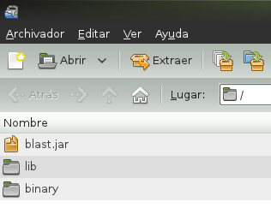

Figure 1 - An example package

Running the application
To run the application on the SDK VM, the path of the application jar must be added to CLASSPATH system variable:
user@bsccompss:~$ cp ~/workspace/simple/package/Simple.tar.gz /home/user/
user@bsccompss:~$ tar xzf Simple.tar.gz
user@bsccompss:~$ export CLASSPATH=$CLASSPATH:/home/user/simple.jar

Once the execution environment is ready, the application can be launched through the following command:

user@bsccompss:~$ runcompss simple.Simple <initial_number>

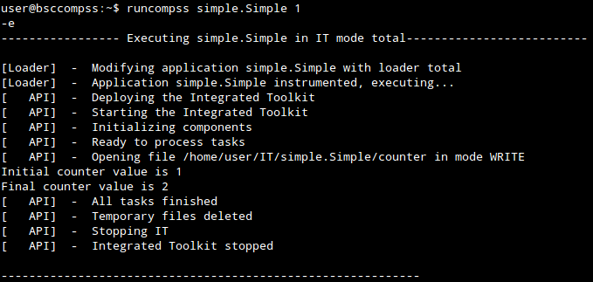

Figure 2 - Execution of a COMPSs application

Logging the execution
The it.log file, that can be found generally in $HOME/it.log (/home/user/it.log, in case of SDK VM). It shows information on the execution of the application including file transfers and job submission details.
user@bsccompss:~$ tail -f it.log

On the other hand, the resources.log file, that can be found in $HOME/resources.log. It shows information about the available resources such as: number of processors of each resource (slots), information about running or pending tasks in the resource queue as depicted in the following picture:

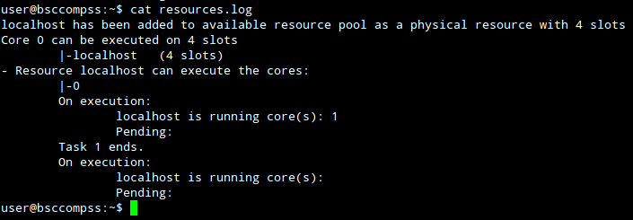
Figure 3 - Information on the available resources

Execution results
After the execution, COMPSs stores the files corresponding to the stdout and stderr of each task in the /home/user/IT/APPNAME/ directory.

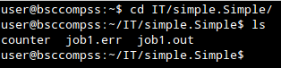
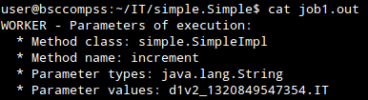
Figure 4 - The log of each task can be retrieved at the end of the execution
The results of an execution will be stored in the /home/user/IT/simple.Simple/ directory in the example application.

Exploring the final execution graph
At the end of the execution a dependency graph can be generated representing the order of execution of each type of task and their dependencies.
user@bsccompss:~$ gengraph graph.dot

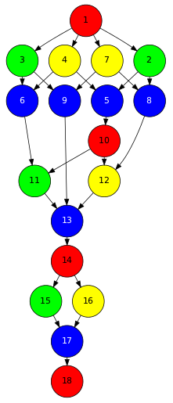
Figure 5 - The dependency graph of the SparseLU application

COMPSs monitoring system
The COMPSs runtime exposes a Web Service with a graphical interface that can be used to monitor the progress of running applications. In order to see it, a specific URL must be used in a web browser:
http://localhost:8080/compss-monitor

As it can be seen in Figure 6, the interface gives details about the execution graph (it can be seen how the data dependency graph is built and consumed at real time, and the status of the tasks), the resource usage information, the number of tasks, and the execution time per task.

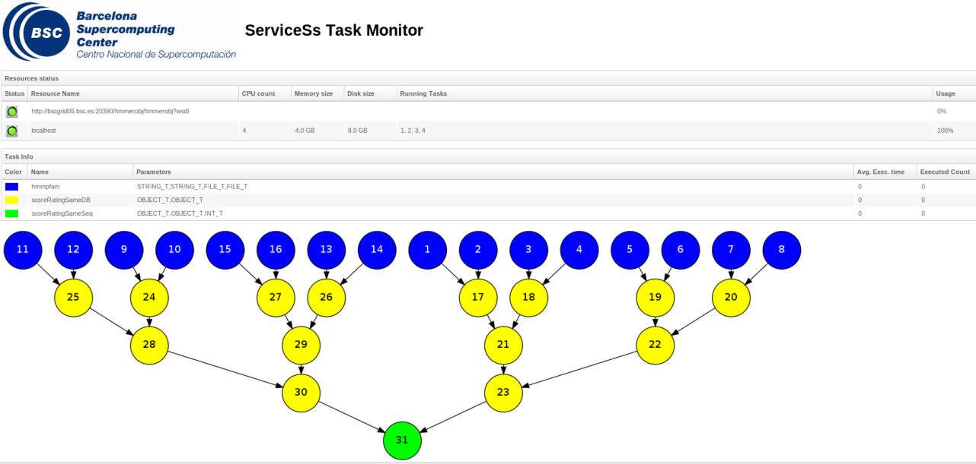
Figure 6 – COMPSs monitoring interface example

Sample applications
The examples in this section consider the execution in a cloud platform where the VMs mount a common storage on /sharedDisk directory. This is useful in the case of applications that require working with big files, allowing to transfer data only once, at the beginning of the execution, and to enable the application to access the data directly during the rest of the execution.
The Blast sample workflows available in the development environment and explained in the next section takes advantage of this functionality.
The development environment provides some sample COMPSs applications that can be found in /home/user/workspace/ directory. The following section describes in detail the development of each of them.

Matrix multiplication
Matrix Multiplication (Matmul) is a pure Java application that multiplies two matrices in a direct way. The application creates 2 matrices of N x N size initialized with values, and multiply the matrices by blocks of 40 floats (by default).
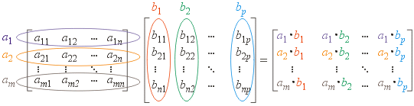

In this application the multiplication is implemented in the multiplyAccumulative that is thus selected as the task that will be executed remotely. In order to run the application the matrix dimension has to be supplied.

user@bsccompss:~$ cp ~/workspace/matmul/package/Matmul.tar.gz /home/user/
user@bsccompss:~$ tar xzf Matmul.tar.gz
user@bsccompss:~$ export CLASSPATH=$CLASSPATH:/home/user/matmul.jar

The command line to execute the application:

user@bsccompss:~$ runcompss matmul.Matmul <matrix_dim>

Sparse LU decomposition
SparseLU multiplies two matrices using the factorization method of LU decomposition, which factorizes a matrix as a product of a lower triangular matrix and an upper one.



The matrix is divided into N x N blocks on where 4 types of operations will be applied modifying the blocks: lu0, fwd, bdiv and bmod. These four operations are implemented in four methods that are selecetd as the tasks that will be executed remotely. In order to run the application the matrix dimension has to be provided.

user@bsccompss:~$ cp ~/workspace/sparselu/package/SparseLU.tar.gz /home/user/
user@bsccompss:~$ tar xzf SparseLU.tar.gz
user@bsccompss:~$ export CLASSPATH=$CLASSPATH:/home/user/sparselu.jar

The command line to execute the application:

user@bsccompss:~$ runcompss sparselu.SparseLU <matrix_dim>

BLAST Workflow
BLAST is a widely-used bioinformatics tool for comparing primary biological sequence information, such as the amino-acid sequences of different proteins or the nucleotides of DNA sequences with sequence databases, identifying sequences that resemble the query sequence above a certain threshold. The work performed by the COMPSs Blast workflow is computationally intensive and embarrassingly parallel.

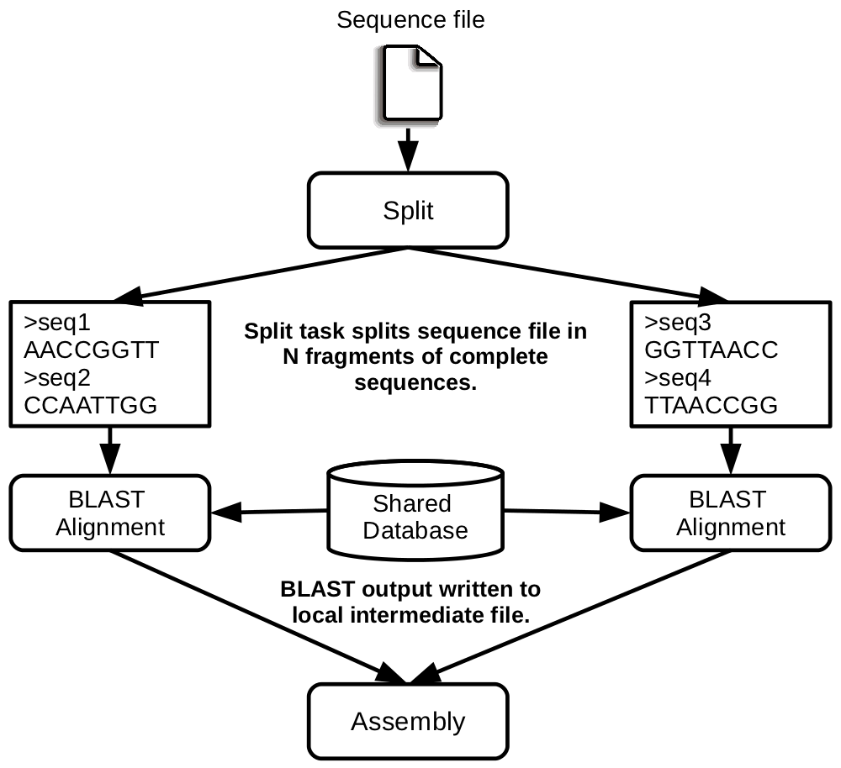
Figure 7 - The COMPSs Blast workflow

The workflow describes the three blocks of the workflow implemented in the Split, Align and Assembly methods. The second one is the only method that is chosen to be executed remotely, so it is the unique method defined in the interface file. The Split method chops the query sequences file in N fragments, Align compares each sequence fragment against the database by means of the Blast binary, and Assembly combines all intermediate files into a single result file.
This application uses a database that will be on the shared disk space avoiding transferring the entire database (which can be large) between the virtual machines.

user@bsccompss:~$ cp ~/workspace/blast/package/Blast.tar.gz /home/user/
user@bsccompss:~$ tar xzf Blast.tar.gz
user@bsccompss:~$ export CLASSPATH=$CLASSPATH:/home/user/blast.jar

The command line to execute the workflow:

user@bsccompss:~$ runcompss blast.Blast <debug> <bin_location>
<database_file> <sequences_file> <frag_number> <tmpdir>
<output_file>

Where:
- debug: The debug flag of the application [true | false].
- bin_location: Path of the Blast binary.
- database_file: Path of database file; the shared disk /sharedDisk/ is suggested to avoid big data transfers.
- sequences_file: Path of sequences file.
- frag_number: Number of fragments of the original sequence file, this number determines the number of parallel Align tasks.
- tmpdir: Temporary directory (/home/user/tmp/).
- output_file: Path of the result file.

Example:

user@bsccompss:~$ runcompss blast.Blast true
/home/user/workspace/blast/binary/blastall /sharedDisk/Blast/databases/swissprot/swissprot /sharedDisk/Blast/sequences/sargasso_test.fasta 4 /tmp/ /home/user/out.txt

COMPSs Configuration
COMPSs SDK VM is a preconfigured light 64-bit Xubuntu distribution providing the necessary set of tools to develop COMPSs applications. The development environment includes an Eclipse IDE, the COMPSs framework and a set of sample applications in order to ease the comprehension of the programing model in a more straightforward way.
The COMPSs framework is installed in /opt/COMPSs/;
For the development of new projects in Eclipse please remember to add the reference to the COMPSs runtime adding /opt/COMPSs/Runtime/rt/compss-rt.jar as referenced library.
Please note that in case of changing the number of available cores in the physical SDK machine, this should be reflected in the COMPSs configurations files, resources.xml and project.xml, as indicated in the picture.
project.xml
user@bsccompss:~$ cat /opt/COMPSs/Runtime/xml/projects/project.xml
<?xml version="1.0" encoding="UTF-8"?>
<Project>
<!--Description for any physical node-->
<Worker Name=“localhost">
<InstallDir>/IT_worker/</InstallDir>
<WorkingDir>/home/user/</WorkingDir>
<User>user</User>
<LimitOfTasks>2</LimitOfTasks>
</Worker>
</Project>

resources.xml
user@bsccompss:~$ cat /opt/COMPSs/Runtime/xml/resources/resources.xml
<?xml version="1.0" encoding="UTF-8"?>
<ResourceList>
<!--Description for any physical node-->
<Resource Name=“localhost">
<Capabilities>
<Host>
<TaskCount>0</TaskCount>
<Queue>short</Queue>
<Queue/>
</Host>
<Processor>
<Architecture>IA32</Architecture>
<Speed>3.0</Speed>
<CPUCount>2</CPUCount>
</Processor>
<OS>
<OSType>Linux</OSType>
<MaxProcessesPerUser>32</MaxProcessesPerUser>
</OS>
<StorageElement>
<Size>30</Size>
</StorageElement>
<Memory>
<PhysicalSize>2</PhysicalSize>
<VirtualSize>8</VirtualSize>
</Memory>
<ApplicationSoftware>
<Software>Java</Software>
</ApplicationSoftware>
<Service/>
<VO/>
<Cluster/>
<FileSystem/>
<NetworkAdaptor/>
<JobPolicy/>
<AccessControlPolicy/>
</Capabilities>
<Requirements/>
</Resource>
<ResourceList>

In order to use external resources to execute the applications, the following steps have to be followed:
- Install the COMPSs framework on the new resources following the installation manual available at http://www.bsc.es/compss.
- Edit the resources.xml and project.xml files in the master machine (the SDK VM) in order to be aware of the new resources (Section 4).
- Create/set the WorkingDir in the path specified in project.xml
- Set SSH passwordless access to the rest of the remote resources.
- In case of cloud resources the application will be deployed automatically, and this, should be set up on COMPSs configuration files. In case of static resources, deploy the application manually on the new ones (see section 3.1 and 3.2).

Grid/Cluster configuration (static resources)
On the following lines, we provide examples about configuration files for Grid and Cluster environments, which can serve as a reference. They can also be compared to the examples previously provided to see the differences in such scenarios.

Resources
<?xml version="1.0" encoding="UTF-8"?>
<ResourceList>
<!--Description for any physical node-->

<Resource Name="172.20.200.18">
<Capabilities>
<Host>
<TaskCount>0</TaskCount>
<Queue>short</Queue>
<Queue/>
</Host>
<Processor>
<Architecture>IA32</Architecture>
<Speed>3.0</Speed>
<CPUCount>1</CPUCount>
</Processor>
<OS>
<OSType>Linux</OSType>
<MaxProcessesPerUser>32</MaxProcessesPerUser>
</OS>
<StorageElement>
<Size>30</Size>
</StorageElement>
…
<Memory>
<PhysicalSize>1</PhysicalSize>
<VirtualSize>8</VirtualSize>
</Memory>
<ApplicationSoftware>
<Software>Java</Software>
</ApplicationSoftware>
<Service/>
<VO/>
<Cluster/>
<FileSystem/>
<NetworkAdaptor/>
<JobPolicy/>
<AccessControlPolicy/>
</Capabilities>
<Requirements/>
</Resource>

<Resource Name="172.20.200.19">
...
</Resource>

<ResourceList>

Project
<?xml version="1.0" encoding="UTF-8"?>
<Project>
<!--Description for any physical node-->

<Worker Name="172.20.200.18">
<InstallDir>/opt/COMPSs/Runtime/scripts/system/</InstallDir>
<WorkingDir>/tmp/</WorkingDir>
<User>user</User>
<LimitOfTasks>1</LimitOfTasks>
</Worker>

<Worker Name="172.20.200.19">
…
</Worker>

…
</Project>

Shared Disks configuration
Configuring shared disks on the runtime configuration might reduce the amount of data transfers improving the application performance. To indicate a shared disk hosted in the master node, the resources list in the resources.xml file must include a disk tag describing the disk and the mount point. The following example of resources.xml states that in the master node there is a shared disk labelled sharedDisk0 mounted on the /home/user directory.
<?xml version="1.0" encoding="UTF-8"?>
<ResourceList>

<Disk Name=sharedDisk0”>
<MountPoint>/home/user</MountPoint>
</Disk>

<ResourceList>

On the other side, also worker nodes description in the resource.xml file should declare the shared disks mounted on them to avoid data transfers as done for sharedDisk0 in the following example. Though, the example only contains the definition of a single shared disk, the Disks tag can have multiple disk child nodes.
<Resource Name="172.20.200.18">
<Capabilities>
…
</Capabilities>
<Requirements/>
<Disks>
<Disk Name=”sharedDisk0”>
<MountPoint>/home/user</MountPoint>
</Disk>
</Disks>
</Resource>

Cloud Provider configuration (dynamic resources)
The COMPSs runtime communicates with the Cloud by means of Cloud connectors. Each connector implements the interaction of the runtime with a given Cloud provider, more precisely by supporting four basic operations: ask for the price of a certain VM in the provider, get the time needed to create a VM, create a new VM and terminate a VM.
Connectors abstract the runtime from the particular API of each provider; furthermore, this design facilitates the addition of new connectors for other providers.
The next subsections describe the basic configuration options for Cloud provider connectors and provide a description of each of the connectors currently available.
Connectors can be configured by providing some information in the resources.xml and project.xml files. These files are located at <COMPSs_INSTALL_DIR>/xml/projects and <COMPSs_INSTALL_DIR>/xml/resources. The example folders in these directories contain some respective examples for different backends,

Resources
The resources.xml file can contain one or more tags <CloudProvider> that encompass the information about a particular Cloud provider, associated to a given connector. The tag must have an attribute name to uniquely identify the provider. Table 1 summarizes the information to be specified by the user inside this tag.

Table 1 – Configuration of resources.xml file, tag <CloudProvider>
Server | Endpoint of the provider’s server
Connector | Class that implements the connector
ImageList  - Image  - Architecture  - OSType  - ApplicationSoftware  - Software  - SharedDisks  - Disk | Multiple entries of VM templates  - VM image  - Architecture of the VM image  - Operative System installed in the VM image  - Multiple entries of software installed in the VM image  - Software installed in the VM image  - Multiple entries of shared disks mounted in the VM image  - Disk description
InstanceTypes  - Resource  - Capabilities  - Processor  - StorageElement  - Memory | Multiple entries of resource templates  - Instance type offered by the provider  - Hardware details of instance type  - Architecture and number of available cores  - Size in GB of the storage  - PhysicalSize, in GB of the available RAM

Project
The project.xml complements the information about Cloud providers specified in the resources.xml file. This file can contain a <Cloud> tag where to specify a list of providers, each with a <Provider> tag, whose name attribute must match one of the providers in the resources.xml file. Thus, the project.xml file must contain a subset of the providers specified in the resources.xml file. Table 2 summarizes the information to be specified by the user in the <Provider> tags of the project.xml file.

Table 2 - Configuration of project.xml file, tag <Cloud>
InitialVMs | Number of VM to be created at the beginning of the application
minVMCount | Minimum number of VMs available in the computation
maxVMCount | Maximum number of VMs available in the computation
Provider | Multiple entries of Cloud providers

Table 3 - Configuration of project.xml file, tag <Provider>
LimitOfVMs | Maximum number of VMs allowed by the provider
Property  - Name  - Value | Multiple entries of provider-specific properties  - Name of the property  - Value of the property
ImageList  - Image  - InstallDir  - WorkingDir  - User  - Package  - Source  - Target  - InstalledSoftware | Multiple entries of VM images available at the provider  - VM image  - Path of the COMPSs worker scripts in the image  - COMPSs working directory in the deployed instances  - Account username  - Multiple entries of local packages that have to be deployed in new instances  - Local path of the package  - Path where to deploy the package in the new instance  - List of software included in the package
InstanceTypes  - Resource | List of resource types that are available in the provider  - Resource description

Connectors

Amazon EC2
The COMPSs runtime features a connector to interact with the Amazon Elastic Compute Cloud (EC2).
Amazon EC2 offers a well-defined pricing system for VM rental. A total of 8 pricing zones are established, corresponding to 8 different locations of Amazon datacenters around the globe. Besides, inside each zone, several per-hour prices exist for VM instances with different capabilities. The EC2 connector stores the prices of standard on-demand VM instance types (t1.micro, m1.small, m1.medium, m1.large and m1.xlarge) for each zone. Spot instances are not currently supported by the connector.
When the COMPSs runtime chooses to create a VM in the Amazon public Cloud, the EC2 connector receives the information about the requested characteristics of the new VM, namely the number of cores, memory, disk and architecture (32/64 bits). According to that information, the connector tries to find the VM instance type in Amazon that better matches those characteristics and then requests the creation of a new VM instance of that type.
Once an EC2 VM is created, a whole hour slot is paid in advance; for that reason, the connector keeps the VM alive at least during such period, saving it for later use if necessary. When the task load decreases and a VM is no longer used, the connector puts it aside if the hour slot has not expired yet, instead of terminating it. After that, if the task load increases again and the EC2 connector requests a VM, first the set of saved VMs is examined in order to find a VM that is compatible with the requested characteristics. If one is found, the VM is reused and becomes eligible again for the execution of tasks; hence, the cost and time to create a new VM are not paid. A VM is only destroyed when the end of its hour slot is approaching and it is still in saved state.
Table 3 summarizes the provider-specific properties that must be defined in the project.xml file for the Amazon EC2 connector.

Table 4 – Properties of the Amazon EC2 connector
Placement | Location of the amazon datacentre to use
Access Key Id | Identifier of the access key of the Amazon EC2 account
Secret Key Id | Identifier of the secret key of the Amazon EC2 account
Key host location | Path to the SSH key in the local host, used to connect to the VMs
KeyPair name | Name of the key pair to use
SecurityGroup name | Name of the security group to use

rOCCI Connector
In order to execute a COMPSs application in the cloud, the rOCCI connector has to be configured properly. The connector uses the rOCCI binary client (version newer or equal than 4.2.5) which has to be installed in the node where the COMPSs main application is executed.
This connector needs additional files providing details about the resource templates available on each provider. This file is located under <COMPSs_INSTALL_DIR>/xml/templates path. Additionally, the user must define the virtual images flavour and instance types offered by each provider; thus, when the runtime asks for the creation of a VM, the connector selects the appropriate image and resource template according to the requirements (in terms of CPU, memory, disk, etc) by invoking the rOCCI client through Mixins (heritable classes that override and extend the base templates).
Table 5 contains the rOCCI specific properties that must be defined in the project.xml file.

Table 5 - rOCCI extensions in the project.xml file
Provider
ca-path | Path to CA certificates directory
user-cred | Path of the VOMS proxy
auth | Authentication method, x509 only supported
owner | Optional. Used by the VENUS-C Job Manager (PMES)
jobname | Optional. Used by the VENUS-C Job Manager (PMES)

Table 6 - Configuration of the <provider>.xml templates file
Instance | Multiple entries of resource templates.
Type | Name of the resource template. It has to be the same name than in the previous files
CPU | Number of cores
Memory | Size in GB of the available RAM
Disk | Size in GB of the storage
Price | Cost per hour of the instance

Bindings
In addition to Java, COMPSs supports the execution of applications written in other languages by means of bindings. A binding manages the interaction of the not-Java application with the COMPSs Java runtime, providing the necessary language translation.
The next subsections describe the language bindings provided by COMPSs.

C/C++
COMPSs provides a binding for C and C++ applications. The new C++ version in the current release comes with support for objects as task parameters and the use of class methods as tasks.

Programming Model

Task Selection
As in Java language the user must write the task selection like an “interface”. In this case the interface file has the same name as the main application file plus the suffix “idl”, i.e. Matmul.idl, where the main file is called Matmul.cc.
interface Matmul
{
// C functions

void initMatrix(inout Matrix matrix,
in int mSize,
in int nSize,
in double val);

void multiplyBlocks(inout Block block1,
inout Block block2,
inout Block block3);

// C++ class methods

void Block::multiply(in Block block1,
in Block block2);

static Matrix Matrix::init(in int mSize,
in int bSize,
in double val);
};

The syntax of the interface file is shown in the previous code. Tasks can be declared as classic C function prototypes, this allow to keep the compatibility with standard C applications. In the example, initMatrix and multiplyBlocks are functions declared using its prototype, like in a C header file, but this code is C++ as they have objects as parameters (objects of type Matrix, or Block).
A class method can be also a task, and it is declared using its signature. In the example, Block::multiply and Matrix::init are class methods. In this example, C functions encapsulates object method calls, as we will see later.
The grammar for the interface file is as follows:
[“static”] return-type task-name ( parameter {, parameter }* );

return-type = “void” | type

task-name = <qualified name of the function or method>

parameter = direction type parameter-name

direction = “in” | “out” | “inout”

type = “char” | “string” | “int” | “short” | “long”
| “float” | “double” | “boolean” | “File” | class-name

class-name = <qualified name of the class>

Value and Object return
Notice that returning a value or an object is now supported, this means a “void” value, a value of a primitive type (an int, long, float, etc.), or an object of a class, can be returned from a function or method.
IMPORTANT:
In C/C++ the default policy is to make a copy of the value or object when it is returned [A = foo();], and this copy (A) is a new position in memory whom reference or address is not possible to know before the return statement.
As the binding can’t know such reference before leaving the task execution (foo) it must do a synchronization before the return statement for the correct value to be copied when returning. This is called an explicit synchronization.
Alternatively, the return of a value or an object can be done also by mean of an out or inout parameter, and no explicit synchronization is needed because the reference is passed to the binding in this case using de & operator [foo(&A);].

Main Program
The main program is a sequential code written in C++ that launches tasks to be executed in parallel and may have several data-synchronization points or none.
#define DEBUG_BINDING

#include "Matmul.h"
#include "Matrix.h"
#include "Block.h"

int N; //MSIZE
int M; //BSIZE
double val;

int main(int argc, char **argv)
{
Matrix A;
Matrix B;
Matrix C;

N = atoi(argv[1]);
M = atoi(argv[2]);
val = atof(argv[3]);

compss_on();

A = Matrix::init(N,M,val);

initMatrix(&B,N,M,val);
initMatrix(&C,N,M,0.0);

cout << "Waiting for initialization...\n";

compss_wait_on(B);
compss_wait_on(C);

cout << "Initialization ends...\n";

C.multiply(A, B);

compss_off();

return 0;
}

The main points when programming the main code are:
  - The directive DEBUG_BINDING can be defined if we need debug information from the binding.
  - A header file with the same name as the main file must be included, in this case Matmul.h. This header file is automatically generated by the binding and it contains other includes and certain type-definitions that are needed.
  - A call to the compss_on binding function to turn on the COMPSs runtime.
  - As in C language, when passing and out or inout parameter, the memory address should be passed in order the parameter can be modified. For that, in a task-function call, we use the “&” operator before the parameter name.
  - Synchronization on a parameter can be done calling the compss_wait_on binding function. The argument of this function must be the variable or object we want to synchronize.
  - There is an implicit synchronization in the init method of Matrix. It is not possible to know the address of “A” before exiting the method call and due to this it is necessary to synchronize before for the copy of the returned value into “A” for it to be correct.
  - A call to the compss_off binding function to turn off the COMPSs runtime.

Functions file
The function file is where the programmer writes the implementation of the tasks in a C or C++ function style. Its name must be the same as the main file followed by the suffix “-functions”. In our case Matmul-functions.cc.
#include "Matmul.h"
#include "Matrix.h"
#include "Block.h"

void initMatrix(Matrix *matrix, int mSize, int nSize, double val) {
*matrix = Matrix::init(mSize, nSize, val);
}

void multiplyBlocks(Block *block1, Block *block2, Block *block3) {
block1->multiply(*block2, *block3);
}

There is no special consideration when writing the functions (or tasks), only to include the Matmul.h header file is needed.
In the previous code, class methods have been encapsulated inside a function. This is useful when the class method returns an object or a value and we want to avoid the explicit synchronization when returning from the method that we have mentioned before.

Other Source Files
The user application for sure will have other source files than the main-file and the functions-file seen in the previous sections. This other files must be placed under the directory “src”.
In this directory the programmer must provide a Makefile that compiles such source files in the proper way. When the binding compiles the whole application it will enter into the src directory and executes the Makefile.
The previous code shows an example of a Makefile. It generates two libraries, one for the master application and another for the worker application. The directive COMPSS_MASTER or COMPSS_WORKER must be used in order to compile the source files for each type of library. Both libraries will be copied into the lib directory where the binding will look for them when generating the master and worker applications.

Class Serialization
As known, the C++ classes can be written in separated files, a header file for the declaration and a source file for the implementation.
Here we show the class Block. The important thing here is that the class must provide the method for the object serialization. This serialization is done using the “boost” library. The “serialize” method is implemented inline in the header file.
#ifndef BLOCK_H
#define BLOCK_H

#include <vector>
#include <boost/archive/text_iarchive.hpp>
#include <boost/archive/text_oarchive.hpp>
#include <boost/serialization/serialization.hpp>
#include <boost/serialization/access.hpp>
#include <boost/serialization/vector.hpp>

using namespace std;
using namespace boost;
using namespace serialization;

class Block {

public:
Block(){};

Block(int bSize);

static Block *init(int bSize, double initVal);

void multiply(Block block1, Block block2);

void print();

private:
int M;
std::vector< std::vector< double > > data;

friend class::serialization::access;
template<class Archive>
void serialize(Archive & ar, const unsigned int version) {
ar & M;
ar & data;
}
};

#endif

For more information about serialization using “boost” visit the related documentation at www.boost.org.

Method – Task
A task can be a C++ class method. A method can return a value, modify the “this” object, or modify a parameter.
If the method has a return value there will be an implicit synchronization before exit the method, but for the “this” object and parameters the synchronization can be done later after the method has finished.
This is due to the “this” object and parameters can be accessed inside the method and outside, but for the variable where the returned value is copied to, it can’t be known inside the method.
#include "Block.h"

Block::Block(int bSize) {
M = bSize;
data.resize(M);
for (int i=0; i<M; i++) {
data[i].resize(M);
}
}

Block *Block::init(int bSize, double initVal) {
Block *block = new Block(bSize);
for (int i=0; i<bSize; i++) {
for (int j=0; j<bSize; j++) {
block->data[i][j] = initVal;
}
}
return block;
}

#ifdef COMPSS_WORKER

void Block::multiply(Block block1, Block block2) {
for (int i=0; i<M; i++) {
for (int j=0; j<M; j++) {
for (int k=0; k<M; k++) {
data[i][j] += block1.data[i][k] * block2.data[k][j];
}
}
}
this->print();
}

#endif

void Block::print() {
for (int i=0; i<M; i++) {
for (int j=0; j<M; j++) {
cout << data[i][j] << " ";
}
cout << "\r\n";
}
}

XML configuration files
The project.xml and the resources.xml files as in Java language must be provided to the COMPSs runtime. This files must be found in the same directory as the main file.
Here is the project.xml file for the Test application.
<?xml version="1.0" encoding="UTF-8"?>
<Project>
<Worker Name="localhost">
<InstallDir>/opt/COMPSs/Runtime/scripts/system/</InstallDir>
<WorkingDir>/home/user/matmul_objects/worker/files/</WorkingDir>
<AppDir>/home/user/matmul_objects/worker/</AppDir>
<User>user</User>
<LimitOfTasks>4</LimitOfTasks>
</Worker>
</Project>

Here is the resources.xml
<?xml version="1.0" encoding="UTF-8"?>
<ResourceList>
<Resource Name="localhost">
<Capabilities>
<Host>
<TaskCount>0</TaskCount>
<Queue>short</Queue>
<Queue/>
</Host>
<Processor>
<Architecture>IA32</Architecture>
<Speed>3.0</Speed>
<CPUCount>4</CPUCount>
</Processor>
<OS>
<OSType>Linux</OSType>
<MaxProcessesPerUser>32</MaxProcessesPerUser>
</OS>
<StorageElement>
<Size>8</Size>
</StorageElement>
<Memory>
<PhysicalSize>4</PhysicalSize>
<VirtualSize>8</VirtualSize>
</Memory>
<ApplicationSoftware>
<Software>Java</Software>
</ApplicationSoftware>
<Service/>
<VO/>
<Cluster/>
<FileSystem/>
<NetworkAdaptor/>
<JobPolicy/>
<AccessControlPolicy/>
</Capabilities>
<Requirements/>
</Resource>
</ResourceList>

Application Compilation
In order to compile the user application against the binding libraries in a proper way a script is accessible in the system path after the binding installation.
In the same directory where the main file resides, just execute the command “buildapp” and pass the name of the application as argument to this script, in this case “Matmul”.

user@localhost:~/matmul_objects$ buildapp Matmul

Building application...
g++ -DCOMPSS_MASTER -g -I. -I/opt/COMPSs/Runtime/bindings/c/include -I/opt/COMPSs/Runtime/bindings/bindings-common/include -c Block.cc Matrix.cc
ar rvs libmaster.a Block.o Matrix.o
g++ -DCOMPSS_WORKER -g -I. -I/opt/COMPSs/Runtime/bindings/c/include -I/opt/COMPSs/Runtime/bindings/bindings-common/include -c Block.cc Matrix.cc
ar rvs libworker.a Block.o Matrix.o
Building all:
Building Master...
g++ -g -O2 -o Matmul Matmul-empty.o Matmul-stubs.o Matmul.o -L../../lib -lmaster -L/usr/lib/jvm/java-6-openjdk-amd64/jre/lib/amd64/server -ljvm -ldl -L/opt/COMPSs/Runtime/bindings/c/../bindings-common/lib -lbindings_common -L/opt/COMPSs/Runtime/bindings/c/lib -lcbindings -lboost_iostreams -lboost_serialization
Building Worker...
g++ -g -O2 -o Matmul-worker Matmul-worker.o Matmul-functions.o -L../../lib -lworker -ldl -lboost_iostreams -lboost_serialization -L/opt/COMPSs/Runtime/bindings/c/lib

Command succesful.

[The previous output has been cut for simplicity]

Application Environment
The following environment variables must be defined before executing a COMPSs C/C++ application:
JAVA_HOME: Java JDK installation directory (e.g. /usr/lib/jvm/java-6-openjdk/)

Application Execution
After compiling the application, two directories are generated, the master and the worker directories. The master directory contains a binary called as the main file, which is the master application, in our example is called Matmul. The worker directory contains another binary called as the main file followed by the suffix “-worker”, which is the worker application, in our example is called Matmul-worker.
In order to run the whole application, master and worker applications, use the “runcompssext” script that can be found in the system path after the runtime installation.
Here is the example of the command execution for the Matmul application.
user@localhost:~/runcompssext
--app=/home/user/matmul_objects/master/Matmul
--project=/home/user/matmul_objects/project.xml
--resources=/home/user/matmul_objects/resources.xml
--lang=c
--graph=true
--tracing=false
--cline_args="3 4 2.0"

The options of the script are:

--lang=c
--app=<path>: path to the binary file containing the main program.
--classpath=<path>: path/s where to search for the application’s modules.
The default value is the current directory.
--library_path=<path>: path/s where to search for libraries that are not in a standard path.
The default value is the variable $LD_LIBRARY_PATH.
--cline_args=<args>: arguments to pass to the application.
--project=<proj_file>: path of the project XML file.
--resources=<res_file>: path of the resources XML file.
--tracing=<true | false>: generate execution traces.
The default value is false.

Matmul Execution Graph
This is the execution graph for the matmul application in its object version with 3x3 matrices of blocks. That means a total of 9 blocks where each block is another 4x4 matrix of doubles.
Each block in the result matrix accumulates three block multiplications, in other words, three multiplications of 4x4 matrices of doubles.
The light blue circle corresponds to the initialization of matrix “A” by mean of a method-task and it has an implicit synchronization inside. The dark blue circles correspond to the other two initializations by mean of function-tasks, the synchronizations are explicit in this case, the user has written them after the task call. Both implicit and explicit synchronizations appear in a red circle.
Each green circle is a partial matrix multiplication of a set of 3. One block from matrix “A” and the correspondent one from matrix “B”. The result is written in the right block in “C” that accumulates the partial block multiplications. Each multiplication set has an explicit synchronization. All green tasks are method-tasks and they are executed in parallel.

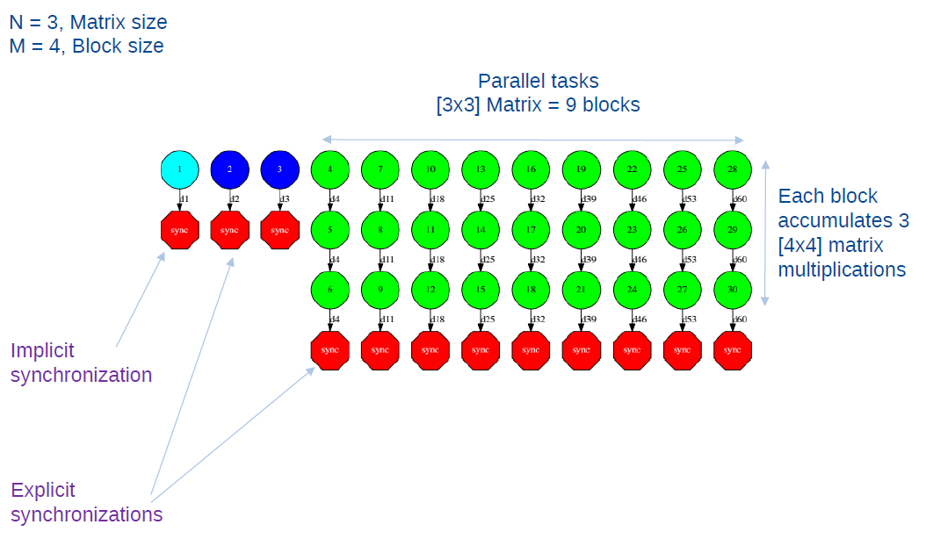

Python
COMPSs features a binding for Python 2.x applications. The next subsections explain how to program a Python application for COMPSs and how to configure the binding library.

Programming Model

Task Selection
Like in the case of the Java language, a COMPSs Python application is a sequential program that contains calls to tasks. In particular, the user can select as a task:
- Functions
- Instance methods: methods invoked on objects.
- Class methods: static methods belonging to a class.
Regarding task selection, in Python it is not done by means of an annotated interface but with the use of Python decorators. In particular, the user needs to add, before the definition of the function/method, a @task decorator that describes the task.
As an example, let us assume that the application calls a function func, which receives a string parameter containing a file name and an integer parameter. The code of func updates the file.
my_file = ‘sample_file.txt’
func(my_file, 1)

In order to select func as a task, the corresponding @task decorator needs to be placed right before the definition of the function, providing some metadata about the parameters of that function. The metadata corresponding to a parameter is specified as an argument of the decorator, whose name is the formal parameter’s name and whose value defines the type and direction of the parameter. The parameter types and directions can be:
- Types: primitive types (integer, long, float, boolean), strings, objects (instances of user-defined classes, dictionaries, lists, tuples, complex numbers) and files are supported.
- Direction: it can be read-only (IN - default), read-write (INOUT) or write-only (OUT).
COMPSs is able to automatically infer the parameter type for primitive types, strings and objects, while the user needs to specify it for files. On the other hand, the direction is only mandatory for INOUT and OUT parameters. Thus, when defining the parameter metadata in the @task decorator, the user has the following options:
- INOUT: the parameter is read-write. The type will be inferred.
- OUT: the parameter is write-only. The type will be inferred.
- FILE: the parameter is a file. The direction is assumed to be IN.
- FILE_INOUT: the parameter is a read-write file.
- FILE_OUT: the parameter is a write-only file.
Consequently, please note that in the following cases there is no need to include an argument in the @task decorator for a given task parameter:
- Parameters of primitive types (integer, long, float, boolean) and strings: the type of these parameters can be automatically inferred by COMPSs, and their direction is always IN.
- Read-only object parameters: the type of the parameter is automatically inferred, and the direction defaults to IN.
Continuing with the example, in the following code snippet the decorator specifies that func has a parameter called fi, of type FILE and INOUT direction. Note how the second parameter, i, does not need to be specified, since its type (integer) and direction (IN) are automatically inferred by COMPSs.
from pycompss.api.task import task
from pycompss.api.parameter import *

@task(f = FILE_INOUT)
def func(f, i):
fd = open(f, ‘r+’)
…

If the function or method returns a value, the programmer must specify the type of that value using the returns argument of the @task decorator:
@task(returns = int)
def ret_func():
return 1

For tasks corresponding to instance methods, by default the task is assumed to modify the callee object (the object on which the method is invoked). The programmer can tell otherwise by setting the isModifier argument of the @task decorator to False.
class MyClass(object):
…

@task(isModifier = False)
def instance_method(self):
… # self is NOT modified here

The programmer can also mark a task as a high-priority task with the priority argument of the @task decorator. This way, when the task is free of dependencies, it will be scheduled before any of the available low-priority (regular) tasks. This functionality is useful for tasks that are in the critical path of the application’s task dependency graph.
@task(priority = True)
def func():
…

Table 6 summarizes the arguments that can be found in the @task decorator.

Table 7 – Arguments of the @task decorator
Argument | Value
Formal parameter name | - INOUT: read-write parameter, all types except file (primitives, strings, objects).  - OUT: read-write parameter, all types except file (primitives, strings, objects).  - FILE: read-only file parameter.  - FILE_INOUT: read-write file parameter.  - FILE_OUT: write-only file parameter.
returns | int (for integer and boolean), long, float, str, dict, list, tuple, user-defined classes
isModifier | True (default) or False
priority | True or False (default)

Main Program
The main program of the application is a sequential code that contains calls to the selected tasks. In addition, when synchronizing for task data from the main program, there exist two API functions that need to be invoked:
- compss_open(file_name, mode = 'r'): similar to the Python open() call. It synchronizes for the last version of file file_name and returns the file descriptor for that synchronized file. It can receive an optional parameter mode, which defaults to ‘r’, containing the mode in which the file will be opened (the open modes are analogous to those of Python open()).
- compss_wait_on(obj, to_write = True): synchronizes for the last version of object obj and returns the synchronized object. It can receive an optional boolean parameter to_write, which defaults to True, that indicates whether the main program will modify the returned object.

To illustrate the use of the aforementioned API functions, the following example first invokes a task func that writes a file, which is later synchronized by calling compss_open(). Later in the program, an object of class MyClass is created and a task method method that modifies the object is invoked on it; the object is then synchronized with compss_wait_on(), so that it can be used in the main program from that point on.

from pycompss.api.api import compss_open, compss_wait_on

my_file = ‘file.txt’
func(my_file)
fd = compss_open(my_file)
…

my_obj = MyClass()
my_obj.method()
my_obj = compss_wait_on(my_obj)
…

The corresponding task selection for the example above would be:
@task(f = FILE_OUT)
def func(f):
…

class MyClass(object):
…

@task()
def method(self):
… # self is modified here

Table 7 summarizes the API functions to be used in the main program of a COMPSs Python application.
Table 8 – COMPSs Python API functions
Function | Use
compss_open(file_name, mode = ‘r’) | Synchronizes for the last version of a file and returns its file descriptor.
compss_wait_on(obj, to_write = True) | Synchronizes for the last version of an object and returns it.

Future Objects
If the programmer selects as a task a function or method that returns a value, that value is not generated until the task executes. However, in order to keep the asynchrony of the task invocation, COMPSs manages future objects: a representant object is immediately returned to the main program when a task is invoked.
@task(returns = MyClass)
def ret_func():
return MyClass(…)

…

# o is a future object
o = ret_func()

The future object returned can be involved in a subsequent task call, and the COMPSs runtime will automatically find the corresponding data dependency. In the following example, the future object o is passed as a parameter and callee of two subsequent (asynchronous) tasks, respectively:
# o is a future object
o = ret_func()

…

another_task(o)

…

o.yet_another_task()

In order to synchronize the future object from the main program, the programmer proceeds in the same way as with any object updated by a task:

# o is a future object
o = ret_func()

…

o = compss_wait_on(o)

The future object mechanism is applied to primitive types, strings and objects (including the Python built-in types list, dictionary and tuple).
It is important to note that, for instances of user-defined classes, the classes of these objects should have an empty constructor, otherwise the programmer will not be able to invoke task instance methods on those objects:

class MyClass(object):
def __init__(self): # empty constructor
…

…

o = ret_func()

# invoking a task instance method on a future object can only be done
# when an empty constructor is defined in the object’s class
o.yet_another_task()

Important Notes
For the COMPSs Python binding to function correctly, the programmer should not use relative imports in her code. Relative imports can lead to ambiguous code and they are discouraged in Python, as explained in:

http://docs.python.org/2/faq/programming.html#what-are-the-best-practices-for-using-import-in-a-module

Application Execution
The next subsections describe how to execute applications with the COMPSs Python binding.

Environment
The following environment variables must be defined before executing a COMPSs Python application:
JAVA_HOME: Java JDK installation directory (e.g. /usr/lib/jvm/java-6-openjdk/)

Command
In order to run a Python application with COMPSs, the script runcompssext can be used, like for Java and C/C++ applications. An example of an invocation of the script is:
> runcompssext --lang=python --app=$TEST_DIR/test.py --classpath=$TEST_DIR --library_path=/home/user/libdir --cline_args="arg1 arg2" --project=$TEST_DIR/project.xml --resources=$TEST_DIR/resources.xml --tracing=true

The options of the script are:
--lang=python
--app=<path>: path to the .py file containing the main program.
--classpath=<path>: path/s where to search for the application’s Python modules. The default value is the current directory.
--library_path=<path>: path/s where to search for libraries that are not in a standard path. The default value is the variable $LD_LIBRARY_PATH.
--cline_args=<args>: arguments to pass to the application.
--project=<proj_file>: path of the project XML file.
--resources=<res_file>: path of the resources XML file.
--tracing=<true | false>: generate execution traces. Default is false.

Tracing
COMPSs runtime can generate a post-execution trace of the distributed execution of the application. This trace is useful for performance analysis and diagnosis.
A trace file may contain different events as task-execution or file-transfer events among others. (In the current release we only support task-execution events and we intend to support file-transfer evens in a future release).
During the execution of the application, an XML file is created at worker nodes to keep track of these events. At the end of the execution, all the XML files are merged to get a final trace file.
In the following sections we will explain the command used for tracing, how the events are registered, in a process called instrumentation, how to visualize the trace file and make a good analysis of performance based on the data shown in the trace.

Trace Command
In order to obtain a post-execution trace file the option “--tracing” of the “runcompssext” command script must be set to “true”. This command is available in the system path after COMPSs runtime installation.
Here is the example of the command execution with the tracing option enabled for our Hmmer application.
runcompssext --app=hmmerobj.HMMPfam --tracing=true --cline_args="/sharedDisk/Hmmer/smart.HMMs.bin /sharedDisk/Hmmer/256seq /home/user/out.txt 2 8 -A 222“

Application Instrumentation
The instrumentation is the process that intercepts different events of the application execution and keeps log of them. This will cause an overhead in the execution time of the application that the user should take into account, but the collected data will be extremely useful for performance analysis and diagnosis.
COMPSs runtime uses the Extrae tool from BSC to dynamically instrument the application. At worker nodes, in background, Extrae keeps track of the events in an intermediate format file (with .mpit extension). In the master, at the end of the execution, Extrae merges the intermediate files to get the final trace file, a Paraver format file (.prv). See the visualization section in this manual for the Paraver tool.
When instrumenting the application Extrae will output several messages before and after the whole user application execution, at the master, and before and after a task execution, at the workers. No messages are output during the execution.
----------------- Executing hmmerobj.HMMPfam --------------------------

[ API] - Deploying the Integrated Toolkit
[ API] - Starting the Integrated Toolkit
[ API] - Initializing components

Welcome to Extrae 2.4.3rc4 (revision 311 based on framework/trunk/files/extrae)
Extrae: Generating intermediate files for Paraver traces.
Extrae: Intermediate files will be stored in /home/user/IT/hmmerobj.HMMPfam
Extrae: Tracing buffer can hold 500000 events
Extrae: Tracing mode is set to: Detail.
Extrae: Successfully initiated with 1 tasks

[ API] - Ready to process tasks

…
…
…
[ API] - No more tasks for app 1
[ API] - Stopping IT
[ API] - Cleaning

Extrae: Application has ended. Tracing has been terminated.
…

merger: Output trace format is: Paraver
merger: Extrae 2.4.3rc4 (revision 311 based on framework/trunk/files/extrae)
…

[ API] - Integrated Toolkit stopped
…

mpi2prv: Selected output trace format is Paraver

mpi2prv: Parsing intermediate files

mpi2prv: Generating tracefile (intermediate buffers of 1342156 events)

mpi2prv: Congratulations! hmmerobj.HMMPfam_compss_trace_1392736225.prv has been generated.

------------------------------------------------------------

For more information about Extrae please visit the following site:
http://www.bsc.es/computer-science/extrae.

Trace Visualization
Paraver is the BSC tool for trace visualization. Trace events are encoded in Paraver (.prv) format by the Extrae tool (see previous section). Paraver is a powerful tool, it can show many views of the trace data by mean of different configuration files, and the user can load and modify these configuration files or create new ones.
In the following subsections we will see how to load a trace file into Paraver, open the task events view by mean of an already predefined configuration file that is provided, and how to adjust the view to display the data in the proper way.
For more information about Paraver please visit the following site:
http://www.bsc.es/computer-sciences/performance-tools/paraver

Trace Loading
The final trace file in Paraver format (.prv) can be found at the application directory under the IT directory after the traced-application execution ends. The fastest way to open it is calling directly the Paraver command passing to it the trace filename as argument.

wxparaver /home/user/IT/hmmerobj.HMMPfam/*.prv

Configuration File
In order to open a view with the task events of the application, an already predefined configuration file is provided. To open it, just go in the main window to the “Load Configuration” option in the menu “File”. The configuration file is under the following path “/opt/COMPSs/paraver/cfgs/tasks.cfg”. After accepting the load of the configuration file, another window will appear to show the view.

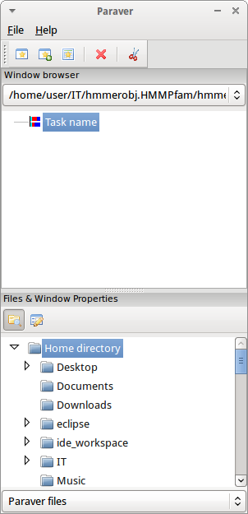

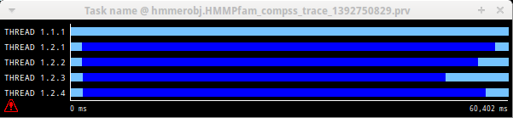

View Adjustment
In a Paraver view, a red exclamation sign may appear on the bottom-left corner (see last picture in previous section). This means that some little adjustments must be done to view the trace correctly:

- Fit window: this will give a better color scale to identify events.
  - Right click on the trace window
  - Chose the option Fit Semantic Scale / Fit Both

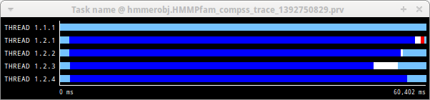

- View Event Flags: This will put a flag whenever an event starts/ends.
  - Right click on the trace window
  - Chose the option View / Event Flags

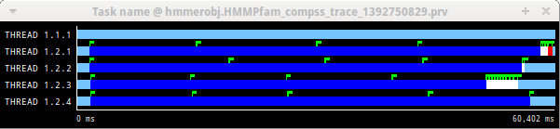

- Show Info Panel: This will show an information panel. In the tab “Colors” we can see the legend of the colors shown in the view.
  - Right click on the trace window
  - Check the Info Panel option
  - Select the Colors tab in the panel

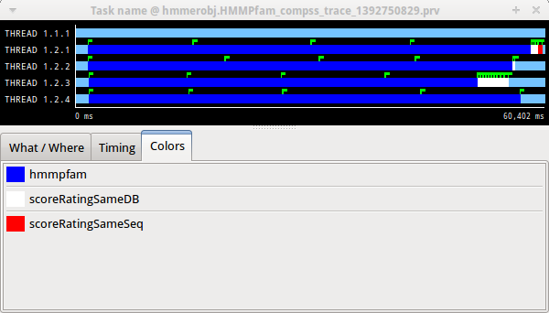

- Zoom: In order to understand a trace view better, sometimes it’s a worth thing to zoom into it a little.
  - Select a region in the trace window to see that region in detail
  - And repeat the previous step as many times as needed
  - The undo-zoom option is in the right click panel

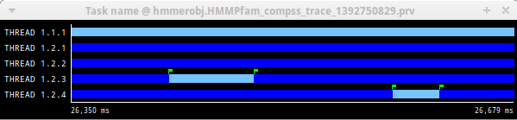
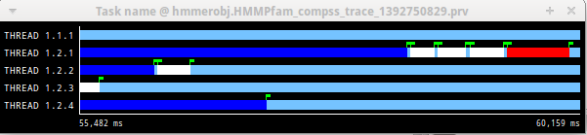

Trace Interpretation
In this section we will explain how to interpret a trace view once it has been adjusted as described in the previous section.

- The trace view has in its horizontal axis the execution time and in the vertical axis one line for the master at the top, and below it, one line for each of the workers.

- In a line, the light blue color means idle state, in the sense that there is no event at that time.

- Whenever an event starts or ends a flag is shown.

- In the middle of an event, the line shows a different color. Colors are assigned depending on the event type.

- In the info panel the legend of assigned color to event type is provided.

Trace Analysis
In this section, we will give some tips to analyse a COMPSs trace from two points of view graphical and numerical.

Graphical Analysis
The main concept is that computational events, the task events in this case, must be well distributed among all workers to have a good parallelism, and the duration of task events should be also balanced, this means, the duration of computational bursts.

In the previous trace view, all the tasks of type “hmmpfam” in dark blue appear to be well distributed among the four workers, each worker executes four “hmmpfam” tasks.
But some workers finish earlier than the others, worker 1.2.3 finish the first and worker 1.2.1 the last. So there is an imbalance in the duration of “hmmpfam” tasks. The programmer should analyse then whether all the tasks process the same amount of input data and do the same thing in order to find out the reason of such imbalance.
Another thing to highlight is that tasks of type “scoreRatingSameDB” are not equal distributed among all the workers. There are workers that execute more tasks of this type than the others. To understand better what happens here, let’s take a look to the execution graph and also zoom in the last part of the trace.

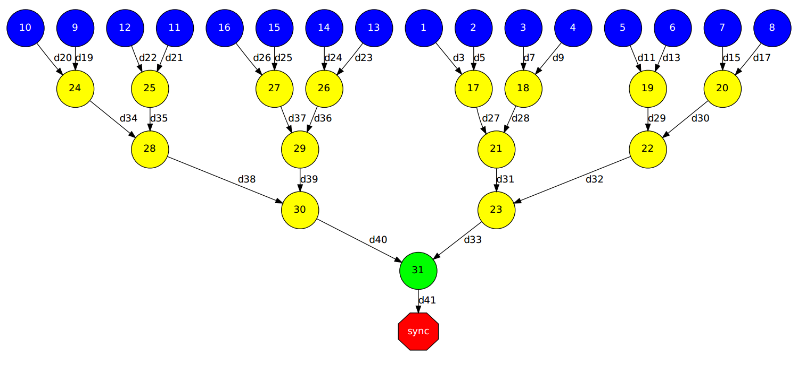

There is only one task of type “scoreRatingSameSeq”. This task appears in red in the trace (and in light-green in the graph). With the help of the graph we see that the “scoreRatingSameSeq” task has dependences on tasks of type “scoreRatingSameDB”, in white (or yellow).
When the last task of type “hmmpfam” (in dark blue) ends, the last dependences are solved, and if we look at the graph, this means going across a path of three dependences of type “scoreRatingSameDB” (in yellow). And because of these are sequential dependences (one depends on the previous) no more than a worker can be used at the same time to execute the tasks. This is the reason of why the last three task of type “scoreRatingSameDB” (in white) are executed in worker 1.2.1 sequentially.

Numerical Analysis
Here we show another trace from a different parallel execution of the Hmmer program.

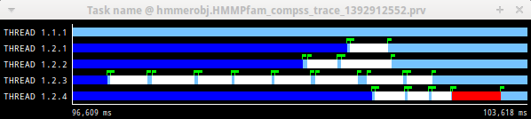

Paraver offers the possibility of having different histograms of the trace events. For it just click the “New Histogram” button in the main window and accept the default options in the “New Histogram” window that will appear.

After that, the following table is shown. In this case for each worker, the time spent executing each type of task is shown. Task names appear in the same color than in the trace view. The color of a cell in a row corresponding to a worker goes in a scale from a light-green for lower values to a dark-blue for higher ones. This conforms a color based histogram.

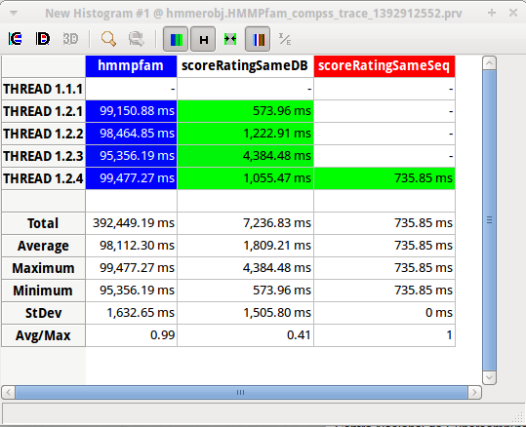

The previous table also gives, at the end of each column, some extra statistical information for each type of tasks (as the total, average, maximum or minimum values, etc.).
In the window properties of the main window we can change the semantic of the statistics to see other factors rather than the time, for example, the number of burst.

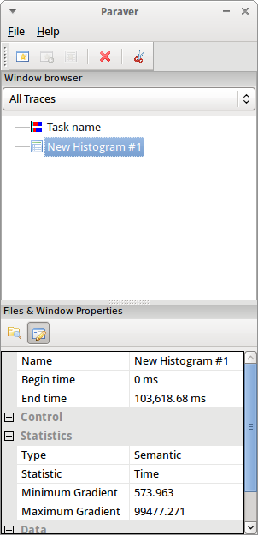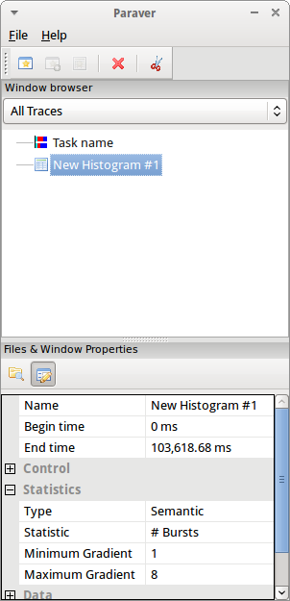

In the same way as before, the following table shows for each worker the number of bursts for each type of task, this is, the number or tasks executed of each type. Notice the gradient scale from light-green to dark-blue changes with the new values.

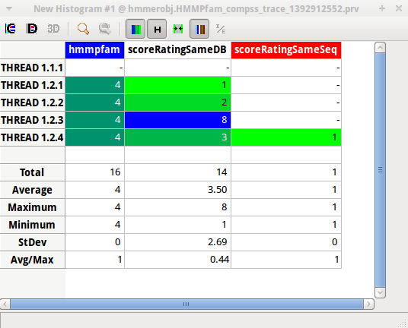

Other Trace examples
To end this section, let’s present some other examples of COMPSs traces. COMPSs traces can be much complex as the number of workers or tasks grows. Just to illustrate this, the following pictures show traces with a greater number of workers and tasks.

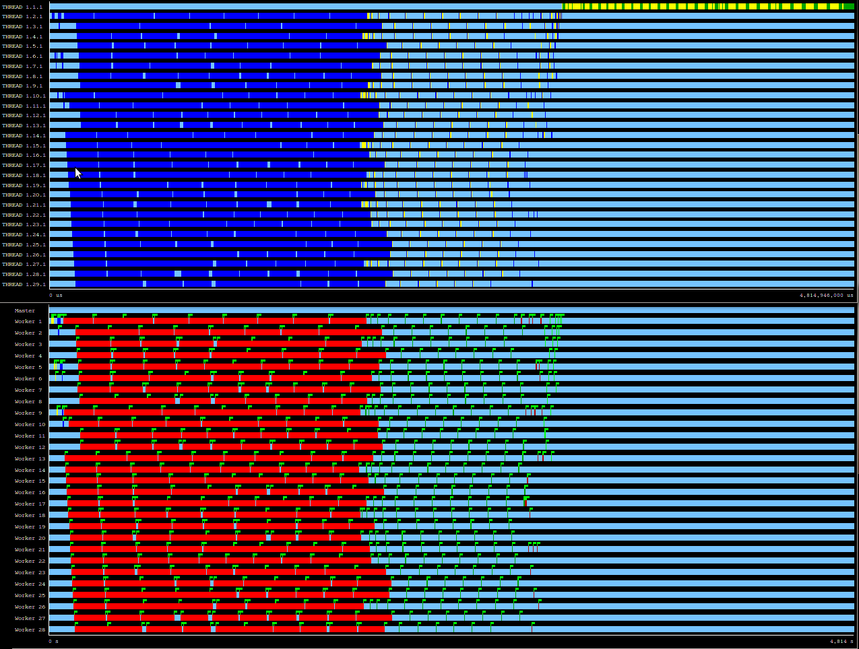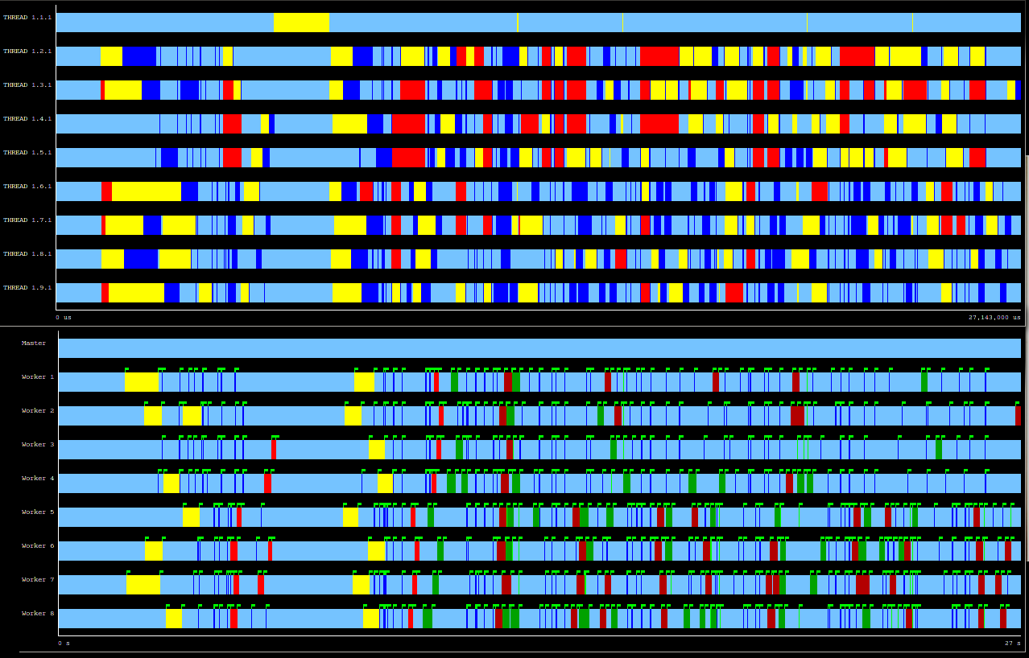

Please find more details on the COMPSs framework at

www.bsc.es/compss

https://appdb.egi.eu/store/software/rocci.cli

