Serious Games Fire Safety Awareness

Univeristy west of scotland | Computer Games Technology

A software solution for fire training procedure

B00243868 – TOADER, CONSTANTIN B00235610 – TAYLOR, WILLIAM B00236297 – LIVINGSTONE, JONATHAN

2016

# Abstract

Accidental fires are causing damages that are difficult to recover. Although the number of fires is on a descend trend, prevention through training could significantly reduce the damages. Current fire training procedures are time consuming and expensive. A serious game has been developed to make the training more entertaining and appealing, but presenting the same learning outcomes as a classic fire training. The iterative aspect of the game results in a steep learning curve, with some certain skills set acquired in a short amount of time. Using an evaluation framework that collected data for each user that played the game, it has been demonstrated that a serious game is not only a cheaper and better solution overall, but also it raised the fire safety awareness for the subjects.

# Contents

Abstract 1

Contents 2

CHAPTER 1 - Introduction 3

1.1 The problem 3

1.2 The solution 3

1.3 Learning Outcomes 3

CHAPTER 2 – Literature review 4

2.1 Overview 4

2.2 Background 4

2.2.1 More training is required 4

2.2.2 Current training 4

2.2.3 Serious games – issues and advantages 5

2.2.4 Previous fire safety applications 6

2.3 Conclusions and discussion 8

CHAPTER 3 – The solution 9

3.1 The main components 9

3.2 The scene 9

3.3 First person 10

3.3.1 The character 10

3.3.2 Movement 10

3.4 The identification task 10

3.5 The scenarios 11

3.5.1 The Good 11

3.5.2 The Bad 11

3.5.3 The Runner 11

3.5.4 The fighter 11

3.6 The acknowledgement 12

3.7 The Menu and the application flow 12

CHAPTER 4 – Evaluation 14

4.1 Quantitative evaluation 14

4.2 Qualitative evaluation 14

4.3 User background 14

4.4 Procedure 14

4.5 Results 15

CHAPTER 5 - Discussion and conclusions 15

Further work 15

References: 16

# CHAPTER 1 - Introduction

## The problem

Even in this modern era, the fire still seems to be one of the most dangerous hazards, causing damages that are difficult to recover. According to "Fire and rescue statistics Scotland 2014-15", (2015) there were 25,002 fires in Scotland of which 10.629 were primary fires: 8,219 (77%) *accidental fires* and 2,410 (23%) deliberate.

Although the number of fires is on a descend trend in Scotland, the dominance of accidental fires is very worrying.

The SFRS’s Strategic Plan for 2016-2019 reinforces that their purpose is “*to work […] on prevention, protection and response, to improve the safety and well-being of people throughout Scotland”* ("Draft Strategic Plan 2016-19 - Scottish Fire and Rescue Services - Citizen Space", 2015). The emphasis should be on the key word *prevention*. This paper tries to help improve the prevention task using the serious game FSA.

This would provide more accessible knowledge regarding the fire safety regulations and using the computer it will make the training more appealing, safe, interactive, and easier to understand.

## The solution

The Fire Safety Awareness application (hereinafter called FSA) is a serious game, a software prototype designed to help trainees to become proactive and reactive to fire events. The application is being developed using the Unity game engine and consists of a fire safety awareness presentation, fire safety tests and a mock certification. More details about the application’s design can be found in chapter 3.

## Learning Outcomes

From the start of the application, FSA is designed to have an educational purpose. Because it uses information from "The Regulatory Reform (Fire Safety) Order 2005" (2005), the game is very accurate and very good at displaying to the regular user essential information related to the current fire safety standards.

After completing the tutorials in the game the user will gain more knowledge about fire hazards, will improve its fire safety awareness and will be able to:

* Identify fire hazards and learn about the fire triangle
  + Identify sources of ignition
  + Identify sources of fuel
  + Identify sources of oxygen
* Identify the fire safety elements
  + Signs and notices
  + Fire doors
  + Escape routes
  + Lighting
* Evacuate a building in case of a fire or a drill
* Identify and correctly use the right type of fire extinguishers
* Virtually put out a fire

# CHAPTER 2 – Literature review

## 2.1 Overview

This part of the paper will analyse the work done previously in the same area where FSA resides. Amongst topics discussed, the review will cover the following (not necessarily in this order):

* the current state of training
* the benefits of using a serious game over traditional methods
* the issues with serious games
* the difference in costs involved when using a serious game compared to a fire training
* the current limitations

## 2.2 Background

Chittaro & Ranon (2009) found that current reactions to fire emergencies are inadequate. The main issue is not only the lack understanding on how to deal with a fire properly but is also down to so called “panic” reactions which disable occupants from applying their limited knowledge to the situation. In their paper, they refer to this as the “cognitive paralysis” phenomenon where people do not take any action at all leading to fatalities in completely survivable situations. The research highlights that traditional methods are not working. It also states that in 2007, 3000 civilians lost their lives in the US alone.

### 2.2.1 More training is required

Research by Silva et al. (2013) found that major hospital fires which have well planned emergency procedures still resulted in fatalities due to unpreparedness for emergency conditions.

Yang & Chen (2015) took a mathematical approach on the spread of fire safety awareness in a University Campus. They revealed a generalised parametrical formula and putting different parameters for students’ awareness about fire safety they concluded that having most students with *Strong* fire safety knowledge, part students with *Medium* fire safety awareness and less students with *Weak* awareness will reduce fire risks and accidents from the source. This only demonstrates that a higher fire safety knowledge and awareness will reduce the risk significantly and backs up the need of training.

### 2.2.2 Current training

Mohd & Ali (2014) highlight the need of training on hazard identification. They define hazard as “*a source or a situation with a potential for harm in term of human injury or ill health; damage to property and to the environment; or a combination of these”*. They describe the current structure of a training, which consist of a lecture, hands-on and video demonstration and promote the need of training on hazard identification. While they put emphasis on a more practical approach when delivering the training, their solution – a technology application, a game – contradicts their suggestion.

They discuss the fact that training is not only costly, but also lacks hands-on input. Using games, training becomes more safe, interactive, and entertaining, but dealing with fire in a hands-on situation, better prepares the trainee to take the right decisions and reduces the fear of fire.

DeChamplain et al. (2012) have highlighted a severe lack of preparedness for fire emergencies with only 23% of those going through house fires in the US stating they had an evacuation plan they executed for their home, showing that preparedness is not just a problem for large urban buildings, but also smaller buildings such as homes as well.

After analysing these articles, it is possible to identify a gap in the current understanding amongst citizens in how to deal with common fire threats and evacuations when presented with a fatal fire. Current training is inadequate due to its inability to simulate proper “panic” conditions to test the subject’s reactions and decision making in this critical juncture. A proper alternative to current training available, which adequately trains people to deal with hazardous situations, would need to ensure that any simulation does its best to mimic real world conditions.

### 2.2.3 Serious games – issues and advantages

Chittaro & Ranon (2009) state that current 3D game engines are unable to provide the immersive graphic fidelity they would expect. This is not a valid statement anymore… the lack of graphical fidelity is a state of the past, which is expected as this paper was written in 2009. Current game engines are capable of photo realistic scenes and these are no longer seen as a limitation. However, the development of realistic assets to be imported into the engine is a limitation, as extra work needs to be inputted in creating an environment that is immersive. Serious Games simulation can only go as far as their paper points out. The ability to simulate fitness, toxic smoke, strength, and injuries are all conditions that cannot be realistically simulated for obvious reasons. While game mechanics can be introduced to fake these effects, it will still relegate a Serious Game on fire training to be a supplement to established traditional training.

In a more recent paper Chittaro & Sioni (2015) discuss how serious games could be used to prepare people for emergency situations. They found that people understood the severity of situations much more clearly in a serious game setting, and their knowledge was vastly superior to people who had not tried the serious game. This aligns closely with the core idea of FSA, as the main purpose of FSA is to teach people knowledge so they are much better equip to deal with emergency-fire situations.

Research conducted by Capuano & King (2015) show Serious Games offer a way of navigating skill and knowledge retention issues that most training methods suffer from today. They found that most training is forgotten about or simply ignored by its participants as they judge it to be mediocre and unimportant to their daily duties. They reveal that Serious Games can be effective tools to support training for emergency preparedness due to their immersive approach. They also identified that gamification resulted in increased learning transfer and retention solving the issues identified in traditional training methods. What is more interesting however is the possibilities above just user simulation but enhanced evaluation.

In their case study Kapralos et al. (2013) found that while Serious Games are very popular in today’s world, representing a $1.5-billion-dollar industry in 2010, the market has been cluttered with too many examples of ineffective Serious Games. Indeed, the market is cluttered with ineffective examples, but there is at least little learning experience in any game that defines itself serious. The conclusion found in the research paper states that it is more of a product of ineffective instructional design rather than Serious Games as a medium being unable to support learning activities.

Smith & Trenholme (2009) talk about how it is difficult to stage fire-drills in modern buildings, and some of the downsides, like lack of smoke or blocked exits. They found that one developer could create a virtual environment in around three weeks, which could be used indefinitely. This has obvious benefits over a fire drill, which cannot be re-created the same was as often. They also found they could see where people went wrong, since all the information of what a person was doing and when was stored. It would be almost impossible in a real-life drill setting to track people movements in the same manner and discover if they endangered themselves when leaving the building, like running down a smoke-filled corridor. FSA uses this idea, by giving the player a "score" of how well they did at the end, based on their reactions and decisions taken when dealing with the issues presented.

Bernardes et al. (2015) talk about how serious games and a virtual environment can be used as a tool to save people money in fire-safety training. They found that, as the serious game could be stopped at any time to issue individual feedback to players, it was much more valuable than a drill, in which more general "group" feedback is applied.

In his research, Ger (2014) shows a key advantage of Serious Games, the ability to provide in detailed assessment that provides a better understanding of a trainee’s progression. He also suggests how this can be expanded on with custom assessment profiles and in detail report generation to provide view of a subject’s skills that goes far beyond a traditional training assessment. Serious Games offer a way around the knowledge retention problem that general education suffers from today and offers ways of analysing subjects that are unseen in traditional training methods. Using Serious Games, we have the ability to attract an audience by going beyond traditional training and providing realistic 3D simulations that is only possible when technology from games are leveraged. Serious games are an opportunity to forego identified issues and present a training alternative that will properly prepare users for fire emergencies through realistic simulation and in detail performance analysis.

Ericson (2007), shows that there was some success in using serious games to teach fire safety to children. Ericson talks about how serious games introduced a “fun” aspect, which many of the children in her study found engaging. In the second iteration of her experiment, she allowed the children to explore the area themselves and found that, without a guide, many of the children enjoyed the experience more and learned how to react in emergency situations better. This demonstrates that, by using a serious game, people can explore otherwise dangerous environments themselves, and become more familiar with how to proceed in an emergency.

Meesters & van de Walle (2013) discuss the use of a serious game over a recreation of a disaster or a drill. They put forward the idea that a full-scale recreation can be overwhelming to newcomers. The paper finds that all the decisions are very similar to the real-life, even if they had no prior knowledge. This shows that serious games could be used for more fully to train people for emergencies.

Kobes et al. (2010) also discuss how people react different in real-life drills and virtual reality. They also found that the participants had very similar times for the drill and the serious game. However, the virtual reality serious game had other benefits over the drill, including being able to simulate smoke which would block exit signs or even make corridors unusable.

### 2.2.4 Previous fire safety applications

In their “Blaze” game, DeChamplain et al. (2012) address the problem of evaluating the fire. Most fire safety games are related to the evacuation procedure, but “Blaze” also teaches the user how to put off a fire if is safe to do so. In the application, the user should only evacuate if the fire becomes too large. The action takes place in a home rather than an office, which makes the user more comfortable and more connected to the environment as all the items seem familiar to the player.

FSA will try to replicate the scenario where the trainee needs to evaluate the fire before deciding to extinguish it or to evacuate.

Radianti et al. (2015) discuss a serious game where they show how flame, smoke, and heat affects a five-story apartment over time. Even despite some limitation in the application, it yielded positive results and players were able to improve their real-time decision making in an emergency situation and react to different dangers. This is similar to the Fire Safety Awareness application (FSA), where players will be able to see how a fire affects a building over time. However, FSA goes one stage beyond this, and allows the user to experience dealing with the fire rather than just observing.

Almeida, Jacob et al. (2014) developed a serious game to track subject’s reaction for evacuation scenarios. Their project technology stack and idea will be similar to what FSA will produce. They used Unity 3D game engine and created a few scenarios. While their paper was mostly focused on evacuation, the benefits of serious games are easy to observe again, as repeating over and over the right procedure can only better prepare the subject for a real-life scenario in the event of a real fire alarm.

In a different paper Ribeiro et al. (2012) noticed that the average time for evacuating a building in a virtual 3D environment is actually higher than the real-life time interval. This only reveals that the evaluation contained a large tolerance for error. It is not mentioned either if the scaling of the 3D models used or if the physics are correctly applied in the application. Even if their serious game was developed using Unity and physics is granted from the start, scaling the models correctly, adjusting the right movement speed of the player are key aspects that need to be perfectly tweaked in order to deliver a player behaviour which can be measured in real time and return satisfying results.

The researcher also points up that the regular game players obtained better times. This could falsely result in a statement that the users with more gaming experience are better at preventing, or extinguishing a fire.

Xi & Smith (2014) bring to the topic the addition of a Non-Playable Character (NPC) when simulating fire drills using serious games. They draw the attention to the fact that NPCs have limited, scripted reactions when are modelled as a finite state machine, while a human would take decisions by also considering social factors. They mention the alternative approach to model a NPC using a Multi-Agent System (MAS) which can simulate basic behaviours, such as “target finding, target recognition and rescue pathfinding”, but raise the problem that not too many of these systems have fire science integrated.

Even though adding NPCs to our application would increase interactivity and realism, this is outside of the scope of this project and NPCs will not be implemented in our fire training scenarios.

Park et al. (2015) come with an interesting solution related to fire safety. In their experiment a HARMS (Human-Agent-Robot-Machine-Sensor) system is used to identify a survivor in a fire scenario. Their solution sounds safe, but even ignoring the flaws noticed by the authors, this does not seem to be something that companies would embrace, due to the high costs of the necessary equipment.

While this scenario sounds plausible and would be nice to have in FSA, the training would be more related to controlling the systems involved in the HARMS solution rather than being focused on human knowledge related to fire safety.

McGrath & Hill (2004) discuss a simulation of a mass-causality incident developed using the Unreal game engine. They found that, compared to traditional methods, their work had a lower cost and much more re-usability compared to traditional methods, like arranging a fire drill. While FSA is being developed with Unity, not Unreal, the benefits a game engine provides for productivity still apply, which is strengthens the choice of using of a good game engine like Unity when developing an application like FSA.

Fang et al. (2014) created a whole system for organisations which allows real-time monitoring to be performed. While their platform could gather statistics about places with most frequent fire alarms and could also suggest where renovation and maintenance should be carried out, these places also highlight where the personnel would need more fire safety education, as it is not only authorities’ responsibility to prevent fires.

Rüppel & Schatz (2010) discuss how the Building Information Model (BIM) can be used to rapidly create some recreations of some buildings which cannot be closed for training, like a hospital. The paper finds that simulation elements, like smoke, closely mirror their real-life equivalents and provide a realistic experience for firefighters. This is similar to FSA, which will have a "evacuation" mode in where players have to escape a burning building in which some exits may be blocked. The paper also discusses how using a serious game is much more cost-effective for the company compared to a drill, as they do not need to shut down during it.

In a more recent paper they use the BIM and virtual reality to present the effects on the condition of a building during a fire evacuation. They found that, using BIM, they could easily import different scenarios. This allows people to get more comfortable dealing with an emergency in a variety of office settings (Rüppel & Schatz, 2011). This is similar to FSA, as people are given multiple scenarios to deal with in a fire-emergency situation, so that they will be more comfortable in a larger number of situations.

## 2.3 Conclusions and discussion

Following the literature review a few conclusions stand out:

* fire safety awareness training is needed to reduce fire risk and to prepare people to deal with fire scenarios
* serious games provide a cheaper alternative to the real training
* a software application enlarges the interest towards learning as it is more comfortable, entertaining, safe and provides subliminal learning due to its iterative property (repeating the scenarios until a pass is obtained helps understanding the right procedures to follow)
* using a game engine helps prototyping the software solution with more ease now than it was previously possible
* serious games allow timing, tracking, and recording of people behaviour during various scenarios and can provide a better analysis, can create hypothetic scenarios without impacting the real world and can accurately model a real fire event
* using serious games will not replace the effectiveness of a real fire training as panic and emotion cannot be entirely accurately reproduced using a game, and these factors can lead to a different (maybe wrong decision) in a real-life scenario. Having the best score at extinguishing a virtual fire, does not make one a firefighter, but the proactive aspect of the serious game can significantly reduce the risks.
* The FSA application will take elements from the current findings and try to learn and produce a better fire safety product, which hopefully will increase people’s respect for fire and people’s fire knowledge

# CHAPTER 3 – The solution

To provide a cheaper, more entertaining, and overall better alternative to the classic fire training, the serious game FSA is created. Using Unity Personal Edition as a game engine, Google Sketchup for 3d modelling, Visual Studio Community Edition for creating Unity scripts, and online tools like NaturalReaders ("Free text to speech with Naturally Sounding Voices Online Demo — Free NaturalReader", 2016) to create audio from text, Pixlr ("Online Photo Editor | Pixlr Editor | Autodesk Pixlr", 2016) to edit textures, and PowerPoint to create videos from presentations, FSA went from prototype to gold master in less than 7 weeks.

For development, the incremental and iterative development model was used (Cockburn, 2008). The application grew from testing the import of a simple Google Sketchup model in Unity, to the final application with multiple scenarios. Each week, features were added and work to be done for the following week was planned. Previous features were re-tested with each addition to the game.

FSA was eventually completed to be a serious game and a fire training material. The game itself comprises of three main parts: the theory, the practice, and the acknowledgement. The theory consists of short educational videos offering enough information to pass a scenario. The practice are the scenarios themselves where the user needs to identify items in a scene or put off a fire, depending on the current scenario. The acknowledgment is the part where the all the progress and score is being calculated to generate a Fire Marshal Certification. The theory and the practice are mixed throughout the completion of the game.

## 3.1 The main components

The theory will contain many videos that will be mixed with the practice. The lecture video will cover notions related to the fire triangle and will reveal the importance of putting off a fire by removing one of the three components of the fire triangle. Other videos are depending on the scenarios the user will play and will be short presentations or reminders related to fire safety, fire hazards, evacuation, and fire extinguishers.

The practice component is divided into 4 scenarios: *The good* (the user will identify as many fire safety elements within 45 seconds), *The bad* (the user will identify as many hazards within 45 seconds), *The runner* (the user will need to evacuate a building) and *The fighter* (the user will put off a fire using the right type of extinguisher).

First the user will play a scenario without any given information. If the user passes the scenario, it will advance to the next one, else helping information related to the currently failed scenario will be given and the user will re-play it until it passes.

The acknowledgement part starts when the last scenario is complete. For a pass a mock certificate will be generated using the full name that will be required in the certification scene.

## 3.2 The scene

The scenarios will be taking place in an office set building comprising of 9 superior floors and one ground floor. The building will be accurately created to include office elements (desks with monitors, keyboards, mice, and desk phones), fire safety elements (exits, signs, lights, etc.) and hazards (any source of heat or fuel).

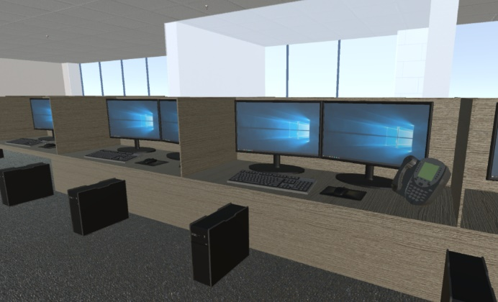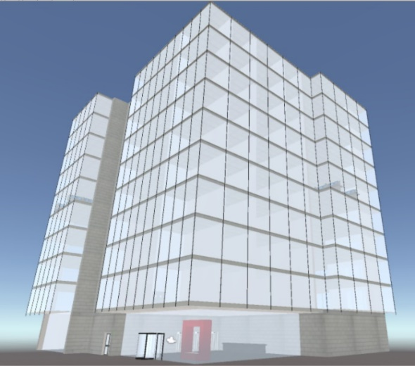Figure 1. The office building model and an internal render from the building

## 3.3 First person

### 3.3.1 The character

The character is an office employee with fire marshal training. He works on the 5th floor and is responsible only for the 5th floor of the building. The character’s access to any other floors’ office space is restricted. The character can open all doors where he has access to.

### 3.3.2 Movement

Movement will be done using the classic W, A, S, D, and SPACEBAR for jumping. The character will use the mouse for looking around and the keys for movement. The left click will also be used to confirm the identification of an item or to equip a fire extinguisher and a second click will cancel the identification of an item (that it is currently being pointed at) or abandon using the current item. The left click is also used to open doors (where the character has access).

### 3.4 The identification task

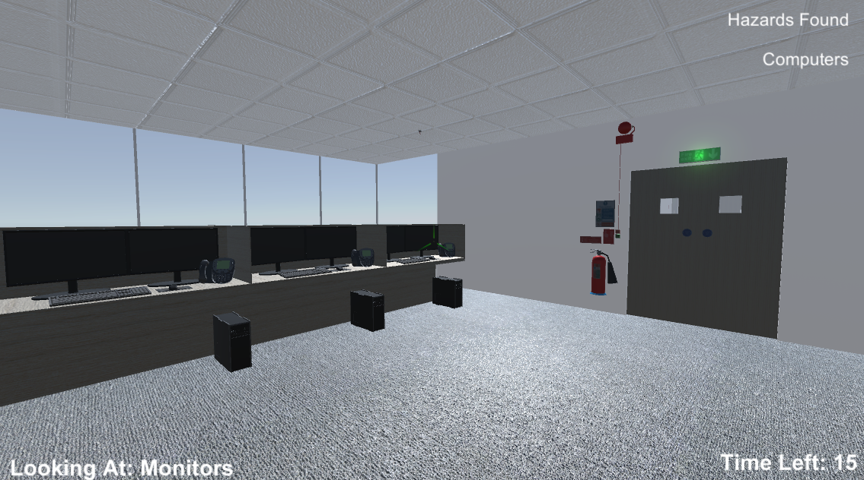The good and the bad are both scenarios where the user must lookup items in the office specific to the scenario. The identification will use a crosshair in the centre of the screen and a description box which will reveal the name of the item the user is currently pointing at, similarly to what is visible in the following image (Figure 2).

Figure 2. The identification tools: the crosshair and the description box

For example, if the state of the game were like in Figure 2, left clicking will add the item “Monitors” to the identified list. To remove one item from the list, the user must point to it again and click again. To remove the item “Computers” the user must point first to any of the computers items and then use the left click.

## 3.5 The scenarios

Each scenario should be played until is passed. The first attempt will allow the user to solve the scenario without any given information. If the user fails, the user should watch a small video where information about what to look for in the specific scenario will be given.

### 3.5.1 The Good

In this scenario, the user must identify as many safety items as possible from the scene within 45 seconds. In this category, the following items are included (but not limited only to these): fire doors, emergency exit sign/light, evacuation procedure sign, fire procedure sign, fire alarm trigger sign, fire alarm, fire alarm trigger, emergency exit door release, fire extinguisher sign, fire extinguishers type A, B, C, D, water hose sign, water hose, first aid box, sprinklers, fire alarm light, etc. The more items the user identifies, the better the score. To pass this scenario, the user must identify 10 correct items.

### 3.5.2 The Bad

This scenario is identical to “The Good” scenario, only this time the user needs to identify hazards like: any source of ignition (microwave, vending machines, computers, desk-phones), any source of heat (microwave, radiators, coffee-machines), any source of fuel (open windows, opened fire-doors, fuel cans), anything that can slow an evacuation (blocked emergency exit) etc. The user should identify at least 5 items within 45 seconds to pass.

### 3.5.3 The Runner

In this scenario, the user must evacuate the building. A timer is started and it shall be stopped only when the user reaches one of the 2 emergency exits at ground floor. A minimum acceptable time should be created and all the users who obtain higher times than the minimum should fail. The user should go to the closest emergency exit and proceed to safety without **rushing or panicking**. This means that a user should fail this scenario if the Shift (Running) key is used.

### 3.5.4 The fighter

There will be three main locations where the fire will be generated:

* At the lifts, where an electricity fire will be generated. This should only be put off with an extinguisher of type blue (dry powder) or black (CO2)
* In the kitchen, at the bins, a combustible material fire will be generated close to bins. This can be put off with any extinguisher type except the black one.
* Close to the radiators, near windows, where fuel cans are located. This can only be extinguished by the blue type (dry powder).

In this scenario, three fires will be created and the user will be spawned in the proximity of it (so the user will notice it). The user should first raise the fire alarm, then should evaluate the fire, and choose either to evacuate or fight the fire. No matter if the fire is big or small, if the user always chooses to evacuate, it is an acceptable outcome.

When the user chooses to put off a fire, it must identify the right type of extinguisher.

The user must point to an extinguisher and press left click to equip it. To unequip it, the user should click again while pointing at the extinguisher. Once the user has an extinguisher it should aim at the bottom of the fire and click the right button to toggle the extinguisher. If the user is not aiming towards the bottom of the fire, the fire should scale up gradually. If a certain amount of time has passed (if the fire evolved) the scenario would end in a failure. If the user extinguishes all the three generated fires within time, then the scenario has been a success no matter how much time it elapsed.

## 3.6 The acknowledgement

This part concludes the training and evaluates the results. If the user managed to pass all the training scenarios, the user will be forwarded to a screen where a mock diploma is displayed containing the user’s name and date and the confirmation that the user passed the fire assessment training.

A user should only be granted a diploma when all scenarios have been completed. If any of the scenarios has been failed, the user will be suggested to watch the theory again and to try harder.

This repetitive approach will eventually make the user learn the right procedures by the time a pass certification is issued.

## 3.7 The Menu and the application flow

The Menu should be a simple list with the following options available for the user:

* Start Training – will start the game
* Fire Marshals – list of previous users who were granted a Fire Marshal Diploma
* Theory – will show a list with all videos available
* About – will show information about the application
* Quit – will exit the application
* Login – authenticates the user to record progress

The application flow is best described in the Figure 3. The application starts and then shows the main menu.

*Fire Marshals*, *About* and *Quit* are one action buttons and are described as following:

* *Fire Marshals* will display a list with previous users who obtained a pass
* *About* will show information related to the application
* *Quit* will exit the application
* *Login* will allow the user to start the assessment framework.

*Theory* will enter another menu where the user can select from a play list a video containing specific theory which interests the user, between these options: *Fire Triangle, Safety Items, Hazard Items, Evacuation* and *How to put off a fire.*

Start Training will first require the user to log in. Then the first scenario will be triggered.

If the scenario is successfully completed, then the score will be recorded and the application will advance to next scenario.

If the scenario is failed, then the application will play the video theory related to the current scenario and then another attempt of the scenario will be started. This will happen until the scenario is successfully completed. The scenarios are linked this way: The Good -> The Bad -> The Runner -> The Fighter.

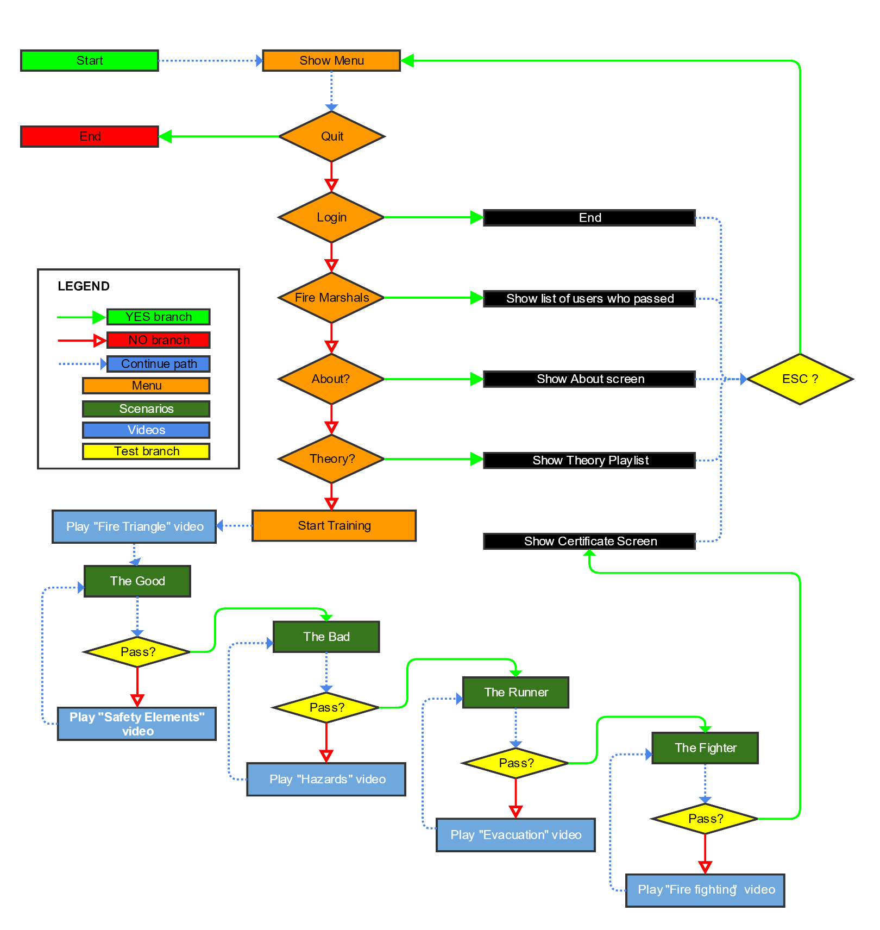When the Fighter scenario will end if the user has passed, the Certificate will be issued containing the user’s name. The certificate will be generated in a modern browser and will persist until the browser tab is closed.

Figure 3. The application’s flow chart

# CHAPTER 4 – Evaluation

To evaluate the game, FSA will benefit of an assessment framework which uses web services to collect gameplay related data for each player.

## 4.1 Quantitative evaluation

Different methods were used to gather quantitative data about users playing FSP: a survey for players to complete about the game, observing people during evaluation, and collecting data on an evaluation framework about gameplay results.

The data on the evaluation framework could be compared between users, and using this data, we could get a better idea about which parts of the game were more difficult than others and tune the performance accordingly. The main benefit of this quantitative data was that it can be very easy to see general trends at a glance, that are easy to summarize and analyse (Mujis, 2010). It also allows people to see solid evidence regarding the games effectiveness. It is true, however, that the data received through these means is not as rich, or detailed, as other means and can only give a general picture.

## 4.2 Qualitative evaluation

The evaluation framework allowed us to understand how well FSA was teaching users, in a way more focused on everyone, and learn how well they could apply what they have learned (Maxwell, 2012). Rich feedback was obtained on specific actions performed by different users. It was noticeable how many times someone had failed a scenario and which scenarios they would fail the most without our presence, meaning the people were in their natural settings and were not influenced by us (Denzin and Lincoln, 2011). Using this data, we could very easily see a learning curve for the individual of how well they were doing in the game, and by extension, how well they were learning the fundamentals of fire safety taught by the game and their feelings towards it (Strauss & Corbin, 1990). While the qualitative results we gained could not be compared in the same way, and were arguably more subjective and slightly less reliable than the quantitative results, they were a big step in helping us develop a great game.

## 4.3 User background

There were **100** subjects used for evaluation were all students of Computer Games Technology with vast knowledge on using computers. They all have played computer games and are familiar with the use of a keyboard to control a character. Only 2 of them had previous fire training. The evaluation took part in the Computer Games Laboratory from the University of the West of Scotland on machines with the following specification:

## 4.4 Procedure

The users would be asked to complete a survey to check their level of knowledge about some terms related to fire safety before starting the game. The user will be told how to control the actions needed to play the game. Then the user will start the game. As mentioned in the design, they will first have to watch an informative video about fire triangle, then they will play the scenarios. If they will fail a scenario (which is predicted to happen on most the users), they will watch a video containing fire safety information that would help them to complete the scenario. During gameplay, their performance is recorded through the integrated assessment engine, which will collect data for later analysis. When they will have passed the game, another questionnaire with the initial questions will be completed and differences between the two should highlight learning progress.

## 4.5 Results

COMPLETE THIS SECTION (use graphs)

CHANGE in 4.3 the number of users

# CHAPTER 5 - Discussion and conclusions

We highlighted the fact that one of the causes of accidental fires are the lack of training. It has been presented that current training procedures are expensive and dull. We have found that other serious games in the field addressed the problem, but most of them focused on the evacuation or obtained inaccurate results. We noticed the benefits of a serious game and developed an application where the user learns to identify fire safety items, fire hazards, learns about evacuation and how to use the right type of fire extinguisher.

We tested the game on several subjects and used an evaluation framework and before and after questionnaires to assess the learning outcomes. Most subjects did not possess any previous fire safety knowledge, but did know how to use a computer. After playing the game, the general conclusion of the players is that they feel they know more about fire safety, they can identify different types of fire extinguishers and they found the experience fun and useful.

The evaluation framework highlights that the learning curve is steep, with most of the players acquiring a lot of information and learning how to do the right thing after only a couple of games. This highlights the subliminal learning provided by the repetitive aspect of the game scenarios.

While it is obvious that this game will not give the players the courage to fight a fire, and only a hands-on training will provide that, it is still remarkable the fact that users’ awareness for fire safety has risen after completing the virtual training.

# Further work

The game could benefit of more sound effects to improve immersion. Minor interaction improvements could be also achieved:

* when equipping a fire extinguisher, it should not still appear in its original place, but holding in hand;
* particle effects should be different for each fire extinguisher
* more fire safety items or more hazardous items could be added and the minimum to pass could be raised to increase difficulty (if needed)
* cut-scenes could be added for the end of scenarios
* informational videos could benefit from more specialised information (such as having the information provided by a firefighter)

The flow of the game could be changed to increase difficulty. The user could only be limited to play the scenario for maximum two times, and then proceed through scenarios and the user should know if they pass or fail only after they play the last scenario. On fail, the user should focus more on theory and watch videos again.

To add more diversity, other scenes could be used, which would be more rich in fire hazards like a factory, a mine, a gas station, a school, etc.

All these addition might improve not only the experience of the game but also the accuracy of the results.

# 

# References:

Almeida, J. E., Jacob, J. T. P. N., Faria, B. M., Rossetti, R. J., & Coelho, A. L. (2014, June). Serious games for the Elicitation of way-finding behaviours in emergency situations. In *2014 9th Iberian Conference on Information Systems and Technologies (CISTI)* (pp. 1-7). IEEE.

Bernardes, S. M. F., Rebelo, F., Vilar, E., Noriega, P., & Borges, T. (2015). Methodological approaches for use virtual reality to develop emergency evacuation simulations for training, in emergency situations. *Procedia Manufacturing*, *3*, 6313-6320.

Capuano, N., & King, R. (2015, September). Adaptive Serious Games for Emergency Evacuation Training. In *Intelligent Networking and Collaborative Systems (INCOS), 2015 International Conference on* (pp. 308-313). IEEE.

Chittaro, L., & Ranon, R. (2009, March). Serious games for training occupants of a building in personal fire safety skills. In *Games and Virtual Worlds for Serious Applications, 2009. VS-GAMES'09. Conference in* (pp. 76-77). IEEE.

Chittaro, L., & Ranon, R. (2009, March). Serious games for training occupants of a building in personal fire safety skills. In *Games and Virtual Worlds for Serious Applications, 2009. VS-GAMES'09. Conference in* (pp. 82-83). IEEE.

Chittaro, L., & Sioni, R. (2015). Serious games for emergency preparedness: Evaluation of an interactive vs. a non-interactive simulation of a terror attack. *Computers in Human Behavior*, *50*, 508-519.

Cockburn, A. (2008). Using both incremental and iterative development. *STSC CrossTalk (USAF Software Technology Support Center)*, *21*(5), 27-30.

DeChamplain, A., Rosendale, E., McCabe, I., Stephan, M., Cole, V., & Kapralos, B. (2012, September). Blaze: a serious game for improving household fire safety awareness. In *Games Innovation Conference (IGIC), 2012 IEEE International* (p. 1). IEEE.

DeChamplain, A., Rosendale, E., McCabe, I., Stephan, M., Cole, V., & Kapralos, B. (2012, September). Blaze: a serious game for improving household fire safety awareness. In *Games Innovation Conference (IGIC), 2012 IEEE International* (pp. 1-4). IEEE.

Denzin, N. K., & Lincoln, Y. S. (2011). *The SAGE handbook of qualitative research*. Sage.

*Draft Strategic Plan 2016-19*. (2015). *Firescotland.citizenspace.com*. Retrieved 24 September 2016, from <https://firescotland.citizenspace.com/planning-and-performance/strategic_plan>

Ericson, E. R. (2007). *Development of an immersive game-based virtual reality training program to teach fire safety skills to children* (Doctoral dissertation, Iowa State University).

Fang, X., Di, Z., & Jun, W. (2014, June). Fire Safety Management Information System Design for Key Social Organizations. In *Intelligent Systems Design and Engineering Applications (ISDEA), 2014 Fifth International Conference on* (pp. 493-496). IEEE.

*Fire and rescue statistics Scotland 2014-15*. (2015). *http://www.firescotland.gov.uk/*. Retrieved 24 September 2016, from <http://www.firescotland.gov.uk/media/880577/statistics_2014_15_v1.1.pdf>

*Free text to speech with Naturally Sounding Voices Online Demo — Free NaturalReader*. (2016). *Naturalreaders.com*. Retrieved 23 November 2016, from <https://www.naturalreaders.com/>

Ger, P. M. (2014, November). eAdventure: Serious games, assessment and interoperability. In *Computers in Education (SIIE), 2014 International Symposium on* (pp. 231-233). IEEE.

Kapralos, B., Haji, F., & Dubrowski, A. (2013, September). A crash course on serious games design and assessment: A case study. In *2013 IEEE International Games Innovation Conference (IGIC)* (pp. 105-109). IEEE.

Kobes, M., Helsloot, I., de Vries, B., & Post, J. (2010). Exit choice,(pre-) movement time and (pre-) evacuation behaviour in hotel fire evacuation—Behavioural analysis and validation of the use of serious gaming in experimental research. *Procedia Engineering*, *3*, 37-51.

Maxwell, J. A. (2012). *Qualitative research design: An interactive approach: An interactive approach*. Sage.

McGrath, D., & Hill, D. (2004, October). UnrealTriage: A game-based simulation for emergency response. In *The Huntsville Simulation Conference, October*.

Meesters, K., & van de Walle, B. (2013). Disaster in my backyard: a serious game introduction to disaster information management. In *Proceedings of the 10th International ISCRAM Conference–Baden-Baden, Germany. T. Comes, F. Fiedrich, S. Fortier, J. Geldermann and T. Müller, eds*.

Mohd, N. I., & Ali, K. N. (2014, April). Addressing the Needs of Gaming Approach in Hazard Identification Training. In *Teaching and Learning in Computing and Engineering (LaTiCE), 2014 International Conference on* (pp. 212-215). IEEE.

Muijs, D. (2010). *Doing quantitative research in education with SPSS*. Sage.

*Online Photo Editor | Pixlr Editor | Autodesk Pixlr*. (2016). *Pixlr.com*. Retrieved 29 November 2016, from <https://pixlr.com/editor/>

Park, S., Kim, Y., Matson, E. T., Jang, H., Lee, C., & Park, W. (2015, February). An intuitive interaction system for fire safety using a speech recognition technology. In *Automation, Robotics and Applications (ICARA), 2015 6th International Conference on* (pp. 388-392). IEEE.

Radianti, J., Lazreg, M. B., & Granmo, O. C. (2015). Fire simulation-based adaptation of SmartRescue App for serious game: Design, setup and user experience. *Engineering Applications of Artificial Intelligence*, *46*, 312-325.

Ribeiro, J., Almeida, J. E., Rossetti, R. J., Coelho, A., & Coelho, A. L. (2012, June). Using serious games to train evacuation behaviour. In *Information Systems and Technologies (CISTI), 2012 7th Iberian Conference on* (pp. 1-6). IEEE.

Rüppel, U., & Schatz, K. (2010, June). BIM-based virtual training environment for fire-fighters. In *Proceedings of the 13th International Conference on Computing in Civil and Building Engineering & 2008 International Conference on Information Technology in Construction* (p. 23).

Rüppel, U., & Schatz, K. (2011). Designing a BIM-based serious game for fire safety evacuation simulations. *Advanced Engineering Informatics*, *25*(4), 600-611.

Silva, J. F., Almeida, J. E., Rossetti, R. J., & Coelho, A. L. (2013, May). A serious game for EVAcuation training. In *Serious Games and Applications for Health (SeGAH), 2013 IEEE 2nd International Conference on* (pp. 1-6). IEEE.

Smith, S. P., & Trenholme, D. (2009). Rapid prototyping a virtual fire drill environment using computer game technology. *Fire safety journal*, *44*(4), 559-569.

Strauss, A., & Corbin, J. (1990). *Basics of qualitative research* (Vol. 15). Newbury Park, CA: Sage.

*The Regulatory Reform (Fire Safety) Order 2005*. (2005). *Legislation.gov.uk*. Retrieved 24 September 2016, from <http://www.legislation.gov.uk/uksi/2005/1541/contents/made>

Xi, M., & Smith, S. P. (2014, March). Simulating cooperative fire evacuation training in a virtual environment using gaming technology. In *2014 IEEE Virtual Reality (VR)* (pp. 139-140). IEEE.

Yang, C., & Chen, X. (2015, May). Fire safety awareness dynamic propagation model on campus with fuzzy information under Lotka-Volterra system. In *The 27th Chinese Control and Decision Conference (2015 CCDC)*(pp. 343-347). IEEE.