Demystifying Volume Information
Abnormal Trading Volume and Stock Returns

Bilal Shahid Cheema
Capstone Project Report

Abstract— Stocks with high trading volume outperform otherwise stocks in short term, but subsequently underperform at the longer horizon. Such time-varying predictability of trading volume is attributed to abnormal trading activity, which is not explained by past volume. Behavioral biases and investors’ attention induces abnormal trading activity, but its price impact is primarily related to behavioral biases. Overall evidence emphasizes the role of behavioral biases and investors’ attention to explain trading volume. It has been observed through various research reports that stocks with lower volatility exhibit superior short term reports when their respective volumes exhibit abnormal turnover. I have researched this over the past 2 weeks and have come to the conclusion that volume trends need to be carefully monitored in order to extract Alpha returns. I am planning to incorporate volatility and market capitalization into consideration too

Short Term Trading System: Using Behavioral biases to process Trading information
I have chosen to work on this project alone. The primary area I want to target is to use stocks volume and volatility information and relate it to the behavioral finance.
I have also explored the daily data volumes as it relates to the subsequent short term (weekly) returns of the stocks.

Project Scope:
The primary area I want to study is using volume information without a consideration of the past returns and mean reversion or momentum trends.
An increased or decreased turnover with respect to long term average volume, is an important information that is a result of behavioral biases, information skew and market attention.
The project will use market data to calculate alphas and will then translate these into stock weights which will then be used in stock clusters to create long-short beta neutral portfolios.
Project Objective:
- I want to study human psychological and behavioral finance in order to analyze the cause and effect of abnormal trading volume and use to as an input to forecast future price returns.
- In addition, I also want to use the cross-section of the stock return in order to differentiate the ones with higher volatility from the ones with lower volatility. This project will differentiate these two sets of stocks and will try to utilize the abnormal trading volume signal to forecast short term trading returns.

Introduction

Trading volume has been considered to contain information about an asset, and plays a critical role in financial markets. It is well established that trading activity is traditionally characterized as either uninformed (liquidity trading) or informed. Kyle (1985) and Foster and Vishwanathan (1996) show that, under information asymmetry, investors trade strategically which results in information being incorporated in prices slowly over time. This could lead to price continuations. Furthermore, investors’ trading can be driven by behavioral biases such as overconfidence, limited attention, and heterogeneous belief
Earlier studies address the relationship between stock returns and contemporaneous volume, which is the well-known price-volume relationship (e.g., Karpoff, 1987; Stoll and Whaley, 1987; Bessembinder et al., 1996; Lo and Wang, 2000). Recent studies further find that volume negatively predicts the cross-section of monthly stock returns, which is interpreted as a compensation for bearing illiquidity risk (e.g., Datar et al., 1998; Brennan et al., 1998; Chordia et al., 2002). At higher frequency, however, the studies find that trading turnover positively predicts stock returns (Avramov et al., 2006; Banerjee and Kremers, 2010). Those disparate empirical patterns across the horizons complicate the interpretation about the role of trading volume in the stock market. Surprisingly, there is no study to examine such inconsistency.

Demystifying the information contained in Trading Volume

The primary motivation of this project is to resolve such varying relations between trading activity and the future stock returns over horizons. I plan to decompose the trading volume into expected trading activity which is the moving average of last 60 trading days (ETURN)and use this in comparison with the trading volume of last 5 days. By comparing these two, the project will analyze the unexpected trading turnover. This unexpected trading turnover has varying predictive power over different time horizons.
First in short-run, at both weekly and monthly horizons, ETURN negatively predicts the cross-section of stock returns, whereas UTURN positively predicts the cross-section of stock returns. For instance, at monthly (weekly) horizons, the quintile portfolio average excess returns formed based on ETURN monotonically decrease from 0.95% (0.25%) for the lowest ETURN portfolio to 0.54% (0.19%) for the highest ETURN portfolio, whereas the quintile portfolio average excess returns formed based on UTURN monotonically increase from 0.45% (0.01%) for the lowest UTURN portfolio to 1.31% (0.53%) for the highest UTURN portfolio. However, in long-run, the quintile UTURN portfolio spreads show significant reversal, whereas the negative predictive power of ETURN is still alive and significant. Overall evidence suggests that the impact of the turnover on subsequent stock returns may be the mixture of the impacts of those two components, which results in disparate predictive power over horizons and test frequencies.

Investors’ Behavoiral Biase

Research has shown that a significant reversal occurs about 4 months after portfolio formation. It is difficult to attribute the forecasting power of UTURN varying across horizons to rational risk taking or good information, but rather it is more likely to reflect overpricing and subsequent correction to fundamental values. Thus, the project will resort to explore the various mechanisms behind abnormal trading activity based on investors’ behavioral biases and short-sale impediments in stock markets.
First, investors’ overconfidence possibly explains such phenomena. Investors’ overconfidence means that investors overestimate the precision of their information or decision, thereby overreact to it in capital markets. The theoretical models of Benos (1998) and Odean (1998) suggest that investors’ overconfidence make investors overreact, and they propose that too much trading by investors is attributable to investors’ overconfidence. Empirically, Odean (1999) finds that investors trade excessively because they are overconfident. Thus, investors’ overconfidence could be a potential driving force of abnormally increased trading volumes.
Also, another aspect of behavior biases affecting changes in overconfidence is biased self-attribution. Daniel, Hirshleifer, and Subramanyam (1998) argue that overconfidence along with biased self-attribution can change investors’ overconfidence and eventually produce stock price over- and under-reaction in short- and long-run, which is consistent with the pattern of cross-sectional price impacts of abnormal trading activity. Also, the theoretical models of Odean (1998) and Gervais and Odean (2001) suggest that higher market returns can increase the overconfidence of noise traders, and subsequent trading volume. Empirically, Statman, Thorley, and Vorkink (2006) and Glaser and Weber (2009) show significant positive relationship between the past market returns and trading volumes. Of course, those papers argue that biased self-attribution strengthens investors’ overconfidence following bull markets, and then increases subsequent investors’ trading activities. In line with those behavioral models and empirics, UTURN shows consistent growing patterns following high market returns, but ETURN does not.
The third behavior bias affecting trading activity is the disposition effect, proposed by Shefrin and Statman (1985), which is that investors desire to realize gains by selling stocks that have appreciated, but to delay the realization of losses. Grinblatt and Han (2005) and Frazzini (2006) combine prospect theory and mental accounting to generate disposition effect, and this can explain positive and negative autocorrelation at short and long horizons, which is also consistent with the profitability of the long-short strategies based on abnormal trading activity.
Fourth, stocks with abnormally high trading volumes have gained high investors’ attention. Barber and Odean (2008) shows that individual investors are more likely to buy rather than sell stocks, which attract attention of investors. They argue that individual investors need to search across thousands of stocks when making a buy decision but investors choose only from the small number of stocks they already own when making a sell decision. Also, as attention is a scarce resource, individual investors are more likely to buy those attention-grabbing stocks than to sell them. Thus, such individuals’ buying pressure results in temporal positive pressure to the prices of attention-grabbing stocks, but such pressure would subsequently reverse when those individuals start to sell what they hold. Such mechanism also explains the patterns on the predictive power of abnormal trading activity. Da, Engelberg, and 4

Gao (2011) prove the similar pattern using Google Search Volume as a proxy for retails’ attention and Lou (2014) confirm this price movements using firms’ advertising expenses.
Finally, investors’ disagreement along with short-sale impediments can be one of mechanism for mispricing. Miller’s (1977) verbal model suggests that when there are optimistic and pessimistic investors (i.e., disagreement among investors) and pessimistic investors are hard to sell short and thus stay on the sideline of markets, the opinions of optimistic investors would be reflected in the stock prices, but the opinions of pessimistic investors would not be incorporated in the stock price, which will cause overpricing after all. Given that trading fundamentally arises because of disagreement among economic agents, abnormal trading activity may reflect the degree of disagreement, and would cause overpricing under short-sale constraints.

Changes in project scope
Since the inception of this project I have incorporated a few changes in the scope and have also been able to define better boundaries of the areas that will be worked upon.
- Long-term ADV: 60 days moving average of the daily volume
- Short term ADV: 5 days moving average of the daily volume
- Market Volatility: standard deviation of the closing price of last 20 days, on a rolling window basis.
- Market Size: Market capitalization (converted to US$).
- Clusters creation: using average daily return and average daily standard deviation of last 1 year.

BASICS OF TRADING SYSTEM

Long-Short Beta Neutral Trading System
The trading system works on the same principle as WEBSIM. The system will be implemented in Python.

Market Data (Yahoo Finance) → Trading System → Alpha Calculator → Stocks Weights (normalized)→Stock Clusters (K-Means) → Cluster-Neutral Portfolio (long-short)

Market Horizon
The project uses Pan-European stocks under EuroStoxx 600 Index as it market universe. In case there is an issue with downloading the market data for free, the system will then use American Stocks or Asian Stocks.

Rebalancing Frequency
The trading system targets short term price prediction trends and trades at market close.

Delay
The trading system operates at Delay 0 and today’s market data will be used to trade at Market close today.

Decay
The trading system uses linear decay function to decay Alpha value over past n days. This decay functions is used to reduce turnover and stabilize trading signals.
Decay_linear(x,n)=(x[date]*n+x[date-1]*(n-1)+…+x[date-n-1])/(n+(n-1)+…+1)

Maximum Stock Weight
I have implemented maximum stock weight function which will ensure than the maximum weight of stock in the portfolio doesn’t exceed the limit. This limit is 10% of the relevant cluster’s weight.

Market Neutralization

The project will use machine learning to implement clustering Algorithm. I plan to use the K-Means algorithm to group stocks based on the risk and returns characteristics.
The risk and return characteristics I want to explore are volatility and historic returns. The trading systems will create portfolios for each cluster that will be long-short neutral.

Alpha ExpressioN

The trading signals is generated based on trading volume and volatility. This is combined with the sum of last 5 days daily returns.

Short term turnover/Long term trading volume * (1- long term volatility)*(-1* Sum of 5 day Daily_Returns)

Short term turnover= Sum of 5 day volume
Long term turnover= Sum of 60 day volume
Long term volatility = 20 day daily return’s standard deviation

Performance Metrics
The project uses the following metrics for measuring the risk-adjusted performance of trading strategies

1) Annualized Return
(2) Annualized Standard Deviation
(3) Sharpe Ratio
(4) Maximum Drawdown
(5) Lake Ratio
(6) Gain-to-Pain Ratio
(7) Win Rate
(8) Loss Rate
(9) Average Win Returns
(10) Average Loss Returns

Program structure
The trading system mimics Websim with additional flexibility of using clustering algorithm based neutralization to achieve superior returns.

The below the the structure of the project that has been designed till now. It outlines various modules that are implemented.

download_data(tickers, startDate, endDate):

This functions takes the list of tickers and downloads data from Yahoo Finance from startDate to endDate

create_clusters(datas, volumes, counter):

This function creates n clusters from the datas DF based on the annual return and volatility of the stocks. These clusters will be calculated on an annual basis using the average volatility and returns from trailing 1-year data.

riskreturn_profile(portfolio):

This functions calculates risk & returns metrics for the trades data and portfolio series. The performance metrics mentioned in the previous sections will be calculated in this module.

calc_alphas(returns, volumes, highs, lows, prices):

This is the core function that calculates the alphas that will be used to calculate stock weights in the portfolio. This function calculates alphas using this expression. The Alpha expression described in Section V will be used and will be fine-tuned after thorough testing.

convert_weights(weights, limit):

This functions takes a series of Weights and converts it so that total sum of the weights remains the same and none of the weight is greater than Limit. It’s used to set max weight of stocks in our alphas

decay_alpha(alphas, n):

This function takes alphas dataframe and apply linear decay formula over n days

neutralization (alphas):

This function uses the alphas values to normalize the alphas for each cluster and then calculate a long-short neutral portfolio within each cluster.

Miscellanious
The trading system will test various combination of the alpha expression above to study the behavioral biases mentioned above as well as the prediction power of trading volume and volatility.
Transactions costs, slippage and other real world considerations will be used to to then calculate the risk and return metrics of the trading system.

roadblocks
There are certain areas that posed issues during the course of this project
- Market data availability: I wanted to use Eurostoxx600 Index components and use yahoo finance API to download daily data.
There was no source available for Yahoo tickers of the 600 components for EuroStoxx index. I pulled the list of stocks and had to manually look up Yahoo tickers from the list, based on the country of listing and the company name. This involved an effort of at least 8 hours of data scrapping.
- FX Rates: European stocks are listed in various countries and while Euro is the main currency, there are stocks listed in different currencies. I had to manually map the currency for each stock and then had to convert the prices in US$ so that I could calculate the P&L uniformly.
- Data Quality: Volume data is the critical part of my analysis. The volume data in Yahoo download is not very clean for various small cap stocks. I had to program the code so that it filters out the stocks with sporadic trading, unstable volume data. For certain stocks, the prices were also not properly adjusted at the back of corporate actions and I had to filter these out. This required through back testing of Yahoo data and cleansing of the data.

Position sizing and investment capital
The trading system will invest $20,000 for each stock in the cluster (i.e. the total investment in each cluster will be equal to number of stocks * 20,000). The positions sizes will depend on the final weights of the stocks as calculated by the trading system. The positions will be rebalanced just before market close time every day.

FX Rates
The trading system will convert all P&L into USD in order to standardize the performance across stocks listed in different currencies. Similarly, the investment capital is all based on USD and the stock prices will be converted to US$ in order to calculates the number of shares invested every day.

Program Structure

The program follows the following structure:

Data Download→Data Cleansing → Alpha Calculation→
Cluster Creation→Loop through each data where portfolio are created at 1 year interval and Short-Long neutral portfolios are built for each cluster

The concept is based on various research papers mentioned in the references. The basic concept is that an abnormal increase in the trading volume points of a mean reversal tendency in the last 5 days price performance. This tendency is reduced with the reduction in the volume as compared to the long term trading volume trend.

Performance
The strategy has performed reasonably well. The CAGR is around x% and the Sharpe ratio is around 1.01. While I would have liked the volatility of be lower than what it is, the performance of the portfolio has beaten market by a huge margin.
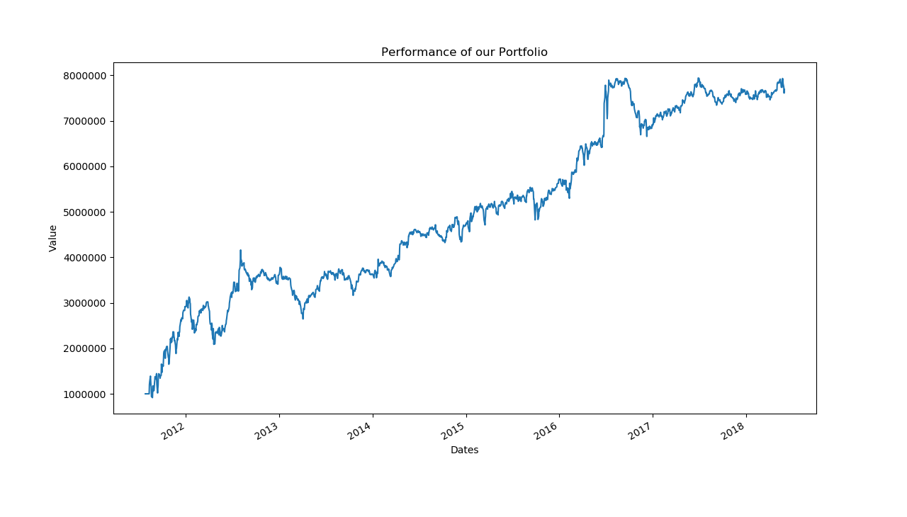

Cluster Analysis
I also analyzed the Clusters for first year into graphs in order to select an optimal number of clusters (k) to be used for K-means Algorithm.
As it can be seen below, the error does not decrease much after 5 clusters and thus I selected k=5 for the portfolio construction.
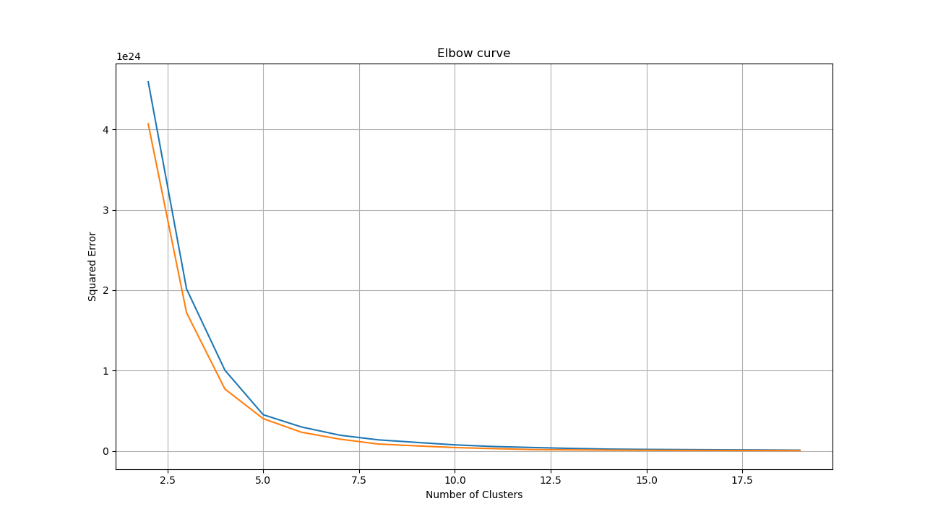

The chart below also described the distribution of the clusters and compares the variances within different clusters.
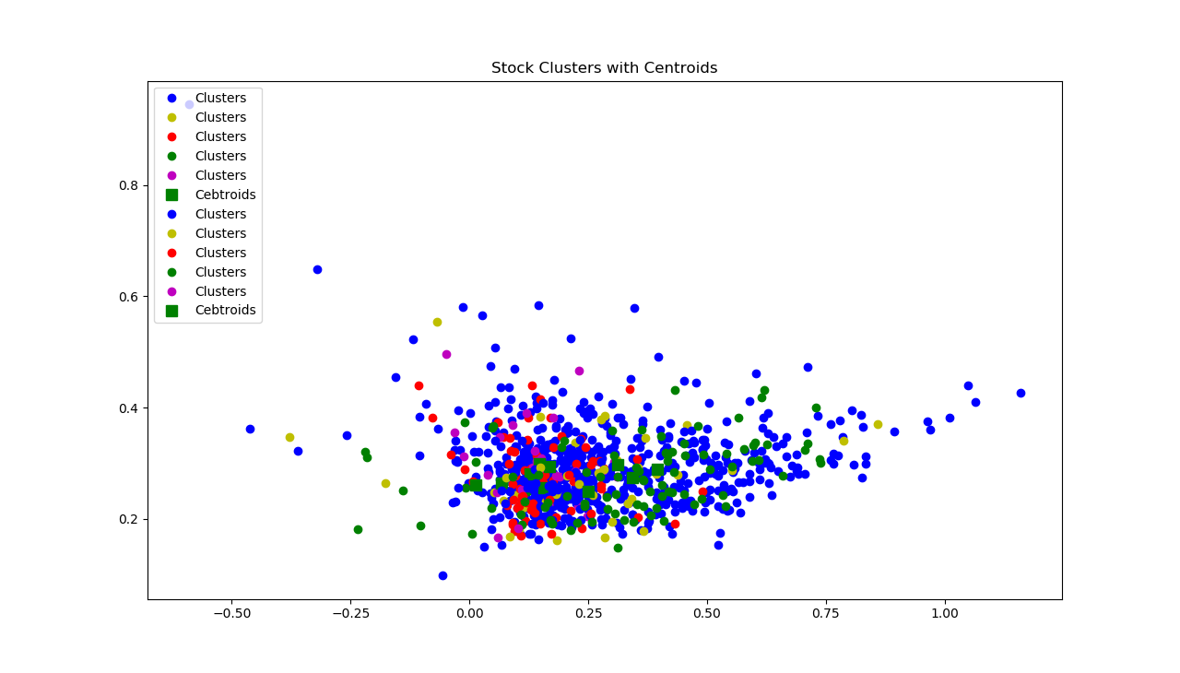

Risk Metrics
The program also calculates the following Risk and Return metrics.

CAGR | 34.7%
Standard_Deviation | 32.9%
MaxDrawdown | 36.4%
LakeRatio | 0.07
GainPainRatio | 0.28
Sharpe_Ratio | 1.02
Win_Rate | 49.1%
Loss_Rate | 50.9%
Average_Win_Returns | 1.29%
Average_Loss_Returns | -1.27%

The CAGR is very high at 34.7% and it points to the fact that the strategy which used volume and standard deviation as a base to assess mean reversion signals, works quite well. The standard deviation is also quite high at 32.9%. The maximum drawdown is reasonably large at 36.4%. This points to the fact that we need to add more variables to the alphas in order to introduce more stability to the performance.
The Lake ratio is 0.07 and is quite low and is another metric that shows good performance. The Gain-to-Pain ratio is on the lower side of acceptable range at 0.28 and depicts that variance of the strategy is much higher than optimal value. The Sharpe ratio is 1.02: it shows that the performance is around average level. In reality, quantitative funds can use Alphas with a Sharpe ratio of greater than 1, given than the Sharpe ratio does consider transaction costs and slippage (in our case we have not considered that). The Win Rate is 49% and Loss rate is 51% which again points to the fact that there is much room for improvement in our strategy. The average Win return is 1.29% and average lose return is -1.27%. Here the average loss return should ideally have been much lower than average Win return.
Overall, the strategy gives an average performance with high returns with a reasonably high volatility.

Improvement and focus areas
There are a few areas that I would like to explore further

- Add transaction cost and slippage costs to the P&L

- Add a fundamental criteria to select the stocks based on market cap, minimum trading volume, maximum volatility

- Add more variables in the Alpha formula in order to reduce volatility

- Explore more innovative ways to create clusters through K-Means algorithm (using industry, sub-industry, fundamental ratios (P/B,P/E etc.)

SWOT Analysis

Strengths  - Project scope targets strategies that are used in industry.  - The Alphas strategy is at the back of various research papers that have been thoroughly tested and have shown good results.  - The project mimics Websim in Python code and hence adds flexibility to a simulator that allows exploring various Alphas expression.  - The project uses machine learning through K-means algorithm to construct Long-Short portfolios.  - The project shows high CAGR and low Lake ratio and hence gives an above average return | Weaknesses  - The project performance has high volatility, high maximum drawdown, low gain-to-pain ratio and an average win ratio  - The project doesn’t explore different settings of Delay, Decay and maximum weight in the code. I have just manually tested various settings and used the optimal one but the code itself doesn’t do it automatically  - The project doesn’t consider the stock turnover.  - The project doesn’t explore more than last 7 years of historical data and also doesn’t cover the performance during 2008 crisis.
Opportunities  - The project should consider the impact of transaction costs and slippages.  - It should also consider using more machine learning algorithms like decision trees and neural networks  - The Alpha expression should include more variable that could help stabilize the performance and reduce volatility  - We could have used some paid service for the data and this would eliminate data noise. It will also improve the stock coverage  - The project should also include fundamental ratios and industry information to select and create clusters  - The project should also use fundamental ratios e.g. P/B, P/E, EPS, Debt coverage etc. in order to select stock universe and also stabilize the Alpha performance  - It could also explore adding more technical indicator like Bollinger Bands and MACD to generate and strengthen existing trading signals and apply stop-limits to existing positions | Threats  - Adding transaction costs and slippages would degrade the performance  - In real world, Delay 0 Alpha strategies are difficult to implement especially when the alphas are based on the closing price (daily returns of that day)  - Real world quantitative funds wouldn’t normally have tolerance for maximum drawdown on 34% and hence the strategy needs to be improved in order to be used practically.  - The strategy might not perform well if tested during the crisis period of 2008.  - The dependency of the strategy on reliable volume data poses limitation with respect to liquidity of the underlying and certain minimum threshold must be applied while selecting liquidity of stocks universe.

References

- Deok Hyeon Lee, Min Ki Kim,and Tong Suk Kim, “Abnormal Trading Volumeand the Cross-Section of Stock Returns”, April 30 2016
- Charles M. C. Lee and Bhaskaran Swaminathan , Price Momentum and Trading Volume , Oct 2000
- Amihud, Y., 2002, Illiquidity and stock returns: cross-section and time-serieseffects. Journal of financial markets, 5(1), 31-56.
- Anderson, A. M. and Dyl, E. A., 2005, Market structure and trading volume. Journal of Financial Research, 28(1), 115-131.
- Asquith, P., Pathak, P. A., and Ritter, J. R., 2005, Short interest, institutional ownership, and stock returns. Journal of Financial Economics, 78(2), 243-276.
- Avramov, D., Chordia, T., and Goyal, A., 2006, Liquidity and autocorrelations in individual stock returns. Journal of Finance, 61(5), 2365-2394.
- Baker, M. and Wurgler, J., 2006, Investor sentiment and the cross‐section of stock returns. The Journal of Finance, 61(4), 1645-1680.
- Ball, R. and Brown, P., 1968, An empirical evaluation of accounting income numbers. Journal of accounting research, 159-178.
- Bamber, L. S. and Cheon,Y. S., 1995, Differential price and volume reactions to accounting earnings announcements. Accounting Review, 417-441.
- Banerjee, S. and Kremer, I., 2010, Disagreement and learning: Dynamic patterns of trade. The Journal of Finance, 65(4), 1269-1302.
- Barber, B. M., & Odean, T., 2000, Trading is hazardous to your wealth: The common stock investment performance of individual investors. The journal of Finance, 55(2), 773-806.
- Barber, B. M. and Odean, T., 2008, All that glitters: The effect of attention and news on the buying behavior of individual and institutional investors. Review of Financial Studies, 21(2), 785-818.
- Barber, B. M., Odean, T., and Zhu, N., 2009, Do retail trades move markets?. Review of Financial Studies, 22(1), 151-186.
- Beaver, W. H., 1968, The information content of annual earnings announcements. Journal of accounting research, 67-92.

