PROJECT DOCUMENT
AI Augmented Backend Development
Weather Wise API
Submitted by
B Anusri

1. Introduction
Weather Wise API is a backend service built with AI-augmented development. It provides current weather conditions and multi-day forecasts through a clean REST interface, and adds an AI-generated, human-friendly summary with a practical tip to every response.
AI tools were used throughout development: to scaffold the project, generate endpoint and schema code, write tests, and review the code for errors. This sped up delivery while keeping the codebase readable and consistent.

2. Objectives
- Deliver accurate weather data through a simple, well-documented REST API.
- Enhance raw data with AI by generating short, natural-language summaries and advice.
- Demonstrate AI-augmented development by using AI assistance across coding, testing, and documentation.
- Keep the backend fast and scalable using asynchronous request handling.

3. Features of the Project
- Current weather by city: temperature, feels-like, humidity, wind speed, and conditions.
- Multi-day forecast: 1 to 7 day forecast through a single endpoint.
- AI-generated weather summary: a friendly one-line summary with a practical tip such as what to wear or carry.
- Input validation: request and response data validated with Pydantic models.
- Clear error handling: proper HTTP status codes, such as 404 for an unknown city.
- Asynchronous processing: non-blocking calls to external weather and AI services.
- Auto-generated API docs: interactive Swagger UI at /docs and ReDoc at /redoc.
- Health-check endpoint: /health for uptime monitoring.
- Secure configuration: API keys kept in environment variables, never in source code.
- CORS support: ready to be consumed by web and mobile front ends.

4. Technology Stack
Component | Technology
Language | Python 3
Framework | FastAPI
Data validation | Pydantic
HTTP client | HTTPX (async)
Server | Uvicorn
AI integration | LLM API for weather summaries
Testing | Pytest

5. Project Structure
The project follows a modular layout that separates routing, business logic, and data models.
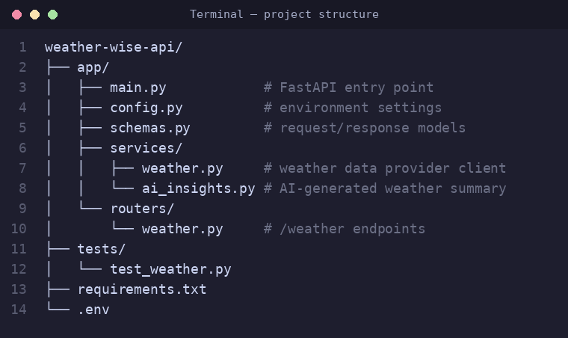
Figure 1: Project folder structure

6. Implementation (Code Screenshots)

6.1 Application entry point
The FastAPI application is created in main.py. CORS middleware, the versioned router, and the health-check endpoint are registered here.
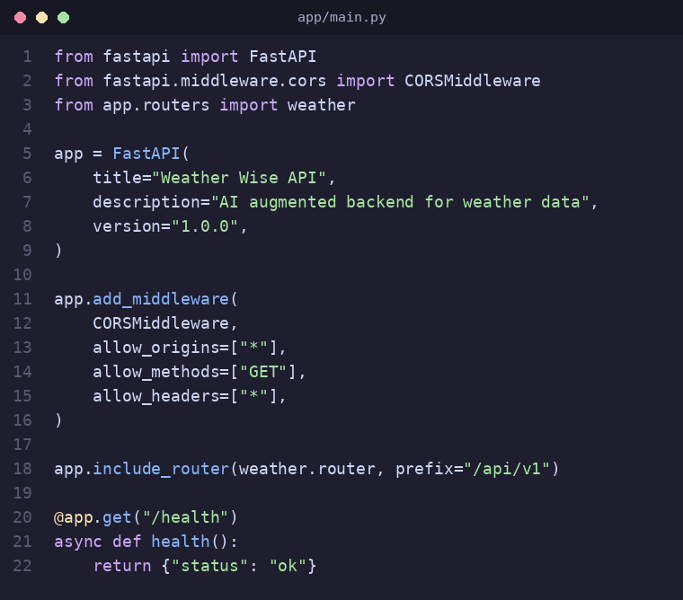
Figure 2: main.py – application setup

6.2 Weather endpoints
The router exposes the current-weather and forecast endpoints. Query parameters are validated, and the AI summary is attached to the weather data before it is returned.
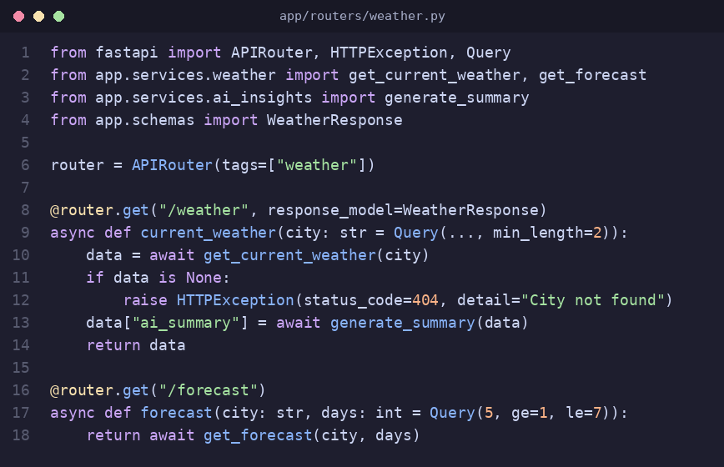
Figure 3: routers/weather.py – API endpoints

6.3 AI insights service
This service sends the weather data to an AI model and returns a short, friendly summary with a practical tip.
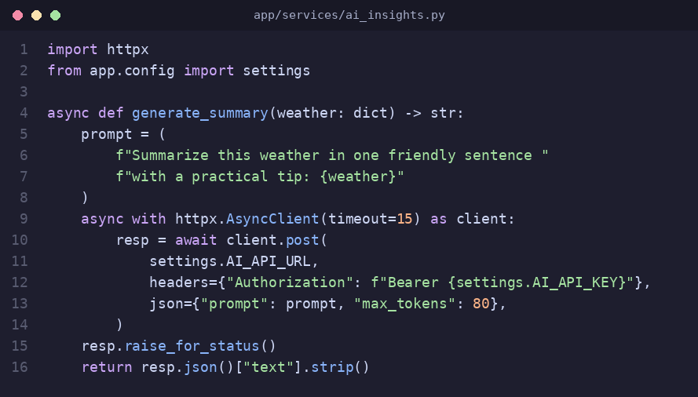
Figure 4: services/ai_insights.py – AI summary generation

6.4 Response schema
Pydantic models define the exact structure of the API response.
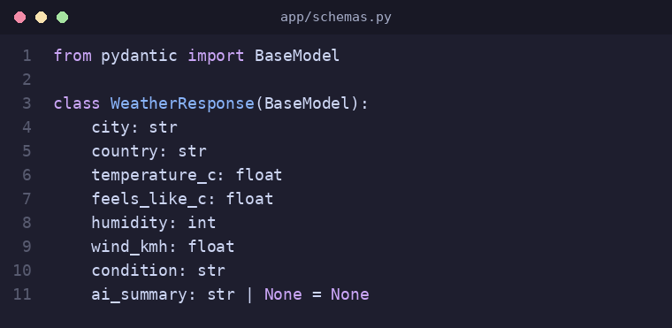
Figure 5: schemas.py – response model

7. API Endpoints
Method | Endpoint | Description
GET | /health | Checks that the service is running
GET | /api/v1/weather?city={name} | Current weather with AI summary
GET | /api/v1/forecast?city={name}&days={1-7} | Multi-day weather forecast
GET | /docs | Interactive Swagger documentation

8. Sample Output
Example request and response for the current-weather endpoint:
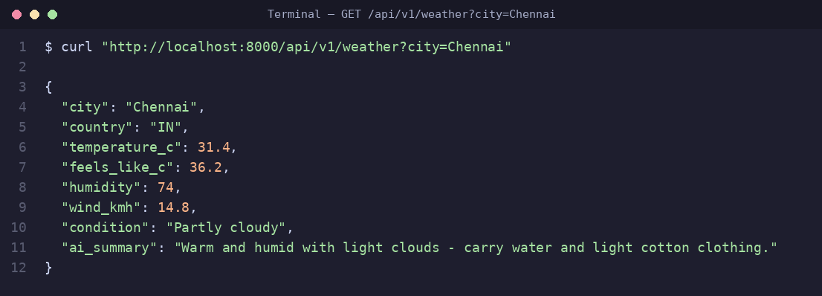
Figure 6: Sample API request and response

9. Role of AI in Development
- Scaffolding: generating the initial project structure and boilerplate.
- Code generation: drafting endpoints, schemas, and service functions.
- Debugging: explaining errors and suggesting fixes.
- Testing: creating unit test cases for the endpoints.
- Documentation: producing docstrings and this project document.

10. Conclusion
Weather Wise API shows how AI assistance can speed up backend development while producing clean, maintainable code. The result is a fast, validated, and well-documented weather service that goes beyond raw data by giving users clear, useful advice.

Future Enhancements
- Response caching to reduce external API calls and improve speed.
- User authentication and rate limiting.
- Weather alerts and saved favorite locations.
- Docker deployment and a CI/CD pipeline.

