PROJECT DOCUMENTATION
AI FitTrack API
A fitness tracking REST API powered by AI
Developed using Node.js, Express and the Google Gemini API
Item | Details
Project name | AI FitTrack API
Runtime | Node.js (v18 or later)
Framework | Express.js
AI provider | Google Gemini API (Google API key)
Editor / IDE | Visual Studio Code
Version | 1.0.0
Document date | September 29, 2026
Author | [Your Name]

Table of Contents

1. Introduction
AI FitTrack API is a RESTful backend that relies on generative AI to create tailored fitness content. Any client, whether a mobile app, a web app or a plain HTTP tool, can submit a brief description of a person's goal, training level and available equipment. The API then responds with a structured JSON workout or meal plan produced by Google's Gemini model.
The service is built in JavaScript on Node.js, with Express handling routing, and was written in Visual Studio Code. Access to the AI service is authorised through a Google API key, which sits in an environment variable on the server and is never sent to the client.

1.1 Problem Statement
One-size-fits-all fitness plans overlook a person's goals, experience and equipment, and employing a personal trainer for each user is not practical at scale. This project automates the creation of plans and keeps the output in a fixed structure, so any front end can display it without extra processing.

1.2 Objectives
- Offer straightforward REST endpoints that return AI-generated workout and meal plans.
- Send back strictly structured JSON so any client can use the responses with ease.
- Keep the Google API key private on the server by storing it in environment variables.
- Check incoming data, report errors in a consistent way and curb misuse through rate limiting.
- Organise the code into modules so further AI-powered features can be added with little effort.

2. Technology Stack
Technology | Version | Purpose
Node.js | 18+ | JavaScript runtime that runs the server
Express.js | 4.19 | Web framework used for routing and middleware
@google/generative-ai | 0.21 | Google's official SDK for working with Gemini models
dotenv | 16.4 | Reads secrets from the .env file into process.env
helmet | 7.1 | Adds secure HTTP response headers
cors | 2.8 | Allows cross-origin requests from front-end apps
express-rate-limit | 7.4 | Guards the API against too many requests
nodemon | 3.1 | Restarts the server automatically while developing
Visual Studio Code | Latest | Code editor with a built-in terminal

3. System Architecture
The API is built in layers, and each layer has one clear job. This makes the code simpler to test and extend.
Layer | Responsibility
Client | Any application that sends HTTP requests with JSON bodies.
Middleware | Helmet, CORS, JSON parsing and rate limiting all run before a request reaches a route.
Routes | Check the request and pass it to the service layer (src/routes/fitness.js).
Service | Creates the prompts, calls Gemini and parses the JSON it returns (geminiService.js).
Google Gemini API | Produces the plan, and is accessed using the Google API key.
Error handler | Turns any error that is thrown into a clean JSON response.

3.1 Request Flow
- A client sends a POST request with a JSON body, for instance to /api/workout-plan.
- The security and rate-limit middleware handle the request first.
- The route checks that the required fields are present and responds with HTTP 400 if any are absent.
- The service assembles a prompt and sends it to the Gemini model together with the API key.
- Gemini returns JSON text, which the service parses and checks.
- The route responds with HTTP 200 and the plan, or the error handler sends back a clean error.

4. Project Structure
ai-fittrack-api/
├── server.js # App entry point
├── package.json # Dependencies and scripts
├── .env # Secrets (not committed)
├── .gitignore
└── src/
├── routes/
│ └── fitness.js # API endpoints
├── services/
│ └── geminiService.js # Google Gemini integration
└── middleware/
└── errorHandler.js # 404 and error handling

5. Installation and Setup

5.1 Prerequisites
- Node.js 18 or newer together with npm (verify using node -v and npm -v).
- Visual Studio Code.
- A Google API key that has the Gemini API enabled.

5.2 Steps
- Launch VS Code, select File > Open Folder and pick the project folder.
- Open the integrated terminal (Ctrl + `) and run: npm init -y
- Install the required packages: npm install express cors helmet dotenv express-rate-limit @google/generative-ai
- Install the development dependency: npm install --save-dev nodemon
- Create a .env file and add your Google API key to it (refer to Section 6).
- Run the server with npm run dev for development or npm start for production.
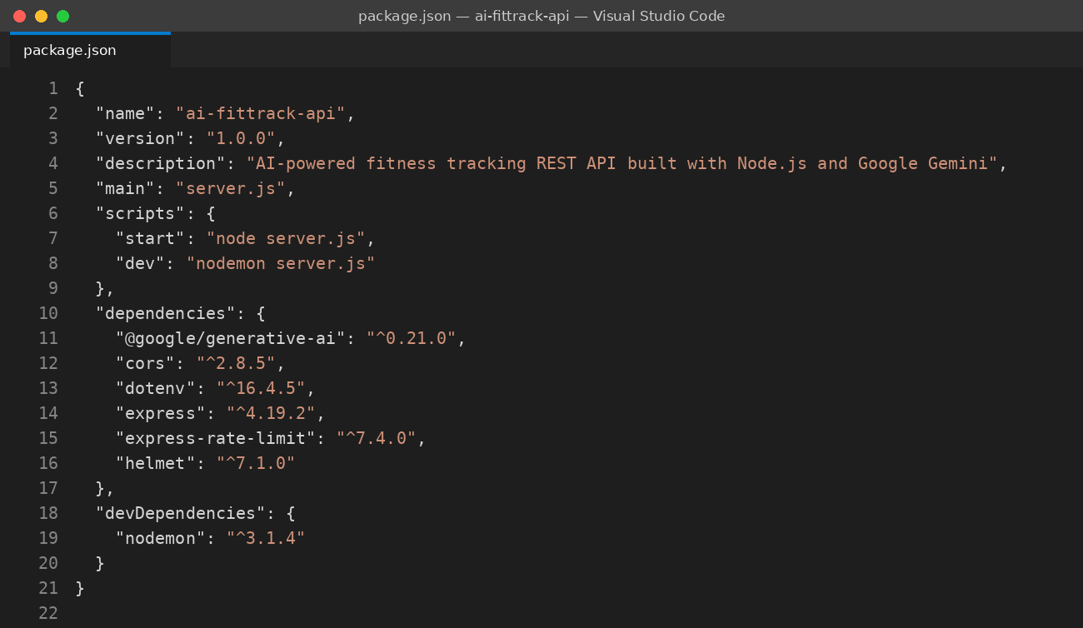
Figure 1: package.json showing the dependencies and npm scripts
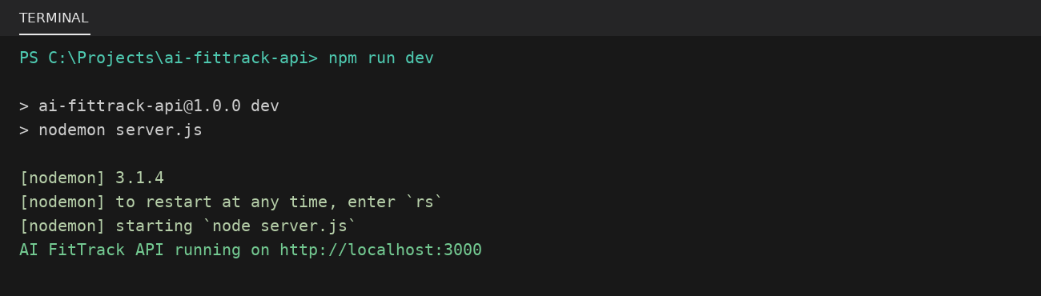
Figure 2: The server starting in the VS Code terminal

6. Google API Key Configuration
The Gemini model is accessed through a Google API key. Use the steps below to generate and set it up:
- Open Google AI Studio (aistudio.google.com) and log in with your Google account.
- Click Get API key and then Create API key.
- Copy the generated key and place it in the GOOGLE_API_KEY variable inside the .env file.
- List .env in .gitignore so the key never gets pushed to GitHub.
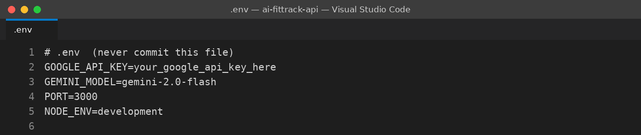
Figure 3: Environment variables kept in the .env file
Security note: Do not hard-code the API key in any source file, avoid sharing screenshots that reveal a real key, and generate a new key straight away if it is ever leaked. For production, rely on the secret manager of your hosting platform.

7. Code Walkthrough

7.1 Application Entry Point (server.js)
server.js loads the environment variables, sets up the global middleware and attaches the routes. Helmet applies secure headers, CORS lets browser-based clients connect, and the rate limiter allows each client 30 requests per minute across all /api routes. A health-check endpoint allows monitoring tools to confirm the service is running.
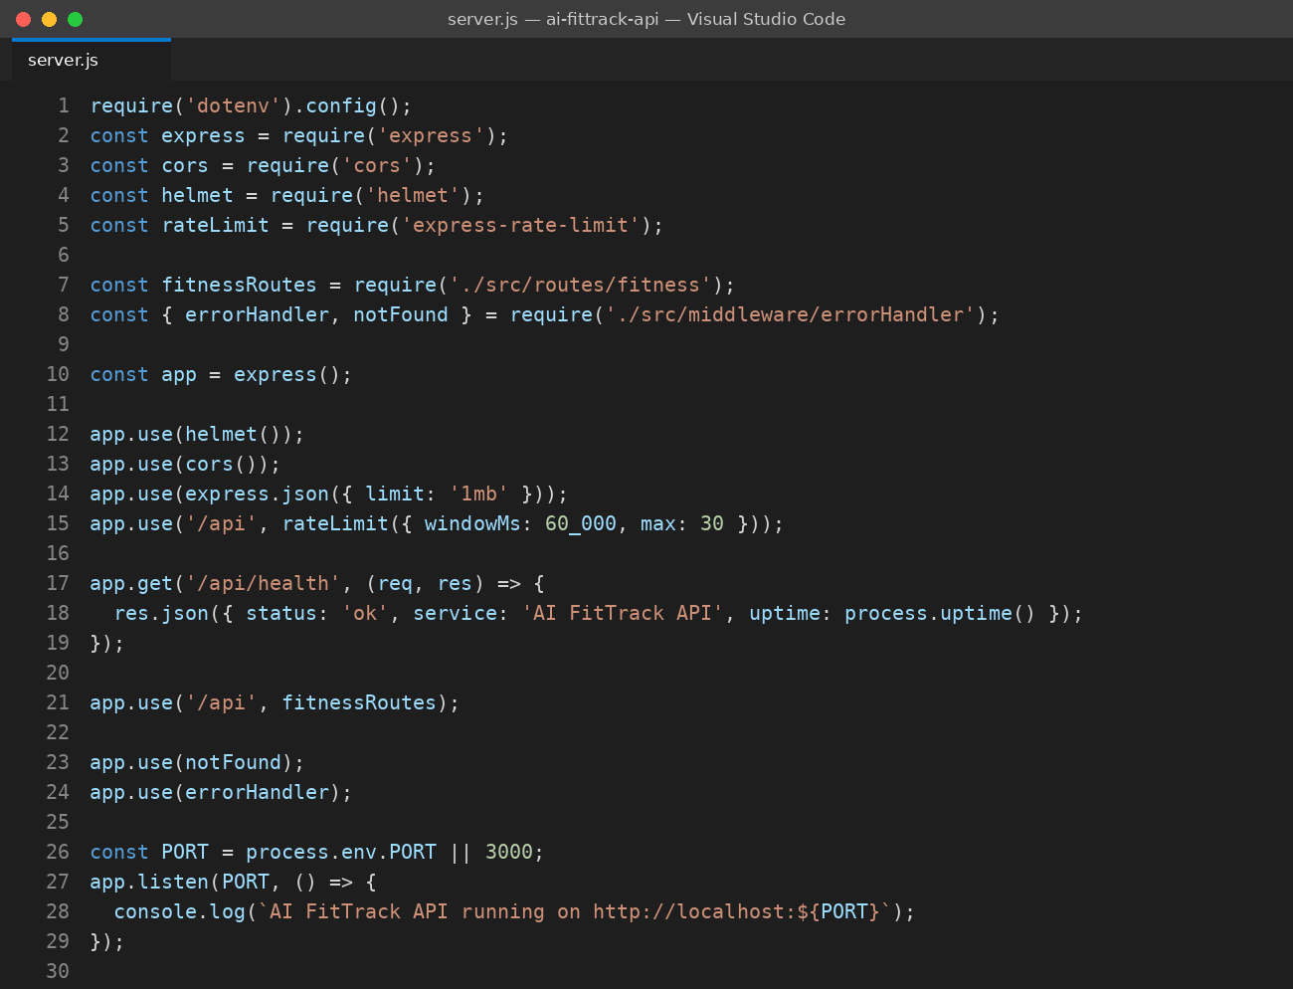
Figure 4: server.js with the Express setup, middleware and health check

7.2 Gemini Service (geminiService.js)
Only this module communicates with Google. It will not start if the API key is absent, it creates the Gemini model, and it instructs the model to reply in JSON (responseMimeType: application/json). The askGemini function parses the response and raises a 502 error when the AI sends back invalid data. workoutPrompt assembles a detailed prompt from the user's goal, level, training days per week and equipment.
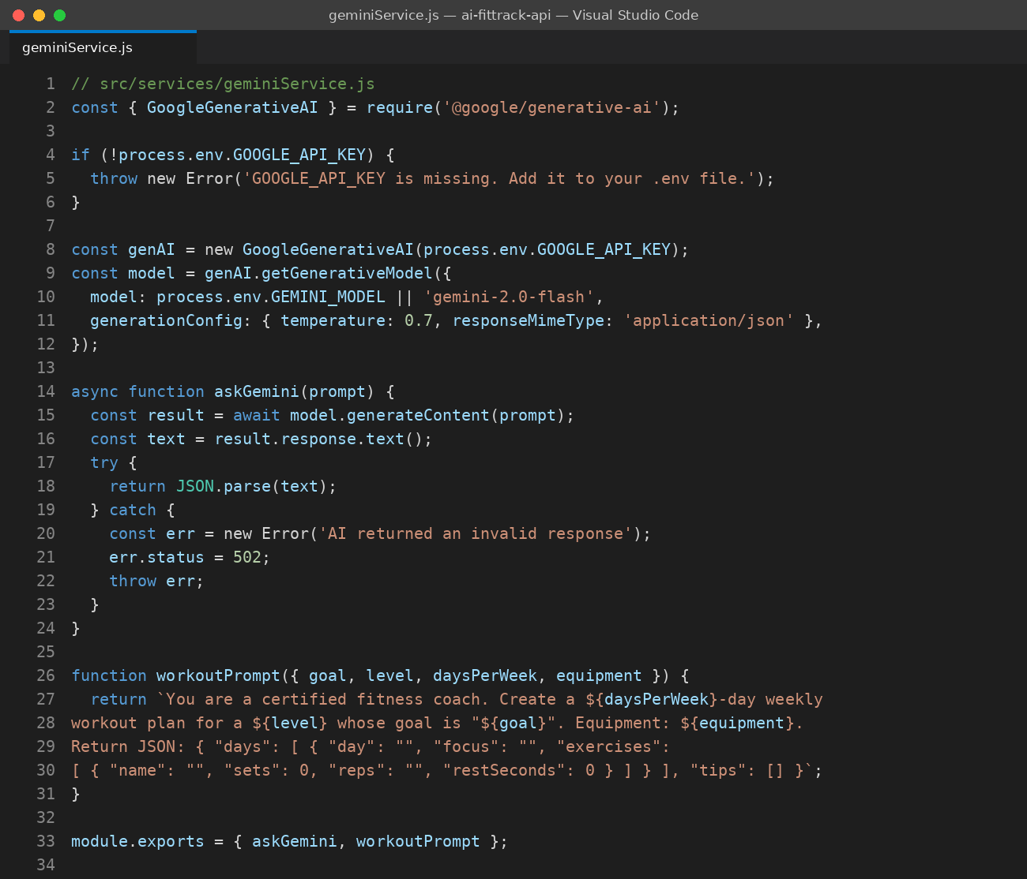
Figure 5: geminiService.js with the Google API key, model setup and prompt builder

7.3 Routes (fitness.js)
The routes check the input and hand the work to the service. Errors are forwarded with next(err), so a single central handler formats every failure.
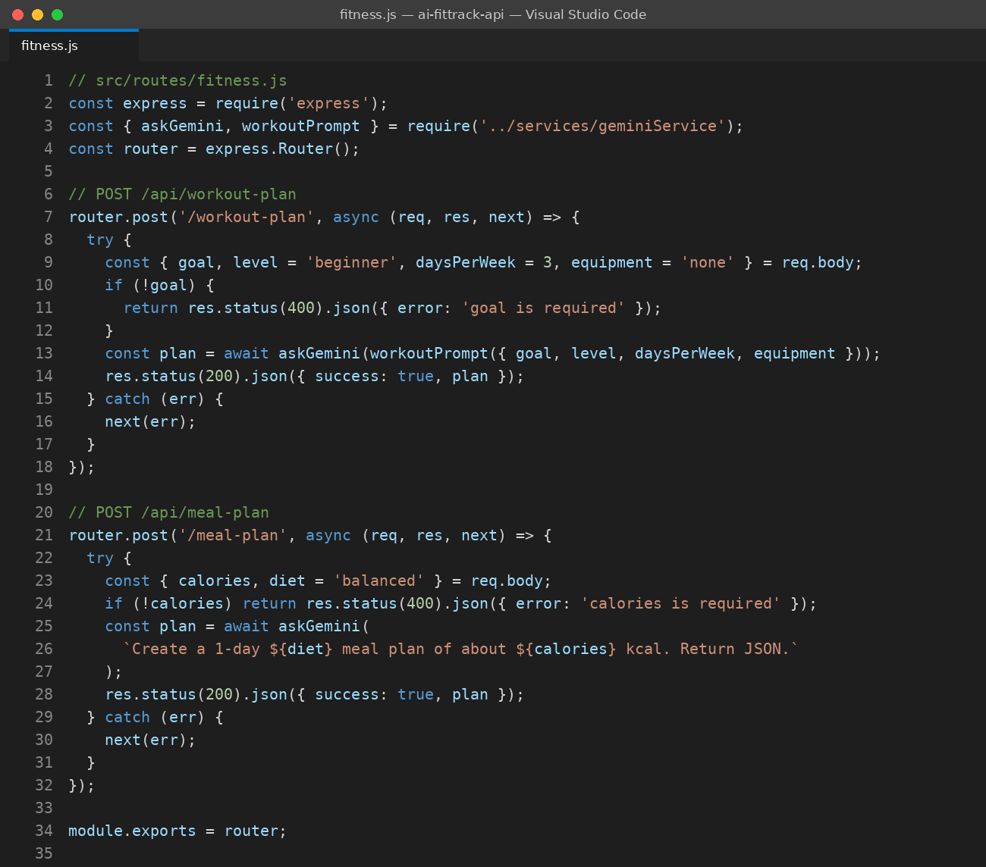
Figure 6: fitness.js with the workout-plan and meal-plan endpoints

7.4 Error Handling (errorHandler.js)
notFound sends a 404 for routes that do not exist. errorHandler records the actual error on the server and sends the client a safe message, which keeps internal details private.
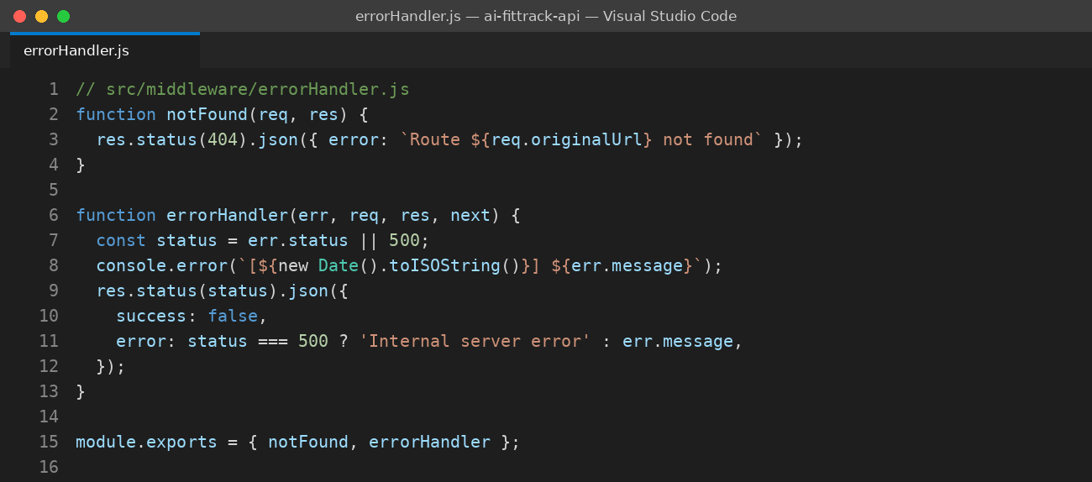
Figure 7: errorHandler.js with centralised error responses

8. API Reference
Base URL (local): http://localhost:3000
Method | Endpoint | Description
GET | /api/health | Reports the service status and uptime.
POST | /api/workout-plan | Creates a weekly workout plan based on the user's goal, level, days and equipment.
POST | /api/meal-plan | Creates a one-day meal plan from a calorie target and a diet type.

8.1 POST /api/workout-plan
Field | Type | Required | Description
goal | string | Yes | Fitness goal, for example "build muscle" or "lose weight".
level | string | No | One of beginner, intermediate or advanced. Default: beginner.
daysPerWeek | number | No | Number of training days each week. Default: 3.
equipment | string | No | Equipment the user has. Default: none.

Example request body:
{
"goal": "build muscle",
"level": "beginner",
"daysPerWeek": 3,
"equipment": "dumbbells"
}

8.2 POST /api/meal-plan
Field | Type | Required | Description
calories | number | Yes | Target number of calories per day.
diet | string | No | Type of diet, for example vegetarian. Default: balanced.

8.3 Response Codes
Status | Meaning
200 | Success. The generated plan is returned in the plan field.
400 | The request is missing a required field.
404 | The route you requested does not exist.
429 | Too many requests. Wait a minute and retry.
502 | The AI service sent back an invalid response.
500 | An unexpected server error occurred.

9. Testing the API
You can test the API from the VS Code terminal using curl, or with tools like Postman, Thunder Client (a VS Code extension) or Insomnia. The example below asks for a beginner workout plan and displays a successful response.
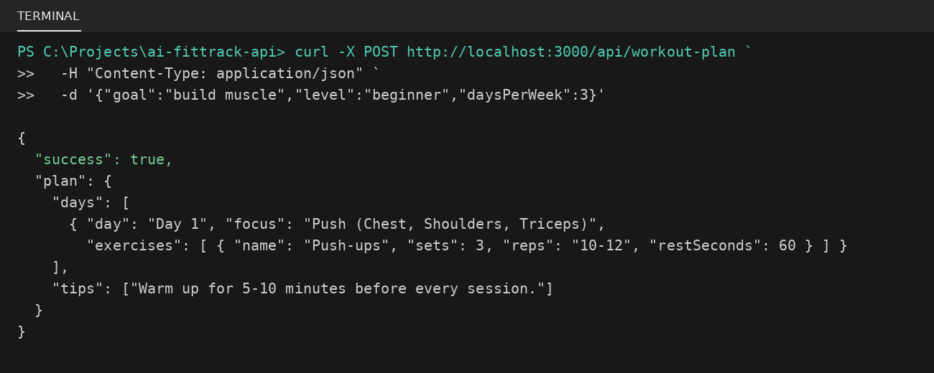
Figure 8: Testing the workout-plan endpoint and its JSON response

9.1 Test Checklist
Test case | Expected result
GET /api/health | Status 200 with { "status": "ok" }
POST /api/workout-plan with a valid body | Status 200 with a plan containing days and tips
POST /api/workout-plan without goal | Status 400 with the message "goal is required"
GET /api/unknown | Status 404 with a route-not-found message
Server started without GOOGLE_API_KEY | Startup error stating that the key is missing
More than 30 requests in one minute | Status 429 returned by the rate limiter

10. Security and Best Practices
- Secret management. The Google API key is stored only in .env and is read through dotenv.
- Secure headers. Helmet applies protective HTTP headers.
- Rate limiting. Rate limiting discourages abuse and safeguards the API quota.
- Input validation. Required fields are verified before any call to the AI is made.
- Safe errors. Internal error details are kept away from clients.
- Payload limits. The JSON request body is limited to 1 MB.

11. Troubleshooting
Problem | Solution
GOOGLE_API_KEY is missing | Add the .env file to the project root folder and restart the server.
API key not valid (403) | Make sure the key was copied correctly and that the Gemini API is turned on.
Cannot find module | Run npm install inside the project folder.
Port 3000 already in use | Change PORT in .env, or close the other program that is using it.
502 invalid AI response | Try the request again, or tighten the prompt so it enforces the JSON schema.
429 Too Many Requests | Wait a minute, or increase the limit in server.js.

12. Future Enhancements
- User accounts secured with JWT authentication.
- A database (MongoDB or PostgreSQL) for saving workout history and progress.
- A progress-analysis endpoint that looks at logged workouts and recommends adjustments.
- Caching of responses to reduce cost and speed up replies.
- Automated testing using Jest and Supertest.
- Docker-based deployment with a CI/CD pipeline.
- Interactive Swagger / OpenAPI documentation.

13. Conclusion
AI FitTrack API shows how a compact Node.js service can turn a generative AI model into a practical, well-structured product feature. Its layered design, careful handling of the Google API key and consistent error handling give it a strong foundation for a complete fitness application.

