PROJECT DOCUMENTATION
AI FitTrack API
An AI-powered fitness tracking REST API
Built with Node.js, Express and the Google Gemini API
Item | Details
Project name | AI FitTrack API
Runtime | Node.js (v18 or later)
Framework | Express.js
AI provider | Google Gemini API (Google API key)
Editor / IDE | Visual Studio Code
Version | 1.0.0
Document date | September 28, 2026
Author | [Your Name]

Table of Contents

1. Introduction
AI FitTrack API is a RESTful backend service that uses generative AI to produce personalised fitness content. A client application (mobile app, web app or any HTTP client) sends a short description of a user's goal, experience level and available equipment, and the API returns a structured JSON workout plan or meal plan generated by Google's Gemini model.
The project is written in JavaScript on the Node.js runtime, uses Express for routing, and was developed in Visual Studio Code. Authentication with the AI service is handled with a Google API key that is stored securely in an environment variable and is never exposed to the client.

1.1 Problem Statement
Generic fitness plans ignore individual goals, experience and equipment. Hiring a coach for every user does not scale. This project automates plan creation while keeping the output structured so that any front end can render it directly.

1.2 Objectives
- Provide simple REST endpoints that return AI-generated workout and meal plans.
- Return strictly structured JSON so responses are easy to consume in any client.
- Keep the Google API key secret on the server using environment variables.
- Validate input, handle errors consistently and limit abuse with rate limiting.
- Keep the code modular so new AI-powered features can be added quickly.

2. Technology Stack
Technology | Version | Purpose
Node.js | 18+ | JavaScript runtime that executes the server
Express.js | 4.19 | Web framework for routing and middleware
@google/generative-ai | 0.21 | Official Google SDK for calling Gemini models
dotenv | 16.4 | Loads secrets from the .env file into process.env
helmet | 7.1 | Sets secure HTTP response headers
cors | 2.8 | Enables cross-origin requests from front ends
express-rate-limit | 7.4 | Protects the API from excessive requests
nodemon | 3.1 | Auto-restarts the server during development
Visual Studio Code | Latest | Code editor and integrated terminal

3. System Architecture
The API follows a layered structure. Each layer has a single responsibility, which keeps the code easy to test and extend.
Layer | Responsibility
Client | Any app that sends HTTP requests with JSON bodies.
Middleware | Helmet, CORS, JSON parsing and rate limiting run before any route.
Routes | Validate the request and call the service layer (src/routes/fitness.js).
Service | Builds prompts, calls Gemini and parses the JSON reply (geminiService.js).
Google Gemini API | Generates the plan. Accessed with the Google API key.
Error handler | Converts any thrown error into a clean JSON response.

3.1 Request Flow
- The client sends a POST request, for example to /api/workout-plan, with a JSON body.
- Security and rate-limit middleware process the request.
- The route validates the required fields and returns HTTP 400 if any are missing.
- The service builds a prompt and sends it to the Gemini model using the API key.
- Gemini replies with JSON text, which the service parses and validates.
- The route returns HTTP 200 with the plan, or the error handler returns a clean error.

4. Project Structure
ai-fittrack-api/
├── server.js # App entry point
├── package.json # Dependencies and scripts
├── .env # Secrets (not committed)
├── .gitignore
└── src/
├── routes/
│ └── fitness.js # API endpoints
├── services/
│ └── geminiService.js # Google Gemini integration
└── middleware/
└── errorHandler.js # 404 and error handling

5. Installation and Setup

5.1 Prerequisites
- Node.js 18 or later and npm (check with node -v and npm -v).
- Visual Studio Code.
- A Google API key with the Gemini API enabled.

5.2 Steps
- Open VS Code, then choose File > Open Folder and select the project folder.
- Open the integrated terminal (Ctrl + `) and run: npm init -y
- Install the dependencies: npm install express cors helmet dotenv express-rate-limit @google/generative-ai
- Install the development tool: npm install --save-dev nodemon
- Create the .env file and paste your Google API key (see Section 6).
- Start the server with npm run dev (development) or npm start (production).
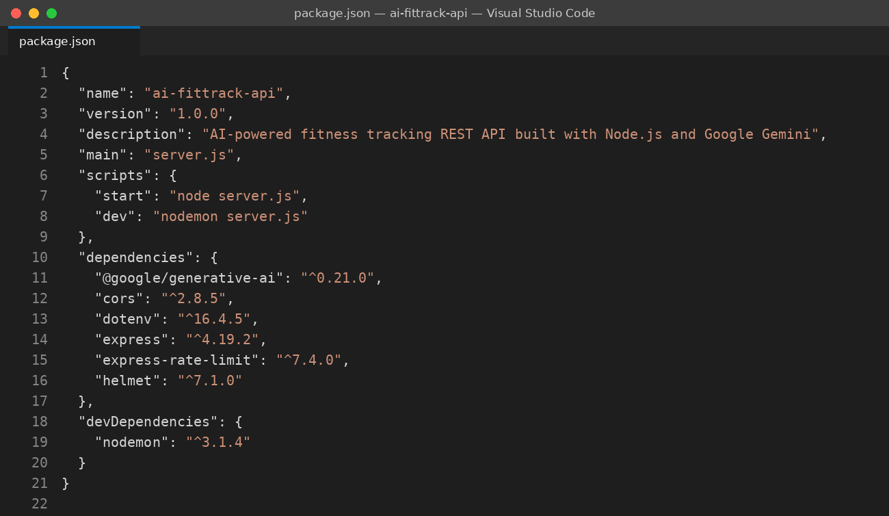
Figure 1: package.json with dependencies and npm scripts
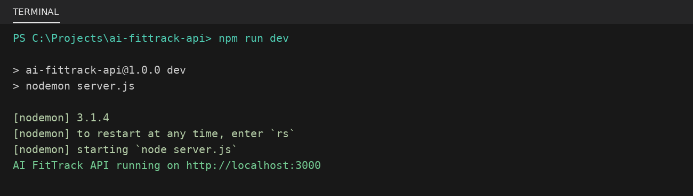
Figure 2: Starting the server from the VS Code terminal

6. Google API Key Configuration
The Gemini model is accessed with a Google API key. Follow these steps to create and configure it:
- Go to Google AI Studio (aistudio.google.com) and sign in with a Google account.
- Select Get API key, then Create API key.
- Copy the key and paste it into the GOOGLE_API_KEY variable in the .env file.
- Add .env to .gitignore so the key is never uploaded to GitHub.
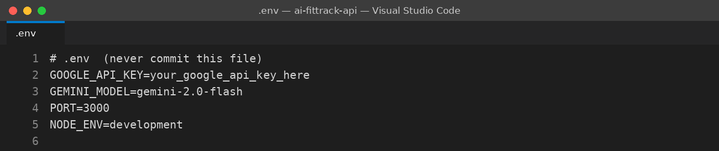
Figure 3: Environment variables stored in the .env file
Security note: Never hard-code the API key in source files, never share screenshots that show a real key, and regenerate the key immediately if it is ever exposed. In production, use the hosting platform's secret manager.

7. Code Walkthrough

7.1 Application Entry Point (server.js)
server.js loads environment variables, configures global middleware and mounts the routes. Helmet adds secure headers, CORS allows browser clients, and the rate limiter restricts each client to 30 requests per minute on all /api routes. A health-check endpoint lets monitoring tools confirm that the service is alive.
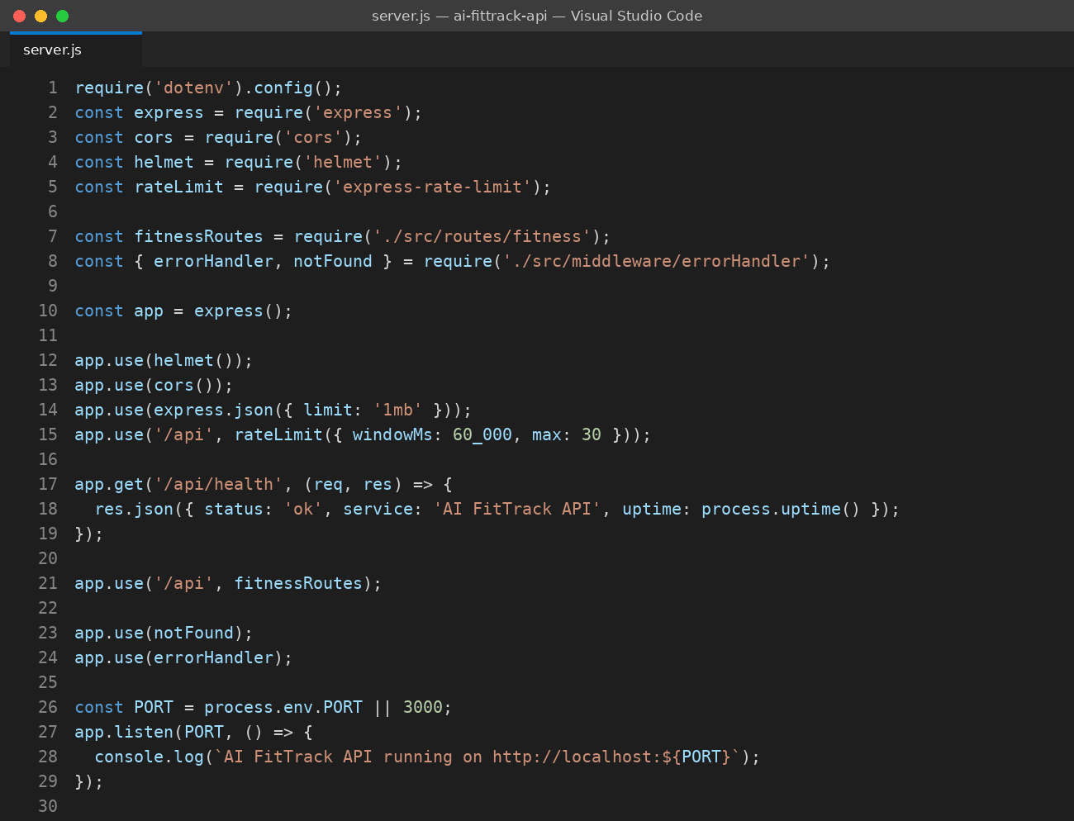
Figure 4: server.js: Express setup, middleware and health check

7.2 Gemini Service (geminiService.js)
This module is the only place that talks to Google. It refuses to start if the API key is missing, creates the Gemini model, and asks it to answer in JSON (responseMimeType: application/json). The askGemini function parses the reply and throws a 502 error if the AI returns invalid data. workoutPrompt builds a detailed prompt from the user's goal, level, days per week and equipment.
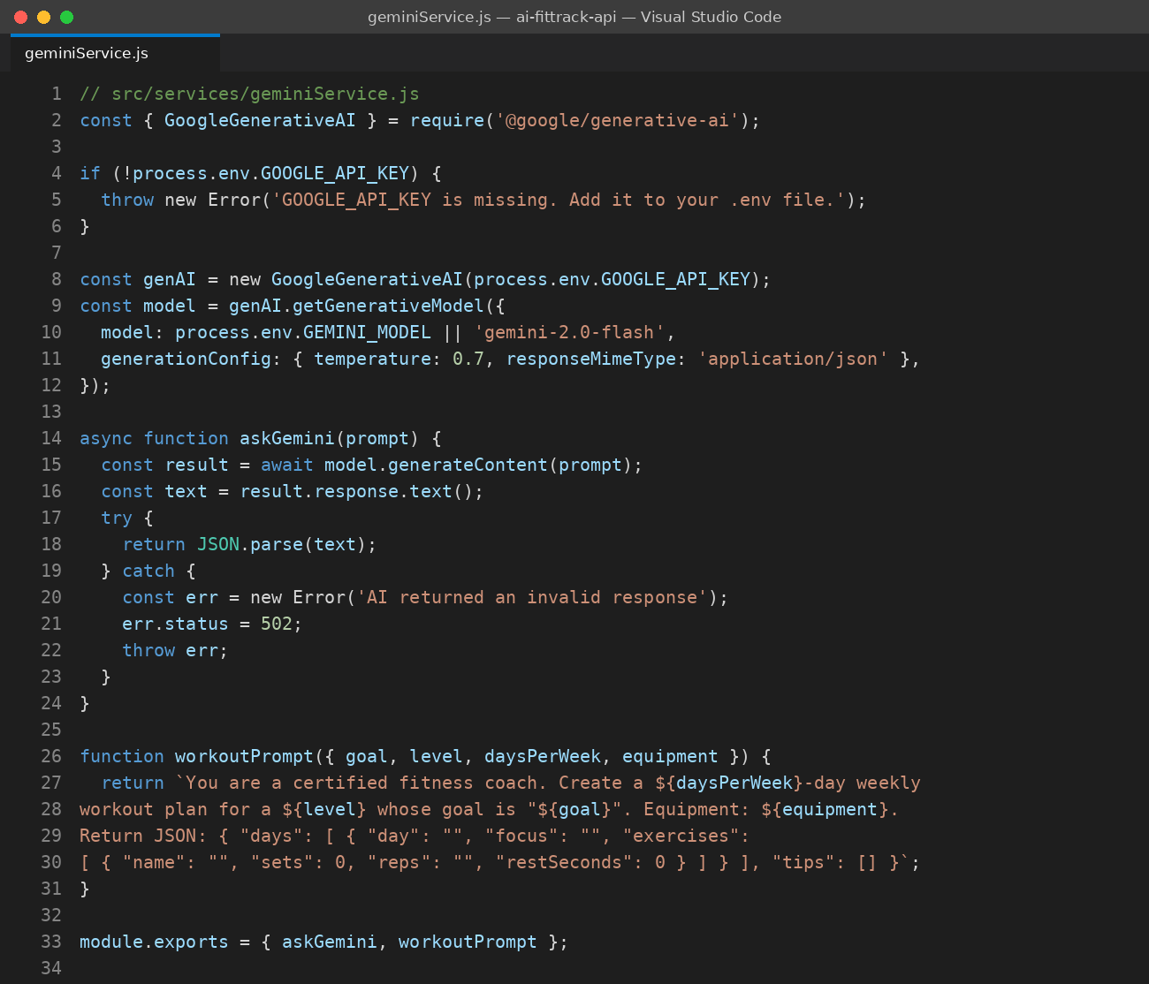
Figure 5: geminiService.js: Google API key, model setup and prompt builder

7.3 Routes (fitness.js)
The routes validate input and delegate to the service. Errors are passed to next(err) so that one central handler formats every failure.
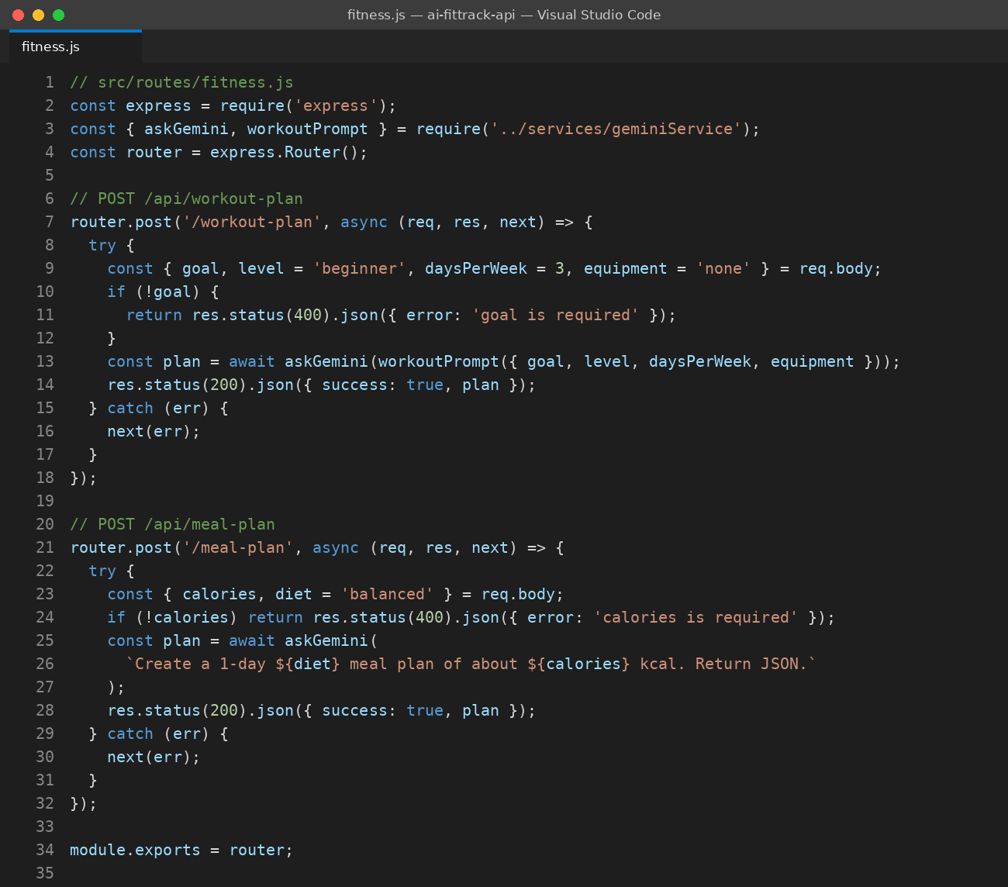
Figure 6: fitness.js: workout-plan and meal-plan endpoints

7.4 Error Handling (errorHandler.js)
notFound returns a 404 for unknown routes. errorHandler logs the real error on the server and returns a safe message to the client, so internal details are never leaked.
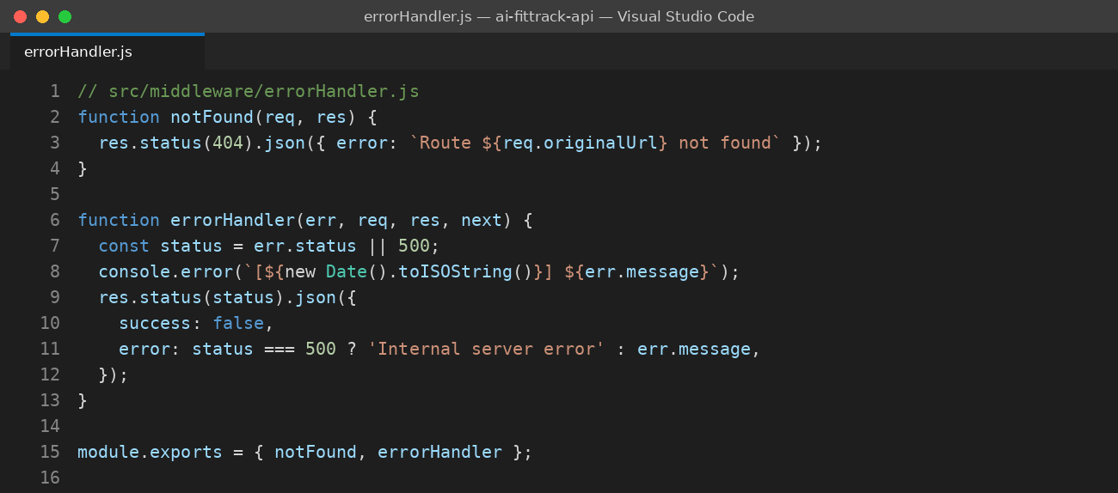
Figure 7: errorHandler.js: centralised error responses

8. API Reference
Base URL (local): http://localhost:3000
Method | Endpoint | Description
GET | /api/health | Returns service status and uptime.
POST | /api/workout-plan | Generates a weekly workout plan from the user's goal, level, days and equipment.
POST | /api/meal-plan | Generates a one-day meal plan from a calorie target and diet type.

8.1 POST /api/workout-plan
Field | Type | Required | Description
goal | string | Yes | Fitness goal, e.g. "build muscle" or "lose weight".
level | string | No | beginner, intermediate or advanced. Default: beginner.
daysPerWeek | number | No | Training days per week. Default: 3.
equipment | string | No | Available equipment. Default: none.

Sample request body:
{
"goal": "build muscle",
"level": "beginner",
"daysPerWeek": 3,
"equipment": "dumbbells"
}

8.2 POST /api/meal-plan
Field | Type | Required | Description
calories | number | Yes | Daily calorie target.
diet | string | No | Diet type, e.g. vegetarian. Default: balanced.

8.3 Response Codes
Status | Meaning
200 | Success. The plan is returned in the plan field.
400 | A required field is missing from the request.
404 | The requested route does not exist.
429 | Rate limit exceeded. Wait a minute and try again.
502 | The AI service returned an invalid response.
500 | Unexpected internal server error.

9. Testing the API
The API can be tested from the VS Code terminal with curl, or with tools such as Postman, Thunder Client (a VS Code extension) or Insomnia. The example below requests a beginner workout plan and shows a successful response.
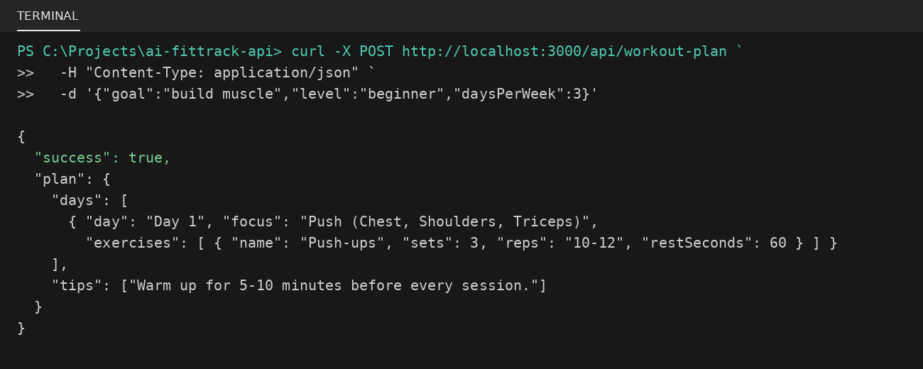
Figure 8: Testing the workout-plan endpoint and the JSON response

9.1 Test Checklist
Test case | Expected result
GET /api/health | Status 200 with { "status": "ok" }
POST /api/workout-plan with a valid body | Status 200 and a plan with days and tips
POST /api/workout-plan without goal | Status 400 with "goal is required"
GET /api/unknown | Status 404 with a route-not-found message
Server started without GOOGLE_API_KEY | Startup error explaining the key is missing
More than 30 requests in one minute | Status 429 from the rate limiter

10. Security and Best Practices
- Secret management. The Google API key lives only in .env and is loaded through dotenv.
- Secure headers. Helmet sets protective HTTP headers.
- Rate limiting. Rate limiting reduces abuse and protects the API quota.
- Input validation. Required fields are checked before any AI call is made.
- Safe errors. Internal error messages are hidden from clients.
- Payload limits. JSON body size is capped at 1 MB.

11. Troubleshooting
Problem | Solution
GOOGLE_API_KEY is missing | Create the .env file in the project root and restart the server.
API key not valid (403) | Check that the key is copied correctly and the Gemini API is enabled.
Cannot find module | Run npm install in the project folder.
Port 3000 already in use | Change PORT in .env or stop the other process.
502 invalid AI response | Retry the request; refine the prompt to enforce the JSON schema.
429 Too Many Requests | Wait a minute, or raise the limit in server.js.

12. Future Enhancements
- User accounts with JWT authentication.
- A database (MongoDB or PostgreSQL) to store workout history and progress.
- A progress-analysis endpoint that reviews logged workouts and suggests changes.
- Response caching to lower cost and latency.
- Automated tests with Jest and Supertest.
- Docker deployment and a CI/CD pipeline.
- Swagger / OpenAPI interactive documentation.

13. Conclusion
AI FitTrack API demonstrates how a small Node.js service can turn a generative AI model into a practical, structured product feature. The layered design, secure handling of the Google API key, and consistent error handling make it a solid base for a full fitness application.

