**CE100: Computer Fundamentals & Programming**

**Midterm Lab Exam (Fall 2021)**

***Name Muhammad Abubakar Saif*** ***Roll# BSCE21017***

**Instructions:**

1. Please try to solve all the questions in the allocated space.
2. Time allowed is the maximum time allowed to solve the paper.
3. It is a closed book and closed notes exam.
4. Every question has the marks mentioned in the rightmost column, so manage the time and answer according to the mentioned numbers.
5. You should not be taking assumptions without mentioning those.
6. **Anybody found cheating or helping any fellow during an exam will get his/her paper cancelled immediately.**

***Time allowed: 120 Minutes Maximum Marks: 50***

|  | **Marks Distribution** | | | |  | **Total** |
| --- | --- | --- | --- | --- | --- | --- |
| **Question** | **0** | **1 a** | **1 b** | **1 c** | **1 d** |
| **CLO** | 1 | 2 | 2 | 2 | 2 |
| **Total Marks** | **10** | **10** | **10** | **10** | **10** | **50** |
| **Marks Obtained** |  |  |  |  |  |  |

**Teaching Team:**  Usama Bin Shakeel, Aqsa Khalid & Nadir Abbas

**Q0 is to ensure you are using the proper environment, GitHub, Cygwin, menu & IDE.**



A milkman got to know that you are becoming an engineer, he is not good in maths, and has a difficulty to bill all his customers on monthly basis, therefore he has few things in his wishlist that if you can code as a program for him for monthly billing. Each functionality in his wishlist would be accessible through a menu.

| Q1 | a- Milkman should have capability to enter quantity (can be in decimal numbers) of the milk he delivered on each day from day 1 - 31, and enter the milk rate in rupees per litre, your program should be able to calculate bill for that client. | **10** |
| --- | --- | --- |
|  | **const int** DAYS = 5;  **void** billMonth(){  **float** quan[DAYS], rate = 0, product = 0, bill = 0;  **for**(**int** i = 0; i < DAYS; ++i) {  cout<<**"Enter the quantity of milk: "**;  cin>>quan[i];  }  cout<<**"Enter the rate of milk: "**;  cin>>rate;  **for**(**int** i = 0; i < DAYS; ++i) {  product = quan[i] * rate;  bill = bill + product;  }  cout<<**"Bill for your required Client is: Rs. "**<<bill<<**" /-"**<<endl;  } |  |

Output:

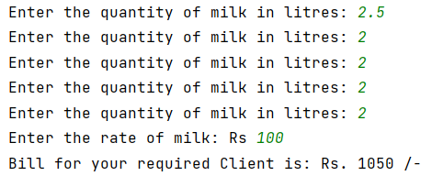

| Q1 | b- Milkman brings milk in package of one litre each, so he wants to charge partial litres with a different rate, eg. 2.5 litres will be charged at 2 x litre rate + 0.5 x partial litre rate. Since partial usage could potentially left him in loss if it gets wasted | **10** |
| --- | --- | --- |
|  | **const int** DAYS = 5;  **void** billPartial() {  **float** quan[DAYS], conv[DAYS] = {0}, rate = 0, product = 0, bill = 0, partial = 0, temp = 0;  **int** converter;  **for** (**int** i = 0; i < DAYS; ++i) {  cout << **"Enter the quantity of milk in litres: "**;  cin >> quan[i];  converter = quan[i];  temp = quan[i] - converter;  **if** (temp != 0) {  conv[i] = temp;  quan[i] = converter; *// floor function*  }  }  cout << **"Enter the rate of milk: Rs "**;  cin >> rate;  **for** (**int** i = 0; i < DAYS; ++i) {  product = quan[i] * rate;  bill = bill + product;  }  **for** (**int** i = 0; i < DAYS; ++i) {  **if** (conv[i] != 0) {  product = conv[i] * rate;  bill += product;  }  }  cout << **"Bill for your required Client is: Rs. "** << bill << **" /-"** << endl;  } |  |

Output:

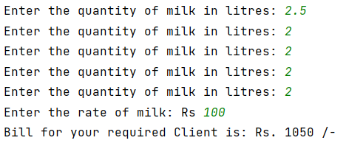

| Q1 | c- Milkman wants to have a capability to dynamically inform number of days a bill should count, to entertain different number of days in a month and few clients joining his service in the middle of the month. | **10** |
| --- | --- | --- |
|  | **Functions.cpp**  void dynamicDays(float arr[31]) {  float size;  int i;  float milkRate,bill;  float sum=0;   cout<<"Please enter total number of days: "<<endl;  cin>>size;  float *ptr1= new float (size);  ptr1= arr;   cout<<"the amount of milk per litre delivered per day is: " <<endl;  for( i=0; i<size ; i++)  {  cin>>arr[i];  }  cout<< "the rate of milk per litre is: "<<endl;  cin>> milkRate;   for( i=0; i<size ; i++)  {  bill = milkRate * arr[i];  sum = sum+bill;  }  cout << "the total bill is: " << sum << " rupees" <<endl;  delete []arr; } |  |
| Q1 | d- Milkman, got to know that you have great understanding of recursive functions, therefore he wants you to do the functionality in part (a) with recursive functions approach | **10** |
|  | void recursiveFunction(float bill, float milkRate) {  int amount;  float milkRate;  float bill;  float sum=0;  cout<<"the amount of milk delivered per day is: "<<endl;  cin>>amount;  if(amount<0)  {  return;  }  else  {  return recursiveFunction(milk*amount , sum+bill);  }   }  **menu**  void menu() {  int option;  float arr[31];    do {  cout << "1) press 1 to perform task 1a" << endl;  cout << "2) press 1 to perform task 1c" << endl;  cout<< "3) press 1 to perform task 1d"<<endl;  cin>>option;  switch (option) {   case 1: {  calculateBill(arr);  break;  }   case 2: {  dynamicDays(arr);  break;  }   case 4:  {  recursiveFunction(bill,milkRate)  break;  }  default:  break;  }  }  while (option != 3);      } |  |