About Us

Volleyball of the Midwest was created to support and enhance the local volleyball community. The idea is simple, a community of volleyball enthusiasts supporting future generations of volleyball enthusiasts, for the players by the players. Our goal is to run tournaments and leagues in order to support camps for youth players and help those individuals supplement the high costs of club sports.

By participating in Volleyball of the Midwest events and activities you help support future generations of volleyball players to come.

So, thank you for your time and contributions, we could not have done this without you.

Summer Grass League

Session 1

* 8 weeks of league play
* Team Ball
* End of the season tournament and BBQ
* League t-shirt
* Getting some exercise
* Playing for a cause

General League Rules

* Leagues games start at 6:00 pm sharp, must show up by early to set up the court.
* If teams do not show up by 6 the opposing team my write a forfeit for late/absent team.
* Teams will play two matches a night or till dark
* Scoring will be Rally scoring.
* Matches will be best of 3 sets win by 2 cap 27 points with the 3rd set being played to 15 no cap.
* If the ball contacts the boundary line the ball is considered in
* If the ball contacts the net on a serve it is considered live and is playable.
* Any contact with the net by a player is considered a foul, the play is dead and a point is awarded to the team who did not commit the foul. (Hair is the only exception, and is able to come in contact with the net)
* Players must right down the name of their subs on the sub sheet.
* D1- Overhand sets need to have little to no spin on the ball (1-2 rotations)
* D2- Overhand sets are nearly clean with slight spin (able to 2-5 rotations)
* D3- Overhand sets can have spin but should not be out of control
* All games are self-governed, please call your own fouls and do not make the other team call them on you.
* Any discrepancy will result in a redo

Specific rules for 4’s

* No sets over the net
* No open hand tips
* All players are live and may spike the ball (no down player)

Locations

Leagues games will be played at Swinney Park

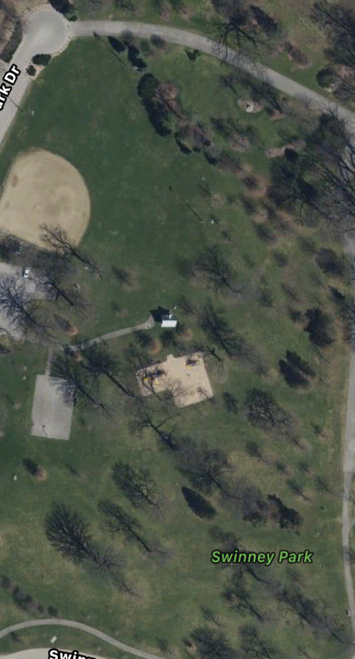

Or Shoaff



End of season tournament will be determined