Database:
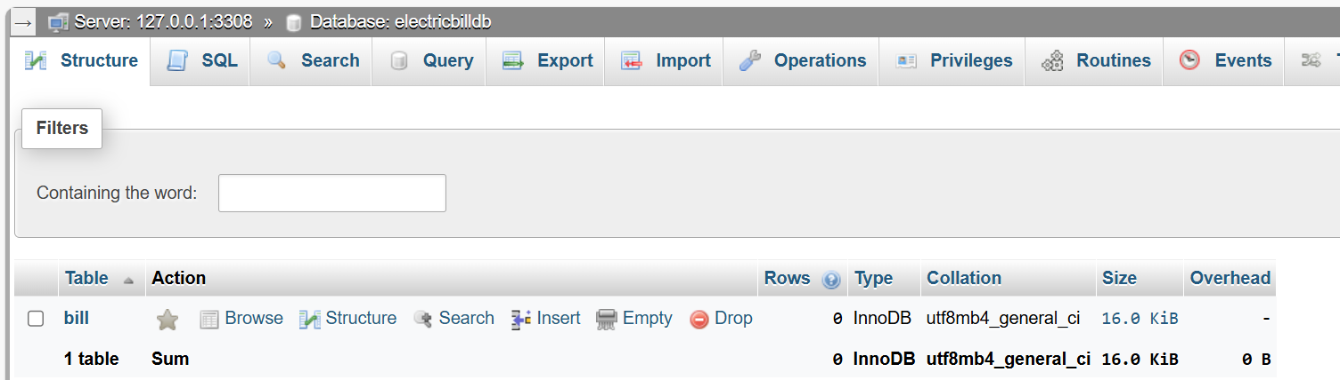
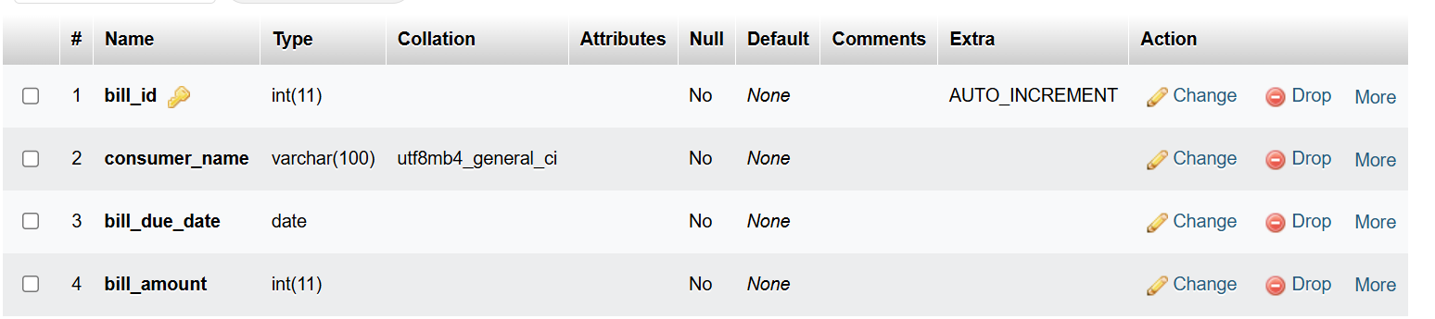
Bill table data:
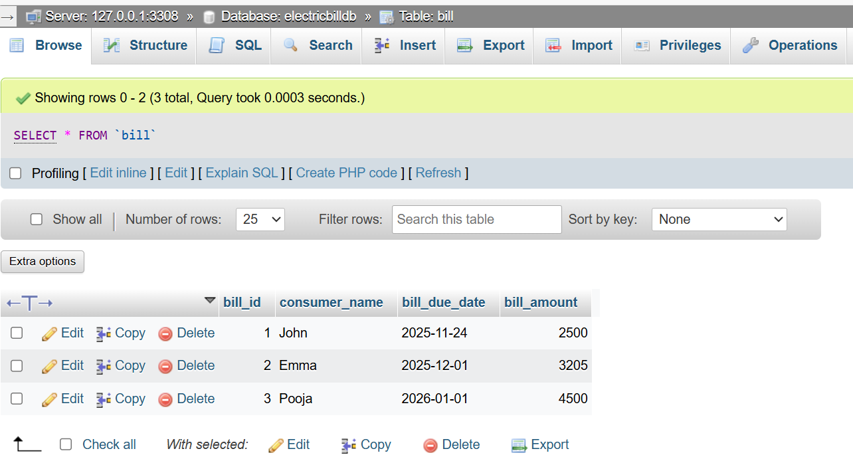

BillInterface.java
package ElectricBillDb;
import java.rmi.Remote;
import java.rmi.RemoteException;
import java.util.List;
public interface BillInterface extends Remote {
List<String> getAllBills() throws RemoteException;
String getBillByConsumerName(String consumerName) throws RemoteException;
}

BillImplementation.java
package ElectricBillDb;
import java.rmi.RemoteException;
import java.rmi.server.UnicastRemoteObject;
import java.sql.Connection;
import java.sql.DriverManager;
import java.sql.PreparedStatement;
import java.sql.ResultSet;
import java.sql.SQLException;
import java.sql.Statement;
import java.util.ArrayList;
import java.util.List;
public class BillImplementation extends UnicastRemoteObject implements BillInterface {
private Connection conn;
protected BillImplementation() throws RemoteException {
super();
try {
conn = DriverManager.getConnection("jdbc:mysql://localhost:3308/electricbilldb", "root", "");
} catch (SQLException e) {
e.printStackTrace();
}
}
@Override
public List<String> getAllBills() throws RemoteException {
List<String> bills = new ArrayList<>();
try (Statement stmt = conn.createStatement()) {
ResultSet rs = stmt.executeQuery("SELECT * FROM Bill");
while (rs.next()) {
bills.add(
rs.getString("consumer_name") + " | " +
rs.getDate("bill_due_date") + " | " +
rs.getInt("bill_amount")
);
}
} catch (SQLException e) {
e.printStackTrace();
}
return bills;
}
@Override
public String getBillByConsumerName(String consumerName) throws RemoteException {
try (PreparedStatement ps = conn.prepareStatement("SELECT * FROM Bill WHERE consumer_name = ?")) {
ps.setString(1, consumerName);
ResultSet rs = ps.executeQuery();
if (rs.next()) {
return rs.getString("consumer_name") + " | " +
rs.getDate("bill_due_date") + " | " +
rs.getInt("bill_amount");
}
} catch (SQLException e) {
e.printStackTrace();
}
return "Bill not found!";
}
}

BillServer.java
package ElectricBillDb;
import java.rmi.registry.LocateRegistry;
import java.rmi.registry.Registry;
public class BillServer {
public static void main(String[] args) {
try {
BillImplementation obj = new BillImplementation();
Registry registry = LocateRegistry.createRegistry(1090);
registry.rebind("BillServer", obj);
System.out.println("Bill RMI Server is Running....");
} catch (Exception e) {
e.printStackTrace();
}
}
}

BillClient.java
package ElectricBillDb;
import java.rmi.registry.LocateRegistry;
import java.rmi.registry.Registry;
import java.util.List;
import java.util.Scanner;
public class BillClient {
public static void main(String[] args) {
try {
Registry registry = LocateRegistry.getRegistry("localhost", 1090);
BillInterface billService = (BillInterface) registry.lookup("BillServer");
Scanner sc = new Scanner(System.in);
System.out.println("\n Electric Bill Management ");
System.out.println("1: Get All Bills");
System.out.println("2: Get Bill By Consumer Name");
System.out.print("Enter Choice: ");
int choice = sc.nextInt();
sc.nextLine(); // Consume newline
if (choice == 1) {
List<String> bills = billService.getAllBills();
if (bills.isEmpty()) {
System.out.println("No bills found.");
} else {
System.out.println("\nAll Bills ");
for (String bill : bills) {
System.out.println(bill);
}
}
} else if (choice == 2) {
System.out.print("Enter Consumer Name: ");
String consumerName = sc.nextLine();
System.out.println(billService.getBillByConsumerName(consumerName));
} else {
System.out.println("Invalid choice!");
}
sc.close();
} catch (Exception e) {
e.printStackTrace();
}
}
}

Output:
(BillServer.java)
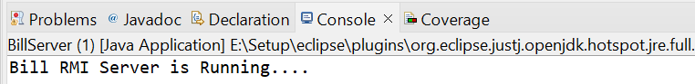

(BillClient.java)
