March 26, 2022

Boban Srezovski

Code adacemy

Street: Anton Popov no.33

Homework 1

Forms

Table of Contents

INTRODUCTION 2

Exercise 01 3

Exercise 02 3

Exercise 03 3

Exercise 04 4

Exercise 05 5

Exercise 06 6

Exercise 07 7

Exercise 08 8

Exercise 09 8

# INTRODUCTION

These exercises are meant to keep you practicing thing we learn and what we are about to learn in the course. If you don’t know how to solve any of the exercise, please first see the solution and try to figure it out, and if you still don’t know how to solve them, please contact me.

The main goal of these exercises is for you to get familiar with HTML and CSS. So, as I said earlier if you get stuck on one, please first see the solution, or continue to the next one.

Best way to learn is to practice coding

### Exercise 01

Create a form with two buttons (HINT: they should not have the submit type).

### Exercise 02

Create links to five different pages on five different websites that should all open in a new window.

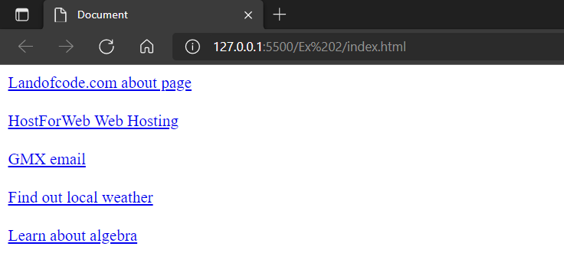

### Exercise 03

Create a page with a link at the top of it that when clicked will jump all the way to the bottom of the page.

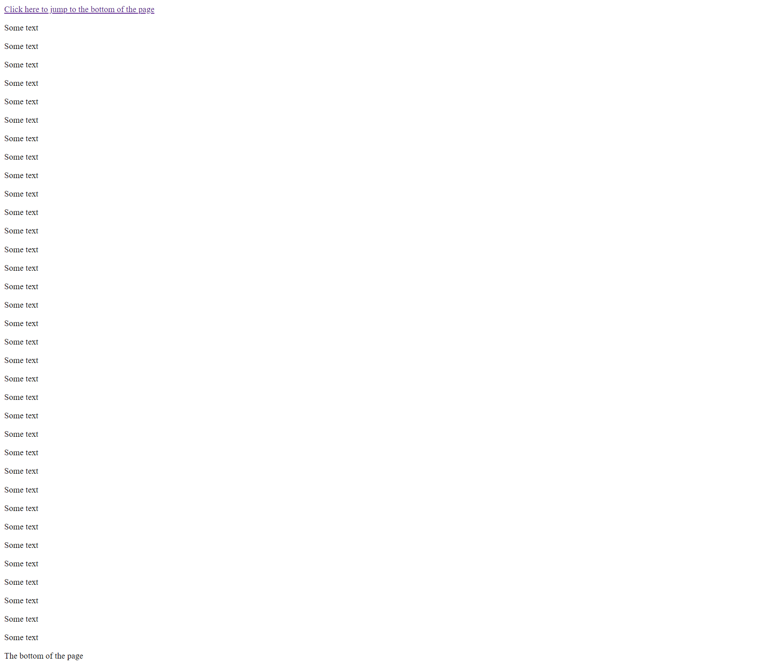

### Exercise 04

Create a page with a link at the bottom of it that when clicked will jump all the way to the top of the page.

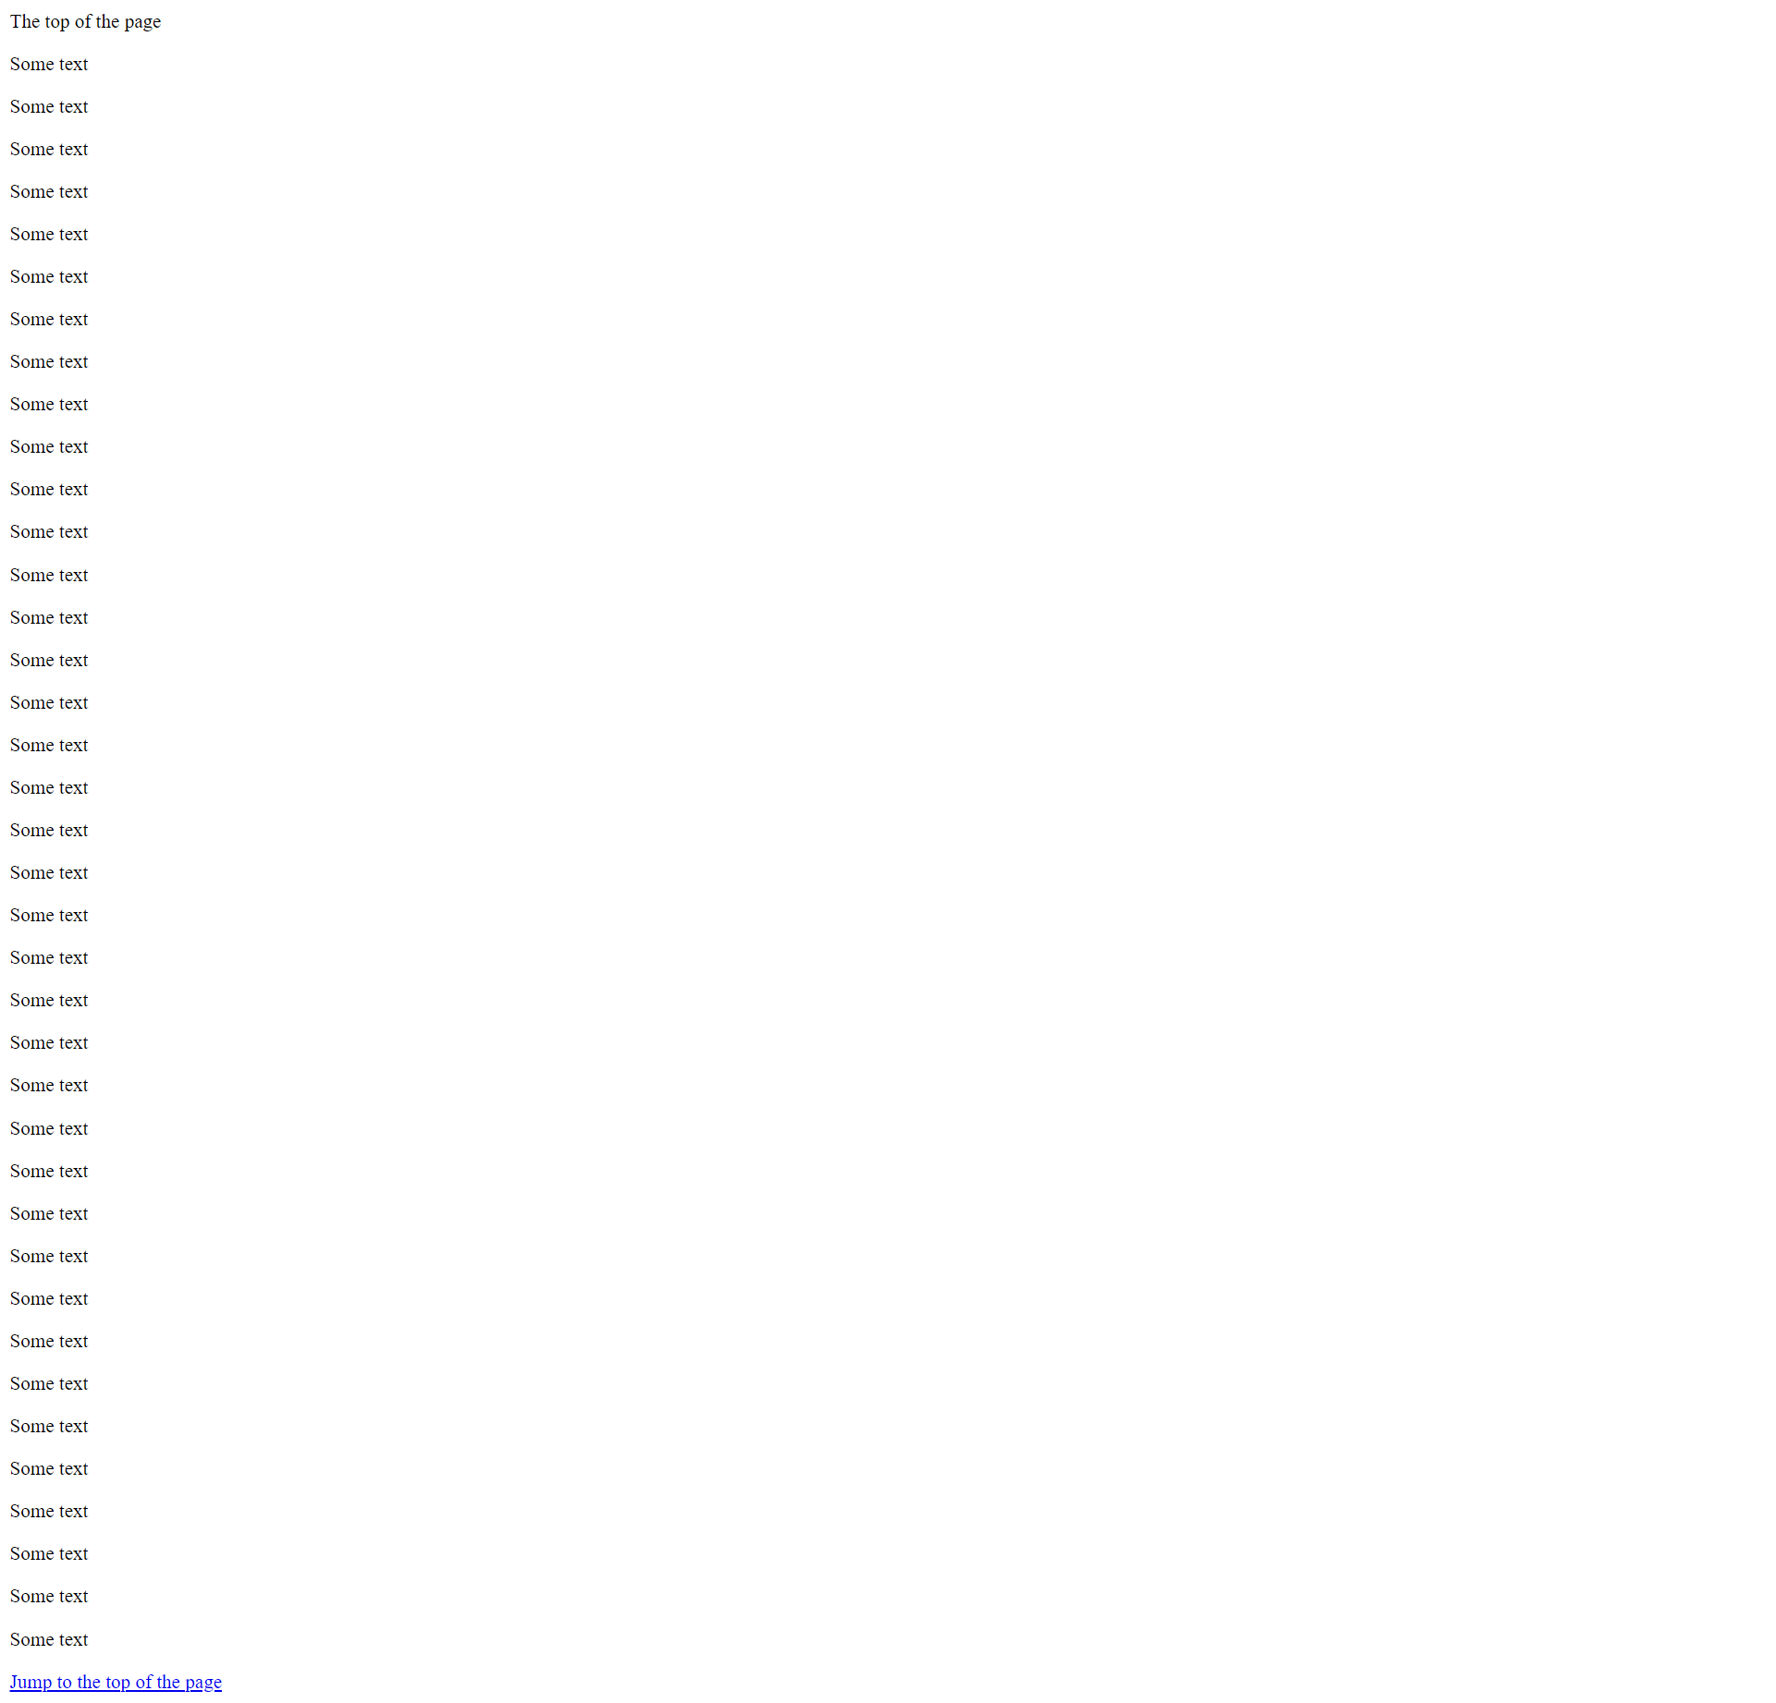

### Exercise 05

Create a page with a link at the top of it that when clicked will jump all the way to the bottom of the page. At the bottom of the page there should be a link to jump back to the top of the page.

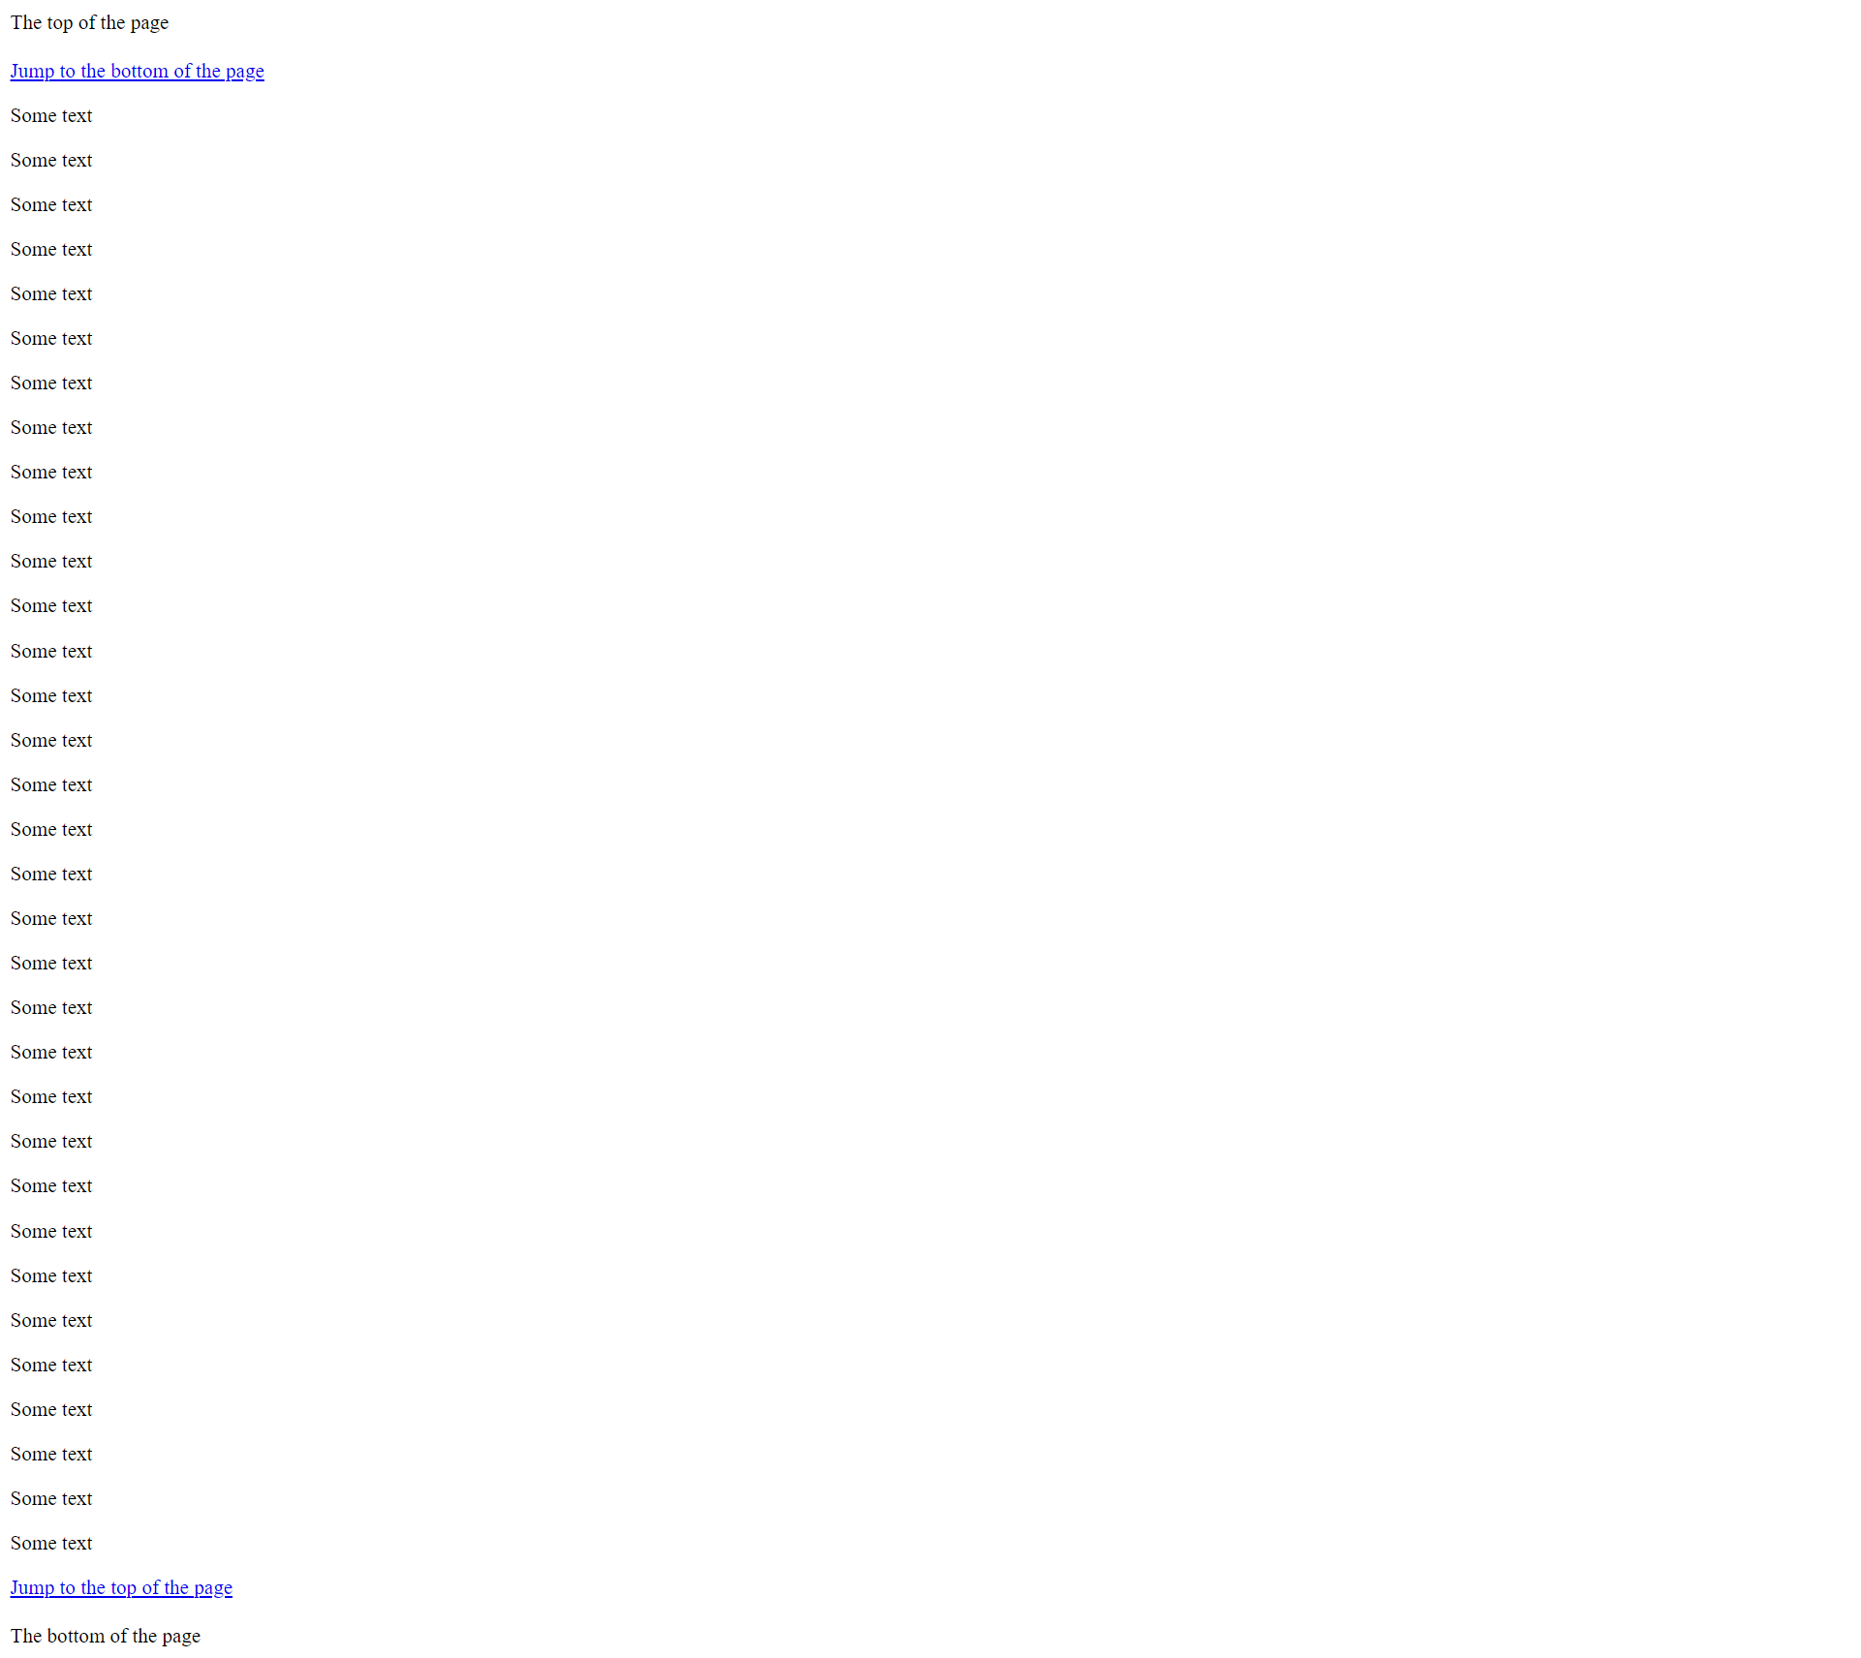

### Exercise 06

Display five different images. Skip two lines between each image. Each image should have a title.

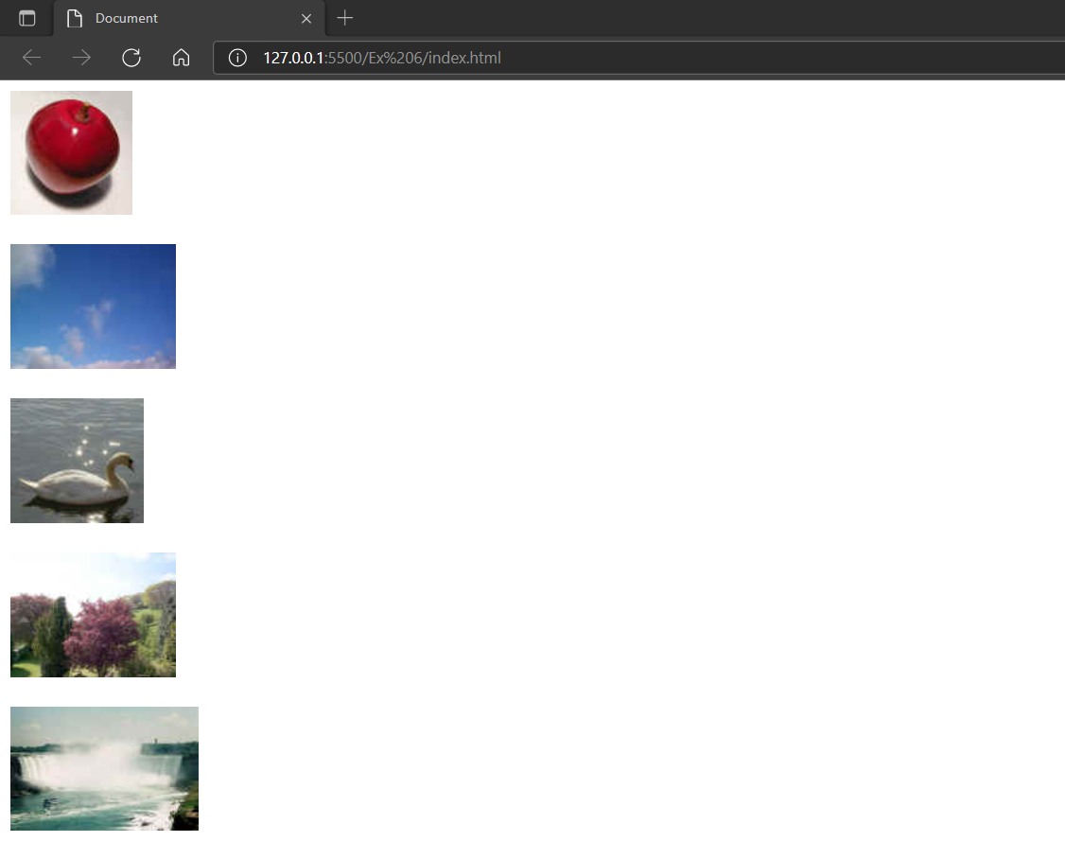

You can find this images in the resource folder homework1_ressources

### Exercise 07

Display an image that has a border of size 2, a width of 200, and a height of 200.

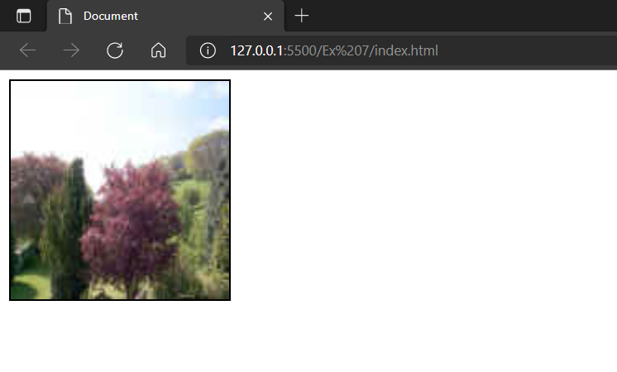

### Exercise 08

Display an image that when clicked will link to a search engine of your choice (should be opened in a new window).

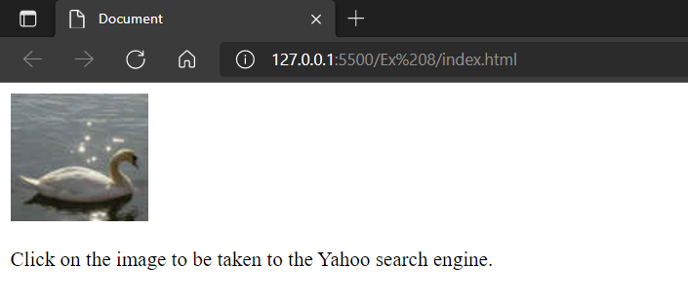

### Exercise 09

Display an image that when clicked will link to itself and will display the image in the browser by itself.

