FAZAIA BILQUIS COLLEGE OF EDUCATION FOR WOMEN
PAF NUR KHAN RAWALPINDI

Lab Assignment 1

Submitted by:
Aiman Arif [19]
Khadija[ ]
Bushra[]

Submitted to: Ma, am Rabia
Section: B
Course: Data Structures
BSCS 3RD Semester
Submission date: 11 Oct 2026

1.Task Manager Using Linked List and Stack
2. Project Title
Task Manager — CS216L Project 1
3. Project Description
Task Manager is a console-based Java application designed to manage tasks efficiently. It allows users to add, delete, search, sort, and view tasks. The application also provides an Undo feature to reverse the last Add or Delete action.
This project demonstrates the use of fundamental data structures and algorithms in Java.
4. Data Structures Used:
Singly Linked List:
A singly linked list is used to store tasks. Each task contains:
- Task ID
- Task title
- Task priority
- Reference to the next task
It supports adding, deleting, searching, sorting, and displaying tasks.
Stack:
A stack is used to store task actions for the Undo feature. It follows the LIFO (Last In, First Out) principle.
Stack operations include:
- Push: Adds an action to the stack.
- Pop: Removes and returns the latest action.
- Peek: Views the latest action without removing it.
5. Features
- Add a new task.
- Delete a task using its ID.
- Search for a task by title using Linear Search.
- Sort tasks by priority using Bubble Sort.
- Display all active tasks.
- Undo the last Add or Delete action.
- View the most recent saved action using Peek.
- Validate numeric input and priority values.
- Prevent duplicate task IDs.
- Display task priorities as High, Medium, or Low.
Priority Levels
- 1 — High
- 2 — Medium
- 3 — Low
6. Algorithms Used
Linear Search
Linear Search checks tasks one by one until the required title is found or the list ends.
Bubble Sort
Bubble Sort compares adjacent tasks and swaps their task data when their priorities are in the wrong order. Tasks are arranged from High priority to Low priority.
7. Time Complexity Analysis
Let n represent the number of tasks.
Operation | Time Complexity
Insert a task | O(n)
Delete a task by ID | O(n)
Linear Search | O(n)
Bubble Sort — Best Case | O(n)
Bubble Sort — Average Case | O(n²)
Bubble Sort — Worst Case | O(n²)
Stack Push | O(1)
Stack Pop | O(1)
Stack Peek | O(1)
Explanation:
- Insertion takes O(n) because the program traverses the list to reach its end.
- Deletion takes O(n) because the program may need to search for the task.
- Linear Search takes O(n) because tasks are checked one by one.
- Bubble Sort takes O(n²) in the average and worst cases.
- Push, Pop, and Peek take O(1) because they operate directly on the top of the stack.
8. Java Source Files
The project contains four Java source files:
- Task.java — Defines the Task class and its attributes.
- Action.java — Defines an action stored in the undo stack.
- TaskEngine.java — Implements the linked list, stack, searching, sorting, and undo operations.
- TaskManager.java — Contains the main method and interactive menu.

9.Working Program Screenshots
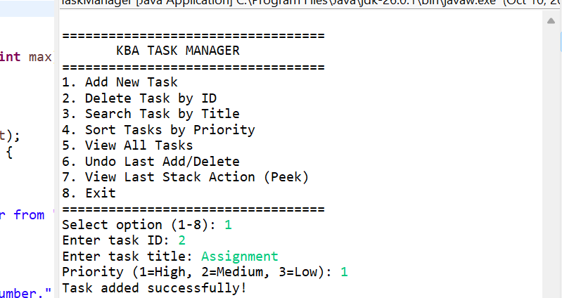

View Tasks
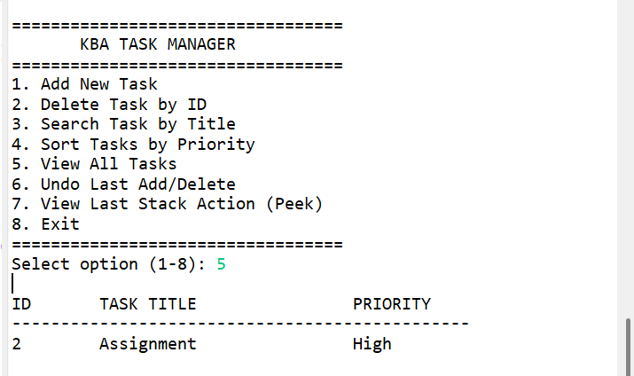

Search Operation
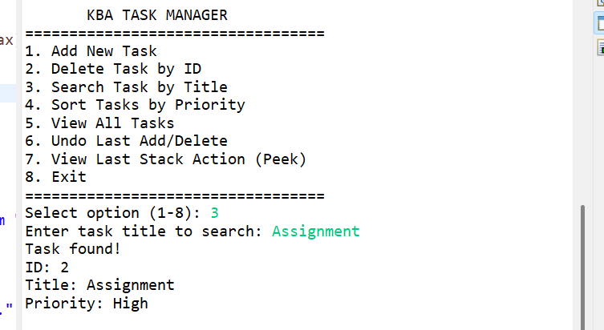

Peek Operation
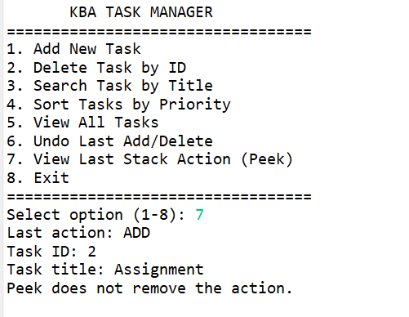
Undo Last Action
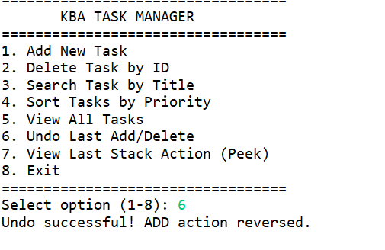

Github repository link:

11. Conclusion
The Task Manager project demonstrates how linked lists, stacks, Linear Search, and Bubble Sort can be used in a practical Java application. It also provides experience with menu-driven programming, input validation, and basic data structure operations.

