CS464 Lab 03: Level Blockout
Mayasa Fakhar · BSCS23069
GitHub repo: https://github.com/bscs23069/ITU-CS-464-LAB-03-BSCS23069
Scenes: Lab 03/Assets/Scenes/Level01.unity and Level02.unity (Unity 2022.3). Both levels are made only from cubes, cylinders, capsules, spheres, a quad and the floor and coin prefabs in the project.
Videos: my screen recordings of a walk through each level in the Scene view are in the same zip as this document.

Level 01: Platform Run (my own design)
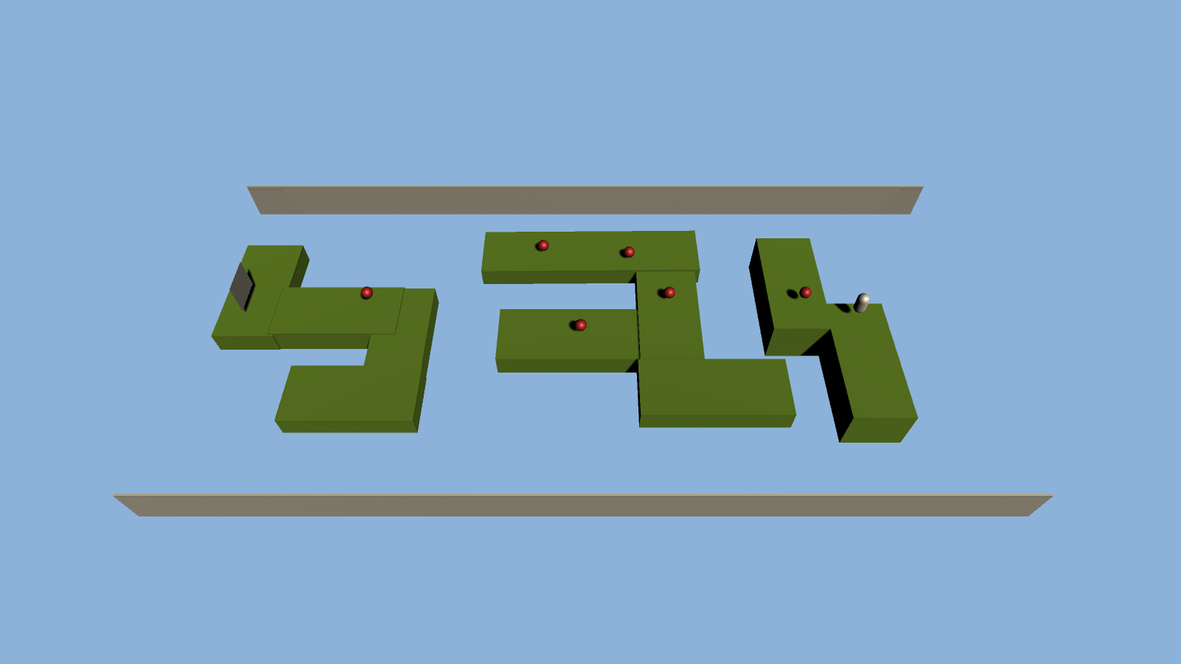
Level 01 from above. The player starts on the right and the sign is at the far left.

The level
Level 01 is a platform run made from my three floor prefabs. You start on the right (the white capsule) and go left to the grey sign at the end, about 52 m away. The route is split into three groups of green platforms with gaps between them, so you have to jump from one group to the next. The groups are at different heights: the first group is 2 m high, the middle group goes from 2.2 m up to 2.6 m, and the last group drops down to about 1 m. There are six red coins along the route, and two long walls (68 m) on the sides show the edge of the play area.

Obstacles
- Gaps: the gaps between the three platform groups. If you miss a jump you fall.
- Height changes: the platforms are at different heights, so some jumps go up and some drop down.
- Turns: the platforms turn corners instead of going in a straight line, so you have to change direction on narrow pieces without falling off.
- Coins: the six red coins are on the route, some near the edges, so collecting them is a small extra risk.
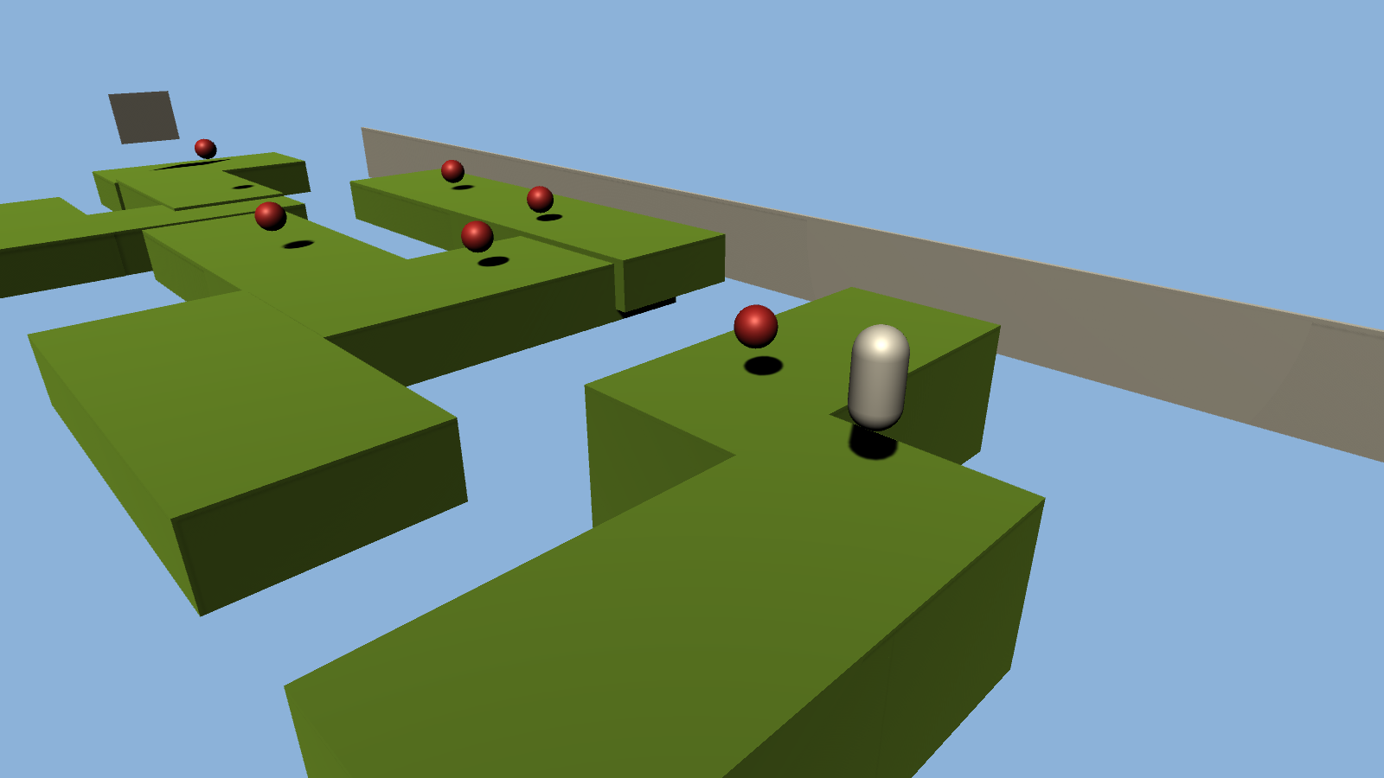 | 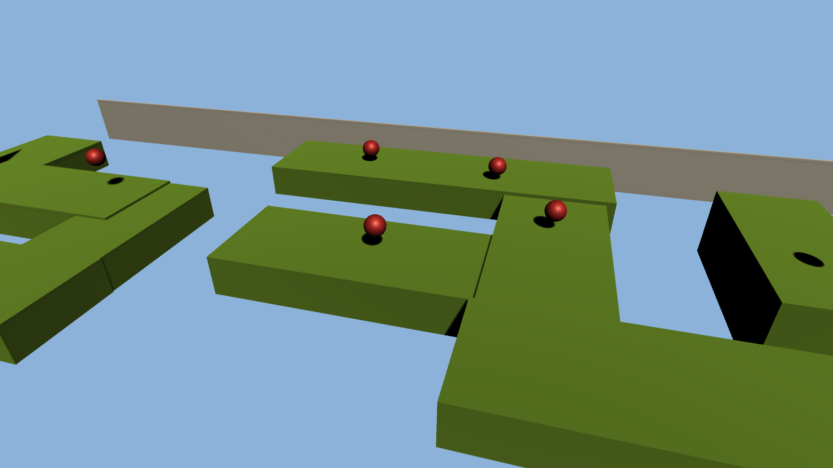
Looking from the start down the route | The middle group, the highest part of the level
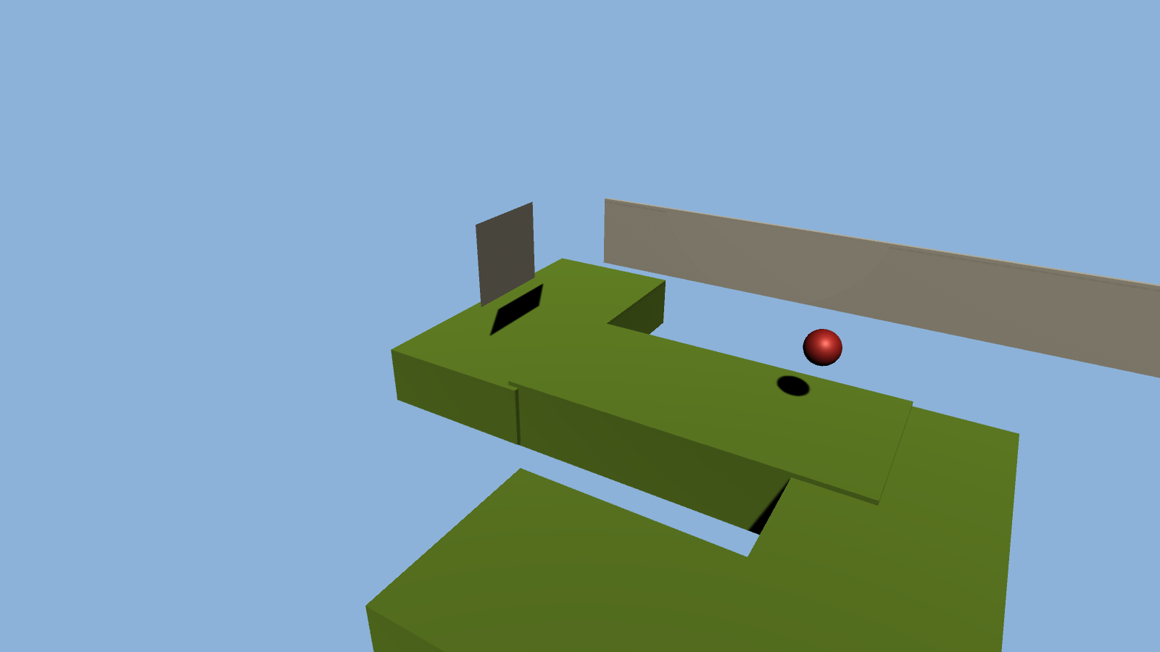
The last group, lower down, and the sign at the end

Why I designed it like this
This was the first blockout I made in the lab. I wanted the jumps to be the main challenge, so the platforms are broken into groups with gaps, and the heights change so the run goes up in the middle and back down at the end. The platforms turn corners so you can't just hold forward. The coins are placed on the route, so they show you where to go next. The walls on both sides keep the level inside one area.
Reference: this level is my own idea, in the style of simple 3D platform and obby games where you hop across platforms and collect coins. The screenshots above and my video are its references.

Level 02: Sky Steps (my own design)
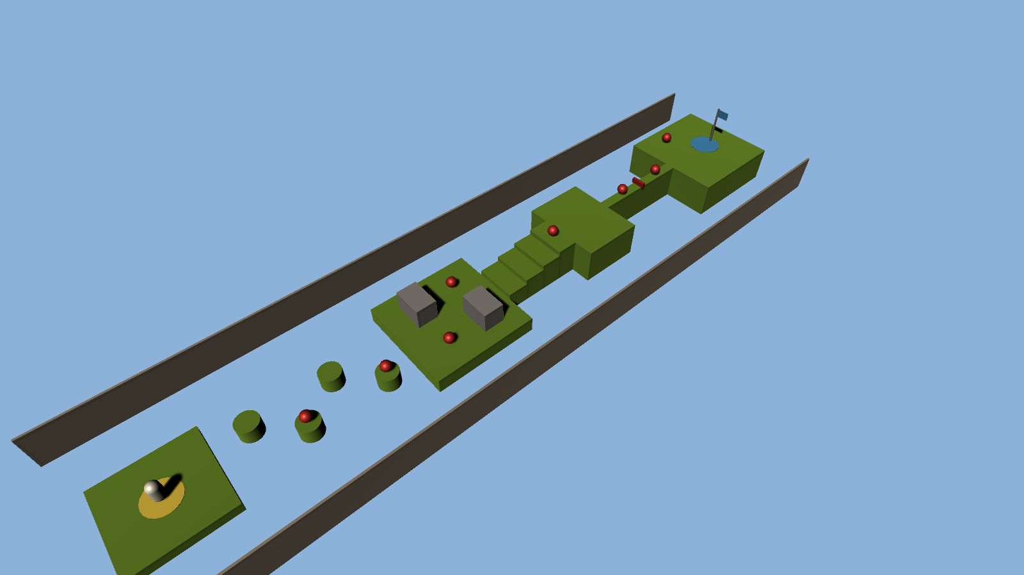
Level 02 from the side. Start at the bottom left (yellow pad), goal at the top right (blue flag).

The level
Level 02 is a short climb in the same style as Level 01, with the same green floor, red coins and side walls. It's about 64 m long and goes in a straight line, so it's easy to read. You start on the yellow pad, hop across four pillars, cross a wide platform, climb a set of stairs to a high platform, walk along a narrow bridge and finish on the blue pad under the flag. The route climbs from 1 m at the start to 3.5 m at the end. There are eight red coins.

Obstacles
- Stepping pillars: four round pillars 2 m wide with 1.5 m gaps, placed left and right, so every jump goes sideways a little.
- Blocks: two grey blocks on the middle platform. They are staggered, so you weave left and right round them, and there is a coin beside each one.
- Stairs: four steps, each 0.5 m higher than the last, up to the high platform at 3.5 m.
- Narrow bridge: a bridge only 1 m wide and 10 m long, high above the ground.
- Red bar: a low red bar across the middle of the bridge that you have to jump over without falling off.
- Goal: a blue pad with a flag on the last platform.
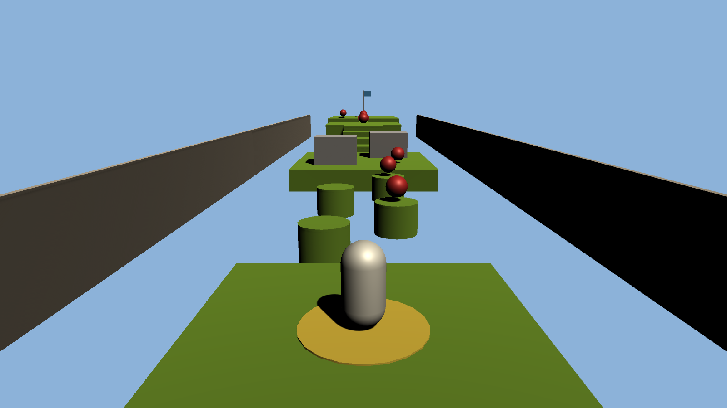 | 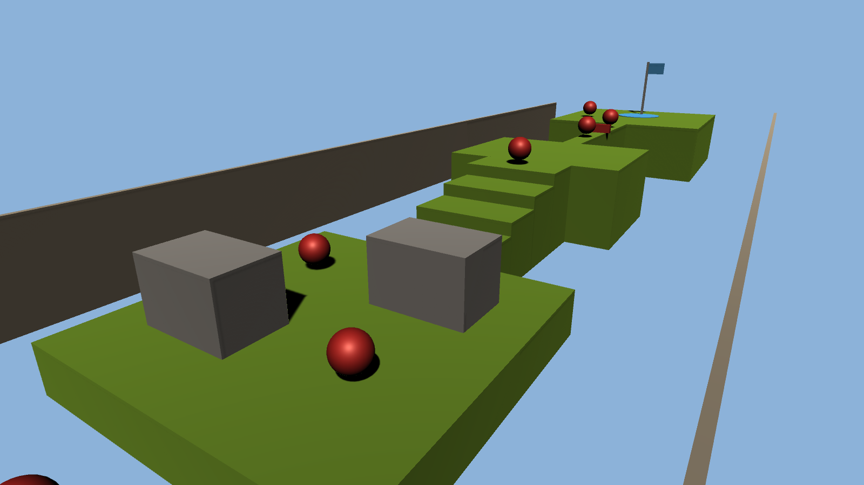
The start pad and the stepping pillars | The blocks to weave round and the stairs
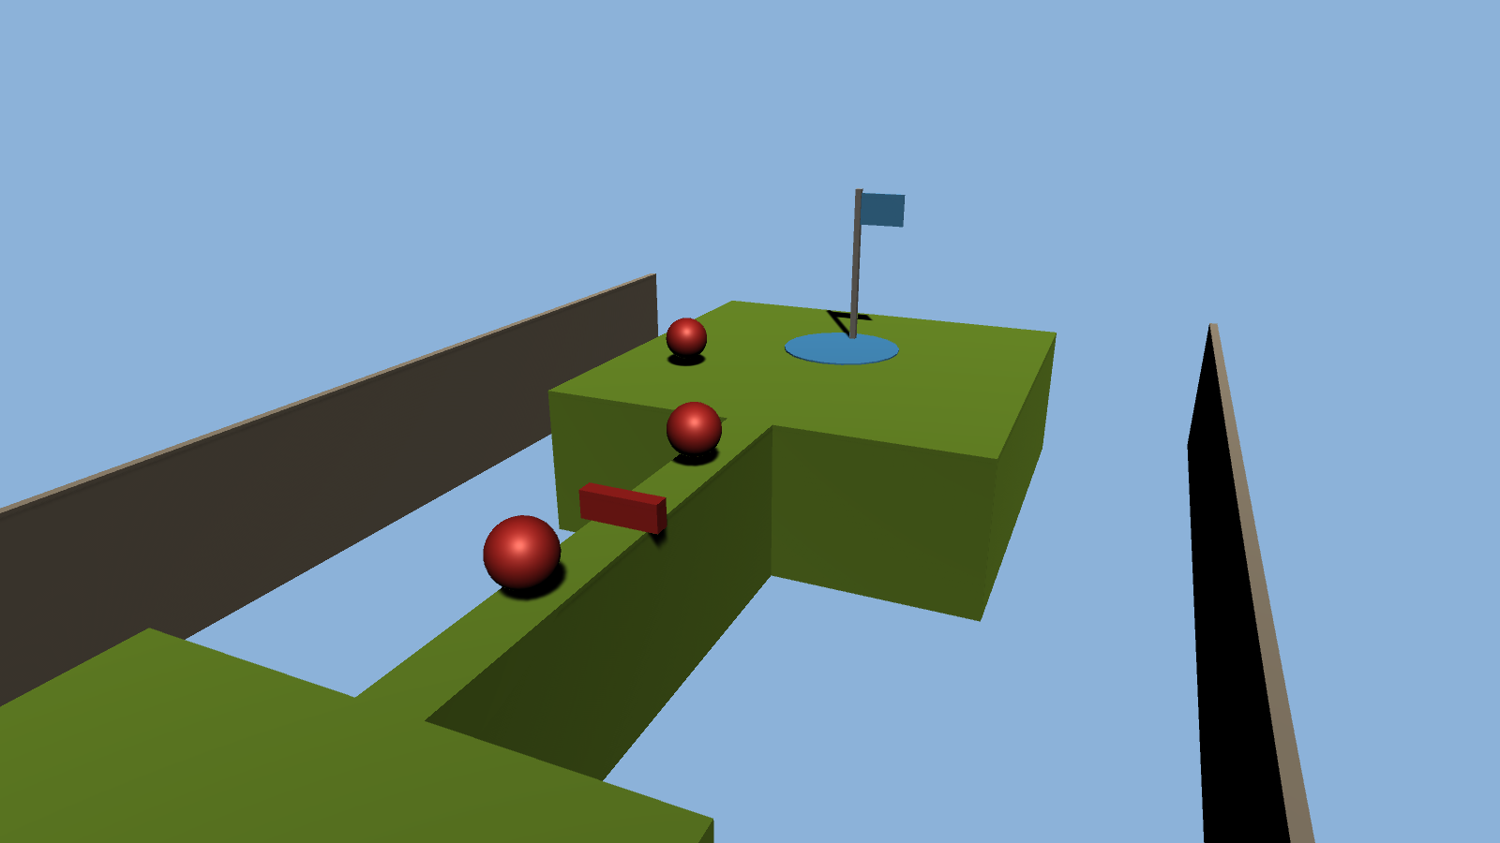
The narrow bridge with the red bar, and the goal

Why I designed it like this
I kept Level 02 simple and in a straight line so the player always sees the flag ahead. Each part adds one new thing: first just jumping on the pillars, then moving round the blocks, then climbing the stairs, and last the narrow bridge where jumping the bar is harder because there is no room either side. The level goes up all the way, so it feels like you are climbing towards the goal, and the hardest part is right at the end. The coins are on each section to pull you along the route.
Reference: this level is my own idea too, in the same obby style as Level 01. The screenshots above and my video are its references.

