AI-BASED TASK MANAGER &
SMART SCHEDULER
Database Design Document
V 1.0
By
GROUP MEMBERS
Mishaal Aqdas (NUM-BSCS-2024-35)
Khadija-tul-Kubra(NUM-BSCS-2024-30)
Muhammad Imran(NUM-BSCS-2024-50)

Department of Computer Sciences
Namal University
Mianwali, Pakistan
Submission Date: June 14, 2026

REVISION HISTORY
Date | Version | Description | Approved by
21/06/26 | V 1.0 | Added Chapter 3 (Logical Database Design: Functional Dependencies and Normalization to 3NF) and Chapter 4 (Implementation: language stack, database connectivity, stored procedures, triggers, views, and GUI modules).
15/05/26 | V 1.0 | Initial submission of Database Design Document. Included project overview, entity identification, data dictionary, business rules, and ERD.

TABLE OF CONTENTS
CHAPTER 1: PROJECT OVERVIEW 4
1.1. INTRODUCTION 4
1.2. PROBLEM STATEMENT 4
1.3. PROJECT OBJECTIVES 5
CHAPTER 2: CONCEPTUAL DATABASE DESIGN 6
2.1. ENTITY 6
2.2. DATA DICTIONARY 6
2.3. BUSINESS RULES 9
2.4. ENTITY RELATIONSHIP DIAGRAM 10
CHAPTER 3: LOGICAL DATABASE DESIGN 11
3.1. RELATIONAL SCHEMA 11
3.2. FUNCTIONAL DEPENDENCIES 11
3.3. NORMALIZATION 13
CHAPTER 4: IMPLEMENTATION 17
4.1. LANGUAGE/FRAMEWORK 17
4.2. DATABASE CONNECTIVITY 17
4.3. STORED PROCEDURES AND FUNCTIONS 18
4.4. INTERFACES 20
REFERENCES 21
APPENDIX: AI USAGE AND PROMPTS 22

CHAPTER 1: PROJECT OVERVIEW

1.1. INTRODUCTION:
The AI-Based Task Manager & Smart Scheduler is a productivity application designed to help users efficiently organize, manage, and track their daily tasks, schedules, reminders, and productivity goals. In modern life, students, professionals, and general users often struggle to manage multiple responsibilities using traditional methods such as handwritten notes, memory, or scattered digital applications. These methods are often inefficient, unstructured, and unreliable.
This system provides a centralized digital platform where users can create, update, delete, and monitor tasks in an organized manner. The system not only stores user tasks and schedules but also uses artificial intelligence to provide smart suggestions and productivity insights based on user behaviour. Through features such as reminders, progress tracking, and AI-generated recommendations, the system aims to improve time management and productivity.
From a database perspective, this project focuses on designing a structured relational database that securely stores user accounts, task records, reminders, AI suggestions, task histories, productivity reports, and system logs. The database serves as the core backbone of the application, ensuring scalability, consistency, and efficient task management for multiple users.

1.2. PROBLEM STATEMENT:
Many individuals currently manage their tasks through informal systems such as notebooks, sticky notes, or memory-based planning. These approaches often lead to poor organization, missed deadlines, and inefficient scheduling. The major problems identified include:
- Absence of a centralized system for storing and managing tasks, schedules, and reminders.
- Difficulty in tracking deadlines, task priorities, and completion progress.
- Lack of automated reminders and intelligent scheduling support.
- No proper data history or analytics for productivity improvement.
- Risk of data loss when using paper-based or unstructured systems.
- Limited scalability for users managing large numbers of tasks.
These challenges negatively affect productivity and reduce efficiency. There is therefore a need for an intelligent, database-driven task management system that automates scheduling, improves organization, and provides smart assistance for better decision-making.

1.3. PROJECT OBJECTIVES:

General Objective:
To design and develop a structured, secure, and scalable AI-Based Task Manager & Smart Scheduler database system that enhances productivity through efficient task organization, intelligent scheduling, and reliable data management.

Specific Objectives:
- To design a well-normalized relational database structure for managing users, tasks, reminders, AI suggestions, task histories, and system logs.
- To develop a secure user management system that supports registration, authentication, and profile maintenance.
- To enable efficient task management operations including task creation, modification, soft deletion, prioritization, and completion tracking.
- To implement AI-generated suggestion features for personalized productivity recommendations.
- To integrate reminder and notification mechanisms for improving deadline awareness.
- To ensure data integrity through the implementation of primary keys, foreign keys, constraints, triggers, and stored procedures.
- To optimize database performance by applying indexing and view-based query strategies.
- To support productivity monitoring and analysis through task history tracking and report generation.

GitHub Repository Link:
GitHub Repository Link
CHAPTER 2: CONCEPTUAL DATABASE DESIGN

2.1. ENTITY:
Entities are the main objects or components of the database system about which data is stored and managed. Each entity represents a real-world concept that plays an important role in the AI-Based Task Manager & Smart Scheduler system.

Sr. No | Entity Name | Description
01 | REGISTERED_USER | Stores all registered user accounts. It is the central entity and acts as a parent for tasks, settings, suggestions, history, and reports.
02 | TASK | Stores all task records created by users, including title, description, deadline, priority, and status. It is the core entity of the system.
03 | SETTING | Stores user-specific application preferences such as language, theme, timezone, and notification settings. Maintains a one-to-one relationship with REGISTERED_USER.
04 | REMINDER | Stores reminder details linked to tasks. A single task may have multiple reminders at different times.
05 | AI_SUGGESTION | Stores AI-generated productivity suggestions and recommendations provided to users based on their tasks.
06 | TASK_HISTORY | Maintains an audit trail of all actions performed on tasks such as creation, updates, and completion.
07 | PRODUCTIVITY_REPORT | Stores aggregated productivity statistics per user, including total tasks and completed tasks for a given period.
08 | SYSTEM_LOG | Records system-level events and activities for monitoring and auditing purposes.

2.2. DATA DICTIONARY:
The data dictionary defines all attributes associated with each entity, including data types, constraints, and descriptions.

2.2.1. REGISTERED_USER
Sr. | Name | Data Type | Constraint | Description
01 | UserID | INT | PK, NOT NULL, AUTO_INCREMENT | Unique identifier of the user
02 | FirstName | VARCHAR(100) | NOT NULL | First name of the user
03 | LastName | VARCHAR(100) | NOT NULL | Last name of the user
04 | Email | VARCHAR(255) | UNIQUE, NOT NULL | Email address used for login
05 | PasswordHash | VARCHAR(255) | NOT NULL | Encrypted password of the user
06 | Age | INT | CHECK (Age >= 0) | Age of the user (optional)
07 | Gender | VARCHAR(20) | NULL Allowed | Gender of the user
08 | CreatedAt | DATETIME | DEFAULT CURRENT_TIMESTAMP | Account creation timestamp
09 | UpdatedAt | DATETIME | AUTO UPDATE | Last profile update timestamp
10 | ProfilePicture | VARCHAR(255) | NULL Allowed | Path to user profile image

2.2.2. TASK
Sr. | Name | Data Type | Constraint | Description
01 | TaskID | INT | PK, NOT NULL, AUTO_INCREMENT | Unique identifier of the task
02 | UserID | INT | FK, NOT NULL | References the user who created the task
03 | Title | VARCHAR(255) | NOT NULL | Title of the task
04 | Description | TEXT | NULL Allowed | Detailed description of the task
05 | Deadline | DATETIME | NULL Allowed | Task deadline date and time
06 | Priority | VARCHAR(20) | Low / Medium / High | Priority level of the task
07 | Status | VARCHAR(20) | Pending / In Progress / Completed | Current status of the task
08 | CreatedAt | DATETIME | DEFAULT CURRENT_TIMESTAMP | Task creation timestamp
09 | UpdatedAt | DATETIME | AUTO UPDATE | Last modification timestamp
10 | IsDeleted | BOOLEAN | DEFAULT FALSE | Soft delete flag

2.2.3. SETTING
Sr. | Name | Data Type | Constraint | Description
01 | SettingID | INT | PK, NOT NULL, AUTO_INCREMENT | Unique setting identifier
02 | UserID | INT | FK, UNIQUE, NOT NULL | References the owning user (1:1)
03 | Language | VARCHAR(50) | DEFAULT 'English' | User selected language
04 | TimeZone | VARCHAR(50) | DEFAULT 'UTC+00:00' | User timezone preference
05 | Theme | VARCHAR(30) | DEFAULT 'Light' | Application theme (Light/Dark)
06 | NotificationPreference | BOOLEAN | DEFAULT TRUE | Whether notifications are enabled
07 | UpdatedAt | DATETIME | AUTO UPDATE | Last settings update timestamp

2.2.4. REMINDER
Sr. | Name | Data Type | Constraint | Description
01 | ReminderID | INT | PK, NOT NULL, AUTO_INCREMENT | Unique reminder identifier
02 | TaskID | INT | FK, NOT NULL | References the associated task
03 | ReminderTime | DATETIME | NOT NULL | Scheduled time for the reminder
04 | IsSent | BOOLEAN | DEFAULT FALSE | Indicates if reminder was sent
05 | NotificationStatus | VARCHAR(50) | DEFAULT 'Pending' | Current status of notification
06 | CreatedAt | DATETIME | DEFAULT CURRENT_TIMESTAMP | Reminder creation timestamp

2.2.5. AI_SUGGESTION
Sr. | Name | Data Type | Constraint | Description
01 | SuggestionID | INT | PK, NOT NULL, AUTO_INCREMENT | Unique suggestion identifier
02 | UserID | INT | FK, NOT NULL | References the user receiving the suggestion
03 | TaskID | INT | FK, NOT NULL | References the related task
04 | SuggestionText | TEXT | NULL Allowed | Content of the AI-generated suggestion
05 | SuggestionType | VARCHAR(50) | NULL Allowed | Category or type of suggestion
06 | GeneratedAt | DATETIME | DEFAULT CURRENT_TIMESTAMP | Timestamp when suggestion was generated

2.2.6. TASK_HISTORY
Sr. | Name | Data Type | Constraint | Description
01 | HistoryID | INT | PK, NOT NULL, AUTO_INCREMENT | Unique history record identifier
02 | TaskID | INT | FK, NOT NULL | References the related task
03 | UserID | INT | FK, NOT NULL | References the user who performed the action
04 | ActionType | VARCHAR(50) | NOT NULL | Type of action (Created, Updated, Deleted, Completed)
05 | ActionTimestamp | DATETIME | DEFAULT CURRENT_TIMESTAMP | Time when the action was performed

2.2.7. PRODUCTIVITY_REPORT
Sr. | Name | Data Type | Constraint | Description
01 | ReportID | INT | PK, NOT NULL, AUTO_INCREMENT | Unique report identifier
02 | UserID | INT | FK, NOT NULL | References the report owner
03 | TotalTasks | INT | DEFAULT 0 | Total number of tasks in the period
04 | CompletedTasks | INT | DEFAULT 0 | Number of completed tasks
05 | ReportPeriod | VARCHAR(50) | NULL Allowed | The time period the report covers
06 | GeneratedAt | DATETIME | DEFAULT CURRENT_TIMESTAMP | Timestamp of report generation

2.2.8. SYSTEM_LOG
Sr. | Name | Data Type | Constraint | Description
01 | LogID | INT | PK, NOT NULL, AUTO_INCREMENT | Unique log identifier
02 | UserID | INT | FK, NULLABLE | References the associated user (if any)
03 | LogType | VARCHAR(50) | NULL Allowed | Category of log entry
04 | Description | TEXT | NULL Allowed | Details of the logged event
05 | Timestamp | DATETIME | DEFAULT CURRENT_TIMESTAMP | Time the event was recorded

2.3. BUSINESS RULES:
Business rules define the policies, conditions, and logic that govern how the system operates. They ensure data consistency, integrity, and correct system behaviour.
- A user must register an account before accessing any system feature.
- Each registered user is assigned a unique UserID.
- Each task must be associated with exactly one registered user.
- A user can create, update, and manage multiple tasks.
- Task status must be one of: Pending, In Progress, or Completed.
- Task priority must be one of: Low, Medium, or High.
- Tasks are soft-deleted using the IsDeleted flag; records are not permanently removed.
- Each task may have multiple reminders scheduled at different times.
- Reminder notifications are only processed if the user has notifications enabled in settings.
- Each registered user has exactly one settings record, created automatically upon registration.
- AI suggestions are linked to both a user and a specific task.
- The same task and user pair can receive multiple different AI suggestions.
- Task history records are generated automatically via database triggers.
- Productivity reports store only TotalTasks and CompletedTasks; CompletionRate is derived at query time.
- User passwords must be stored in encrypted (hashed) format.
- System logs record critical operations and may exist without an associated user (UserID is nullable).

2.4. ENTITY RELATIONSHIP DIAGRAM:
The Entity Relationship Diagram (ERD) below illustrates all entities, their attributes, primary keys, and the relationships and cardinalities between them.
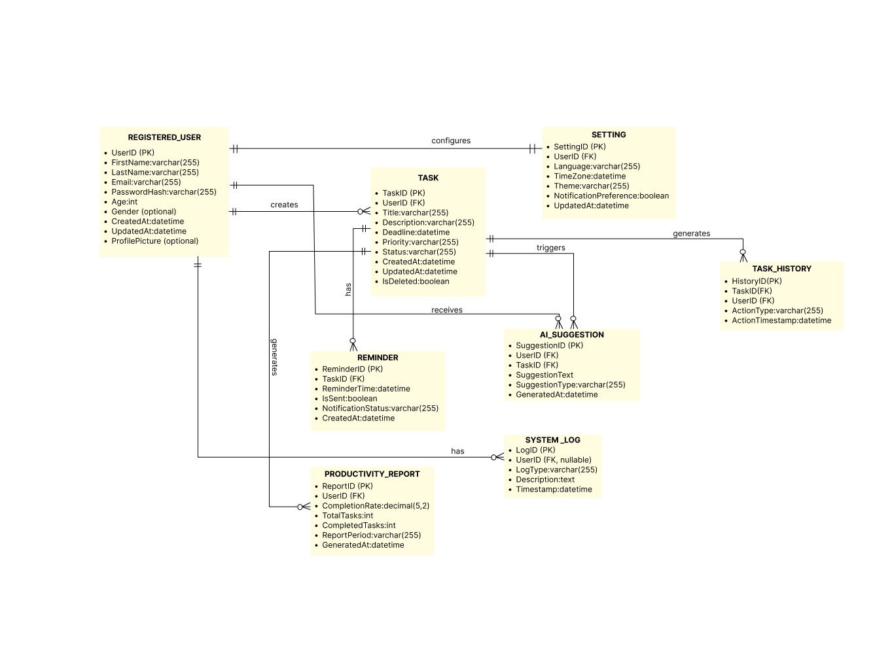

CHAPTER 3: LOGICAL DATABASE DESIGN

3.1. RELATIONAL SCHEMA:
The relational schema below was derived by converting the Entity Relationship Diagram into a set of relations. Each relation specifies its primary key, foreign keys, and all attributes. The schema image below shows the final structure with all inter-table relationships.

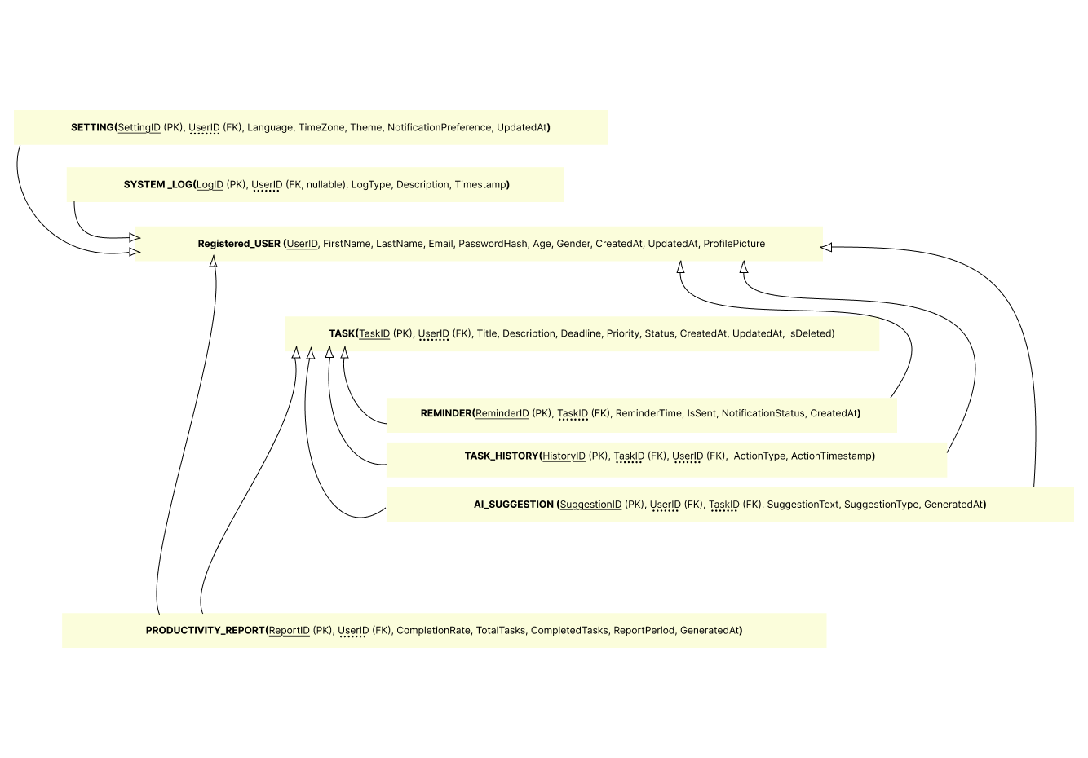
Figure 3.1 – Relational Schema Diagram

3.2. FUNCTIONAL DEPENDENCIES:
A Functional Dependency (FD) A → B states that for any two tuples sharing the same value of A, they must also share the same value of B. The analysis below covers every table in the schema.

3.2.1. REGISTERED_USER
- UserID → FirstName, LastName, Email, PasswordHash, Age, Gender, CreatedAt, UpdatedAt, ProfilePicture
Note: PK — fully determines all attributes.
- Email → UserID, FirstName, LastName, PasswordHash, Age, Gender, CreatedAt, UpdatedAt, ProfilePicture
Note: Candidate key — also a full determinant.

3.2.2. TASK
- TaskID → UserID, Title, Description, Deadline, Priority, Status, CreatedAt, UpdatedAt, IsDeleted
Note: PK — only valid determinant.

3.2.3. SETTING
- SettingID → UserID, Language, TimeZone, Theme, NotificationPreference, UpdatedAt
Note: PK — fully determines all attributes.
- UserID → SettingID, Language, TimeZone, Theme, NotificationPreference, UpdatedAt
Note: Candidate key — 1:1 with REGISTERED_USER.

3.2.4. REMINDER
- ReminderID → TaskID, ReminderTime, IsSent, NotificationStatus, CreatedAt
Note: PK — sole determinant.
- TaskID does NOT determine ReminderTime
Note: One task can have many reminders at different times.

3.2.5. AI_SUGGESTION
- SuggestionID → UserID, TaskID, SuggestionText, SuggestionType, GeneratedAt
Note: PK — sole determinant.

3.2.6. TASK_HISTORY
- HistoryID → TaskID, UserID, ActionType, ActionTimestamp
Note: PK — sole determinant.

3.2.7. PRODUCTIVITY_REPORT
- ReportID → UserID, TotalTasks, CompletedTasks, ReportPeriod, GeneratedAt
Note: PK — sole determinant of stored attributes.
- (CompletedTasks, TotalTasks) → CompletionRate [DERIVED — not stored]
Note: Transitive FD — CompletionRate = (CompletedTasks / TotalTasks) × 100. This is computed at query time, not stored.

3.2.8. SYSTEM_LOG
- LogID → UserID, LogType, Description, Timestamp
Note: PK — sole determinant. UserID is nullable and is not a determinant within this relation.

3.3. NORMALIZATION:
Each relation was examined for violations of First Normal Form (1NF), Second Normal Form (2NF), and Third Normal Form (3NF). The subsections below document the analysis and any transformations applied.

3.3.1. REGISTERED_USER
1NF: All attributes are atomic and single-valued. No repeating groups are present. The relation is in 1NF.
2NF: The primary key is UserID (single attribute). Partial dependency cannot arise with a single-column key. The relation is in 2NF.
3NF: All non-key attributes depend solely and directly on UserID. Email is a candidate key, so Email → other attributes is a candidate-key dependency, not a transitive dependency. No violation exists. The relation is in 3NF.
Resulting relation:
REGISTERED_USER (UserID [PK], FirstName, LastName, Email [UNIQUE], PasswordHash, Age, Gender, CreatedAt, UpdatedAt, ProfilePicture)

3.3.2. TASK
1NF: All attributes are atomic. The relation is in 1NF.
2NF: Primary key is TaskID (single attribute). No partial dependency can arise. The relation is in 2NF.
3NF: No non-key attribute determines another non-key attribute. UserID (FK) does not determine Title, Priority, Status, or any other task-specific attribute. The relation is in 3NF.
Resulting relation:
TASK (TaskID [PK], UserID [FK → REGISTERED_USER], Title, Description, Deadline, Priority, Status, CreatedAt, UpdatedAt, IsDeleted)

3.3.3. SETTING
1NF: All attributes are atomic. The relation is in 1NF.
2NF: Primary key is SettingID (single attribute). No partial dependency can arise. The relation is in 2NF.
3NF: UserID is a candidate key in this relation due to the 1:1 cardinality with REGISTERED_USER. Therefore UserID → Theme, Language, etc. is a candidate-key dependency, not a transitive dependency. No violation of 3NF exists. A UNIQUE constraint on UserID enforces the 1:1 cardinality at the database level.
Resulting relation:
SETTING (SettingID [PK], UserID [FK → REGISTERED_USER, UNIQUE], Language, TimeZone, Theme, NotificationPreference, UpdatedAt)

3.3.4. REMINDER
1NF: All attributes are atomic. The relation is in 1NF.
2NF: Primary key is ReminderID (single attribute). No partial dependency can arise. The relation is in 2NF.
3NF: No non-key attribute determines another. TaskID (FK) does not determine ReminderTime or NotificationStatus. The relation is in 3NF.
Resulting relation:
REMINDER (ReminderID [PK], TaskID [FK → TASK], ReminderTime, IsSent, NotificationStatus, CreatedAt)

3.3.5. AI_SUGGESTION
1NF: All attributes are atomic. The relation is in 1NF.
2NF: Primary key is SuggestionID (single attribute). No partial dependency can arise. The relation is in 2NF.
3NF: Neither UserID nor TaskID, individually or combined, determines SuggestionText or SuggestionType — the same task can receive multiple distinct AI suggestions. The relation is in 3NF.
Resulting relation:
AI_SUGGESTION (SuggestionID [PK], UserID [FK → REGISTERED_USER], TaskID [FK → TASK], SuggestionText, SuggestionType, GeneratedAt)

3.3.6. TASK_HISTORY
1NF: All attributes are atomic. The relation is in 1NF.
2NF: Primary key is HistoryID (single attribute). No partial dependency can arise. The relation is in 2NF.
3NF: The combination (TaskID, UserID) does not determine ActionType — the same task-user pair generates multiple different action types over the task lifecycle. The relation is in 3NF.
Resulting relation:
TASK_HISTORY (HistoryID [PK], TaskID [FK → TASK], UserID [FK → REGISTERED_USER], ActionType, ActionTimestamp)

3.3.7. PRODUCTIVITY_REPORT
1NF: All attributes are atomic. The relation is in 1NF.
2NF: Primary key is ReportID (single attribute). No partial dependency can arise. The relation is in 2NF.
3NF — Violation Detected: A transitive dependency exists:
- ReportID → CompletedTasks
- ReportID → TotalTasks
- (CompletedTasks, TotalTasks) → CompletionRate
Therefore CompletionRate is transitively dependent on ReportID via (CompletedTasks, TotalTasks). Storing CompletionRate would introduce update anomalies (updating CompletedTasks without recalculating CompletionRate leaves the table inconsistent) and insertion anomalies (a report could be stored with an incorrect rate).
Resolution applied: CompletionRate is removed from the stored schema. It is computed on retrieval as (CompletedTasks / TotalTasks) × 100 by the application layer or a database view, eliminating all anomalies with no loss of information.
Resulting relation (after transformation):
PRODUCTIVITY_REPORT (ReportID [PK], UserID [FK → REGISTERED_USER], TotalTasks, CompletedTasks, ReportPeriod, GeneratedAt)
Note: CompletionRate is intentionally omitted as a stored column.

3.3.8. SYSTEM_LOG
1NF: All attributes are atomic. The relation is in 1NF.
2NF: Primary key is LogID (single attribute). No partial dependency can arise. The relation is in 2NF.
3NF: No non-key attribute determines another. UserID is nullable and is not a determinant within this relation. The relation is in 3NF.
Resulting relation:
SYSTEM_LOG (LogID [PK], UserID [FK → REGISTERED_USER, NULLABLE], LogType, Description, Timestamp)

3.3.9. Normalization Summary
Table 3.1 provides a consolidated view of the normalization outcome for every relation in the schema.

Relation | 1NF | 2NF | 3NF | Transformation Applied
REGISTERED_USER | ✔ Already | ✔ Already | ✔ Already | No transformation needed
TASK | ✔ Already | ✔ Already | ✔ Already | No transformation needed
SETTING | ✔ Already | ✔ Already | ✔ Already | UNIQUE constraint on UserID enforces 1:1 cardinality
REMINDER | ✔ Already | ✔ Already | ✔ Already | No transformation needed
AI_SUGGESTION | ✔ Already | ✔ Already | ✔ Already | No transformation needed
TASK_HISTORY | ✔ Already | ✔ Already | ✔ Already | No transformation needed
PRODUCTIVITY_REPORT | ✔ Already | ✔ Already | ⚠ Violated | CompletionRate removed — transitive dependency eliminated
SYSTEM_LOG | ✔ Already | ✔ Already | ✔ Already | No transformation needed
Table 3.1 – Normalization Summary

3.3.10. Final 3NF Relations
The complete, final set of relations after normalization to 3NF is listed below.
- REGISTERED_USER (UserID [PK], FirstName, LastName, Email [UNIQUE], PasswordHash, Age, Gender, CreatedAt, UpdatedAt, ProfilePicture)
- TASK (TaskID [PK], UserID [FK → REGISTERED_USER], Title, Description, Deadline, Priority, Status, CreatedAt, UpdatedAt, IsDeleted)
- SETTING (SettingID [PK], UserID [FK → REGISTERED_USER, UNIQUE], Language, TimeZone, Theme, NotificationPreference, UpdatedAt)
- REMINDER (ReminderID [PK], TaskID [FK → TASK], ReminderTime, IsSent, NotificationStatus, CreatedAt)
- AI_SUGGESTION (SuggestionID [PK], UserID [FK → REGISTERED_USER], TaskID [FK → TASK], SuggestionText, SuggestionType, GeneratedAt)
- TASK_HISTORY (HistoryID [PK], TaskID [FK → TASK], UserID [FK → REGISTERED_USER], ActionType, ActionTimestamp)
- PRODUCTIVITY_REPORT (ReportID [PK], UserID [FK → REGISTERED_USER], TotalTasks, CompletedTasks, ReportPeriod, GeneratedAt) — CompletionRate computed as (CompletedTasks / TotalTasks) × 100 at query time.
- SYSTEM_LOG (LogID [PK], UserID [FK → REGISTERED_USER, NULLABLE], LogType, Description, Timestamp)

CHAPTER 4: IMPLEMENTATION

4.1. LANGUAGE/FRAMEWORK:
The technology stack for this project was selected based on simplicity, compatibility, and ease of integration. The table below summarizes the tools used at each layer of the application.

Layer | Language / Technology
Database | SQL (MySQL 9.6) — DDL, DML, stored procedures, triggers, views
GUI & Backend | Python 3.13
GUI Framework | Tkinter (built into Python — no external installation needed)
Database Connector | mysql-connector-python 9.7
AI-Assisted Development | Kiro AI (used to assist in building the GUI)
Table 4.1 – Technology Stack
MySQL 9.6 was selected as the database management system because it is an industry-standard relational DBMS that supports all required SQL features including stored procedures, triggers, views, and indexing.
Python 3.13 was selected for the backend and GUI because it is straightforward to write, widely taught at university level, and has good support for database connectivity.
Tkinter was used as the GUI framework because it is included with Python and requires no additional installation.
Kiro AI was used during GUI development to assist with code generation and interface design.

4.2. DATABASE CONNECTIVITY:
The GUI application communicates with the MySQL database through the mysql-connector-python 9.7 library. A central module named db.py is responsible for establishing and managing the database connection.
The connection is configured using the following parameters: host, port, database name (AI_Task_Management), username, and password. All database operations pass through two core functions defined in db.py:
- call_proc(): Executes stored procedures and returns query results as a list of dictionaries.
- query_view(): Retrieves data from database views with optional filtering conditions.
The application follows a clean separation of concerns: the GUI layer only handles display and user input, while all data operations are performed through db.py. No direct INSERT, UPDATE, or DELETE statements are issued from the GUI. All write operations are handled by stored procedures, which improves security and maintainability.

4.3. STORED PROCEDURES AND FUNCTIONS:
All database programmability objects are documented below. The system uses stored procedures for all data modifications, triggers for automated auditing, and views for simplified data retrieval.

4.3.1. Stored Procedures
# | Object Name | Object Type | Description
1 | sp_RegisterUser | Stored Procedure | Registers a new user account in the system.
2 | sp_AddTask | Stored Procedure | Adds a new task for a specified user.
3 | sp_UpdateTaskStatus | Stored Procedure | Updates the status of an existing task.
4 | sp_DeleteTask | Stored Procedure | Soft deletes a task by setting IsDeleted to TRUE.
5 | sp_GetUserTasks | Stored Procedure | Retrieves all active tasks for a given user.
6 | sp_GetProductivityReport | Stored Procedure | Generates a productivity report including dynamically calculated completion rate.
7 | sp_AddReminder | Stored Procedure | Creates a new reminder linked to a specified task.
Table 4.2 – Stored Procedures

4.3.2. Triggers
# | Object Name | Object Type | Description
1 | trg_task_created | Trigger (AFTER INSERT on Task) | Automatically inserts a 'Created' record into TASK_HISTORY whenever a new task is added.
2 | trg_task_completed | Trigger (AFTER UPDATE on Task) | When task status changes to Completed, inserts a record into TASK_HISTORY and creates a SYSTEM_LOG entry.
3 | trg_user_default_settings | Trigger (AFTER INSERT on Registered_User) | Automatically creates a default settings record for every new user with Language=English, Theme=Light, and Notifications=Enabled.
Table 4.3 – Triggers

4.3.3. Views
# | Object Name | Object Type | Description
1 | vw_ActiveTasks | View | Returns all non-deleted tasks along with the associated user's full name. Used for the task management dashboard.
2 | vw_CompletedTasks | View | Returns all completed tasks that have not been deleted. Used for productivity reporting and analysis.
3 | vw_UserProductivity | View | Returns productivity statistics per user and dynamically calculates CompletionRate as (CompletedTasks / TotalTasks) × 100, maintaining 3NF compliance.
4 | vw_PendingReminders | View | Returns all reminders that have not yet been sent, along with their associated task titles.
Table 4.4 – Views

4.3.4. Indexes
Index Name | Table | Column | Purpose
idx_task_status | Task | Status | Fast filtering by task status
idx_task_deadline | Task | Deadline | Deadline-based sorting
idx_task_user | Task | UserID | Optimized joins with user table
idx_user_email | Registered_User | Email | Fast login and authentication lookup
idx_reminder_task | Reminder | TaskID | Join optimization for reminders
idx_log_user | System_Log | UserID | User-specific log retrieval
Table 4.5 – Database Indexes

4.4. INTERFACES:
The graphical user interface was developed using Python 3.13 and the Tkinter framework. Kiro AI was used to assist in building the GUI. The application consists of the following main modules, each connected to the database through stored procedures and views:

Module | Database Operations
Dashboard | Reads vw_ActiveTasks and displays summary statistics for the logged-in user.
Users | User registration via sp_RegisterUser and user management operations.
Tasks | Add tasks (sp_AddTask), update status (sp_UpdateTaskStatus), soft delete (sp_DeleteTask), and view via vw_ActiveTasks.
Reminders | Create reminders (sp_AddReminder) and monitor pending reminders via vw_PendingReminders.
AI Suggestions | Manage AI-generated recommendations linked to users and tasks.
Task History | View audit trail records from the TASK_HISTORY table.
Reports | Generate productivity reports via sp_GetProductivityReport and vw_UserProductivity.
Settings | Update user preferences stored in the SETTING table.
System Logs | Monitor system events from the SYSTEM_LOG table.
Table 4.6 – GUI Modules and Database Operations

The screenshots below show the main interface screens of the application.
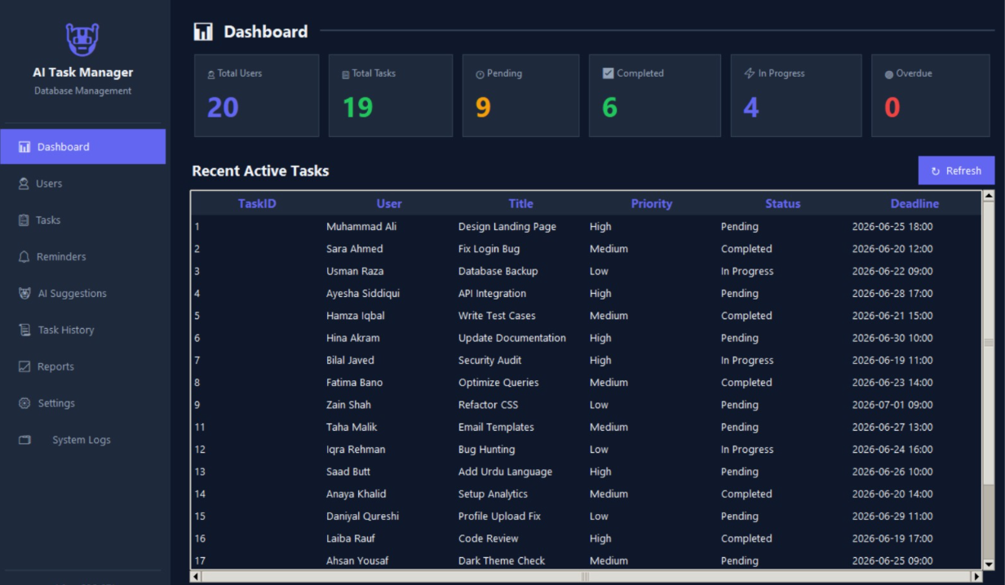
Screenshot 4.1 – Dashboard Screen
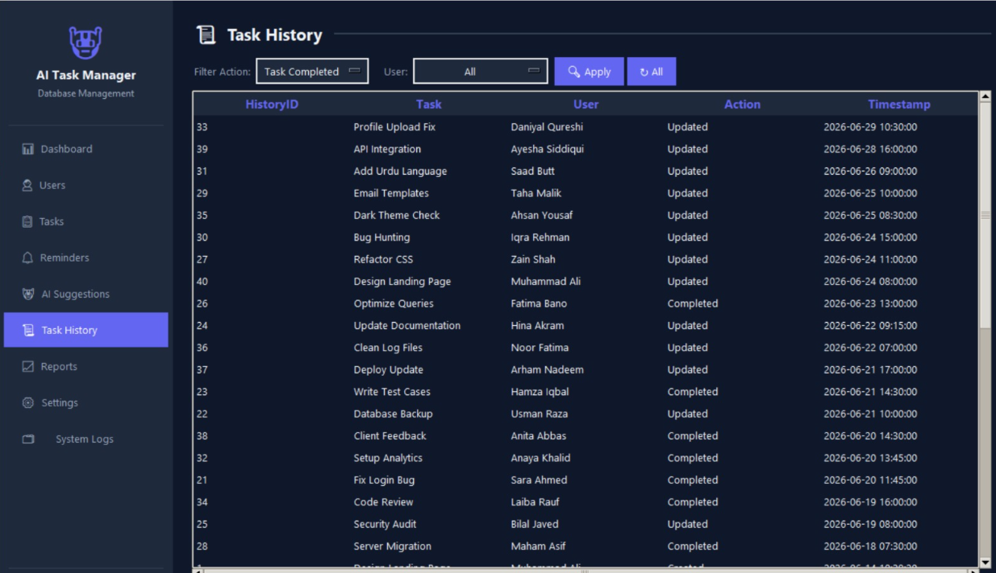
Screenshot 4.6 – Task History Screen

APPENDIX: AI USAGE AND PROMPTS
This section documents all AI tools used during the development of this project, along with the prompts used and their purpose.

# | AI Tool Used | Purpose | Output Generated
1 | Kiro AI | GUI development and code generation | Tkinter GUI screens and layout code
2 | Chatgpt | To understand milestone requirements, clarify project objectives, and explain concepts related to the project. | Explanation of milestone requirements, task breakdown, and guidance for project implementation.
3 | Claude | To assist in writing and structuring the design document. | Design document draft, formatting suggestions, and content organization.

