**What is merge sort?**

1. it is divide and conquer sort algorithm

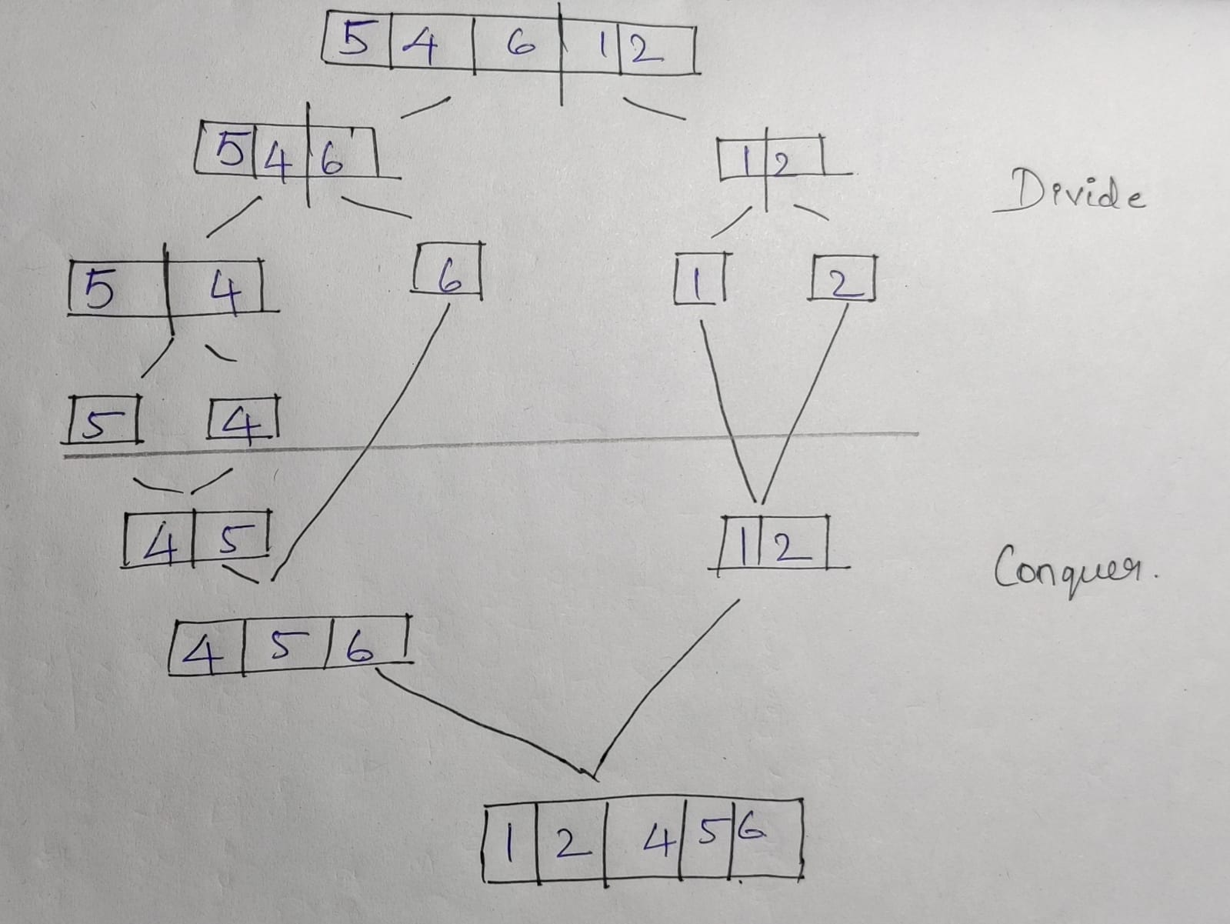

**Steps:**

i) Split list with middle element

ii) Sort the list

iii) Merge the sorted list