Umple
Link to main umple site here.

Umple is an open source language that can be used with Java, C++ and PHP projects.

Umple can be run online, as an Eclipse plugin or a command-line Jar.

Since it can work in object oriented programming languages projects you could use a language like Java to import the data and then use Umple to create textual UML diagrams. You could turn data into Umple code to create models.

Can make text umls, Yuml class diagrams, structure diagrams and other kinds of diagrams and models.

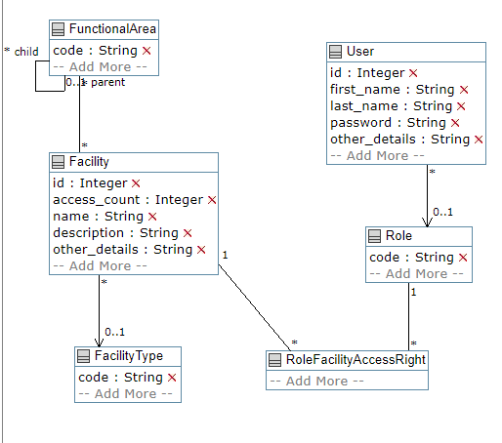
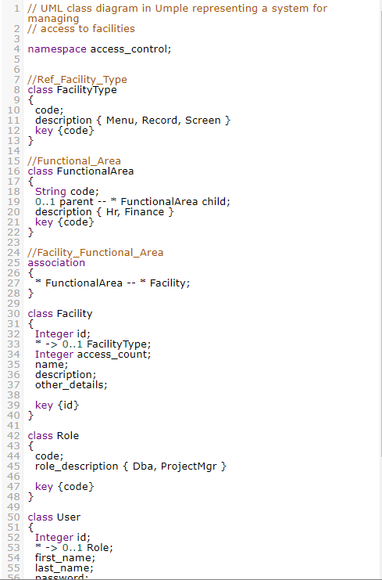
On the left is the Umple code that is used to make models.

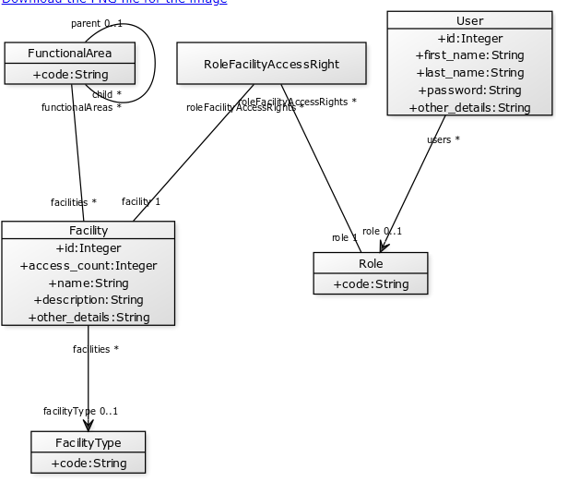

Example of 1 type of model Umple can generate.

Pros:
- Online tool which can be very useful for grasping Umple’s capabilities
- Eclipse plugin
- User manual, Github site and other social medias
- Many examples on their website with instructions
- Open source
Cons:
- New language
- Generates models and code by using Umple code, so you would have to transform data into Umple before being able to generate anything.

