Automatic Discovery of State

Withheld Pending Review Department Name
Institution/University Name
City State Country
email@email.com
Withheld Pending Review
Department Name
Institution/University Name
City State Country
email@email.com
Withheld Pending Review
Department Name
Institution/University Name
City State Country
email@email.com

ABSTRACT
Formal definitions of state have been used to great effect for test coverage analysis, program verification, and defect detection. Developers, however, create informal state-related elements far more frequently than anything formally defined in development artifacts. Current state of the art does not afford opportunities to examine informal state-related program elements except at the cost of extensive human code review hours. This paper discusses a novel heuristic algorithm that automatically classifies all program elements with respect to state. This paper also describes a study funding that that algorithm correctly identifies about half the state members and reduces the total labor by more than 90%.
Permission to make digital or hard copies of part or all of this work for personal or classroom use is granted without fee provided that copies are not made or distributed for profit or commercial advantage and that copies bear this notice and the full citation on the first page. Copyrights for third-party components of this work must be honored. For all other uses, contact the owner/author(s).
WOODSTOCK’18, June, 2018, El Paso, Texas USA
© 2018 Copyright held by the owner/author(s). 978-1-4503-0000-0/18/06...$15.00
https://doi.org/10.1145/1234567890
CCS CONCEPTS
• Software and its engineering • Software notation and tools • Software maintenance tools
KEYWORDS
State, automation, heuristic, classifier
1 Introduction
Any program that does not maintain internal state is incapable of learning or remembering past experiences. Even a garage door opener must recognize its current state (e.g., OPEN) to correctly operate. A slightly more complex pocket calculator must remember multiple states, including the current screen value, the last button pushed, any previous answer, etc. While some elements of a program can and do serve their function without internal state, the program as a whole must maintain state between user actions (e.g., recalling all the characters I have already typed) as well as between executions (e.g., remembering my preference for the window size and location of the word processing program).

In discussing state it is useful to distinguish between formal and informal state. Finite state machines, State design patterns [6], and other documented state features are categorized as formal state because they are critically engineered and difficult to casually change. For example, it may be a non-trivial exercise to add a new state or create a new edge between states in a finite state machine. Informal state, however, is almost casually added by developers to enable specific program features. An example of this might be that a specific button turns a verbose log on or off. The button somehow affects the state of the logger, and that state enforces one of two behaviors on the application. Formal state is usually well-defined in design documentation or models that contribute skeleton code to an application. Informal state, on the other hand, occurs much more frequently and with little, if any, representation in documentation or other artifacts.

Formal state has been shown to be extremely useful to researchers for a variety of purposes. Automatic source code generation has been enabled by formal state [13], [11]. Software testing [2], [3], [5] and automated fault detection [13] have also been shown to benefit from formal state. Somewhat reversing the role, one researcher [1] derived a test coverage prediction capability from the same formal state machine that specified the application. Knowledge of the formal state embodied in an application opens up windows of understanding into its workings.

Informal state should be just as interesting to researchers. Unfortunately, informal state is far less accessible. Developers may create a state machine, perhaps of very limited scope, without documenting its presence. As an undocumented feature, the state machine may be grown by aggregation, copied to create a series of related state features, or otherwise changed over time. Developers, maintainers, and researchers cannot subject informal state to the same kind of analysis supported by formal state because specific and current knowledge of the informal state is inaccessible. Discovery of informal state must involve an extensive, manual effort—possibly expending more effort than is saved.

In various areas where human time is a limiting factor, heuristic algorithms have often proved useful. This strategy was employed successfully by [8], where model checking was guided by a heuristic algorithm to replace “considerable nonautomatic work by [human] experts”. That case used a heuristic algorithm to identify counter examples and thereby prune unproductive portions of the search space. Another case [9] used a set of heuristic algorithms to detect different characteristics of interest. The resulting combination served to identify the feature of interest correctly. It is noteworthy that in each case several different heuristic algorithms were employed with various levels of success. This pattern, using various heuristic algorithms to approximate human evaluation of a problem space, is frequently used to alleviate the drain on human resources. The work described in this paper will employ a similar strategy.
1.1 Research Questions and Objectives
As described above, other researchers [1] [2] [3] [5] [11] [13] have demonstrated the value in identifying and analyzing the state space of a software program. Obtaining that data, is expensive and laborious. Formal state can only account for a minor portion of the state space. Informal state is not readily available. That is the problem. Only manual evaluation of a code base can derive the valuable data. Heuristic algorithms offer some hope of replacing manual evaluation. There are two research questions: What algorithmic means might be used to identify state? How closely will algorithmic classification approximate human classification?

This paper describes a novel method developed to automatically discover program elements associated with state. The paper is organized as follows: Section II describes the development of a heuristic algorithm for the identification of state. Section III describes the methodology used to evaluate the algorithm. Section IV describes the results of the evaluation and analyzes those results. Section V gives some conclusions and highlights future research areas of interest made available by this work.
2 Heuristic Algorithm Development
The definition of “state” is unclear and subjective. Therefore, much effort was expended to more formally define state. That reasoning was eventually incorporated into an algorithm to classify all program elements according to their association with state. The rationale behind that classification system is presented in the three axioms that follow.

Axiom I: State is evidenced by distinct and mutually exclusive behaviors. This statement should be self-evident even from the various informal definitions of state. If the state of the program has changed, then the behavior of the program must also change. Conversely, if the behavior of the program has changed, some element of state must be involved. Merely random fluctuations in behavior are not related to state and although multiple states may coexist independently, they must exist in separate state machines (e.g., the network state of my computer is independent of the save state of my document). In all cases where a program element may be classified as state-related, a change in behavior must be indicated.

Axiom II: Changes in program behavior are derived from control structures. Control structures offer an obvious handle with which to correlate state-based behaviors with specific lines of code. In a simple if-then-else structure each of the then-else branches embodies a distinct behavior. The expression in the if statement uniquely determines which behavior will be evoked. As such, it is evident that control structures are the source of state behaviors.

Axiom III: Any program element related to state will affect the evaluation of a control structure. While many class members may exist for various other reasons (e.g. a data structure), state-related members should stand out for their frequent association with control structures. This introduces the concept of control structure incident count I_{C} representing the number of times that each program element is used logically in the evaluation of control structure logic. Figure 1 shows the theoretical distribution of state and non-state members with respect to I_{C}. The distribution of non-state members will skew heavily toward I_{C}=0. The distribution of state members should have an appreciably distinct mean value I_{C}>0. A fuzzy boundary between the two distributions should exist at some critical value I_{C}=C. If this relationship is true, then it should be possible to identify the fuzzy threshold I_{C}=C where non-state and state may be separated.
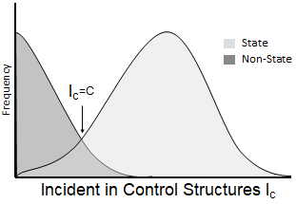
Figure 1: Theoretical view of state vis-à-vis Axiom III

2.1 Automatic Classification
In order to evaluate this theoretical relationship, a tool was needed to automatically apply these axioms. A purpose-built tool was developed based on ANTLR and a Java grammar, identifying each field and calculate its I_{C}. That tool was used to examine three codebases and identified 1408 variables and methods with some relation to control structures I_{C}>0. These members inevitably included a variety of behaviors that were patently unrelated to state (e.g., null checks, comparison between values, checks for equality, and type checks), but all such cases were initially included to offer the widest possible opportunity to detect state.

2.2 Manual Classification
The same members were manually classified as state or non-state by an expert developer. Of the 1408 variables classified, the majority (60%) were determined to be non-state and were most often used to prevent null pointers, validate data, order objects, check against min/max values, perform modulo arithmetic, and report successful completion of a subroutine. Almost without exception, the remaining state-related members were linked to Boolean or Enumerated types. This finding suggested that Boolean and Enumerated types had some native relationship with state.

Based on this preliminary analysis, the automated tool was altered to exclude the unrelated control structure incidents and produce a modified I_{C} for each program element. Under the new system, many of the 1408 members had a zero count I_{C}=0. Comparing the new counts with the manual classification revealed additional trends:
- Although many Boolean and Enumerated variables were manually classified as state-related, these variables often had a low count I_{C}<2.
- The vast majority of the non-state program elements had a very low count I_{C}<1 as expected. The highest incident numbers I_{C}>3 were all manually classified as state-related.

These results were decidedly mixed when compared with the theoretical relationship. All of the highest incident counts were obviously state related, but far too many low incident counts were also state related. A more careful examination of the latter group led to further insight into the cause.

Many of the low-count state members were fields that were private and untouched by control structures within that single class. These fields, however, had public accessor methods with a much higher count in other classes. Considering the accessor methods in conjunction with the private fields, it appeared that the trio had a significant relationship to state that was not apparent by examining each member alone. Also among the low-count state members were methods that were child-class implementations of an abstract or interface method. The child-class implementations had very low counts, but the parent method had a much higher count. Again, considering the set of all implementations as a whole, the I_{C} was much higher.
2.3 Formulation of Heuristic
The findings from manual classification served to enhance understanding of the theoretical relationship and limit the heuristic to the most relevant indications of state. In spite of an initial preference for the widest possible interpretation of state, exclusionary and inclusionary criteria were developed that conformed to the trends observed from empirical data.

Theorem I: Only direct evaluation of a program element in a control structure may be included in calculation of I_{C}. This theorem represents the modified I_{C} calculation for both fields and methods. For example, if(isSomeState()) and if(someState || otherState) are direct evaluations of the method and both fields. Nevertheless, this criterion demonstrably creates minor errors. Direct evaluation of b in if(b) is counted while indirect evaluation in if(b==true) is not. Because the two expressions are logically equivalent, the second case would incorrectly diminish the I_{C} for b.

Theorem II: Members with a logical association must be counted jointly as a single feature. This theorem takes into account the accessor and implementation/override relationships that masked the state relationship on the basis of counts alone. Using this logic, the I_{C} for a field and the I_{C} for its getter/setter methods would be combined into a single value (1). A similar calculation would apply to a set of methods implementing an interface. The application of this theorem may result in a slightly higher aggregate count. All members conglomerated in this fashion are said to be “linked” to each other for state evaluation.

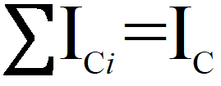 
Theorem III: A high I_{c} value is indicative of state. This theorem is the application of Axiom III and is supported by the empirical evidence of extremely high-count members that were exclusively state-related. Members identified as state-related under this theorem are known as “statistical” state.

Theorem IV: Any Enumerated or Boolean variable is considered to be state-related as a native property of the variable type. The validity of this final theorem is debatable. The initial data set showed Boolean and Enumerated types had some relationship with state, but the strength of that relationship or the potential for false positives on this basis alone bears further investigation. Members identified as state-related under this theorem are known and “native” state.
2.4 Applying Statistical Methods
Theorems I through IV broaden the definition of state beyond the straightforward tabulation of I_{C}. Nevertheless, the results of the manual classification do confirm a fuzzy boundary exists between state and non-state members on the basis of I_{C}. The hypothesis is that the mean I_{C} of state members will occur a significant distance from I_{C}=0, representing non-state members. Significance may be determined by evaluating the standard deviation of I_{C} from zero (2).

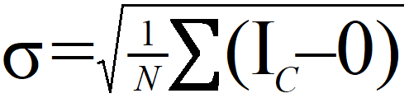 
Initially, it was believed that the fuzzy boundary would occur at a Z value of 1.75σ i.e. a 95% confidence level. A quick comparison with the evaluation data showed that far too many non-state variables had counts above this threshold. The I_{C} values and manual evaluation data from the 1408 members was plotted at various multiples of the Zσ value. That plot, shown in Figure 2, revealed that the critical value occurred between 2Zσ and 3Zσ, sharply reducing the number of false positives and false negatives. These results held true for each codebase in the dataset.

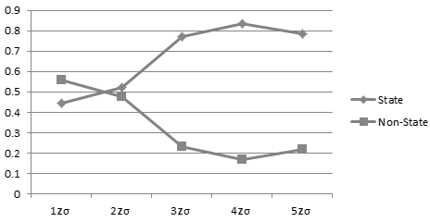
Figure 2: State and Non-state portions at nZσ
Naturally, this classification system provides a number of opportunities for type I and type II errors. As noted earlier, Theorem I may incorrectly lower I_{C} increasing false negatives, while Theorem IV almost certainly introduces false positives. Furthermore, the data in Figure 2 indicates a false positive rate of 15–20% even among those members classified statistically. These sources of error are to be expected of heuristic algorithms that, by definition, are not demonstrably correct. The full details of the heuristic algorithm are the subject of a pending patent [4].
2.5 Comparison with Theory
From the manual classification data, it is possible to determine how native state and the linking of related members affect the theoretical “statistical state” predicted in Axiom III. Figure 3 depicts some 509 members from one of the three codebases used in manual classification. The graph shows the distribution of these members at various I_{C} values along the horizontal axis. The manual classification data may be compared with the nZσ threshold, depicted as a vertical line. Base on Axiom III alone, 58% of the sample would have been incorrectly classified. This would have resulted in an accuracy of only 40%.

Figure 4 revises the same data set, applying different markings to distinguish the various theorems used to identify state-related members.. Those members which were identified as “state” based on statistical means (white), through linking (vertical stripe), and as a native property of the type (horizontal stripe) can be distinguished. Observe that:
- Theorem IV (native state) reduces the false negatives by 63%. Theorem IV also accounts for 31% of the true positives above the nZσ threshold.
- Theorem II (linked state) accounts for an additional 26% of false negatives. Very few linked state members are found above the nZσ threshold.
- The residual portion of false negatives (11%) from statistical classification is acceptable.

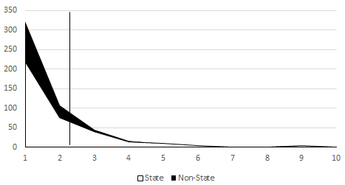
Figure 3: Results of manual classification
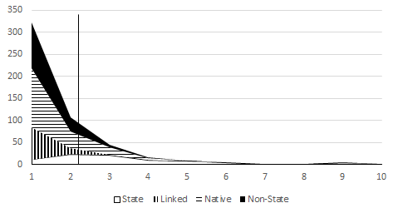
Figure 4: Heuristic algorithm results
Having accounted for and removed native and linked state, what may be observed from the residual state and non-state members? Does the data fit the predicted distributions in Figure 1? Figure 5 shows the remaining state and non-state members. It is now apparent that there is a modal peak in the distribution of statements slightly above the nZσ threshold. The distribution of non-state members is heavily skewed toward zero, as predicted. Each of these characteristics is consistent with the theory.
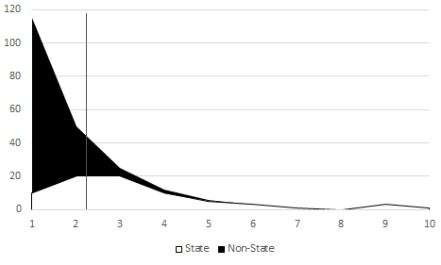
Figure 5: Residual distribution of state and non-state

Figure 6 alters the display of the data a final time to show each distribution separately over the same horizontal axis. Now the fuzzy boundary between state and non-state distributions is more clearly visible. In fact, this view compares quite favorably with Figure 1, although the peak of state members is quite a bit lower than expected. The nZσ threshold is in nearly perfect alignment with the predicted crossover. That anomaly is more fortuitous than may be expected in all cases and is likely the result of over-tuning. Nevertheless, the relationship shown in Figure 6 conforms to the theoretical relationship in all relevant points.

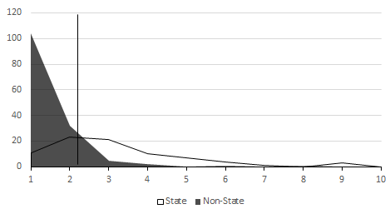
Figure 6: Confirmed statistical crossover
3 Methodology
The basic design of the evaluation study is simple. Select a large random sample of program members (e.g. fields and methods). Classify each member as state or non-state using the developed heuristic algorithm. Compare that classification with the true classification of the same sample. Determine the accuracy, precision, etc. of the heuristic algorithm with appropriate error ranges.
3.1 Sample Selection
A variety of source code was available to the author through open-source repositories and collaboration with various software development organizations in commercial and defense industries. The three codebases used to develop the algorithm were not considered eligible. Ten new codebases (Table 1) were selected. Using multiple projects prevented the characteristics of any one codebase from skewing the results. These applications were developed by distinct groups of programmers, with different management, for different applications, and on distinct scales as measured in Standard Lines of Code (SLOC). Their only common characteristic was the programing language, a limitation of the Java grammar and ANTLR-based tool used to develop the heuristic algorithm. A random sample of 100 members were selected from each of the codebases for a total of 1000 samples (n=1000) distributed equally among the ten codebases.
3.2 Obtaining True Classification Data
To the knowledge of the author, no oracle exists to predict the presence of state. Formal state, as discussed in the introduction, might be used to provide true classification data. This method, however, has certain drawbacks, principally a lack of randomness and complete ignorance of the negative cases. Again, manual classification would be used to obtain true classification data.

Table 1: Sample codebases by domain, source, and size
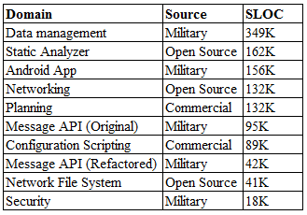
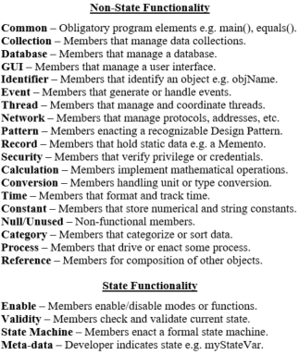
Figure 7: Manual classification criteria
To avoid excess subjectivity in the manual classification, a set of criteria were developed in a two-tier system, see Figure 7. The major categories, state and non-state, were of interest as true classification data. Within each category were several sub-categories suggesting the functionality expressed by that member. GUI elements, for example, would not typically be associated with state. Ideally, an evaluator would review the member and easy fit it into a sub-category that justified the broader state/non-state designation to his or her satisfaction.

At some point, however, subjectivity comes into play. While the majority of the members firmly fit into one of the well-defined categories, an expert may still feel there is ambiguity. Several state and non-state sub-categories were left open to interpretation, allowing the expert final authority in the classification. The expert was encouraged to add notes explaining the final rationale behind the classification. Remember that the goal of the classification criteria was to evoke a firm designation of state or non-state in the first tier. As long as the expert is certain of that designation, error is tolerable among the sub-categories.
3.3 Sources of Error
Entirely aside from the subjectivity of human evaluators and the ambiguity of the categories, there is another significant source of error in this evaluation process. This error is derived from the code itself and especially the potential for multiple categories within a limited amount of code. In order to better define this type of error and its effects, let us consider a few exemplary code segments.
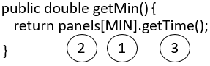
Figure 8: Category ambiguity within non-state group

The code segment in Figure 8 is very short, but it contains elements that suggest three distinct sub-categories that may pertain to getMin(). The evaluator’s note indicates some angst over this decision. In this snippet of code there is a collection (1) containing GUI elements (2) that are used to get a time value (3). In this case, however, each sub-category is firmly in the non-state category. Although there may be error, the primary category of non-state is perfectly obvious and confidence in that classification is high.

The code segment in Figure 9 is slightly more complicated, and includes elements belonging to four sub-categories. The method name (A) is metadata suggesting state is involved. The method is handling an event (B). Furthermore, the event is apparently related to a GUI (C) element operating on a tree collection (D) of nodes. In this case, the expert decided that the primary purpose of stateChanged() was to handle and distribute an event. The fact that the event was generated by a state change leaves some doubt as to the accuracy of this classification.

These examples demonstrate the level of confusion that may exist and especially the effect of ambiguity on the dependent variable of interest: state or non-state. There are several techniques that may be used to reduce the effect of these errors, each of which has drawbacks.
- Members may be assigned to multiple categories thereby identifying the several elements represented. This assignment assumes equal relationship with all elements and changes from binary to a multi-label classification system at odds with the heuristic algorithm.
- Percentages or rankings may be applied to each of the represented elements, making all categories fuzzy, and increasing ambiguity in final result.
- Classification can be limited to a single category that represents the “main” or “most important” concept associated with the member. This may increase the number of false positives or false negatives where a member has relationships with multiple elements.

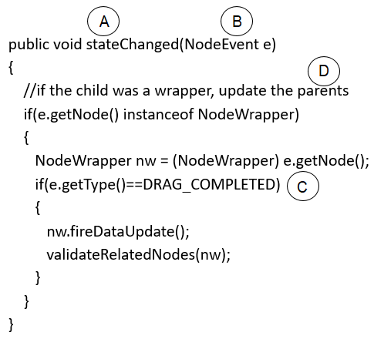
Figure 9: Cross group ambiguity

The categorization described above is an example of the technique in the third bullet. That technique was selected for two reasons. First, if the heuristic algorithm had produced a confidence factor or likelihood ratio, it would have been profitable to compare the results with a multi-label system. In this case, however, the binary result is best contrasted with an equally binary set of truth data. Second, the error resulting from misclassification (either from subjectivity or ambiguity) only has the potential to decrease the observed accuracy of the classifier. Therefore, the observed accuracy of the binary classification system would represent an upper bound on error. The potential to accept the null hypothesis (i.e. conclude that the heuristic is no better than random) is higher, but that can only strengthen the case for the heuristic if the null hypothesis is rejected.
3.4 Accuracy Paradox Avoidance
One final concern for the evaluation is the relatively low frequency (prevalence) of state-related members among those evaluated. The random sample cannot be intentionally seeded with any state-related members. After several of the samples had been evaluated it became apparent that the natural prevalence of state was less than 10% of all members. The wide difference between state and non-state prevalence raises concerns over the accuracy paradox [12].

Among binary classifiers, the F1 score is a test that may be used to identify classifications where high accuracy masks an unfair advantage based on prevelance. One technique for applying the F1 is to consider precision and recall for each category separately and as an average. The resulting scores show which category receives an unfair advantage and the average may be used with accuracy to compare different classifiers.
Table 2: Evaluation results of samples ordered by application size
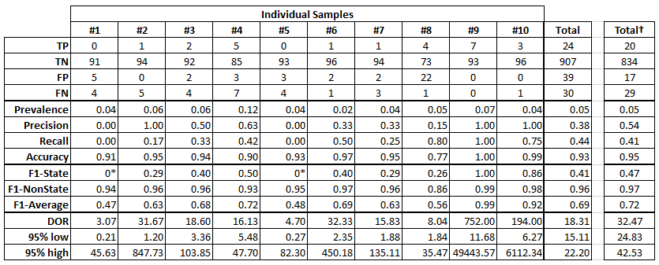

Among medical classifiers, however, the Diagnostic Odds Ratio (DOR) [7] has been used to much greater effect. The DOR is not dependent on prevalence and affords additional advantages over accuracy alone. In this experiment, accuracy, F1, and DOR values will all be considered in order to give a holistic view of the heuristic algorithm’s capabilities. DOR is calculated using the full ambiguity matrix so that type I and type II errors are equally represented.
- DOR runs on the continuous interval [0,∞] with a mean value of 1 allowing for negative, positive, or neutral comparison with random classification.
- DOR has a normal distribution on a logarithmic scale so that the confidence interval may be calculated.
- DOR is undefined if any count is zero, but a small non-zero seed value added to each count resolves these discontinuities.
4 Results
The results from the classification experiment are organized first in relation to each of the 10 codebases and then as an aggregate whole. The first set of values will gauge the effectiveness of the heuristic on each program. The second considers the 1000 members as a statistical sample indicative of effectiveness on all programs. In each case, values are calculated for precision, recall, accuracy, F1, and DOR. The prevalence of state (TP+FN) is included as a matter of interest.

Some of the samples have zero values for TP or FP. The presence of a zero does not affect precision, recall, or accuracy, but it does have an effect on the DOR and the F1. Following the indicated best practice, the DOR calculation is performed after seeding each category with the value 1. This value is relatively small when compared with the sample size and will not skew the results. The F1 score is not valid when TP=0. In these cases, the value of the classifier is 0* or completely non-predictive in the true case. Note that the order of samples in Table 2 is identical with that shown in Table 1. The column Total† at far right will be explained later.

Among the results shown in Table 2 are several anomalies. Samples 1 and 5 have no TPs, indicating that in these cases the heuristic completely misclassifies state members. Compare these results with sample 9 where all state members were correctly classified and there are no FNs. Both cases create unusual statistical properties in the evaluation metrics. These are anomalies, but they are within the bounds of reasonable variance. They do not unduly affect the final outcome and the totals at right are not subject to any challenge to validity based on these results.

Based on the aggregate values, the heuristic algorithm is 93% accurate. That value far exceeds the “stable” value suggested by [13]. The average F1 of .69 is derived from a high ability to exclude non-state members .96 and a reasonable ability to identify state members .41. The 95% confidence interval on the DOR is [15.11, 22.20], suggesting the heuristic algorithm is significantly better than random chance (1) in the classification of state and non-state members. These results are highly encouraging. On a random sample of 1000 program members, these results lead to the rejection of the null hypothesis that the described algorithm is no better than random selection when compared with classification by humans.

Note, however, the values for precision and recall. These values are very low <50%, indicating that this heuristic may be improved. About half of all state-related members were correctly classified. Of the reported state members, 2 of out 3 were false positives. Clearly, both of these values might be improved by altering the heuristic. Nevertheless, the ability to correctly exclude 95.8% of the non-state members is a great achievement. Put another way, including FPs, this algorithm can identify half of the informal state and while some FPs may lead to additional labor, the total labor to review the reported positive is only 6.3% of the original task.
4.1 Threats to Validity
As an aggregate sample, there is nothing unusual about the sampling or evaluating method which is a threat to the validity of the study. The samples were taken randomly and from multiple projects. The samples were evaluated by developers with over 10 years of experience. The accuracy paradox was addressed by the addition of F1 scores. The DOR even affords the opportunity to evaluate a normal distribution and reject the null hypothesis with ρ<.05 confidence. As a whole, the data indicates a positive outcome.

Sample 8, however, poses grave concerns for the validity of the results. In that program, the heuristic was only 77% accurate, a value far outside the range defined by the other samples. An examination of the confusion matrix shows that the problem stems from the unusually high number of false positives. Is this an outlier, or is there a problem with the algorithm?

A superficial examination of the data does not reveal anything unusual about sample 8. The prevalence of state was absolutely average. The same expert evaluated other samples, so the evaluator does not appear to have unusual expectations. Initially, it appears that the anomaly is solely caused by an error in classification by the heuristic—an error that is significant enough to merit further attention.

To determine which theorem was responsible for the error, the FPs from sample 8 were compared with those from the other 9 samples. Booleans and methods linked to Booleans accounted for 75% of the correct classifications. Enumerations and methods linked to enumerations accounted for a similar portion of erroneous classifications. Recall that native state (theorem IV) was never critically examined. Figure 10 calls into question the place of Enumeration as a native state type, showing stronger evidence for Boolean types and equally strong evidence against Enumerations. The concept of native state may need to be refined in future work.
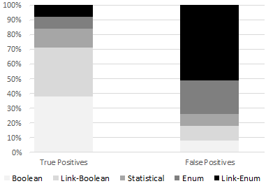
Figure 10: TP and FP trends in relation to theorems
Nevertheless, the FP trend in sample 8 was consistent with the overall rate from other samples. Enumerations alone could not explain the unusual results in sample 8. Attention finally returned to the sample itself. Were there any unusual characteristics of sample 8 that could account for the high FP rate? At this point, it is helpful to recall that sample 8 was taken from one of the smaller applications, comprising only 42 KSLOC. Further examination of the refactored message API revealed that the new message classes made heavy use of Enumerations. In such a small code base, the high incident of Enumerations might account for the disparity in FPs.

An investigation of the ten applications confirmed this conjecture. In order to examine the prevalence of Enumerations, a survey was made of all the fields in each of the 10 projects. This included fields that had not been manually evaluated, as the type of the field could be readily assessed without additional labor. The fields were separated into three categories: Boolean, Enumeration, and all other types. The results shown in Figure 11 immediately demonstrate that sample 8 is quite unusual. There is a lot of noise in the proportions of types for such a small sample (N=9), but it is possible to calculate a confidence interval for the occurrence of Enumerations in the other programs. From that data Enumerations should account for 1.9%±3.9% of all fields (95% confidence). The portion of Enumerations in sample 8 is 14.7%, over 8 standard deviations from that mean. The unusual results for 8 could finally be explained.
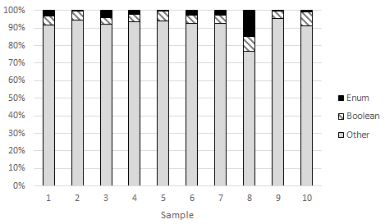
Figure 11: Proportion of field type in samples
The unusual number of FPs in sample 8 appears to be caused by the unfortunate conjunction of a weakness in theorem IV and the over-abundance of Enumerations in the data. Far from being a cause for concern, sample 8 may indicate a pathway for future work in refining theorem IV and further improving the heuristic. Nevertheless, because sample 8 is so atypical, one might justify its exclusion from the result set as an outlier. It has been included in Table 2, but a separate column of cumulative data Total† has been calculated to exclude sample 8. The new calculation in Total† does not greatly affect accuracy, and only slightly raises the F1 values for the classifier. It does, however, give a statistically higher confidence interval for the DOR. The reader is free to accept either data set as valid.

4.2 Parameterization of nZσ
One unexpected benefit of this algorithm is that the nZσ calculation is parameterized for various values of n. Reducing n will increase recall while decreasing precision. Is it possible to improve the former without adversely affecting the latter? Among the non-state members in the sample, the distribution was even tighter than that predicted by the preliminary data. The vast majority (98.8%) of non-state members had no relation to control structures at all I_{C}=0. A much smaller portion (0.7%) had just one count. The remainder were clear outliers with 10 or more counts. Given this information, it seemed possible to further improve the heuristic by reducing n.
The sample was revisited and the confusion matrix was altered for various values of n. This change had no effect on TP and FP values, but FN and TN values that met the lower threshold were moved to TP and FP respectively. The value of n was optimized with and without sample 8, but the two cases were found to have nearly identical results at the same optimal value.

Reducing n by 62% (1.33σ) produced slight improvements on recall without affecting precision. Further reducing n by 77% (0.81σ) produced an optimal heuristic for this sample. These calculations are not meant to suggest the true value of nZσ, but they do tend to confirm that the original formulation was overly conservative. Some increase in FPs will actually improve the performance considerably. The exact calculation of the correct nZσ value must be left for future work. The optimized values for this sample are shown in Table 3.
Table 3: Optimized totals for 23% of nZσ
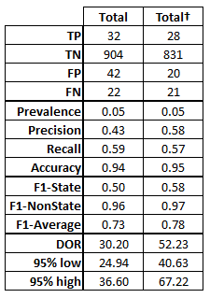
Finally, the parameterization of nZσ offers another opportunity to improve the classifier using fuzzy logic. The current algorithm delivers only a binary decision on the statistical classification of each member. It should be possible to indicate the portion of σ for each member. Instead of comparing the count I_{C} of a member with a static nZσ threshold, the I_{C} would be subject to Z value analysis. Whether or not that classification will be more valuable, the portion-of-σ value may be used to further explore the fuzzy boundary hypothesized in Figure 1.
5 Conclusions and Future work
Thus far, we have described the development of a state-detection heuristic algorithm and evaluated its performance with a sample of 1000 members from 10 distinct codebases. The results are highly encouraging with an accuracy of 93% and an average F1 score above .69. Furthermore, using the DOR we obtain a 95% confidence interval of 15.11 to 22.20 that suggests an excellent classifier for a phenomenon with extremely low prevalence (~5%). Furthermore, the classifier is able to reduce the manual work by more than 90% while identifying close to have of the state members in the code.

Of interest in these findings are indications that the heuristic’s performance may be improved by reducing the nZσ parameter and refining the native state standing for Enumerations. The combination of these actions should reduce both false negatives and false positives. Individually, each of these measures may yield a significant improvement. Clearly, future work is justified to refine the proposed heuristic algorithm.

The parameterization of nZσ suggests another area for future work. The classification results in this paper were binary with members being designated either as state or non-state. The parameterization of n, however, could be used as a means of creating a continual value. Instead of classifying a variable as state or not state it could be said that the variable is statistically state for an n>.23. Such analysis has great potential for exploration of the fuzzy boundary between state and non-state.

Having shown that the proposed heuristic algorithm performs well when compared to expert human classification, there is reason to utilize this heuristic in order to further the ongoing research work related to state. These results suggest that some 40-44% of the state members may be identifiable using this method. The next step would be to compare these results with those available from formal state. What portion of the detected state is formal state? Can this heuristic add value to research work in software testing and correctness proving by identifying a larger portion of the state space within a program?
REFERENCES
- FirstName Surname, FirstName Surname and FirstName Surname. 2018. Insert Your Title Here: Insert Subtitle Here. In Proceedings of ACM Woodstock conference (WOODSTOCK’18). ACM, New York, NY, USA, 2 pages. https://doi.org/10.1145/1234567890
- J. Blom, A. Hessel, B. Jonsson, and P. Pettersson. 2005 Specifying and Generating Test Cases Using Observer Automata. Formal Approaches to Software Testing Lecture Notes in Computer Science, vol. 3395, Sep., pages 125–139.
- T. Chow. 1978. Testing Software Design Modeled by Finite-State Machines. IEEE Transactions on Software Engineering, vol. SE-4, no. 3, pages 178-187.
- B. A. Curtis and M.-D. J. Hsu. 2002. System, method, and program for automatic error detection while utilizing a software state machine for carrying out the process flow of a software program. U.S. Patent 6,397,355.
- Citation removed pending peer review process.
- G. Friedman, A. Hartman, K. Nagin, and T. Shiran. 2002. Projected state machine coverage for software testing. In Proceedings of ACM Special Interest Group on Software Engineering (SIGSOFT’02), vol. 27, no. 4, pages 134-143.
- Glas, Afina S., et al. 2003. The diagnostic odds ratio: a single indicator of test performance. Journal of clinical epidemiology, vol. 56, no. 11, Nov, pages 1129-1135.
- E. Gamma, R. Helm, R. Johnson, and J. Vlissides. 1995. Design patterns: elements of reusable object-oriented software, Boston, MA: Addison-Wesley Longman Publishing Co., Inc..
- A. Groce and W. Visser. 2004. Heuristics for model checking Java programs. International Journal on Software Tools for Technology Transfer, vol. 6, no. 4, pages 260–276.
- C. Kästner, A. Dreiling, and K. Ostermann. 2014 Variability mining: Consistent semi-automatic detection of product-line features. IEEE Transactions on Software Engineering, vol. 40, no. 1, pages 67-82.
- Kremenek, Ted, Andrew Y. Ng, and Dawson R. Engler. 2007. A Factor Graph Model for Software Bug Finding. International Joint Conferences on Artificial Intelligence (IJCAI).
- R. A. Kita, M. E. Trumpler, and L. S. Elkind. 1999. Method and apparatus for generating an extended finite state machine architecture for a software specification. U.S. Patent 5,870,590.
- F. Valverde-Albacete, and C. Peláez-Moreno. 2014 100% classification accuracy considered harmful: The normalized information transfer factor explains the accuracy paradox. PloS one, vol. 9, no. 1, p. e84217.
- J. E. Walker. 2000. Generic software machine. U.S. Patent 6,138,171.

