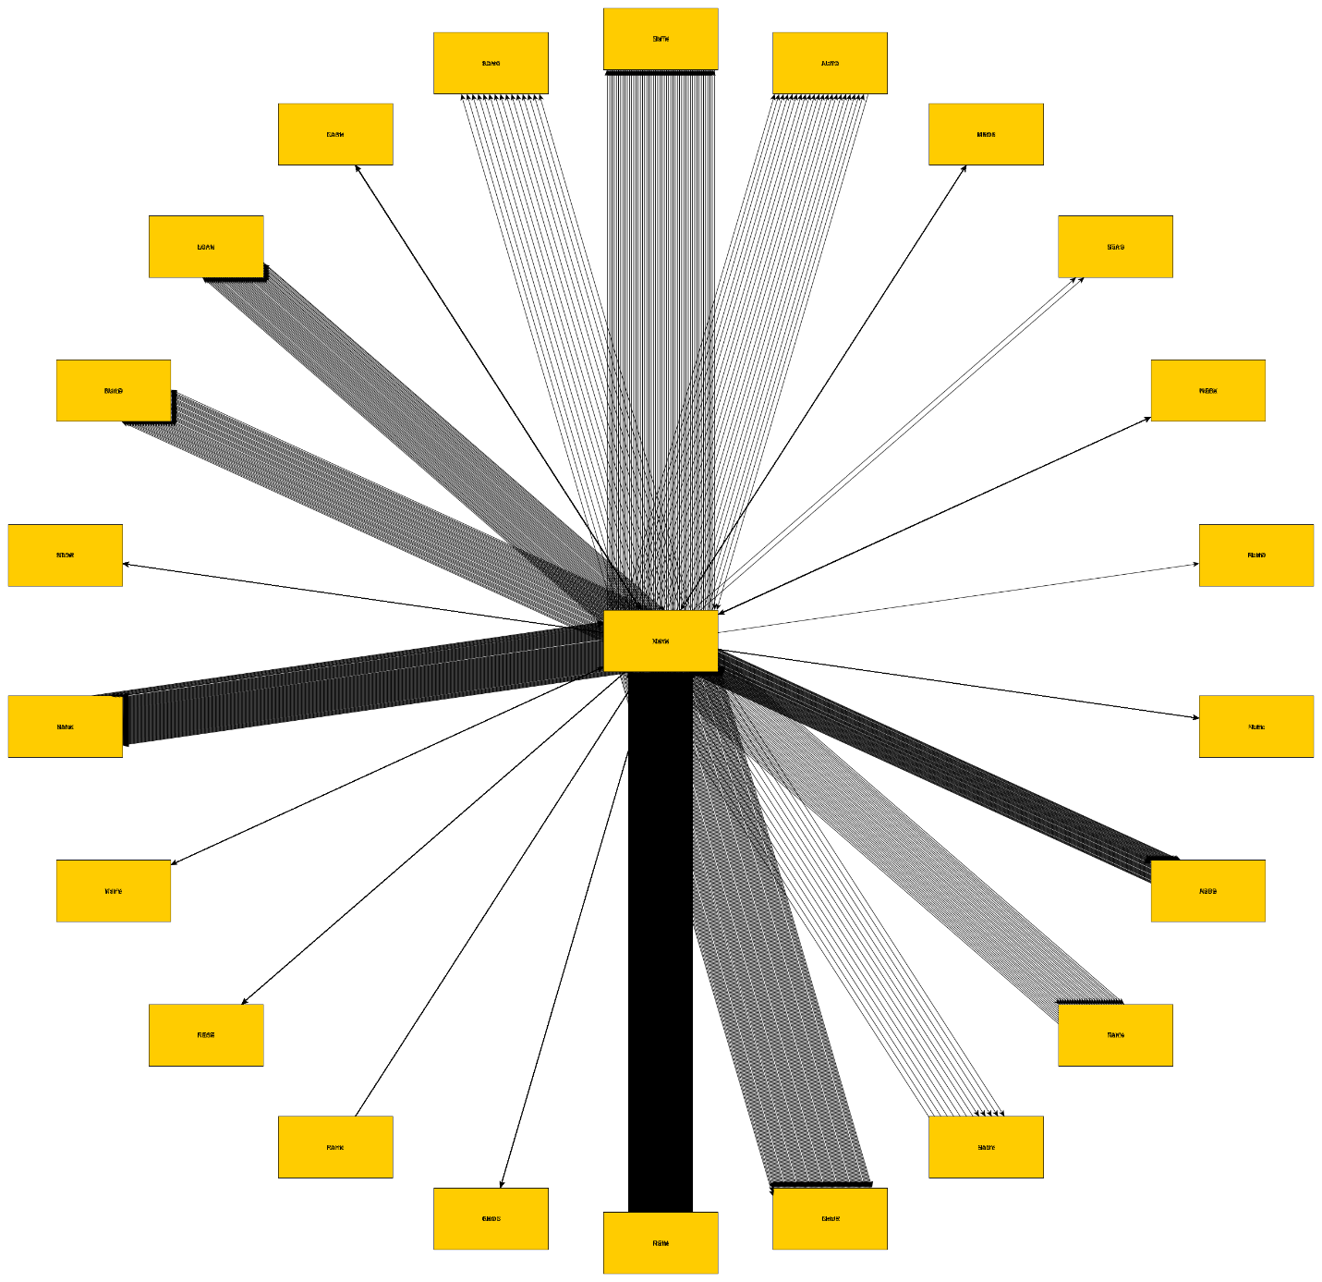

Automation process
- Create a excel sheet in the source of sender in 1 column, Target in 1 column, a column of all of the node names
  - Any additional information that needs to be mapped can be in adjacent columns
- Go into yed and create a template or use an existing template
- Now open the excel file in Yed
- Once open there will be a box that allows you to select the columns corresponding to the 3 columns mentioned in step 1
- Once that data is selected apply and click ok
- The graph will be created but the data will only be metadata to the nodes and not displayed
- To display the metadata go to the edit tab in the top left of yed and open the properties mapper
- Apply the metadata to the display options that you want and the information will be displayed

Links to help:
Emanual- https://yed.yworks.com/support/manual/import_excel.html
Helpful youtube Video - https://www.youtube.com/watch?v=l-ktE8syWUI

