Metric Matrix Installation Instructions

Metric Matrix Files:
- Copy to File System
  - Create a new folder named “Metric Matrix” within the C: drive (“C:\Metrix Matrix”) or a networked folder. The files must be accessible by any user accessing the machine
  - Copy the files from the disc to the created folder.
Python:
- Download/Install
  - https://www.python.org/downloads/release/python-389/
  - Download Windows Installer 64-bit
  - Check “Add Python 3.8 to PATH” and then click “Customize Installation” 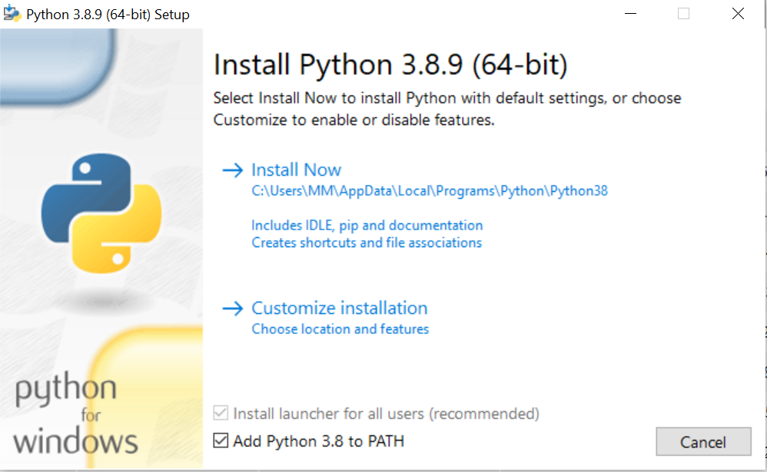
  - Check the Optional Features: documentation, pip, tcl/tk and IDLE, and Python test suite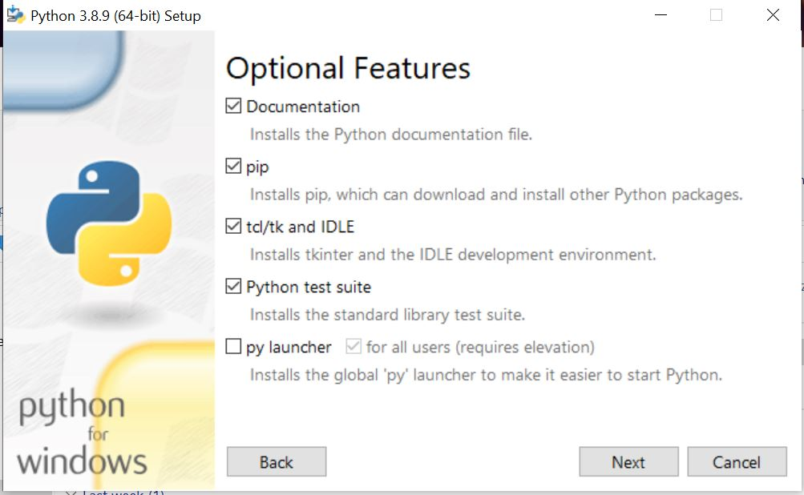
  - Advanced Options: Ensure “Add Python to environment variables” is checked. 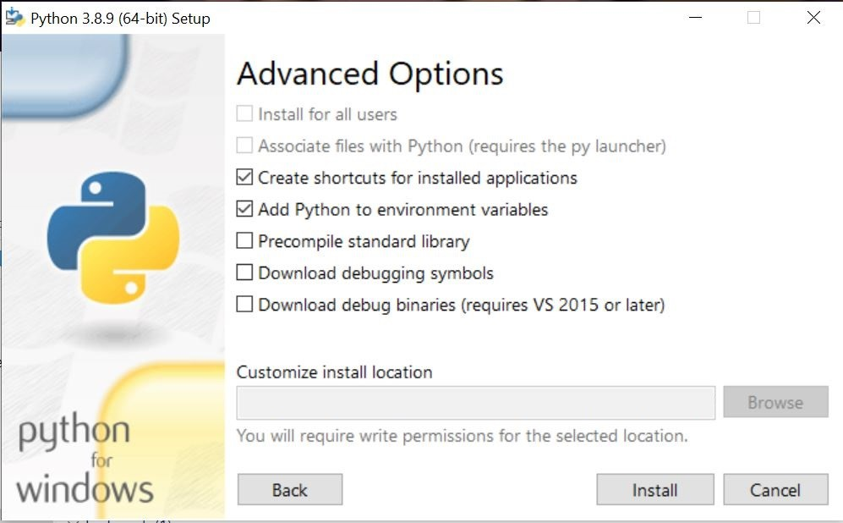
  - Click Install
Apache:
- Download/Install
  - https://www.apachelounge.com/download/
    - Do not click ads.
    - Download httpd-2.4.51-win64-VS16.zip. (maybe 2.4.52?)
    - Unzip folder and Move the Apache24 folder to the C: drive. (C:\Apache24)
  - If the machine does not have Visual C++ Microsoft Redistributable for Visual Studio 2015-2019 installed, install it using https://aka.ms/vs/17/release/vc_redist.x64.exe.
  - May also require build tools for Visual Studio 2022 https://visualstudio.microsoft.com/downloads/ When installing, make sure the following options are checked: 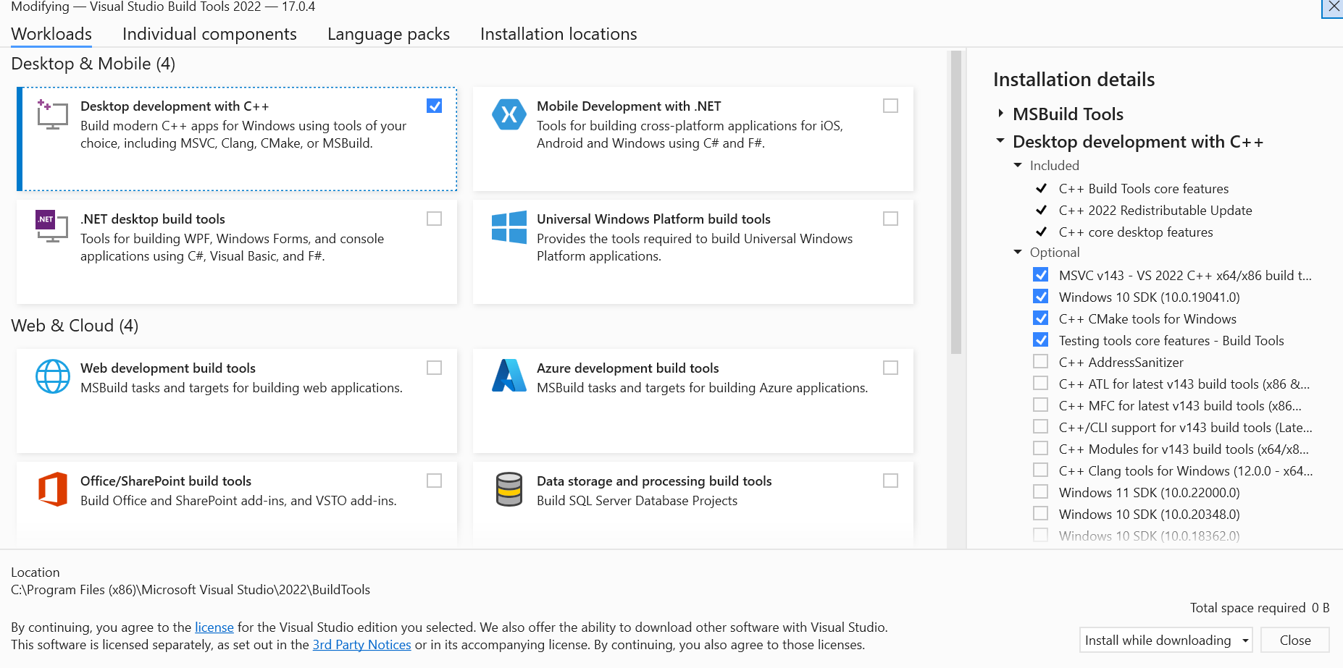

- Set MOD_WSGI_APACHE_ROOTDIR Environment Variable
  - Open a new command prompt and type:
    - setx MOD_WSGI_APACHE_ROOTDIR “C:/Apache24”
  - Close the command prompt.

Packages:
- Set up a Virtual Environment
  - After installing Python 3.8.9 and copying the files into the Metric Matrix folder on the C: drive, open a new command prompt and type: cd C:\path\to\Metric Matrix. Afterwards, type: python –m venv venv.
    - This command sets up virtual environment and creates a new folder called “venv”
- Activate the Virtual Environment
  - Type venv\Scripts\activate to activate the virtual environment.
    - You should see “(venv)” at the beginning of your command line prompt
  - This creates a virtual environment for installation of project dependencies
- Install Required Packages
  - Type “pip install –r path\to\requirements.txt” (e.g. pip install –r C: \MetrixMatrix\requirements.txt) to install all of the requirements necessary for the project at once.
Apache Setup:
- Open the “C:\Apache24\conf\httpd.conf” file in a text editor and ensure that line 37 reads: “Define SRVROOT “C:/Apache24””.
- Make sure line 176 is not commented out (LoadModule … /mod_ssl.so)
- Ensuring that you are still within the virtual environment (“(venv)”is at the front of the command line), open the venv command prompt and type: mod_wsgi-express module-config. Copy the output of that command into httpd.conf after line 541 (at the absolute bottom of the file) Output should look similar to:
- Open the httpd_extra.conf file found within the MetricMatrix\Installation folder and copy the lines starting with “WSGIPythonPath” to the bottom of the http.conf file. Change any directory names to match the server’s file system structure.
- Once the httpd.conf file is finished, open a new command prompt and type:
  - cd C:\Apache24\bin.
- Type: httpd.exe and then click enter. If no errors occur, the server is successfully running. If errors occur, the console contains output on the error and the source of the error is likely within httpd.conf.
- Assuming the server is running, open a browser window and type “127.0.0.1”. If you are using the sslserver development certificates, click advanced options and continue to 127.0.0.1. If the API Root page displays, the server is working.

