This is a take-home test, but it is still a test. The full honor code will apply. For this test you must abide by the following rules for academic honesty.

You **MAY**:

* Find already existing sources at w3schools or any other website.
* Make use of any materials from Canvas or previous assignments

You **MAY NOT**

* Discuss the questions with your classmates or another person.
* Ask new questions on stackoverflow, quora, yahoo answers, etc.
* Give assistance to another student on this test.

By submitting this test and signing here I agree to abide by the honor code as applied to this assignment.

________________________________

1. Create a single web page with the following features (5 points+bonus):

* This paragraph in red

There is nothing in the world like getting your program to run and run correctly. Of course, if it runs perfectly the first time, I tend to be more suspicious. That never happens, so if it appears to work, I might ask why. In most cases, however, my code runs after a long fight to get it working and when it finally does… well, I feel pretty good about myself.

* This paragraph in blue

Computers are little minions of Satan. They are silicon-based evil temptresses that believe I will always come back. They believe that I am held enraptured by the seducing call of free automation, quicker download times, and nearly limitless power. “Come,” they say, “come and be a god among men as you create a mighty universe that only you control. Come and we will give you power.” The sad thing is, they are completely right.

* Use italics for the quote in the paragraph above. JUST that quote. The rest of the text should be normal.
* An image (I suggest www.developermemes.com/wp-content/uploads/2014/01/CSS-Sucks-TShirt-Meme.jpg but you can use any image you like) with a red border.
* (Bonus point) Use some mechanism to make the text wrap appropriately around the image.

**Desired outcome**

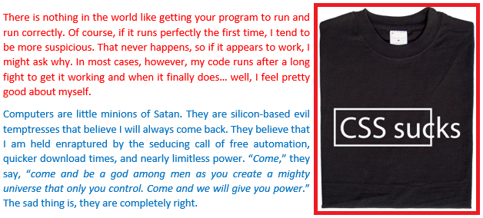

1. Create the following function on a web page. Use the supplied data to prove that it works as expected (2 points).

* Define a function named “square” that takes one parameter and returns the square of that value.
* The function should be able to reproduce this test set.

|  |  |
| --- | --- |
| **Param** | **Returns** |
| -2 | 4 |
| -1 | 1 |
| 0 | 0 |
| 1 | 1 |
| 2 | 4 |

1. Create a web page that prints the current time (just once) when it loads. (4 points+bonus).

* 2 Bonus points have the current time update every second.

1. Define an object Coronavirus with the following members (6 points):

* The constructor takes a parameter for tpPrice.
* A function *infect* that takes a parameter *place* and puts text on the screen “Coronavirus has infected *place*”
* A variable tpSales that starts at zero.
* A function *buyMoreTP* that adds tpPrice to the tpSales.
* A function currentSales that puts text on the screen “Current toilet paper sales are $xxx.xx” with the value of tpSales.
* The object should be able to reproduce this test set.

|  |  |  |
| --- | --- | --- |
| tpPrice | Test case | Output |
| 1.25 | buyMoreTP()  currentSales()  infect(“Virginia”) | “Current toilet paper sales are $1.25”  “Coronavirus has infected Virginia” |
| 2.17 | buyMoreTP()  currentSales()  infect(“Washington”) | “Current toilet paper sales are $2.17”  “Coronavirus has infected Washington” |
| 3.99 | buyMoreTP()  currentSales()  buyMoreTP()  currentSales()  buyMoreTP()  currentSales()  infect(“Maryland”) | “Current toilet paper sales are $3.99”  “Current toilet paper sales are $7.98”  “Current toilet paper sales are $11.97”  “Coronavirus has infected Maryland” |

1. Create an array *input* with the numbers 1 through 10. Create a second array *output*. Write a function *f1* that takes a parameter *x* and returns the value x2-1. Use *f1* and *input* to fill *output*. The contents of *output* should be as follows (5 points).

|  |  |
| --- | --- |
| Input | Output |
| 1 | 0 |
| 2 | 3 |
| 3 | 8 |
| 4 | 15 |
| 5 | 24 |
| 6 | 35 |
| 7 | 48 |
| 8 | 63 |
| 9 | 80 |
| 10 | 99 |

1. Copy and fix the web page https://bsdillon.github.io/cs200_Spring2020/exam2_6.html. It should allow me to push the button as many times as I want to. It should say “There have been *x* button pushes” with a new number each time. Several things are wrong. Please fix the errors, document what was wrong in each case, and I will give you 1 point for each error you identify (minimum of 3 points).