Test #1

This is a take-home test, but it is still a test. The full honor code will apply. For this test you must abide by the following rules for academic honesty.

You **MAY**:

* Find already existing sources at w3schools or any other website.
* Make use of any materials from Canvas or previous assignments

You **MAY NOT**

* Discuss the questions with your classmates or another person.
* Ask new questions on stackoverflow, quora, yahoo answers, etc.
* Give assistance to another student on this test.

By submitting this test and signing here I agree to abide by the honor code as applied to this assignment.

________________________________

Unless otherwise stated, each question is one point.

Questions 1-6 refer to the code in figure 1.

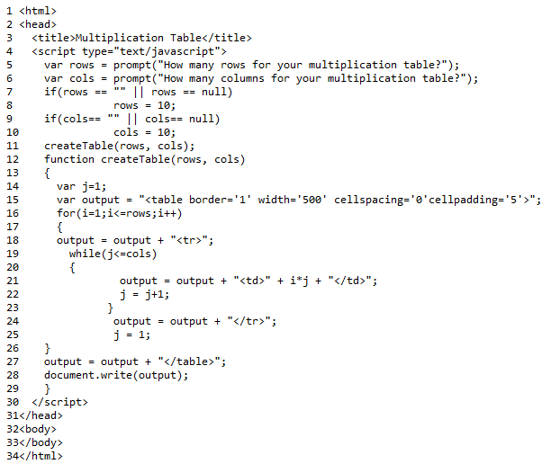

1. Identify an example of each from this code. In each case give the line number where it is found and the identifier given. (1 each)
   1. A field (also known as a variable)?
   2. A function (also known as a method)?
   3. A parameter?
   4. An attribute?
2. How does the ‘rows’ used on line 8 differ from the ‘rows’ used on line 16?
3. What part of the program is ‘output’ on line 18?
4. What part of the program is ‘write’ on line 28?
5. What part of the program is ‘function’ on line 12?
6. **BONUS** Describe the scope of ‘i’ defined on line 16?
7. For each of the following, is this a valid identifier? If not, explain why. (1 each)

* myIdentifier
* my Identifier
* threePigs
* 3Pigs

1. Create a program with the following elements (4 points)

* Two ***p*** tags with ids ***Bob*** and ***Dave***.
* A button with an ***onclick*** event that calls a function ***func1***
* In ***func1*** put the text “I am Bob” into the Bob ***p*** and “I am Dave” into the Dave ***p***.
* Use appropriate style to make Bob red and Dave blue.

1. What is difference between an interval and a timeout? Give an example of when you might use each.
2. What is the difference between a for loop and a while loop? Give an example of when you might use each.
3. For the array below, what is the value of arr[3]?

var arr = [7, 8, 9, 10, 11, 12, 13, 14, 15];

1. If you saw the image below on a computer screen and knew the coordinates of the green point were (100, 100), what might you estimate to be the coordinates of the red point?

