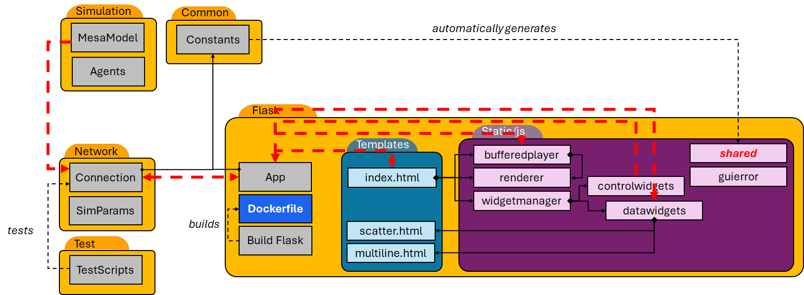
The system is built in three main folders, the test scripts and common constants not being considered code per se.
- Simulation is variable but conforms to the Mesa paradigm.
  - There may be some opportunity to improve the parent class of Model to conform to my new GUI use case.
- Network mitigates the communication network between the model and the GUI.
- Flask is a containerized GUI solution serving on port 5000.
  - There are HTML pages for the main gui and for two data widgets that need a pop-up window for statistical graphs.
  - There are several javascript files that manage the server-side processes
A bit about the common.py/shared.js files
- Common defines constants and processes ONE TIME in python, but there is a JavaScript version built at run time from the Flask app. This includes functionality for:
  - HTTP request types
  - Signals between members on either side
  - Data and Control Widget construction/validation
  - There is much room for growth so that no “magic” strings exist on either side
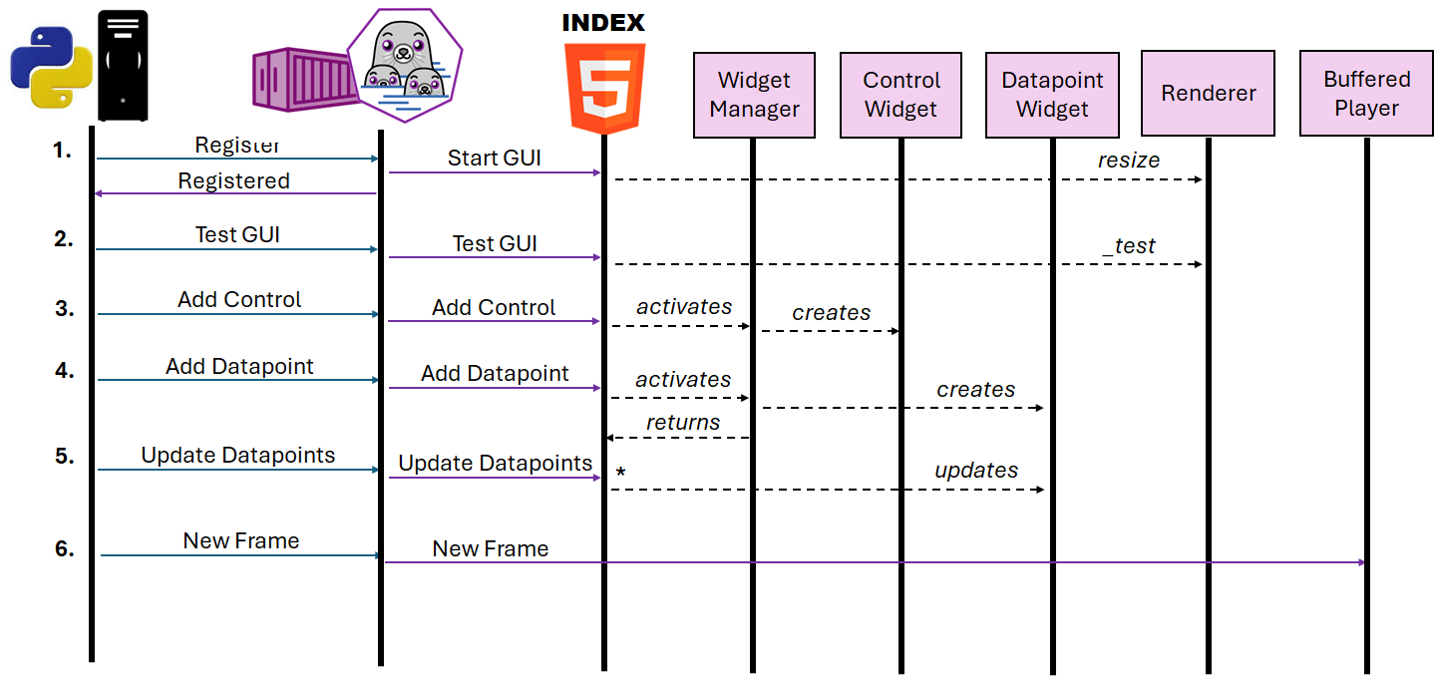There are six SocketCommands, indicating that the model is commanding the GUI to take some action.
- Registration simply distinguishes the desktop Python application from webclients in the Flask server. It allows specific messages to be sent ONLY to the desktop. It also allows us to identify error states if no desktop has been identified.
- Test GUI is a one-time event correlated with the testing scripts and verifying the GUI operation. The test is directly implemented on the renderer.
- Adding controls is a Widget Manager operation as they are GUI members in addition to logical components.
- Adding datapoints is similar in that they are widget members, but they are stored in the index page so they can be individually updated in the next signal.
- Update datapoints contains a JSON with at least one datapoint message by name. These are related to each Datapoint object individually.
- New frame sends a specific description of the scene for a specific timestep. These are stored in the player for later use.
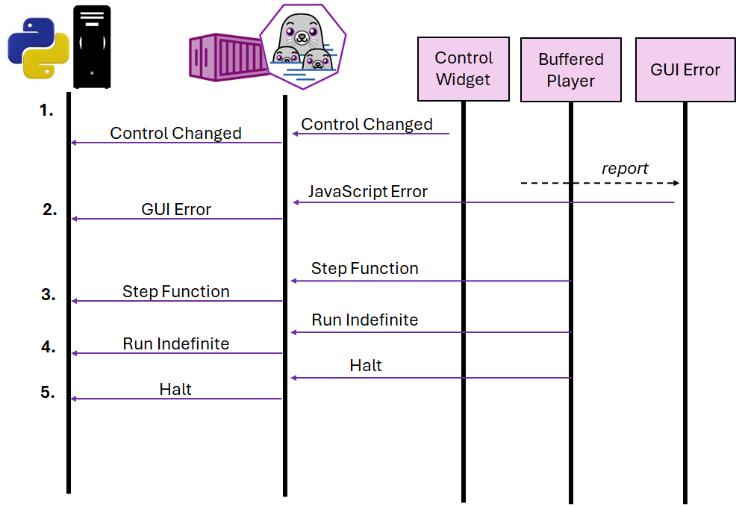
There are 13 SocketSignals which are mostly used to communicate from Flask-side components to the Flask App and then on to the desktop. Some of these have already been shown (e.g. Registered), however, five of these sequences deserve mention.
- When any Control needs to communicate a change to the model, that signal is sent from the Control to Flask and then on to the desktop.
- If any error is detected on the Flask-side, the GUI Error sends a “JavaScript” error to flask, which reports it as a “GUI” error to the client.
- The BufferedPlayer sends a request for a single step function via Flask to the model.
- Similarly, BufferedPlayer may tell the model to generate data indefinitely.
- At some point the BufferedPlayer will tell the model to discontinue the data generation.
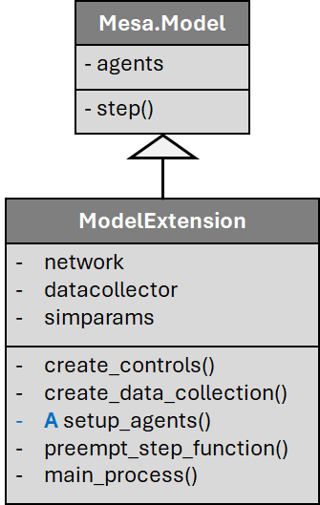
ModelExtension class. There is a lot of code that is built into ModelExtension, but five specific functions that need specification.
- create_controls - Optional ability to add any controls required for the simulation. Default version creates no simulation controls
- create_data_collection - Optional ability to add any datapoints required for the simulation. Default version creates no datapoints
- setup_agent – ABSTRACT Required ability to create all agents based on specific simulation requirements.
- preempt_step_function - Optional ability to prevent execution of a step function under some conditions. Returns True if the main_process should be preempted. Default does NOT preempt the main_process.
- main_process - Optional ability that replaces the concept of the step function in Mesa.Model. The default version just calls the step function on all agents in the model.

