**Mobile Computing**

**Roll No: BSEF18A009**

**Name: Muhammad Usama**

**Version Control Systems**

**What will we learn?**

• Version Control Systems

• Concepts like Online Editing and Merge Conflicts

• Different cmd commands

* git-add
* git-commit
* git status
* git-push
* git-pull
* git-log
* git rm
* git-branch
* git-checkout
* git-merge

To achieve these goals do these steps:

1. Go to the following link (<https://github.com>) 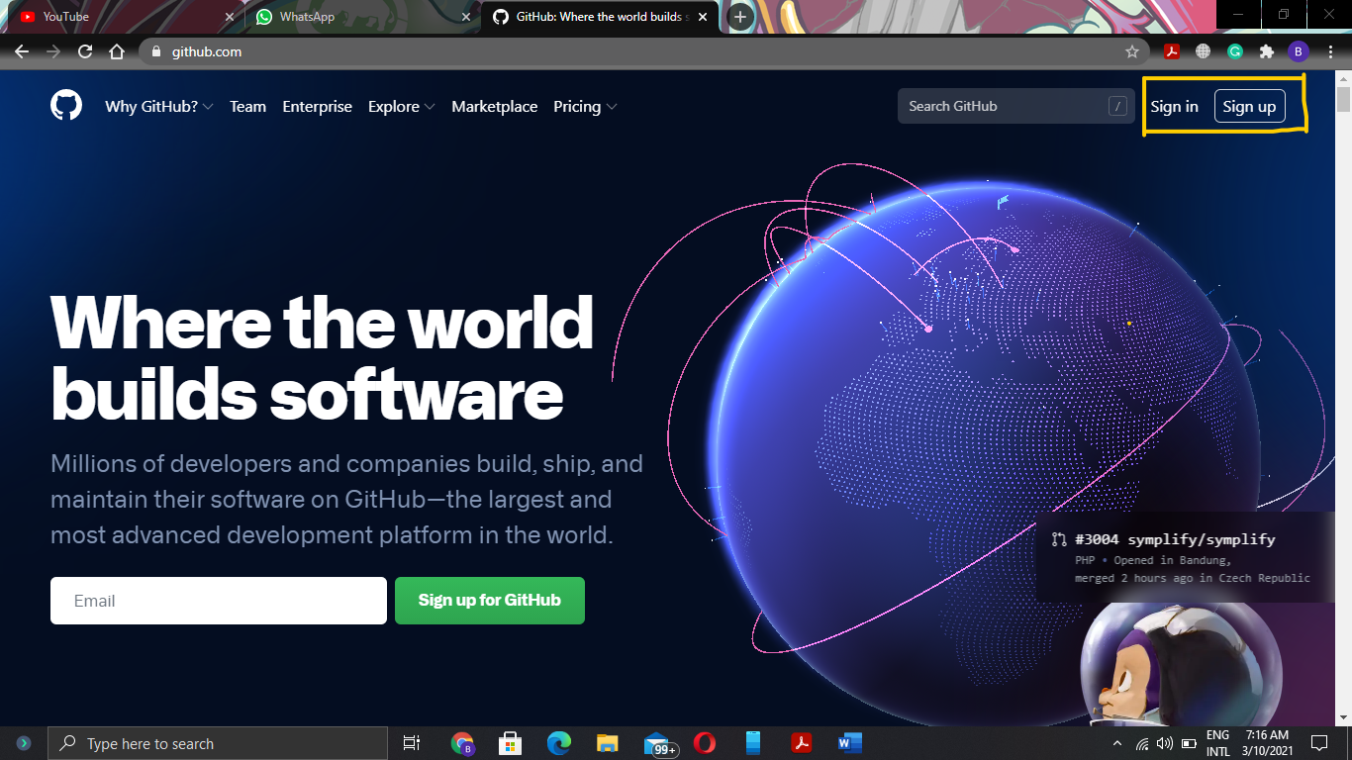

* Here is two options Sign In and Sign Up if you already have account then click on Sign In button else click on Sign Up button to make a new account.

1. After Signing In now this screen opens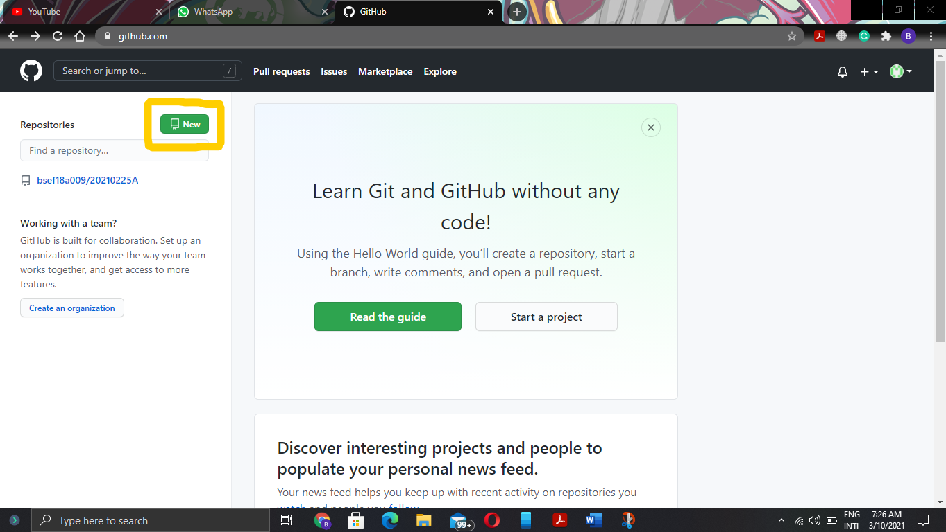click on the **New** button to make a new repository.
2. After previous step give a meaningful name to the repository in my case I give it Mobile-Computing-Work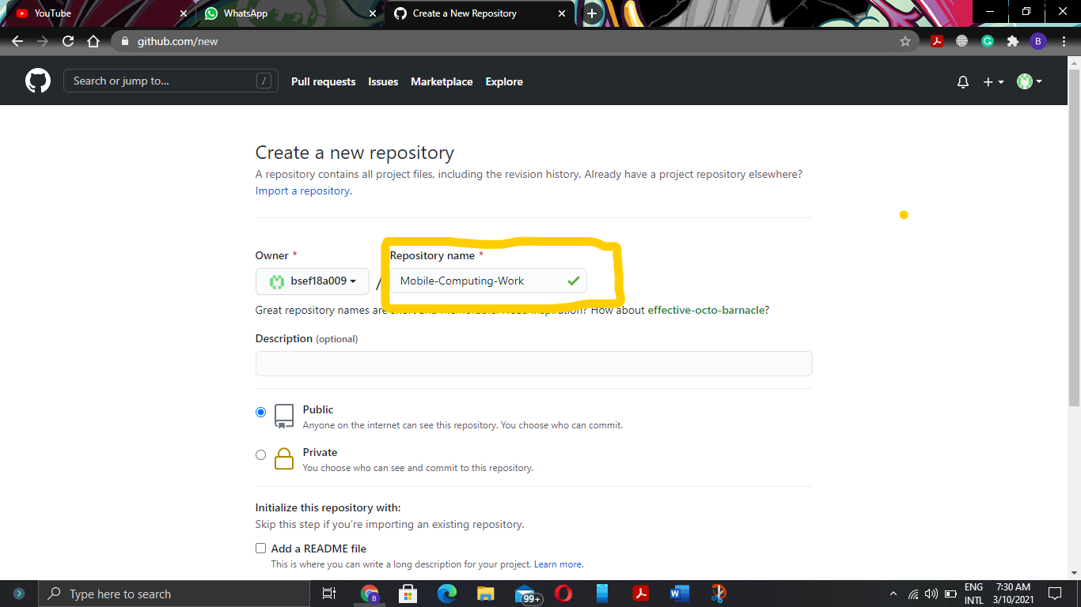
3. After giving meaningful name to the repository scroll down the screen and click on the **Create Repository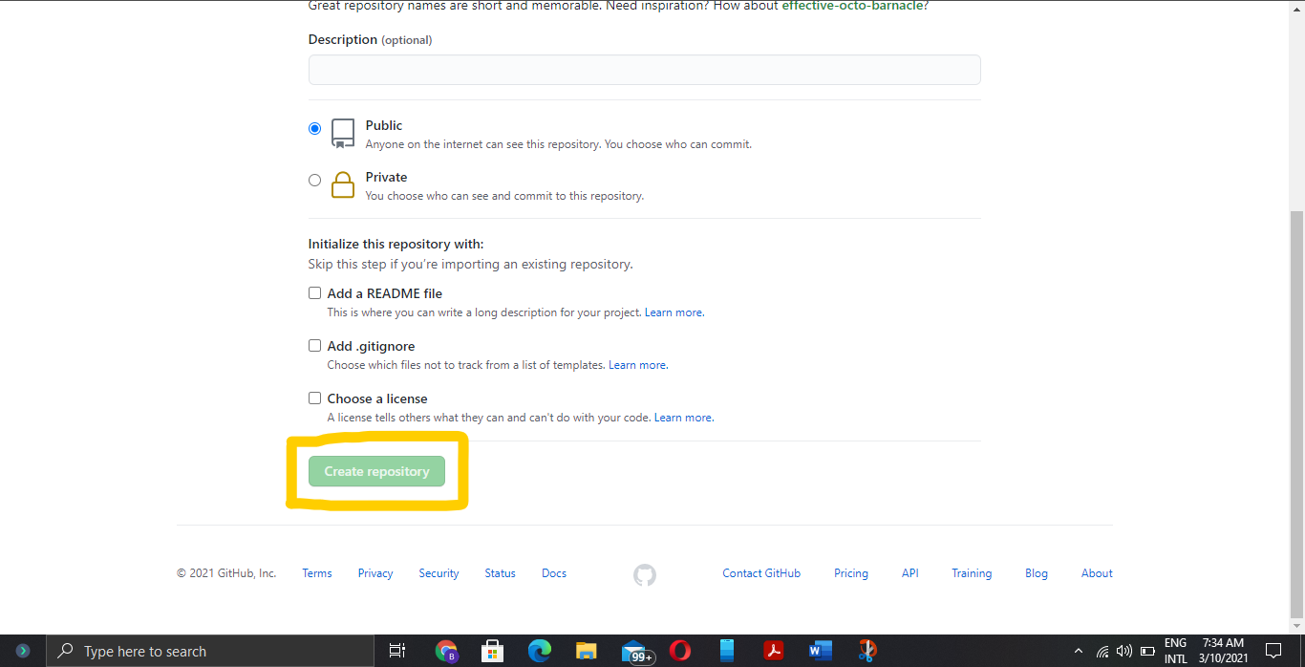**now your new repository is created.
4. Now to complete further steps you have to install git on your machine because it needs to run commands successful. Go to this link (<https://git-scm.com/downloads>) and install git according to your machine. 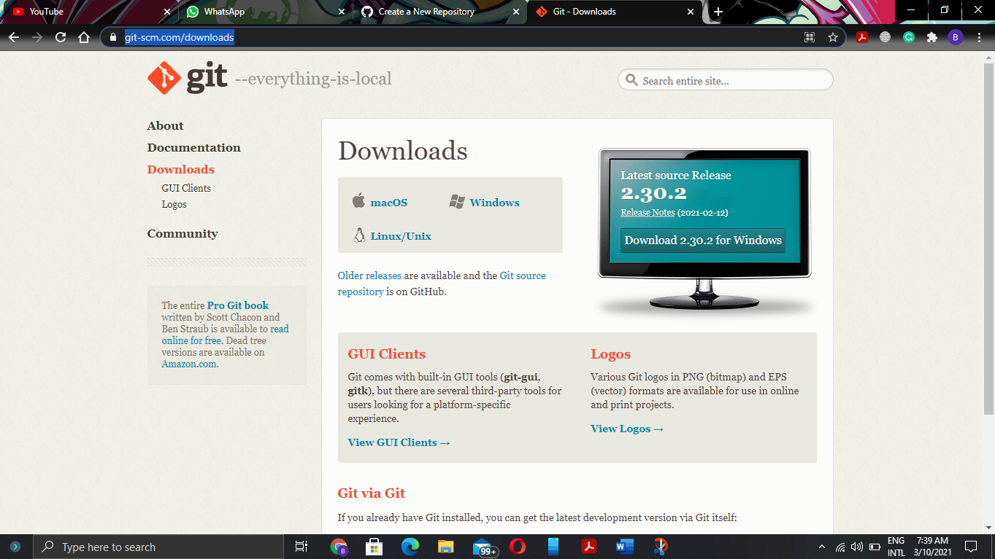
5. Now make a new folder named it git and remember its path because you need it in next steps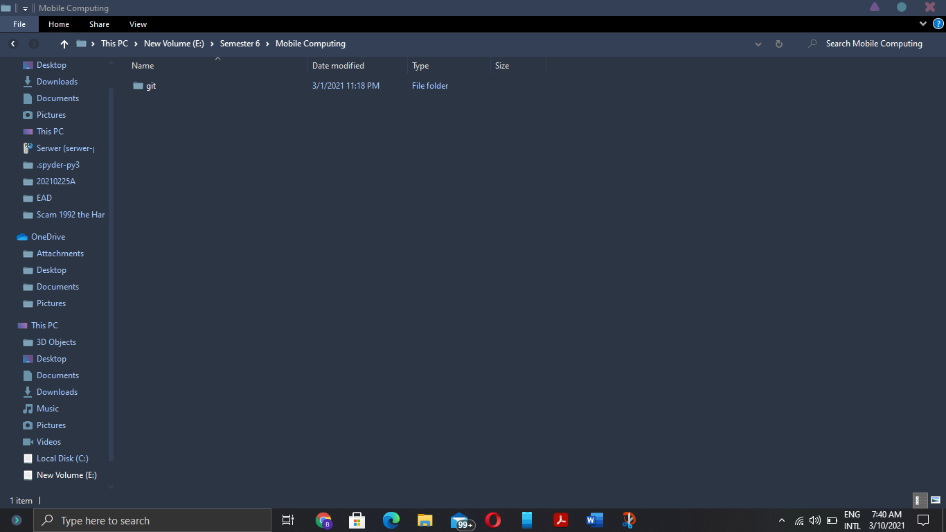
6. Now open cmd and run cmd as an administrator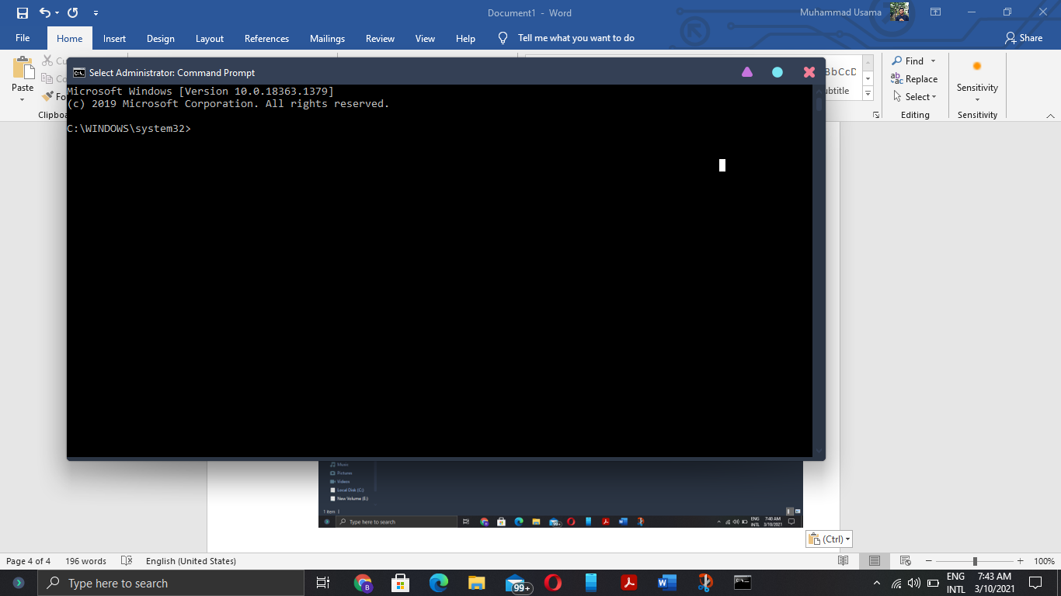
7. Now copy the path of the folder name git and go this folder in cmd using cd command like this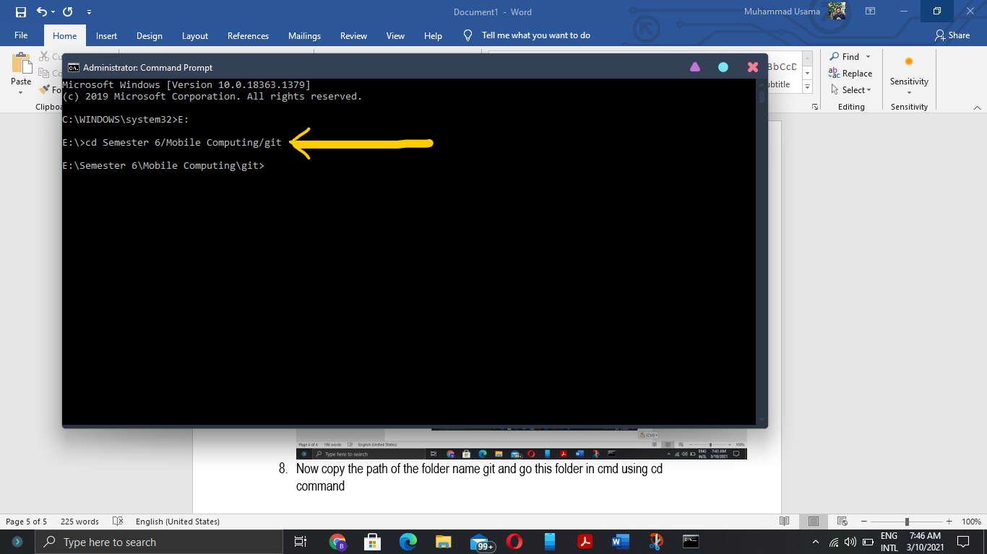
8. Now copy the link of your git repository from here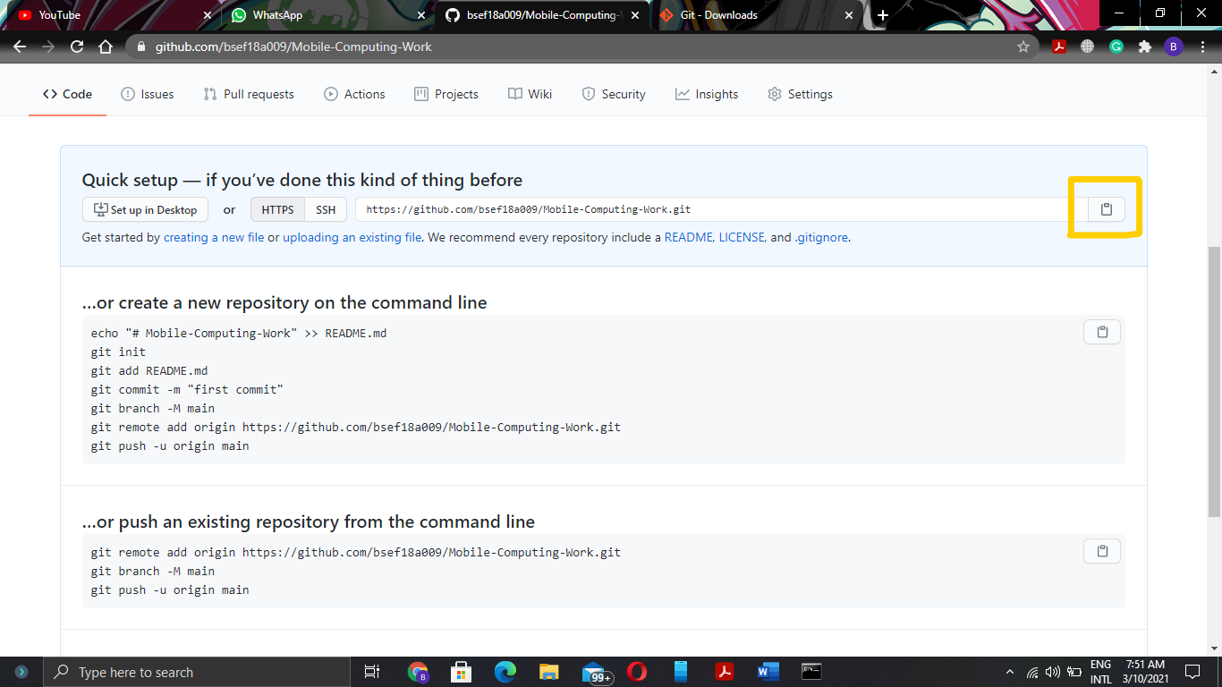
9. Type a command on cmd git clone and paste your cpoied link of your git repository to make a clone of your repository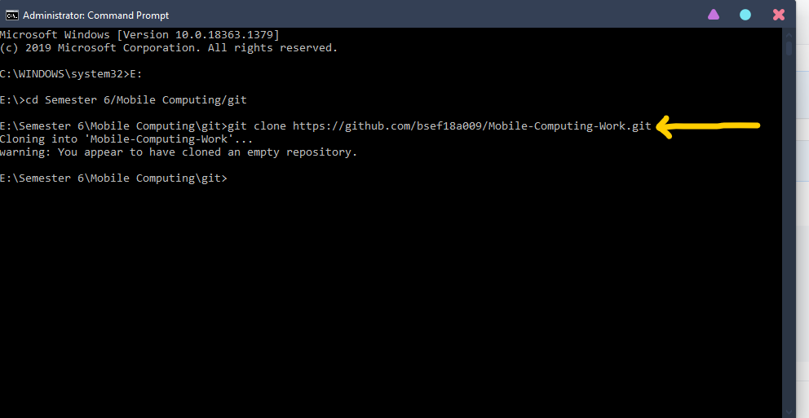
10. Now go in **git** folder and you notice that there is a new folder with the name of your repository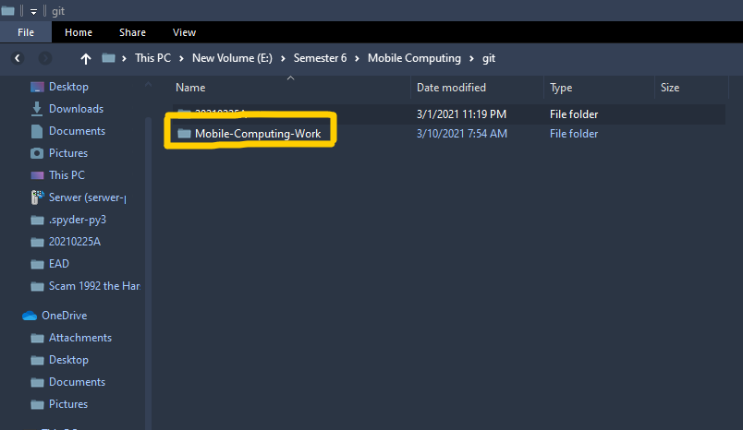
11. Now make a .txt file in your folder that made to see how we push our code to github now go to cmd and using cd go to that repository named folder and then type command **git add filename.txt**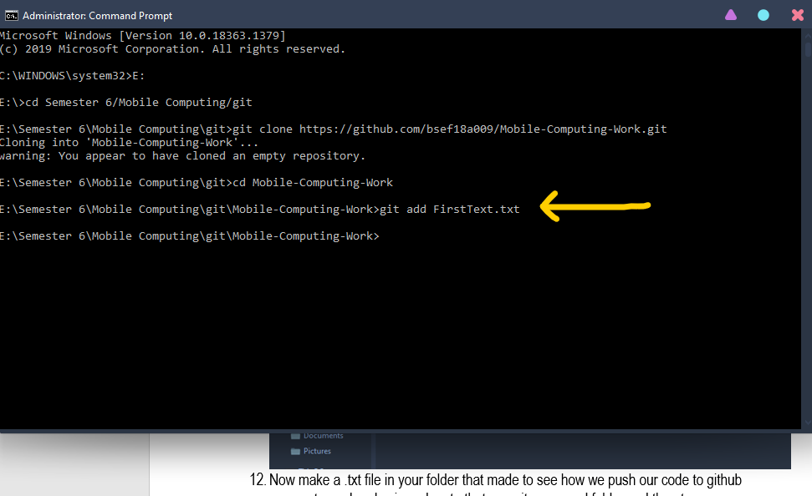
12. Now type **git commit -m “Message”** on cmd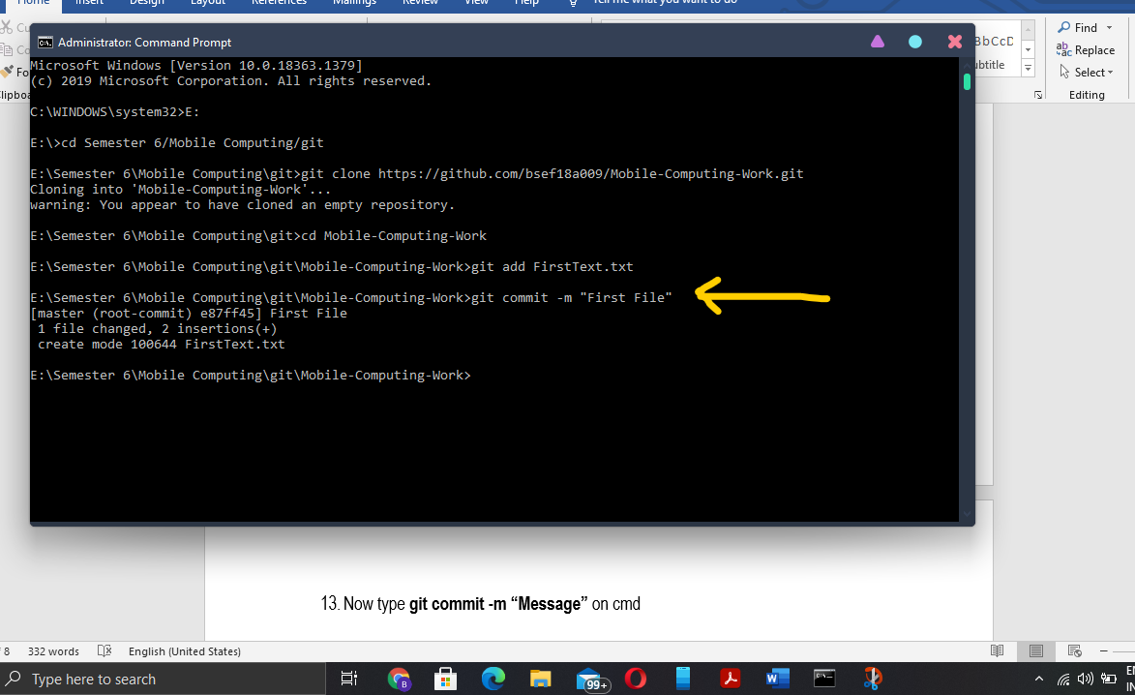
13. Now push the .txt file to the repository by typing **git push**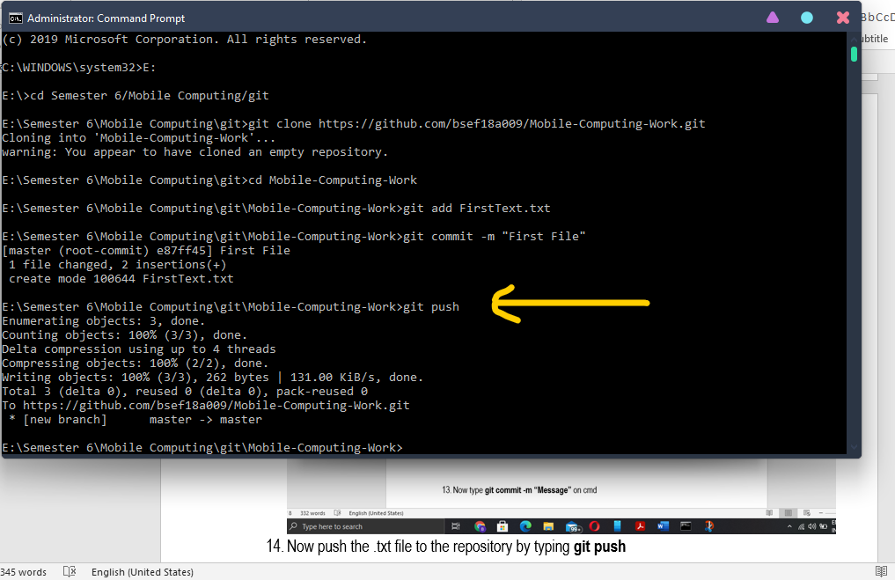
14. Refresing the chrome screen you can see online your file is added to the repository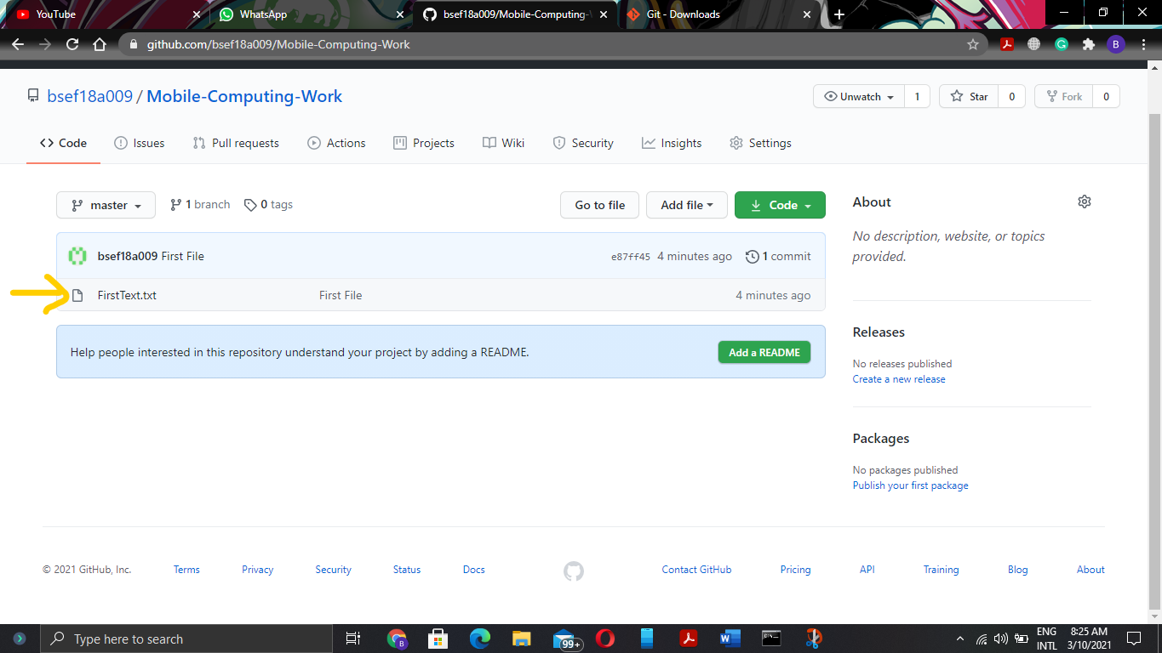
15. Now if you want to update the same file repeat the procedure and you notice that you see your parent previous verison of your file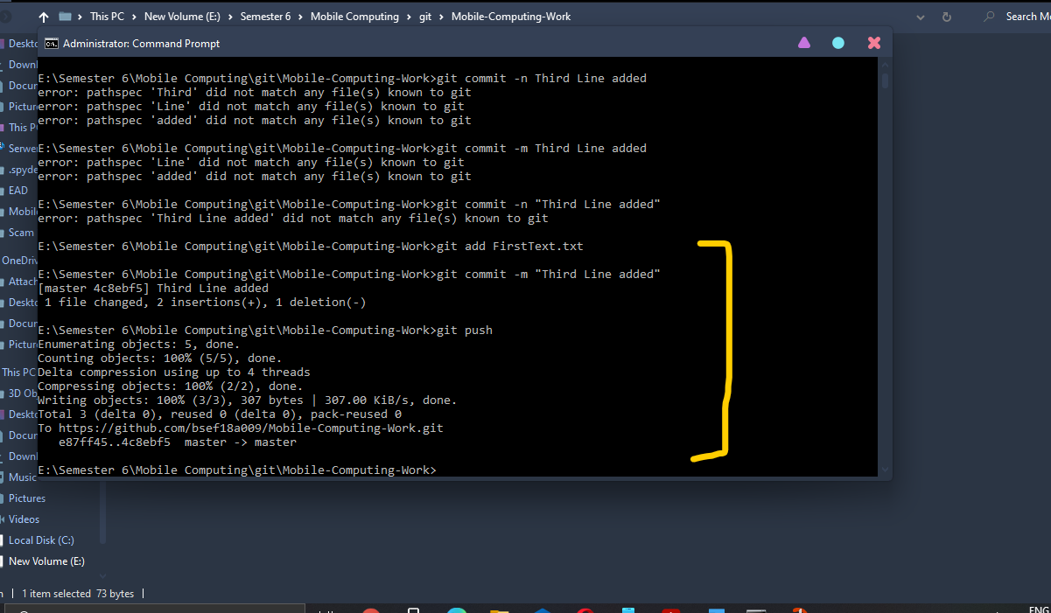
16. Now you check on github your file is updated having 2 commits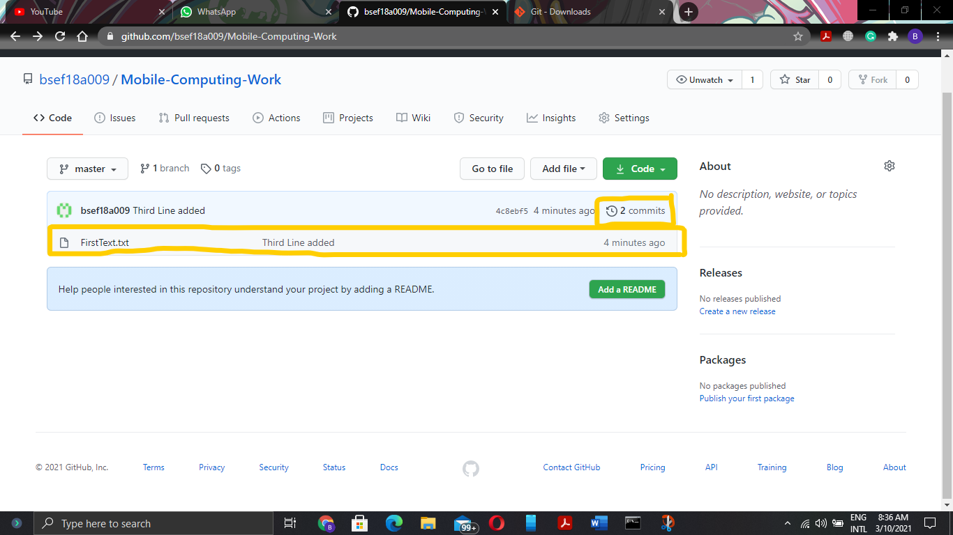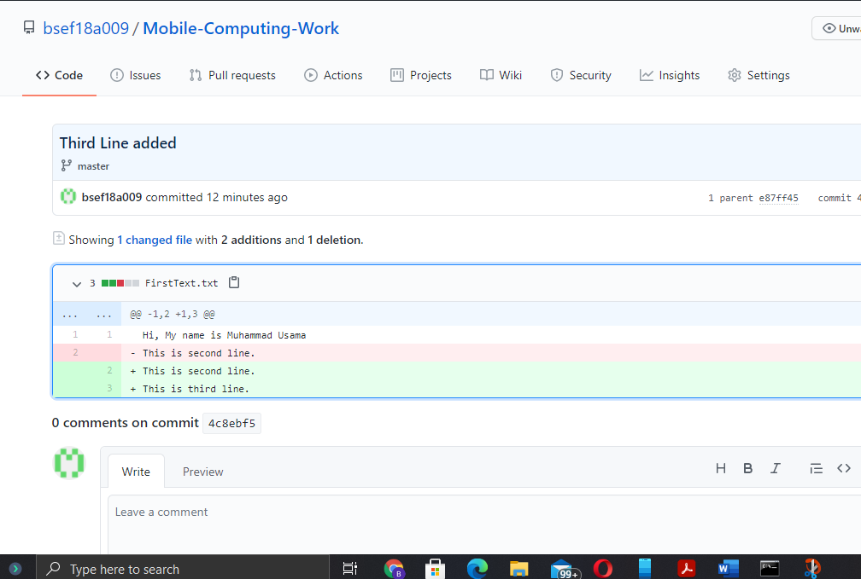
17. Now we see if you want changing in local by changing the file online do these steps click on the pen icon your file is open in edited mode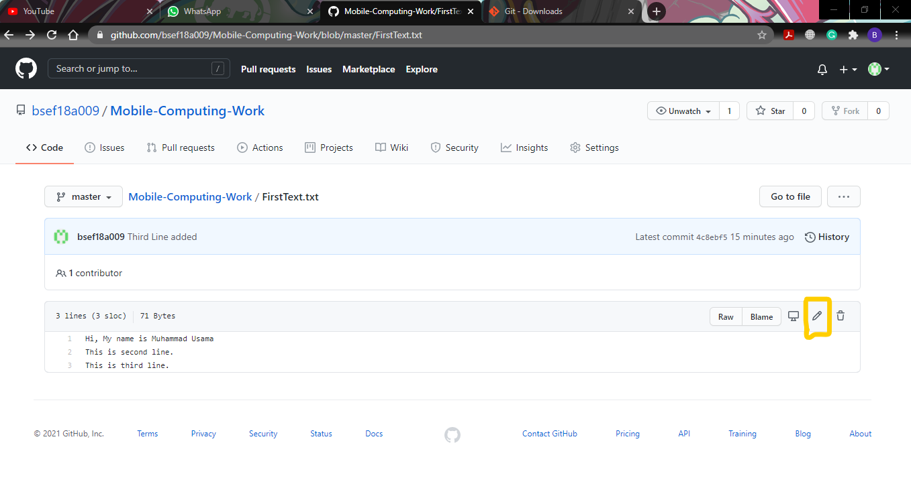here in my case I added forth line online 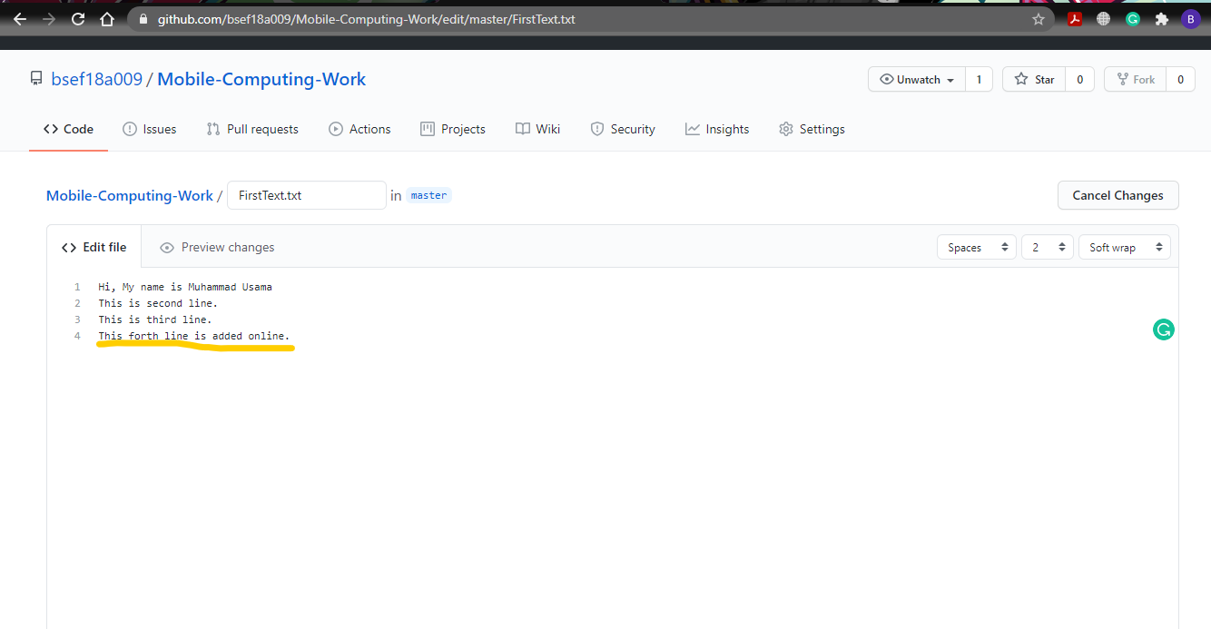and scroll down and click on commit changes your online file now updated.
18. Now if you want to get data from online repository to our local machine type **git pull** on cmd your data from online repository now get. 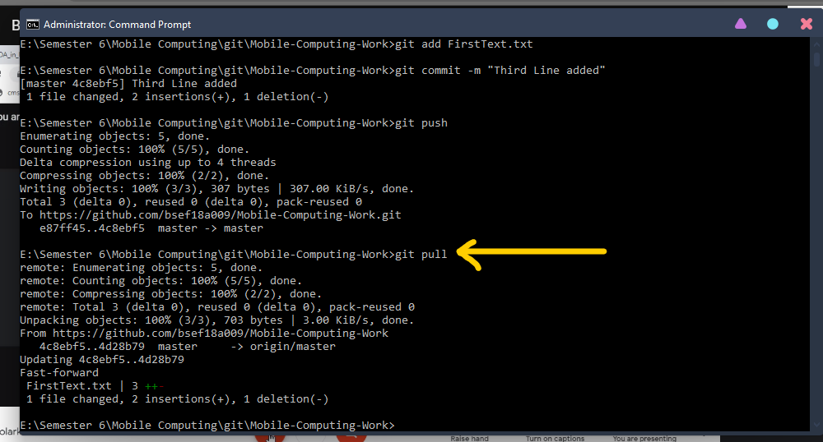Now you can open your file in local machine and see the changes done? 