**Mobile Computing Progress**

Lecture no. 02

In this lecture, discuss about git, GitHub use. Why and how we use them. Main purpose of using GitHub is team collaboration.

* First of all create an account on GitHub via any of your email.
* On the right top corner we can edit our profile and on its left we have drop-down menu for repositories management. Where we can create our new repositories. We can make our work on GitHub Public/Private.
* Install git or GitHub Desktop to work on GitHub.
* Login to Git or GitHub Desktop to proceed work.

**Steps to clone a Repository:**

* Click file option present on left most position of menu bar
* Drop-down menu appears -> select **clone repository** option
* Copy the link of repository you want to clone on your system.
* Paste the repository link in GitHub Desktop.
* Choose clone option and select directory of system to save it.

**Push, Pull** and **Commit:**

* To save the changes made in the local folder we use the term commit.
* After committing the changes we need to pull changes to origin.
* If the changes were made on GitHub by other user then we push the origin first and then merge files

Lecture no. 04

Downloading Android Studio:

1. Search **Android Studio**  from browser

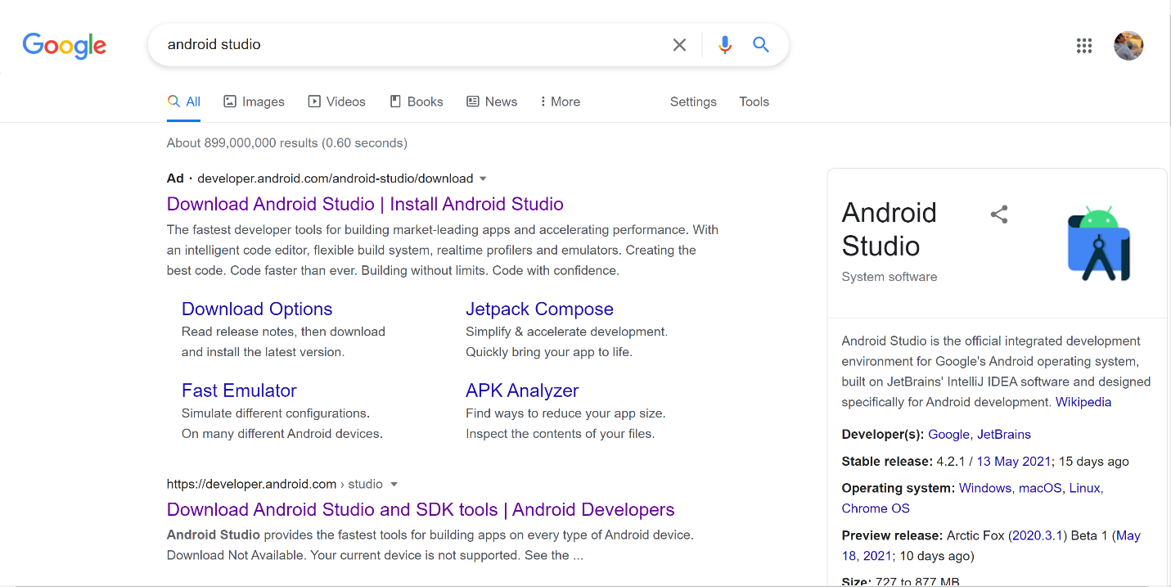

1. 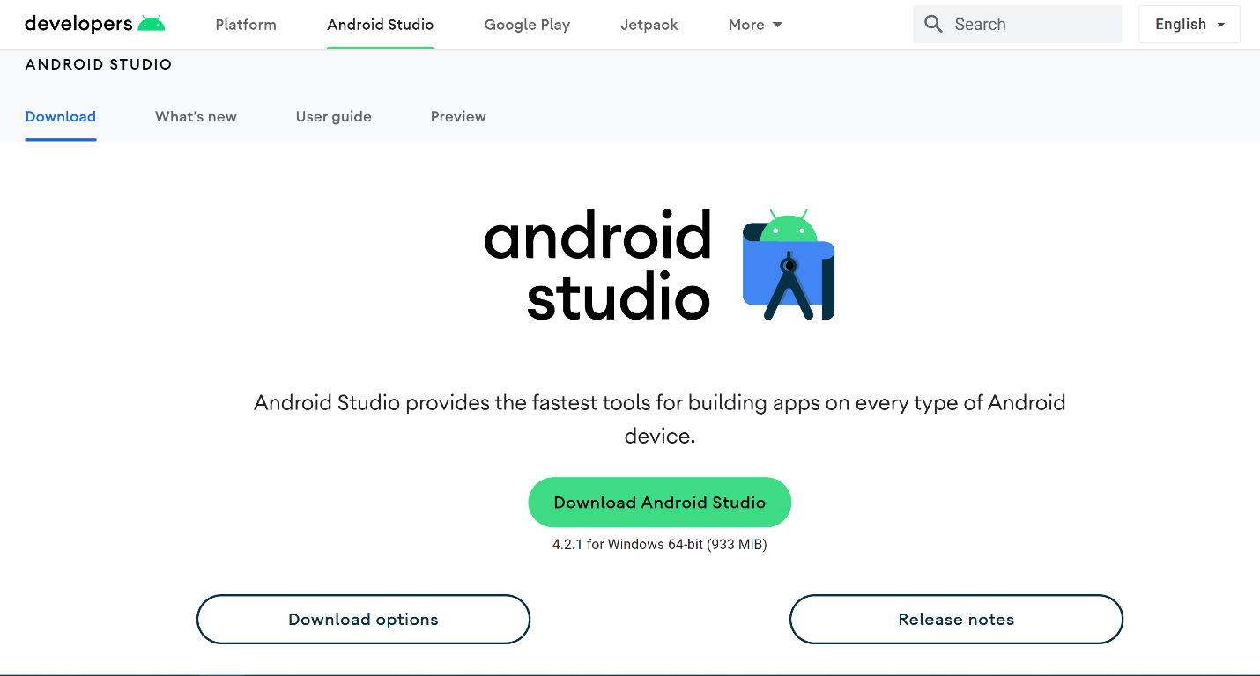Click on first link to open the Website
2. ****Click on **Download Android Studio** depending upon the machine
3. Following pop-up window opens up, after clicking checkbox click download button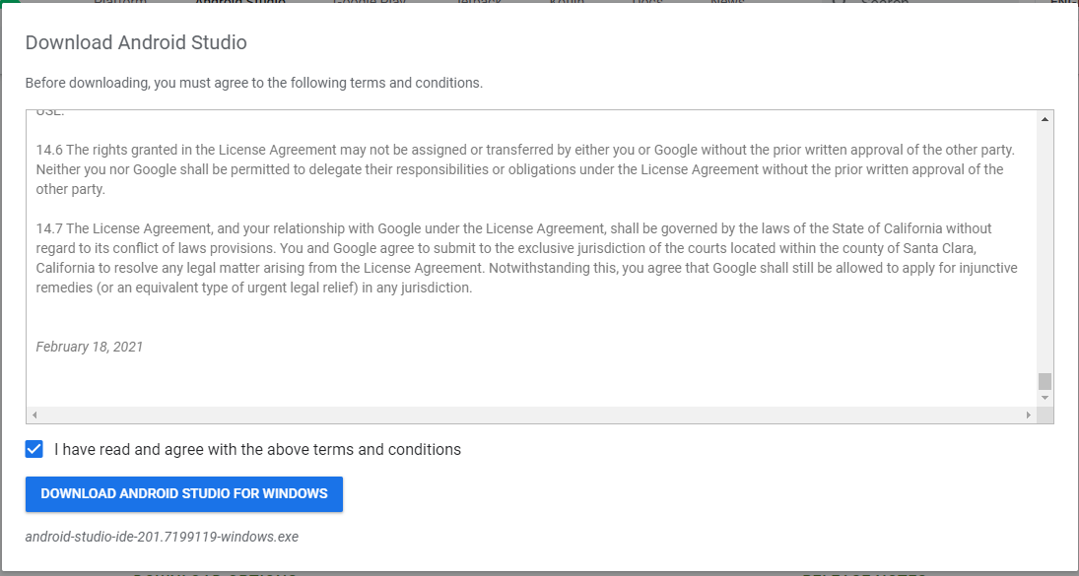
4. .exe file will start downloading, wait till the download complete
5. **Double-Click .exe** file following screen will appear. Click “Yes” to start Installation process.
6. 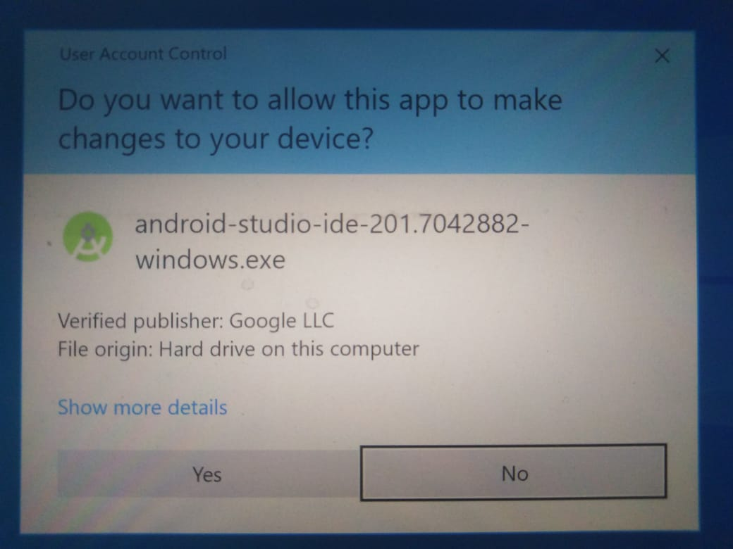Wait until the Installation process complete.
7. Run the Android Studio, following screen appears.

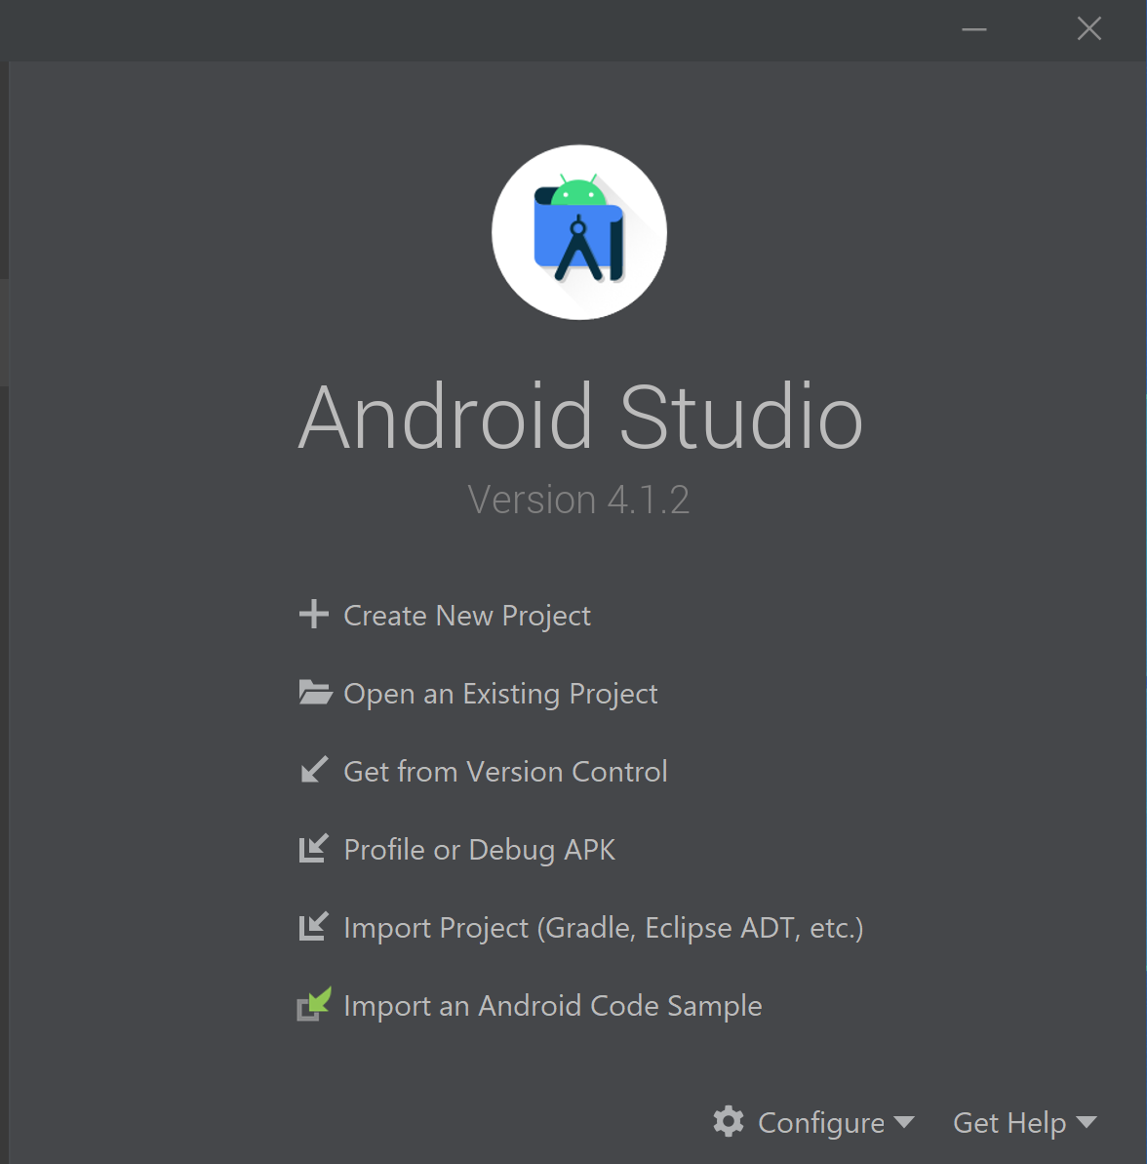

1. **Select** Option to create a New Project
2. **Select “Empty Activity”** Project Template to proceed
3. Enter “Name of Project” in **Name** field and select the destination folder where you want to save the project.
4. Select **Java** from language drop-down menu.
5. Select version of Android you want your app to support in the **Minimum SDK** field.
6. Click Finish.

After some processing Android Studios main activity appears.