**Change 1**

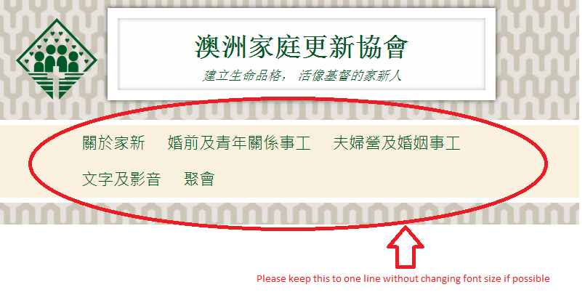

**Change 2**

On the page at <http://www.mffc.org.au/news/reunion-dinner/>

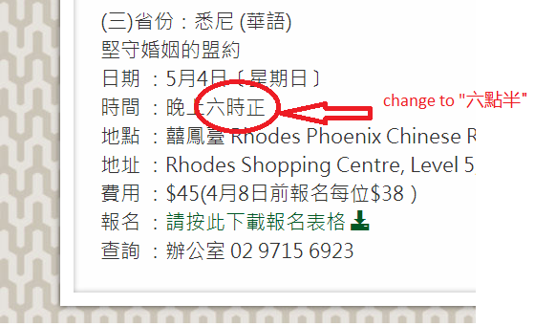

**Change 3**

On the page at <http://www.mffc.org.au/mer/mer/>

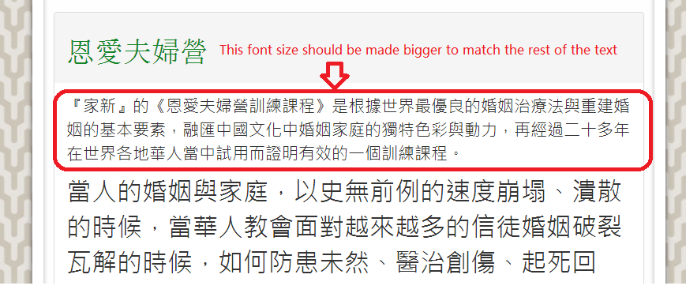

**Change 4**

On the page at <http://www.mffc.org.au/mer/mer/#mer>.

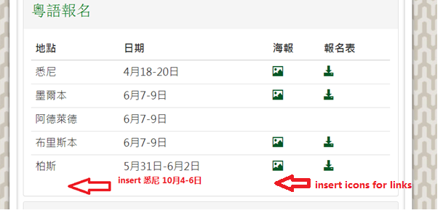

Please see attached Poster (SC1410 LR.jpg) and Registration Form (2014 MER Master Rego.pdf) in email, and upload them to the website.

**Change 5**

On the page at <http://www.mffc.org.au/mer/mer/#mer>.

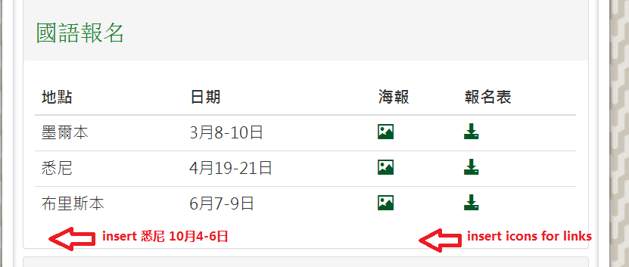

Please see attached Poster (SM1410 LR.jpg) and Registration Form (2014 MER Master Rego.pdf) in email, and upload them to the website.