hi professor,

It was a good lesson, actually I know html and I have a lot of experience, but I am learning new things. For example, I just realized that a web page can be hosted on github.

There was no problem with my homework, I completed all the tasks.

I found a nice template, I edited it nicely and made the new joints you want. Also, I added the mailing section and this section calls a webapi on aws, this is a small problem, but I will solve it :) maybe I can get help from you here.

My background in web: I worked as backend-fullstack and architect in general. Except for the CSS issue, I have a lot of knowledge on the subject. I did software architect of b2b and b2c site for unilever turkey, and many similar tasks. Except for my poor English, I have a good experience in software.

Best regards

1-List

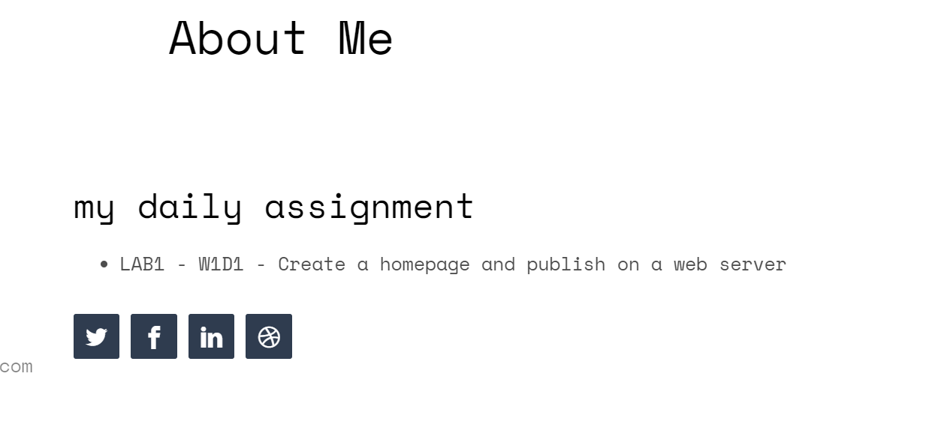

2-Validation

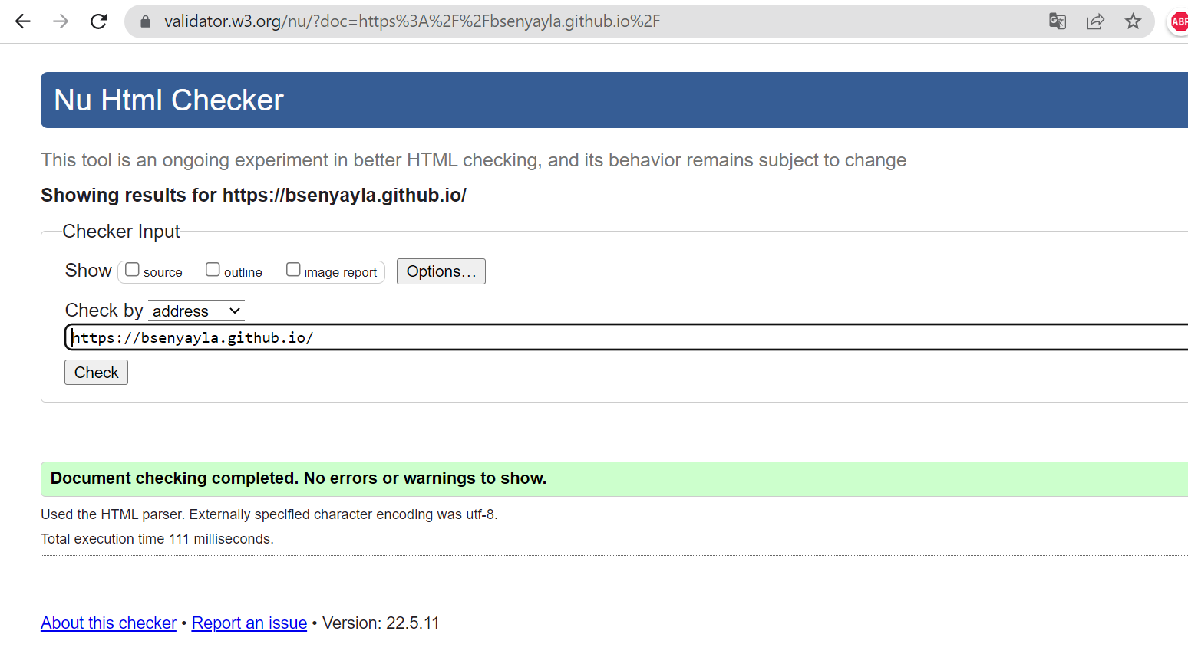

3- my account and my profile Links  
My GitHub Account : <https://github.com/bsenyayla/CS472>

My GitHub Web Side: https://bsenyayla.github.io/

4- i added some some text and img at my profile page

