**Equations Used**

M-Current:

E_M=-100

g_M=1.5 (can vary for different frequency of slow oscillations)

Q_s=3.209

I_app_py= 1.8

alpha_M_py=Q_s*(0.0001)*(v_py+30)/(1-np.exp(-1*(v_py+30)/9))

beta_M_py = -1*Q_s*(0.0001)*(v_py+30)/(1-np.exp((v_py+30)/9))

Mdot_py = alpha_M_py*(1-M_py)-beta_M_py*M_py

I_M_py=g_M*M_py*(v_py-E_M)

ATP-Current:

ATP_scale=1

J_ATP= 2*ATP_scale #production rate of ATP (linked to metabolism)

ATP_max= 1.5 # ?

K_m= 6*(10**(-8)) # govern the NA-ATP pump dynamics

F= 2*3*.000168*1.8 #8.8*(10**(-5)) # help govern the NA-ATP pump dynamics

z = 1/(1+6*ATP)

Nadot = 2*3*((0.000168)*1.8*np.abs(I_Na_py)-(3*(0.00000006)*ATP*Na*Na*Na))#F*np.abs(I_Na_py)-3*K_m*(Na**3)*ATP

ATPdot = 2*5*((J_ATP*0.0004)*(2.00-ATP)-(2*(0.00000006)*ATP*Na*Na*Na))#J_ATP*(ATP_max - ATP) - K_m*(Na**3)*ATP

I_K_ATP = g_K_ATP*z*(v_py-E_K_py)

**Results**

G_M=1.3

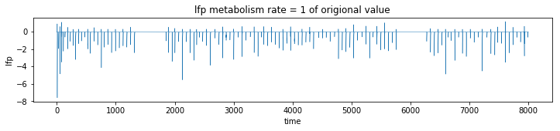

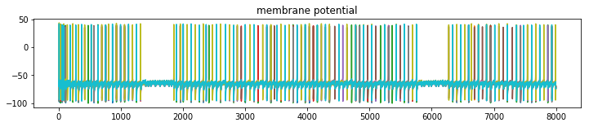

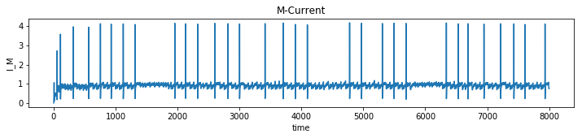

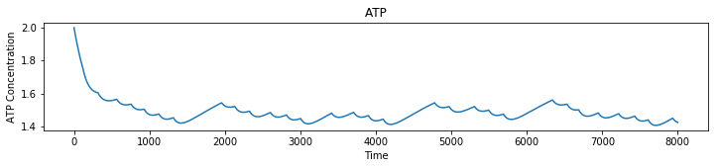

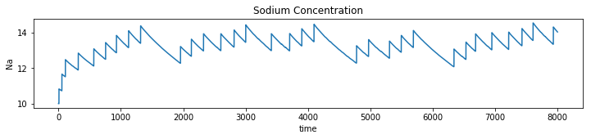

G_M=1.5

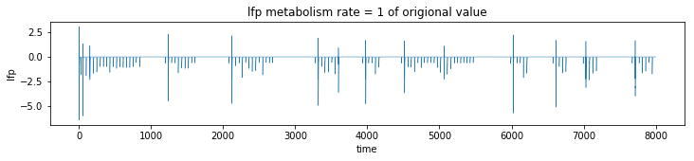

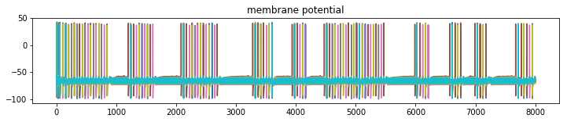

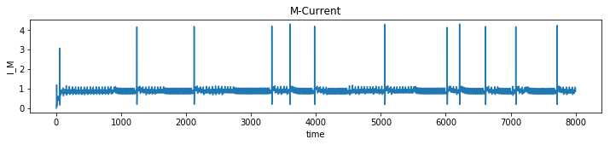

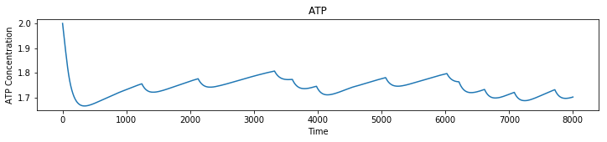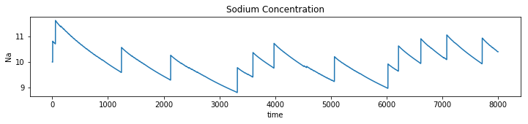

Gaba = 20 I_app = 3.8

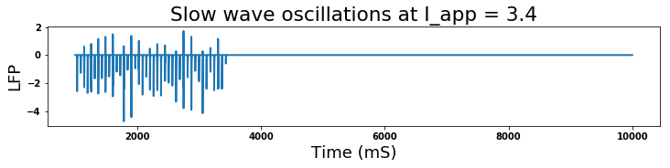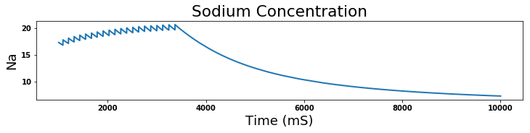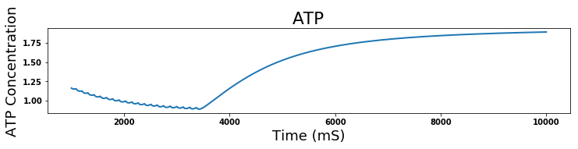

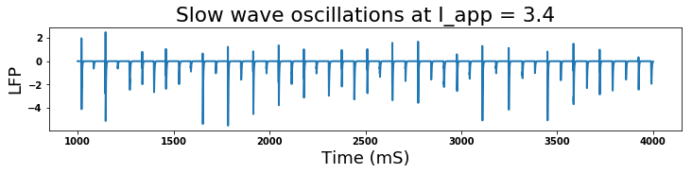

I

I_app = 3.56

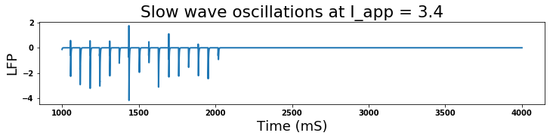

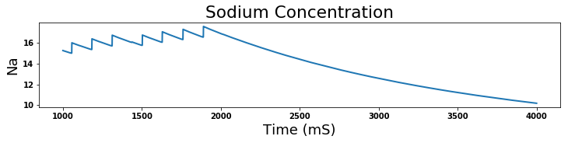

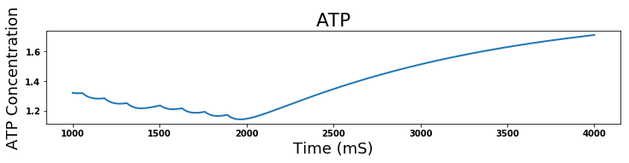

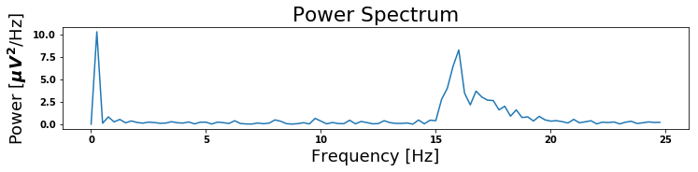

I_app= 3.56 15 seconds

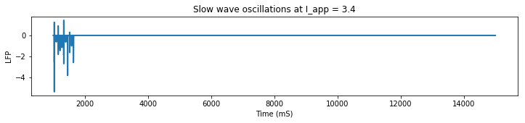

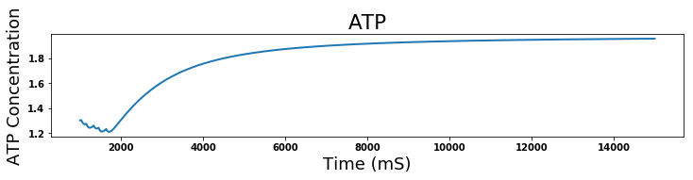

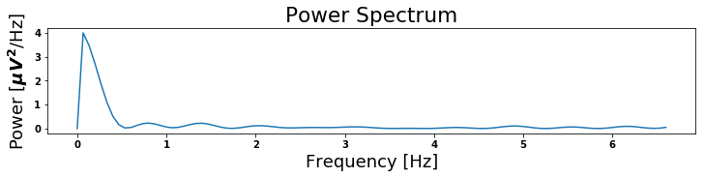

NO M-CURRENT !!

I_APP = 2.7

GABA = 20

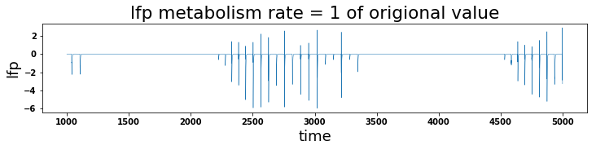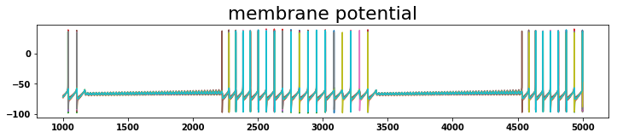

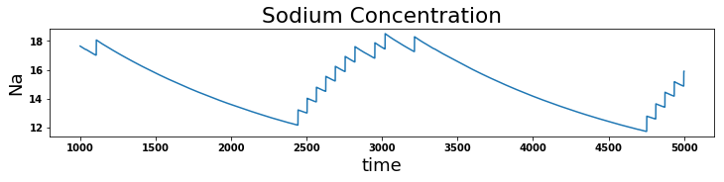

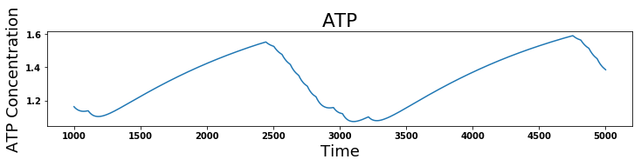

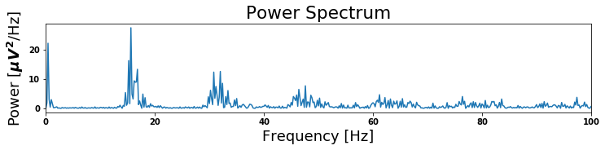

I_app = 2.8

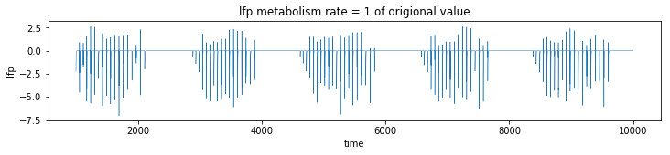

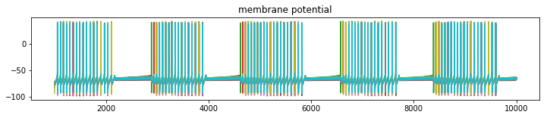

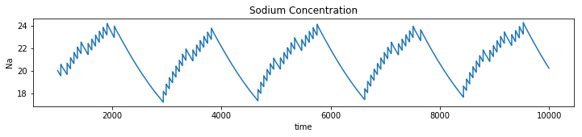

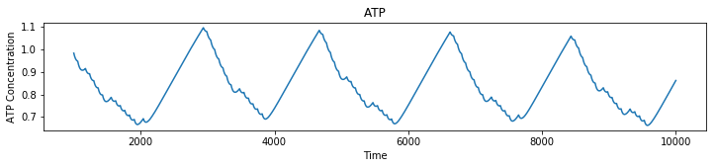

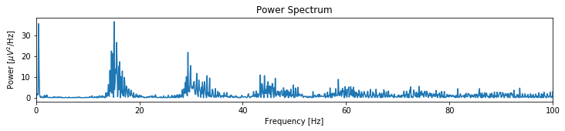

-try reducing FS_Iapp so they only spike with pyramidal

- could do multi-scale model of anesthesia

- can start with Jake’s data of coupling oscillations

-propofol alpha, ketamine gamma

-alpha coordinated, delta not?