**ANNUAL SURVIVAL OF LAND BIRDS ALONG A RURAL-TO-URBAN LAND USE GRADIENT USING CITIZEN AND SCIENTIST GENERATED DATA**

Brian S. Evans1,2, Thomas B. Ryder2, Robert Reitsma2, Allen H. Hurlbert1,3, and Peter P. Marra2

1 Curriculum for the Environment and Ecology, University of North Carolina, Chapel Hill, NC 27599, USA

2 Migratory Bird Center, Smithsonian Conservation Biology Institute,

National Zoological Park, P.O. Box 37012-MRC 5503, Washington, DC 20013, United States

3 Department of Biology, University of North Carolina, Chapel Hill, NC 27599, USA

*Abstract.* Bird species that persist in urbanized areas are thought to have life histories strategies that allow them to be successful in human-dominated landscapes. Despite high abundances of some species in urban landscapes, little is known of the demographic consequences of urbanization on urban-adapted bird species. In this study, we investigated the effects of urbanization on the survival of seven species of birds common to urban environments in the Greater Washington D.C. metropolitan area. We used mark-recapture data collected during the breeding seasons of 2000-2012 to address how apparent survival and detectability varied with the proportion of impervious surface, a common proxy for characterizing urban land cover, surrounding a banding site. Six of our seven focal species exhibited differential survival about the rural-to-urban gradient. Two of our target species, American Robin and Song Sparrow, showed peak survival at intermediate levels of urbanization while Northern Cardinal and Gray Catbird exhibited higher survival rates with increasing urbanization. The remainder of our species showed no (Carolina Chickadee) or slightly negative response (Carolina Wren and House Wren) to urban land cover. Our results demonstrate variation in species vital rates in response to urban land use practices and highlight the need to address the mechanisms by which urbanization affects species persistence.

**Keywords:** Avian, bird, survival, urbanization, mark-recapture, citizen science

**INTRODUCTION**

Urbanization during the latter half of the twentieth century has altered habitats, restructured avian communities, and influenced the range sizes and population dynamics of animal species (Mckinney and Lockwood 1999, Marzluff 2001, Chace and Walsh 2006). The unique characteristics of human-built environments confers a conflicting set of benefits and challenges that make it difficult to determine whether urban habitats are advantageous or constitute demographic sinks (Gates and Gysel 1978) for urban bird populations. As the developed land area in the United States is projected to increase by 79% by 2025 (Alig et al. 2004), understanding how organisms respond to these habitats is of paramount importance. Despite the urgency of the problem for conservation, the population level consequences of urbanization on birds remain poorly understood (Shochat 2007).

The ability of populations and individuals to persist along the urban gradient is in part determined by the life history traits of the associated species. Urban environments tend to be dominated by a few species, which have higher abundances in the urban matrix than in rural and exurban habitats (Blair 1996). Whether a given species will be a “winner” (urban-adapted or urban-obligate species, hereafter synanthropes) or “loser” (urban-avoiding species) at higher levels of urbanization is in part a function of ecological niche breadth. For example, urban-adapted species are often able to utilize abundant anthropogenic food resources (Beissinger and Osborne 1982, Marzluff and Rodewald 2006). Given that urban environments also pose novel threats, however, it remains unknown whether some synanthropic populations have expanded into habitats that are otherwise suboptimal for their survival (Anderies et al. 2007).

It is hypothesized that urban habitats may influence bottom-up controls on the distribution and abundance of populations of birds by affecting the resources that determine whether species are able to exist in these habitats (Shochat 2010). Urban environments often contain an abundance of consistent food resources for many species of birds. For example, supplemental feeding by humans, especially for overwintering resident birds, has been found to be positively associated with adult survivorship for a number of granivorous synanthropes (Doherty and Grubb 2002). Moreover, supplemental feeding has been hypothesized to be a primary driver in the northward range expansion of some seed-eating species, such as the Northern Cardinal (*Cardinalis cardinalis*) because it relaxes winter starvation (Robb et al. 2008). Likewise, urban landscapes are also often dominated by ornamental and invasive species, which have been found to provide crucial resources for frugivorous bird species during winter months and thus facilitate winter survival (e.g., Leston and Rodewald 2006, McCusker et al. 2010). The low temporal variability of resources is also hypothesized to support higher densities of individuals in urban environments because they can persist in a state of reduced body condition relative to their rural counterparts (the Credit Card Hypothesis, Shochat 2004).

The benefits of anthropogenic resources, however, may be offset by the fitness costs associated with increased competition and the quality of resources available. For instance, plant communities dominated by non-native species may support lower concentrations of protein-rich arthropod resources (Tallamy 2004), which are necessary for nestling and fledgling development (Atchison and Rodewald 2006, Chamberlain et al. 2009). This may lead to lower nestling survivorship, poorer fledging quality, and structurally smaller adults (Liker et al. 2008). This may lead to lower reproductive fitness of individuals in urban areas despite higher rates of adult survival. Therefore, while the temporal and spatial distribution of these anthropogenic resources allow some synanthropes to maintain high densities in urban habitats, it also may result in fitness trade-offs and differential selection for specific life history stages and traits (Shochat 2004).

Similarly, the resource advantages of urbanization for some species may be offset by top-down controls imparted by unique hazards associated with urban environments (e.g., predation, contaminants and disease). For example, birds may experience higher rates of predation in urban environments due to high densities of small and medium-sized mammalian predators (Crooks and Soule 1999), novel human-subsidized predators (e.g., domestic or feral cats, Balogh et al. 2011, Loss et al. 2013), and locally-high densities of raptors and corvids (Chace and Walsh 2006). Collisions with manmade objects, such as buildings and automobiles, are another threat expected to be a significant source of mortality for urban birds (Chace and Walsh 2006). Urban bird populations are also exposed to higher levels of pollutants, such as lead (Roux and Marra 2007), that could negatively affect vital rates. Finally, rates of disease transmission are also higher in urban areas (Kilpatrick 2011), with the effects potentially exacerbated by increased avian densities around common resources such as bird feeders (Robb et al. 2008).

Despite evidence that urban environments can present opposing selection pressures, the fitness impacts for species persisting in urban environments are still not yet fully understood. Research to date on certain life history stages (e.g., post-fledging survival, Whittaker and Marzluff 2007, Ausprey and Rodewald 2011 and nestling survival, Ryder et al. 2010) have failed to document the negative impact of urbanization. Despite its importance for population demography, adult survival is rarely estimated along the rural-to-urban land use gradient, in part because it is data-intensive, requiring multiple years of data collection. To date, most studies on the impacts of urbanization on adult survivorship have compared rural and urban populations (e.g., Horak and Lebreton 1998) or examined forested patches embedded within the broader matrix (e.g., Rodewald and Shustack 2008). These studies have found little or no effect of urbanization on adult survivorship. No studies have yet to be conducted across the continuous rural-to-urban land use gradient from within the urban and suburban matrix habitat. Ultimately, studying the survivorship of urban birds from directly within their habitat is necessary for understanding the demographic consequences of urbanization because these species achieve peak densities within the urban matrix (Ryder et al. 2010).

In this study we assess the annual adult survivorship of seven urban-adapted bird species using mark-recapture and resight data. To overcome sampling limitations associated with data collection across the rural-to-urban gradient, we employ a unique sampling design that utilizes citizen scientists to sample directly within the urban matrix (private yards, etc.). We develop and compare competing models of annual survivorship using various combinations of model covariates to determine how the degree of urbanization affects apparent annual survival for migrant and resident land birds.

**METHODS**  
 This study was conducted from 2000 to 2012 within a 100 km extent encompassing a rural-to-urban land use gradient in the greater Washington D.C. and Baltimore, M.D. metropolitan region. Despite intense levels of human development, the study area includes a heterogeneous patchwork of urban (approximately 41% of the study area), suburban (18%), forested (21%), and open/agricultural (20%) habitats due to local zoning regulations and federal management of forested and open-canopy parks (Masek et al. 2000, Jantz et al. 2003). The variety of habitat types within a relatively small spatial extent, as well as their patterns of dispersion (e.g., the presence of large forested areas adjacent to or contained within the most intensely-developed urban matrix), make this region ideal for the study of the impacts of urbanization on birds (see Fig. 1).

Research in urban environments is often limited by accessibility and adequate coverage of the urban gradient (Cooper et al. 2007). The Neighborhood Nestwatch Program (hereafter referred to as “NN”) is a citizen science project run by the Smithsonian Migratory Bird Center that uses a network of 240 study sites composed predominantly of single-family homes but also includes multi-family dwellings, open and forested public parks and multi-family dwellings. By incorporating privately owned land within our study design, we are able to capture portions of the urban and suburban matrix not normally monitored in avian survivorship studies.

Annually, NN technicians visit participant properties during the avian breeding season (between the months of May and August, sites are predominantly visited by one technician). During each visit, technicians provide an educational banding demonstration for program participants and set two to eight mist nets for a period of three to five hours of mark-recapture. Birds are captured using target netting with playback of mobbing calls or conspecific song. Individuals are marked with a unique US Fish and Wildlife aluminum band and a unique combination of colored plastic bands. Technicians measure body mass (to the nearest 0.01 g) on an electronic balance and unflattened wing chord (to the nearest 0.25 mm) with a wing rule. Birds are aged into hatch year (HY) and after hatch year (AHY) age classes using plumage, skull ossification, or molt criteria (methodologies vary by species, see Pyle 1997). During the annual banding visit, technicians spend one hour attempting to resight birds banded during previous visits. We search all accessible areas within a 200 m radius of the site, using playback techniques. At the end of each visit, participants are provided with a list of color-banded birds, trained on resighting techniques, and expected to attempt to resight and report observations of marked individuals throughout the year.

*Model development*

We estimated the annual survival of seven species of birds most common across the development gradient within our study region: American Robin (*Turdus migratorius*), Carolina Chickadee (*Poecile carolinensis*), Carolina Wren (*Thryothorus ludovicianus*), Gray Catbird (*Dumetella carolinensis*), House Wren (*Troglodytes aedon*), Northern Cardinal (*Cardinalis cardinalis*), and Song Sparrow (*Melospiza melodia*). We fit Cormack-Jolly-Seber survivorship models to these data to investigate the effects of individual covariates on apparent survivorship (Φ) and the probability of detecting marked individuals given that they remained within the sampling location (*p*). All models were constructed in the R package RMark (v. 2.14.1, R Core Team 2013, Laake 2013) and implemented in Program MARK (White and Burnham 1999). Covariates used in model construction were unstandardized and included the degree of urbanization, method of data collection (citizen scientist or technician), sex, body condition, and time-since-marking (see Table 1). To assess the effects of citizen scientist participation and urbanization covariates on avian survival, we compared an *a priori* model that included sex, body condition, and time-since marking variables against models that also included our variables of interest. We used Akaike’s Information Criteria (AIC, Akaike 1973) to select the best models among a set of biologically plausible candidate models (see below).

*A priori model variables*

To account for variation or potential bias in detectability and survivorship estimates, sex, time-since-marking, body condition, and project participant resight effort covariates were used in the construction of the *a priori* model. Because territorial males may be much more likely to be encountered than females due to behavioral differences (Amrhein et al. 2012), *sex* was included as a binary dummy covariate for estimating detectability. As males and females may experience differential rates of survival (Donald 2007) or site fidelity (Murphy 1996), sex was also used as a covariate for Φ to account for variation in true survival or emigration. Due to low relative sample sizes of females for House Wren and Song Sparrow, sex could not be included as a predictor of survival for either of these species as inclusion of this variable as a predictor of Φ caused considerable model instability (see Fig. 2).

A population of birds captured during a given sampling event could contain both transient and resident individuals. Because there is a low probability of reencountering transient birds, failure to account for this could negatively bias survival estimates (Pradel 1996). We incorporated transience in the model structure by including a binary time-since-marking (TSM) term for the estimation of Φ. We then calculated separate survival estimates for the year after the initial capture occasion and between the second and following years of sampling. Because males and females may show differential rates of transience (Murphy 1996), an interaction term between TSM and sex was included within the *a priori* model.

Body condition is a potentially important determinant of avian survivorship in different environments (Johnson et al. 2005) and is theorized to decline in urban environments (Shochat 2004). To incorporate the effects of body condition on Φ, we used a scaled body condition index (BCI) derived from body mass and wing chord lengths (Peig and Green 2009, see supplemental). Because variation in body condition may have differential effects on the survival of males and females, we included an interaction term between sex and BCI within the *a priori* model.

While we acknowledge the potential of time-dependence in both survivorship and detection probabilities, the estimation of a time effect was not possible because the annual sample size was insufficient to provide stable estimates of model parameters. Moreover, due to funding and logistical constraints, neither resighting nor banding effort was consistent across years and several sites were not sampled during every year of the study or discontinued. To account for this, individual observations in the encounter history were coded as positive sample occasions, negative sample occasions, and unsampled occasions (“1”, “0”, and “.”, respectively). While this technique (dot notation) has been used to account for missing sampling data (e.g., Danner et al. *in press*), a drawback of this method is that goodness-of-fit tests are not currently available to estimate overdispersion (ĉ) with missing data.

We examined the influence of citizen scientist sampling in our study by comparing estimates of detectability and survivorship using data gathered by citizen scientists versus those collected by NN technicians. Because both technicians and participants attempted to resight birds at several locations, we were unable to evaluate the origin of individual observations. To account for citizen scientist *participation*, we therefore separated encounter records into those that originated from sites that included participant data (“active” sites, n = 100) and those that did not (“inactive” sites, n = 140), coded as a binary dummy variable. Due to substantial model instability, the effects of participation on detectability estimates could not be evaluated for Carolina Wren, therefore we only estimated the effects of participation on survival estimates for this species (see Fig. 4). While we acknowledge that participation effects on survival and detectability estimates are predominantly a function of sample size, the effect of citizen scientist participation may extend beyond those of sample size alone. For example, if males are more detectable during the breeding season but males and females are equally detectable during non-breeding season, participation may have a differential effect on survival and detectability estimates due to year-round monitoring by participants. To investigate this, we included an interaction term between sex and participation.

To explore the influence of urbanization on survival, we used the proportion of impervious surface (IMP) within a 500 m radius of NN sites to characterize the degree of urbanization at each banding location. This proxy variable and scale of analysis was chosen because they have been found to be most predictive of demographic response to urbanization (see Ryder et al. 2010). Spatial analyses were conducted in ArcGIS 10.0 (ESRI 2012). We obtained 30 m resolution impervious surface data from the 2006 National Land Cover Database (Fry et al. 2011) and determined the mean impervious surface within a 500 m neighborhood of each map pixel. Because several NN sites adjacent to the Chesapeake Bay and Potomac River included open water within the 500 m radius, this land-use type was excluded from estimates of proportional impervious surface cover. Additionally, because avian response to urbanization may be nonlinear, we included a quadratic term for impervious surface (IMP2) as a model covariate for candidate models.

*Model selection and evaluation*

We used AICc and Akaike weights to identify the models best supported by the data. Models in which the ∆AICc between a given model and the best model was less than 2 were considered equally supported by the data (Burnham and Anderson 2002). We used normalized Akaike weights, the ratio of the likelihood of a given model relative to the sum of the likelihood across models, to evaluate the weight of evidence for a given model relative to the full set of candidate models. To determine the relative importance of a given variable (), we calculated the cumulative Akaike weights for models that included the variable (Burnham and Anderson 2002) divided by the number of models in which the variable was present (see Kittle et al. 2002). We further assessed the effects of predictor variables by averaging β estimates and unconditional standard errors by Akaike weights across candidate models (Burnham and Anderson 2002).

**RESULTS**

A total of 4,379 individuals, captured from 240 NN sites, were used in this analysis (Table 2). Among these individuals, 79% were never reencountered (n = 3,462). Across species, the ∆AICc of the model relative to a true null model (ɸ~1, p~1) was 18.5, suggesting considerable support for the a priori model. While not explicitly tested, there was supportive evidence that survival and detection estimates varied markedly between males and females and by species (Fig. 2). Across all species, models that included additional urbanization and participation variables had substantially more support than the *a priori* model (Table 3).

The proportional cover of impervious surface was predictive of survivorship for all of our target species except Carolina Chickadee (Table 3). There was a positive relationship between impervious surface and survival of American Robin, Gray Catbird, Northern Cardinal, and Song Sparrow and a negative relationship for Carolina Wren and House Wren (Fig. 3, Table 4). Annual survival probabilities for American Robin and Song Sparrow were highest at intermediate levels of urbanization (45 and 47% impervious surface, respectively), with both species exhibiting a strong quadratic response to impervious surface (Fig. 3, Table 4). Northern Cardinal and Gray Catbird exhibited a nearly linear increase in apparent survival with increasing urbanization. While there was substantial support for models that included a quadratic response to impervious surface cover for both of these species, estimates at the upper end of the rural-to-urban gradient contain considerable uncertainty due to small sample sizes at highly urban sites (see Appendix II). Similarly, while Carolina Wren and House Wren exhibited a quadratic response, with lower rates of survival at higher levels of urbanization (Fig. 3), no individuals of these species were reencountered at sites with greater than 50 % impervious surface and beta estimates contain considerable uncertainty (Table 4, see Appendix II).

**DISCUSSION**

Understanding the demographic consequences of anthropogenic habitat change is essential as natural habitats are being rapidly converted to human dominated landscapes. Despite the pace of urbanization few studies have addressed survivorship of adult birds in urban environments (Chace and Walsh 2006) and none to our knowledge have yet explored survival along the rural-to-urban gradient from within urban or suburban matrices (but see Stracey et al. 2012). Here, we utilized a unique study designed to determine the effects of urbanization on the annual survival of resident and migrant land birds. Citizen scientists provided access to previously under-sampled portions of the rural-to-urban gradient and assisted in resighting color-banded birds. We evaluated the annual survival of seven bird species common to suburban and urban matrices and assessed the efficacy of using citizen scientists in a large scale study of avian demography. Our results show that the effects of citizen scientist participation helped increase sample size and improved parameter estimates (survival and detection probabilities) for color marked individuals. Through the Smithsonian’s Neighborhood Nestwatch program which uses citizen scientists throughout the Washington D.C. greater metropolitan area, we were able to identify variation in survivorship along the rural-to-urban gradient, with higher apparent survival in suburban and urban environments for four of our seven species than at the rural end of the gradient. Cumulatively, our results suggest that the effect of urbanization does influence avian vital rates and that species-specific differences may in part be driven by life history strategies.

Previous studies estimating adult survivorship of birds in human dominated systems have reported mixed results, most often showing little or no influence of urban land cover. Rodewald and Shustack (2008, 2008a), for example, found no difference between survivorship of Northern Cardinals occupying forests embedded within an urban matrix versus those occupying forests embedded within a rural matrix. In contrast, our results provide strong evidence that survival rates vary along the rural-to-urban gradient in six of our seven study species. As populations of these species often exhibit peak abundances in suburban and low-intensity urban habitats (Blair et al. 1996), the disparity between our results and those of other urban demographic studies suggests that local habitat quality within the urban-suburban matrix may be more predictive of avian survival than the landscape context of forested patches for synanthropic species.

Our focal species exhibited differential rates of survival with increasing urban land cover. Survival at the rural end of the rural-to-urban gradient was similar across species with the exception of Gray Catbird and American Robin, which had lower rates of survival relative to the other focal species, suggesting species-specific resource limitations or mortality risks. Carolina Chickadee, Carolina Wren, and House Wren each exhibited their highest rates of survival at the rural portions of the gradient, with Carolina Chickadee showing no response to urbanization and Carolina Wren and House Wren showing only a slight decrease. The peak apparent survival of these species, however, was similar to the lowest annual survival of Northern Cardinal and Song Sparrow, suggesting low relative survival rates for these species across our study area. Apparent survival of American Robin, Gray Catbird, Northern Cardinal, and Song Sparrow increased markedly with urbanization, peaking at intermediate proportions of the gradient for American Robin and Song Sparrow and at the most urban sites for Northern Cardinal and Gray Catbird. While the effects of urbanization at the highest proportions of impervious surface cover are largely obscured by sample size limitations, the apparent survival of Song Sparrow was decreased and American Robin survival fell below baseline survival rates at this portion of the gradient, suggesting some factor may be limiting their survival in high-intensity urban habitats.

*Top-down and bottom-up controls on avian population processes*

Observed patterns of survival across the rural-to-urban gradient may offer clues as to mechanisms that underlie the demographic response. If avian survival is determined by top-down controls, then it would be expected that survivorship should decline with increasing urban land cover, as urban environments potentially provide increased mortality risk associated with increased rates of disease transmission, novel threats (e.g., collisions with man-made objects, Chace and Walsh 2006), and locally high densities of predators such as domestic and feral cats (Sorace 2002, but see Shochat 2010). Conversely, if resource availability determines survival in urban landscapes, it is expected that survivorship would be enhanced in these environments for many species due to anthropogenic resources (e.g., supplemental feeding), high densities of some invertebrates (especially for ground-foraging birds), and abundant fruit resources associated with ornamental and non-native plants (McIntyre 2000, Reichard et al. 2001, Craves 2009, but see Tallamy 2004 and Burghardt et al. 2009). The extent of bottom-up effects on avian demography are likely dependent on the degree of urbanization, the type and abundance of available resources, and the life histories of the affected bird species.

Higher apparent survivorship for the American Robin, Gray Catbird, Northern Cardinal, and Song Sparrow fits the pattern expected of bottom-up controls on survival with increasing urbanization. These species are often considered habitat generalists (Poole 2013) and may therefore more readily adapt to challenges associated with urban landscapes (McKinney and Lockwood 1999). Additionally, a considerable proportion of the diets of these species consists of fruit resources (Poole 2013) that are more abundant in urban environments, especially in winter months when survival of the resident species (all except Gray Catbird) is heavily dependent on a consistent food supply (Shochat 2010).

Samples of Carolina Chickadee, Carolina Wren, and House Wren were limited to the lower end of the urban gradient and these species, all of which are cavity nesters, exhibit very low abundances at the urban end of the rural-to-urban gradient (Evans et al., unpublished data). A lack of these individuals within the suburban and urban portions of the matrix may reflect a reduction in nesting resources due to a loss of adequate cavity trees or interspecific competition for nest cavities with matrix-dwelling species such as the European Starling (*Sturnus vulgarus*) or House Sparrow (Newton 1994, Blewett and Marzluff 2005). Alternatively, observed patterns of survivorship and abundance for these species may be driven by declines in the size of suitable forest patches, the quality of the surrounding matrix along the rural-to-urban gradient, and/or behavioral avoidance of open urban habitats (Robbins et al. 1989, Medley et al. 1995). While directly addressing the mechanisms by which resource availability and other factors affect survivorship estimates is unfeasible, further research is necessary to determine the relative role of resource availability in urban environments.

*Potential influence of urbanization on avian fitness*

The influence of urbanization on adult survival may significantly alter avian fitness in human-dominated systems. While the response of Northern Cardinal to urbanization was somewhat moderate, strong positive effects of urbanization on annual survival estimates of American Robin, Gray Catbird, and Song Sparrow suggest that habitat modification associated with urban land cover may positively influence population persistence for these species. If adult survivorship plays a dominant role in population persistence, our results predict differential population trajectories for Gray Catbird, Northern Cardinal, American Robin, and Song Sparrow relative to Carolina Wren, House Wren, and Carolina Chickadee in urban areas. To address this prediction at broader spatial scales, further research is needed to determine if population trends of these species diverge in parts of the country that have seen higher rates of urbanization.

Taken in concert with the finding that our study species exhibit greater nest success at higher levels of urbanization within the Washington, D.C metropolitan area (Ryder et al. 2010), our results suggest that the suburban-urban matrix may be a source for populations of some species in this region. Conversely, populations of these species exhibited their lowest rates of adult survivorship and nest success within the rural habitats of our study area, suggesting that undeveloped portions of this landscape may actually constitute demographic sinks for some synanthropic species (Pulliam 1988). Ultimately, if species show habitat preferences (i.e., higher population density) for rural patches embedded within the urban matrix yet suffer lower survival across life history stages, then urban green areas may actually constitute an ecological trap for avian populations (Gates and Gysel 1978). Further research is needed on dispersal and recruitment of juvenile birds (but see Balogh et al. 2011) to adequately model how population growth trajectories vary across the rural-to-urban gradient.

*Conclusion*

Variation in adult survival along the rural-to-urban gradient, even among the urban-adapted species in this study, highlights a need to address which life history traits allow species to persist in urban environments and which life history stages most affect population viability. Further study is necessary to assess the distribution of risks, such as building collisions and free-roaming cats, and resources, such as fruit and arthropods, across the rural-to-urban gradient. As the costs and benefits of urban environments may differentially affect avian vital rates, dependent on a species’ life history traits, the impacts of urbanization on populations remains largely uncertain.

The study of avian vital rates provides a valuable tool in determining how population dynamics may be shaped by urbanization processes and the sensitivity of populations to extinction in urban environments. Our findings that the adult survival of several of our focal species was higher in urban relative to rural environments, in conjunction with previous findings of higher rates of nest success (Ryder et al. 2010), suggest that the effects of urbanization on these life history stages may facilitate the expansion of synanthropic populations. Future comparisons of the vital rates of urban-adapted and urban-avoiding species may provide clues as to potential causes of the extirpation of many species in urban areas and allow us to target specific conservation measures to mitigate the effects of urbanization.

**ACKNOWLEDGEMENTS**

The Mills Corporation, Wallace Genetic Foundation, Susan and Frank Mars, Youth Access Grants, and the National Science Foundation (ESI-0540185) provided financial support for this study. We are grateful to Smithsonian’s National Zoo and Environmental Research Center as well as the many talented field assistants for their contributions over the course of this project. Special thanks goes to N. Diggs, A.M. Kilpatrick, and K. Sullivan for their invaluable training and support. Finally, we thank all of the Neighborhood Nestwatch participants for their kindness, access to their property, and commitment to this project.

**LITERATURE CITED**

Akaike, H. 1973. Information theory and an extension of the maximum likelihood principle. Pages 267–281 in F. Csaki, editor. Second International Symposium on Information Theory. Akamemiai Kiado, Budapest, Hungary.

Alig, R.J., J.D. Kline, and M. Lichtenstein. 2004. Urbanization on the US landscape: Looking ahead in the 21st century. Landscape and Urban Planning 69: 219-234.

Amrhein, V., B. Scaar, M. Baumann, N. Minery, J.P. Binnert, and F. Korner-Nievergelt. 2012. Estimating adult sex ratios from bird mist netting data. Methods in Ecology and Evolution 3: 713-720.

Atchison, K. A., and A. D. Rodewald. 2006. The value of urban forests to wintering birds. Natural Areas Journal 26: 280-288.

Anderies, J.M., M. Katti, and E. Shochat. 2007. Living in the city: Resource availability, predation, and bird population dynamics in urban areas. Journal of Theoretical Biology 247: 36-49.

Ausprey, I. J. and A.D. Rodewald. 2011. Postfledging survivorship and habitat selection across a rural-to-urban landscape gradient. Auk 128: 293–302.

Balogh, A. L., T.B. Ryder, and P.P. Marra. 2011. Population demography of Gray Catbirds in the suburban matrix: sources, sinks and domestic cats. Journal of Ornithology 152: 717-726.

Beissinger, S.R. and D.R. Osborne. 1982. Effects of urbanization on avian community organization. Condor 84: 75-83.

Blair, R. B. 1996. Land Use and Avian Species Diversity Along an Urban Gradient. Ecological Applications 6:506–519.

Blewett, C. M., and J. M. Marzluff. 2005. Effects of urban sprawl on snags and the abundance and productivity of cavity-nesting birds. The Condor 107:678–693.

Burghardt, K. T., D. W. Tallamy, and W. Gregory Shriver. 2009. Impact of Native Plants on Bird and Butterfly Diversity in Suburban Landscapes. Conservation Biology 23:219–224.

Burhans, D.E. and F.R. Thompson III. 2006. Songbird abundance and parasitism differ between urban and rural shrublands. Ecological Applications 16: 394-405.

Burnham, K. P., and D. R. Anderson. 2002. Model selection and multimodel inference: a practical information-theoretic approach. Second edition. Springer-Verlag, New York, New York, USA.

Chace, J.F. and J.J. Walsh. 2006. Urban effects on native avifauna: a review. Landscape and urban planning 74: 46-69.

Chamberlain, D. E., A.R. Cannon, M.P. Toms, D.I. Leech, B.J. Hatchwell, and K.J. Gaston. 2008. Avian productivity in urban landscapes: a review and meta‐analysis. Ibis 151: 1-18.

Cohn, J. P. 2008. Citizen science: Can volunteers do real research?. BioScience, 58: 192-197.

Cooper, C.B., J. Dickinson, T. Phillips, and R. Bonney.2007. Citizen Science as a Tool for Conservation in Residential Ecosystems. Ecology and Society 12: 11. [online] [URL:http://www.ecologyandsociety.org/vol12/](url:http://www.ecologyandsociety.org/vol12/)

Craves, J.A. 2009. A Fifteen-year Study of Fall Stopover Patterns of Catharus Thrushes at an Inland, Urban Site. The Wilson Journal of Ornithology 121: 112-118,

Crooks, K. R. and M.E. Soulé. 1999. Mesopredator release and avifaunal extinctions in a fragmented system. Nature 400: 563-566.

Doherty, P.F., and T.C. Grubb. 2002. Survivorship of permanent-resident birds in a fragmented forested landscape. Ecology 83:844-857.

Danner, RM, R. Greenberg, J. Danner, L.T. Kirkpatrick, and J. R. Walters. *In press*. Experimental support for food limitation of a short-distance migratory bird wintering in the temperate zone. Ecology.

ESRI 2011. ArcGIS Desktop: Release 10. Redlands, CA: Environmental Systems Research Institute.

Fry, J., G. Xian, S. Jin, J. Dewitz, C. Homer, L. Yang, C. Barnes, N. Herold, and J. Wickham. 2011. National Land Cover Database 2006 Percent Developed Imperviousness. Raster digital data. MRLC.gov. http://www.mrlc.gov/nlcd06_data.php.

Gates, J. E. and L.W. Gysel. 1978. Avian nest dispersion and fledging success in field-forest ecotones. Ecology 59: 871-883.

Grubbs, F. E. 1950. Sample criteria for testing outlying observations. The Annals of Mathematical Statistics, 21: 27-58.

Kilpatrick, A.M. 2011. Globalization, Land Use, and the Invasion of West Nile Virus. Science 334: 323-327.

Kittle, A.M., Fryxell, J.M., Desy, G.E., and J. Hamr. 2008. The scale-dependent impact of wolf predation risk on resource selection by three sympatric ungulates. Oecologia 157: 163-175.

Jantz, C.A., S.J. Goetz, and M. K. Shelley. 2003. Using the SLEUTH urban growth model to simulate the impacts of future policy scenarios on urban land use in the Baltimore Washington metropolitan area. Environment and Planning 31: 251-271.

Johnson, M. D., T.W. Sherry, R. T. Holmes, and P.P. Marra. 2006. Assessing habitat quality for a migratory songbird wintering in natural and agricultural habitats. Conservation Biology 20: 1433-1444.

Laake, J.L. (2013). RMark: An R Interface for Analysis of Capture-Recapture Data with MARK. AFSC Processed Rep 2013-01, 25p.

Leston, L. F., and A.D. Rodewald. 2006. Are urban forests ecological traps for understory birds? An examination using Northern Cardinals. Biological Conservation, 131: 566-574.

Loss, S. R., T. Will, and P.P. Marra. 2013. The impact of free-ranging domestic cats on wildlife of the United States. Nature communications 4: 1396.

Lucas, J.R., T.M. Freeberg, J. Egbert, and H. Schwabl. 2006. Fecal corticosterone, body mass, and caching rates of Carolina Chickadees (*Poecile carolinensis*) from disturbed and undisturbed sites. Hormones and Behavior 49: 634-683.

Marzluff, J.M., R. Bowman and R.E. Donnelly. 2001. Avian Ecology and Conservation in an Urbanizing World. Kluwer Academic Publishers, Norwell, MA.

Masek, J., F.E. Lindsay, and S.N. Howard. 2000. Dynamics of urban growth in the Washington DC metropolitan area, 1973–1996, from Landsat observations. International Journal of Remote Sensing 21:3473–3486.

McCusker, C.E., M.P. Ward, and J.D. Brawn. 2010. Seasonal responses of avian communities to invasive bush honeysuckles (*Lonicera* spp.). Biological Invasions 12: 2459-2470.

McIntyre, N. E. 2000. Ecology of urban arthropods: A review and a call to action. Annals of the Entomological Society of America 93:825–835.

McKinney, M.L. and J.L. Lockwood. 1999. Biotic homogenization: a few winners replacing many losers in the next mass extinction. Trends in Ecology & Evolution 14: 450-453.

McKinney, M. L. 2002. Urbanization, biodiversity, and conservation. BioScience 52: 883-890.

Medley, K. E., M.J. McDonnell, and S.T. Pickett. 1995. Forest‐Landscape Structure along an Urban‐To‐Rural Gradient. The Professional Geographer 47: 159-168.

Melles, S., Glenn, S., and K. Martin. 2003. Urban Bird Diversity and Landscape Complexity: Species–environment Associations along a multiscale habitat gradient. Conservation Ecology 7: 5.

Murphy M.T. 1996. Survivorship, breeding dispersal and mate fidelity in Eastern Kingbirds. Condor 98: 82–92.

Newton, I. 1994. The role of nest sites in limiting the numbers of hole-nesting birds: A review. Biological Conservation 70: 265–276.

Peig, J. and A. J. Green. 2009. New perspectives for estimating body condition from mass/length data: the scaled mass index as an alternative method. Oikos 118:1883-1891.

Poole, A. (Editor). 2005. The Birds of North America Online: http://bna.birds.cornell.edu/BNA/. Cornell Laboratory of Ornithology, Ithaca, NY.

Pulliam, H. R. 1988. Sources, Sinks, and Population Regulation. The American Naturalist 132:652–661.

Pyle, P., S.N.G. Howell, R.P. Yunick and D.F. DeSante. 1987. Identification Guide to North American Passerines,1st edition, Slate Creek Press, Bolinas, CA.

R Development Core Team. 2011. R: A language and environment for statistical computing. R Foundation for Statistical Computing, Vienna, Austria. http://www.R-project.org/.

Reichard, S. H., L. Chalker-Scott, and S. Buchanan. 2001. Interactions among non-native plants and birds. Pages 179–223 *in* J. M. Marzluff, R. Bowman, and R. Donnelly, editors. Avian Ecology and Conservation in an Urbanizing World. Springer US.

Roux, K. E., and P.P. Marra. 2007. The presence and impact of environmental lead in passerine birds along an urban to rural land use gradient. Archives of environmental contamination and toxicology 53: 261-268.

Robb, G. N., R.A. McDonald, D.E. Chamberlain, and S. Bearhop. 2008. Food for thought: supplementary feeding as a driver of ecological change in avian populations. Frontiers in Ecology and the Environment 6: 476-484.

Rodewald, A.D. and D.P. Shustack. 2008. Consumer resource matching in urbanizing landscapes: Are synanthropic species over-matching? Ecology 89: 515-521.

Rodewald, A.D. and D.P. Shustack. 2008a. Urban flight: understanding individual and population-level responses of Nearctic-Neotropical migratory birds to urbanization. Journal of Animal Ecology 77: 83-91.

Ryder, T.B., R. Reitsma, B. Evans, and P.P. Marra. 2010. Quantifying avian nest success along an urbanization gradient using citizen and scientist generated data. Ecological Applications 20:419–426.

Shochat, E., 2004. Credit or debit? Resource input changes population dynamics of city slicker birds. Oikos 106: 622–626.

Shochat, E. P.S. Warren, S.H. Faeth, N.E. McIntryre and D. Hope. 2006. From patterns to emerging processes in mechanistic urban ecology. Trends in Ecology and Evolution 21: 2-7.

Shochat, E., S. Lerman, and E. Fernández-Juricic. 2010. Birds in urban ecosystems: Population dynamics, community structure, biodiversity, and conservation. Urban Ecosystem Ecology: 75–86.

Silvertown, J. 2009. A new dawn for citizen science. Trends in Ecology & Evolution 24: 467-471.

Sorace, A. 2002. High density of bird and pest species in urban habitats and the role of predator abundance. Ornis Fennica 79: 60-71.

Stracey, C.M. and S.K. Robinson. 2012. Are urban habitats ecological traps for a native songbird? Season-long productivity, apparent survival, and site fidelity in urban and rural habitats. Journal of Avian Biology 43: 50-60.

Tallamy, D. W. 2004. Do alien plants reduce insect biomass? Conservation Biology 18: 1689-1692.

White, G. C., and K. P. Burnham. 1999. Program MARK: survival estimation from populations of marked animals. Bird Study 46(Supplement): 120–138.

Whittaker, K.A. and J.M. Marzluff. 2009. Species-Specific Survival and Relative Habitat Use in an Urban Landscape During the Postfledging Period. The Auk 126: 288-299.

Zuefle, M.E., W.P. Brown, and D.W. Tallamy. 2007. Effects of non-native plants on the native insect community of Delaware. Biological Invasions 10: 1159-1169.

**TABLES**

**Table 1.** Variables used in the development of *a priori* and urbanization-participation models. Continuous variables are reported in upper case and factors are reported in lower case.

|  |  |  |  |
| --- | --- | --- | --- |
| **Model set** | **Variable** | **Variable description** | **Parameter** |
| *a priori\** | BCI | Scaled body condition index | Φ |
| *a priori\** | sex | Binary sex (male, female) | Φ, p |
| *a priori\** | tsm | Binary time-since-marking | Φ |
| *a priori\** | sex:BCI | Interaction term between sex and body condition index | Φ |
| *a priori\** | sex:tsm | Interaction term between sex and time-since-marking | Φ |
| urbanization-participation | IMP | Impervious surface cover (%) | Φ |
| urbanization-participation | IMP2 | Impervious surface, quadratic form | Φ |
| urbanization-participation | IMP:sex | Interaction term between impervious surface and sex | Φ |
| urbanization-participation | part | Binary active vs. inactive participation by citizen-scientists | Φ, p** |
| urbanization-participation | part:sex | Interaction term between participation and sex | Φ, p** |
| \**a priori* model, AMRO, CACH, CARW, GRCA, NOCA: ɸ (sex+BCI+tsm+sex:bci+sex:tsm), p (sex)  *a priori* model, SOSP and HOWR: ɸ (BCI+tsm), p (sex)  ** CARW models do not include participation as a predictor variable for detectability estimates | | | |

**Table 2.** Sample counts of captured and reencountered birds in the Neighborhood Nestwatch program across years.

|  |  |  |  |  |  |  |  |
| --- | --- | --- | --- | --- | --- | --- | --- |
| Species | ALPHA | Female captures | Male captures | Total captures | Female recaptures | Male recaptures | Total recaptures |
| American robin | AMRO | 198 | 218 | **416** | 24 | 22 | **46** |
| Carolina Chickadee | CACH | 192 | 211 | **403** | 43 | 57 | **100** |
| Carolina wren | CARW | 211 | 251 | **462** | 37 | 74 | **111** |
| Gray catbird | GRCA | 329 | 646 | **975** | 38 | 143 | **181** |
| House wren | HOWR | 191 | 432 | **623** | 15 | 49 | **64** |
| Northern cardinal | NOCA | 402 | 603 | **1005** | 85 | 186 | **271** |
| Song Sparrow | SOSP | 101 | 407 | **508** | 21 | 131 | **152** |
| **Totals across species** | | 1624 | 2768 | **4392** | 263 | 662 | **925** |

|  |  |  |  |  |  |  |  |  |  |
| --- | --- | --- | --- | --- | --- | --- | --- | --- | --- |
|  | Statistic | Top 5 models | | | | | *a priori*  *model* |  | Variable  rank |
|  | 1 | 2 | 3 | 4 | 5 |
| American  robin | ∆AICc | 0.00 | 1.60 | 2.11 | 2.44 | 2.86 | 29.60 | na | na |
| *w* | 0.360 | 0.162 | 0.125 | 0.106 | 0.086 | 0.000 | na | na |
| β: IMP, Φ | 12.1 | 12.1 | 12.1 | 12.0 | 11.81 | - | 0.056 | 2 |
| β: IMP2, Φ | -13.4 | -13.4 | -13.4 | -13.4 | -13.4 | - | 0.108 | 1 |
| β: part, Φ | - | - | 0.02 | -1.08 | -1.64 | - | 0.026 | 5 |
| β: part:sex, Φ | - | - | - | - | -0.98 | - | 0.019 | 6 |
| β: part, p | -1.71 | -2.04 | -1.73 | - | - | - | 0.045 | 3 |
| β: part:sex, p | - | 0.73 | - | - | - | - | 0.027 | 4 |
| Carolina  chickadee | ∆AICc | 0.00 | 1.96 | 2.07 | 2.07 | 3.45 | 6.44 | na | na |
| *Model weight* | 0.243 | 0.091 | 0.086 | 0.086 | 0.070 | 0.012 | na | na |
| β: IMP, Φ | - | - | - | 0.05 | - | - | 0.024 | 4 |
| β: IMP2, Φ | - | - | - | - | - | - | 0.016 | 5 |
| β: part, Φ | -0.77 | -0.69 | -0.80 | -0.77 | -1.11 | - | 0.070 | 1 |
| β: part:sex, Φ | - | - | 0.05 | - | - | - | 0.037 | 2 |
| β: part, p | - | -0.24 | - | - | - | - | 0.031 | 3 |
| β: part:sex, p | - | - | - | - | - | - | 0.014 | 6 |
| Carolina  wren | ∆AICc | 0.00 | 0.32 | 1.44 | 1.74 | 3.07 | 7.67 | na | na |
| *Model weight* | 0.314 | 0.267 | 0.152 | 0.131 | 0.067 | 0.007 | na | na |
| β: IMP, Φ | - | - | -0.85 | -0.85 | -0.65 | - | 0.069 | 3 |
| β: IMP2, Φ | - | - | - | - | -4.36 | - | 0.042 | 4 |
| β: part, Φ | -0.34 | -0.78 | -0.37 | -0.81 | -0.36 | - | 0.165 | 2 |
| β: part:sex, Φ | -0.82 | - | -0.82 | - | -0.82 | - | 0.178 | 1 |

**Table 3.** Statistical summaries of the *a priori* and top 5 models, as ranked by AICc. Variable weights () represent mean cumulative weights of models containing a given variable. Estimates for sex and participation are relative to female and active participants, respectively.

**Table 3, con’t**

|  |  |  |  |  |  |  |  |  |  |
| --- | --- | --- | --- | --- | --- | --- | --- | --- | --- |
|  | Statistic | Top 5 models | | | | | *a priori*  *model* |  | Variable  rank |
|  | 1 | 2 | 3 | 4 | 5 |
| Gray  catbird | ∆AICc | 0.00 | 1.37 | 1.79 | 1.94 | 1.97 | 11.06 | na | na |
| *Model weight* | 0.174 | 0.088 | 0.078 | 0.073 | 0.072 | 0.001 | na | na |
| β: IMP, Φ | 3.44 | 1.57 | 3.45 | 3.40 | 1.58 | - | 0.055 | 2 |
| β: IMP2, Φ | -3.28 | - | -3.30 | -3.18 | - | - | 0.056 | 1 |
| β: part, Φ | - | - | - | -0.08 | - | - | 0.025 | 5 |
| β: part:sex, Φ | - | - | - |  | - | - | 0.014 | 6 |
| β: part, p | -0.58 | -0.60 | -0.37 | -0.51 | -0.49 | - | 0.045 | 3 |
| β: part:sex, p | - | - | -0.27 |  | - | - | 0.026 | 4 |
| House  wren | ∆AICc | 0.00 | 0.70 | 1.19 | 1.50 | 1.91 | 4.95 | na | na |
| *w* | 0.194 | 0.137 | 0.107 | 0.092 | 0.074 | 0.016 | na | na |
| β: IMP, Φ | **-** | 5.98 | **-** | 6.37 | - | - | 0.045 | 4 |
| β: IMP2, Φ | **-** | -16.0 | **-** | -16.8 | - | - | 0.060 | 2 |
| β: part, Φ | -0.73 | -0.67 | **-** | - | -0.58 | - | 0.069 | 1 |
| β: part, p | **-** | **-** | -1.0 | -0.93 | -0.29 | - | 0.046 | 3 |
| β: part:sex, p | - | **-** | - | - | - | - | 0.026 | 5 |
| Northern  cardinal | ∆AICc | 0.00 | 0.94 | 1.08 | 1.36 | 1.54 | 20.36 | na | na |
| *Model weight* | 0.159 | 0.100 | 0.093 | 0.081 | 0.074 | 0.000 | na | na |
| β: IMP, Φ | 1.20 | 1.17 | 2.21 | 1.20 | 1.21 | - | 0.051 | 1 |
| β: IMP2, Φ | - | - | -2.02 | - | - | - | 0.037 | 4 |
| β: part, Φ | -0.41 | -0.60 | -0.41 | -0.39 | -0.59 | - | 0.048 | 2 |
| β: part:sex, Φ | - | - | - | - | 0.24 | - | 0.030 | 5 |
| β: part, p | -0.54 | - | -0.53 | -0.87 | -0.52 | - | 0.041 | 3 |
| β: part:sex, p | - | - | - | 0.43 | - | - | 0.027 | 6 |
| Song  Sparrow | ∆AICc | 0.00 | 1.25 | 1.83 | 1.88 | 1.91 | 11.47 | na | na |
| *Model weight* | 0.298 | 0.160 | 0.119 | 0.116 | 0.114 | 0.001 | na | na |
| β: IMP, Φ | 5.88 | 5.37 | 5.67 | 5.90 | 5.88 | - | 0.082 | 2 |
| β: IMP2, Φ | -6.55 | -5.89 | -6.27 | -6.62 | -6.54 | - | 0.142 | 1 |
| β: part, Φ | - | 0.36 | -0.14 | - | - | - | 0.044 | 4 |
| β: part, p | -0.58 | - | -0.46 | - | -0.36 | - | 0.056 | 3 |
| β: part:sex, p | - | - | - | - | 0.76 | - | 0.031 | 5 |

**Table 4.** Model-averaged Beta estimates for the influence of the proportional cover of impervious surface on annual survival probability.

|  |  |  |  |  |  |
| --- | --- | --- | --- | --- | --- |
|  | Impervious surface (%) | |  | Impervious surface2 | |
| Species |  |  |  |  |  |
| AMRO | 11.78 | 3.04 |  | -13.31 | 4.58 |
| CACH | 0.54 | 1.50 |  | -3.88 | 5.31 |
| CARW | -0.39 | 1.53 |  | -4.31 | 7.05 |
| GRCA | 2.50 | 0.97 |  | -3.21 | 2.20 |
| HOWR | 4.26 | 2.82 |  | -16.42 | 10.51 |
| NOCA | 1.57 | 0.74 |  | -2.01 | 2.06 |
| SOSP | 5.21 | 1.65 |  | -6.38 | 2.59 |

**Table 5.** Beta estimates for ɸ and p averaged across models by model weight. Participation values represent the effect of inactive participation sites relative to sites in which citizen scientists actively report data.

|  |  |  |  |  |  |
| --- | --- | --- | --- | --- | --- |
|  | Participation, ɸ | |  | Participation, p | |
| Species |  |  |  |  |  |
| AMRO | -0.68 | 0.73 |  | -1.78 | 0.71 |
| CACH | -0.76 | 0.34 |  | -0.53 | 0.64 |
| CARW | -0.56 | 0.33 |  | na | na |
| GRCA | -0.20 | 0.28 |  | -0.49 | 0.33 |
| HOWR | -0.65 | 0.37 |  | -0.79 | 0.66 |
| NOCA | -0.52 | 0.22 |  | -0.72 | 0.36 |
| SOSP | -0.27 | 0.25 |  | -0.48 | 0.41 |

**Figure captions**

**Figure 1.** The study extent of the Neighborhood Nestwatch Program. Black dots represent Nestwatch sites. Inset displays the land cover within a 5km extent area in northwest Washington, D.C.

**Figure 2.** Estimates of annual detection and survival probabilities by species and sex. Due to substantial model instability, the effect of sex on annual survival probabilities of HOWR and SOSP could not be estimated.

**Figure 3.** Model-averaged estimates of American robin, Gray catbird, Song Sparrow, and Northern cardinal annual survival probabilities across the rural-to-urban gradient.

**Figure 4.** Annual detection probabilities and survivorship estimates for sites in which participants report resighting data ("Active"), and those in which only technicians conduct resighting. The effects of participation on the detectability of the Carolina wren could not be estimated

**FIGURE 1**

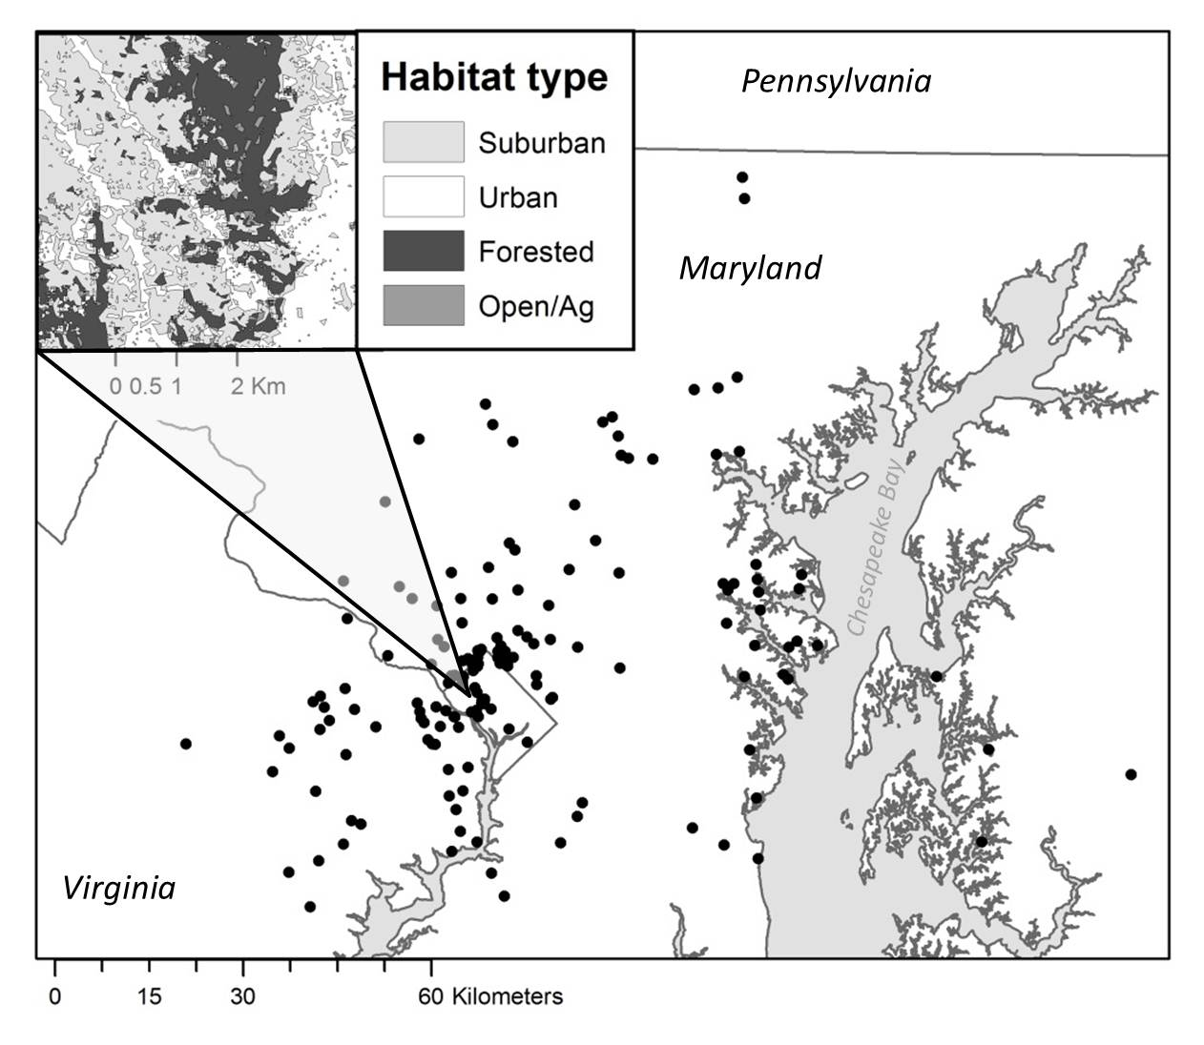

**FIGURE 2**

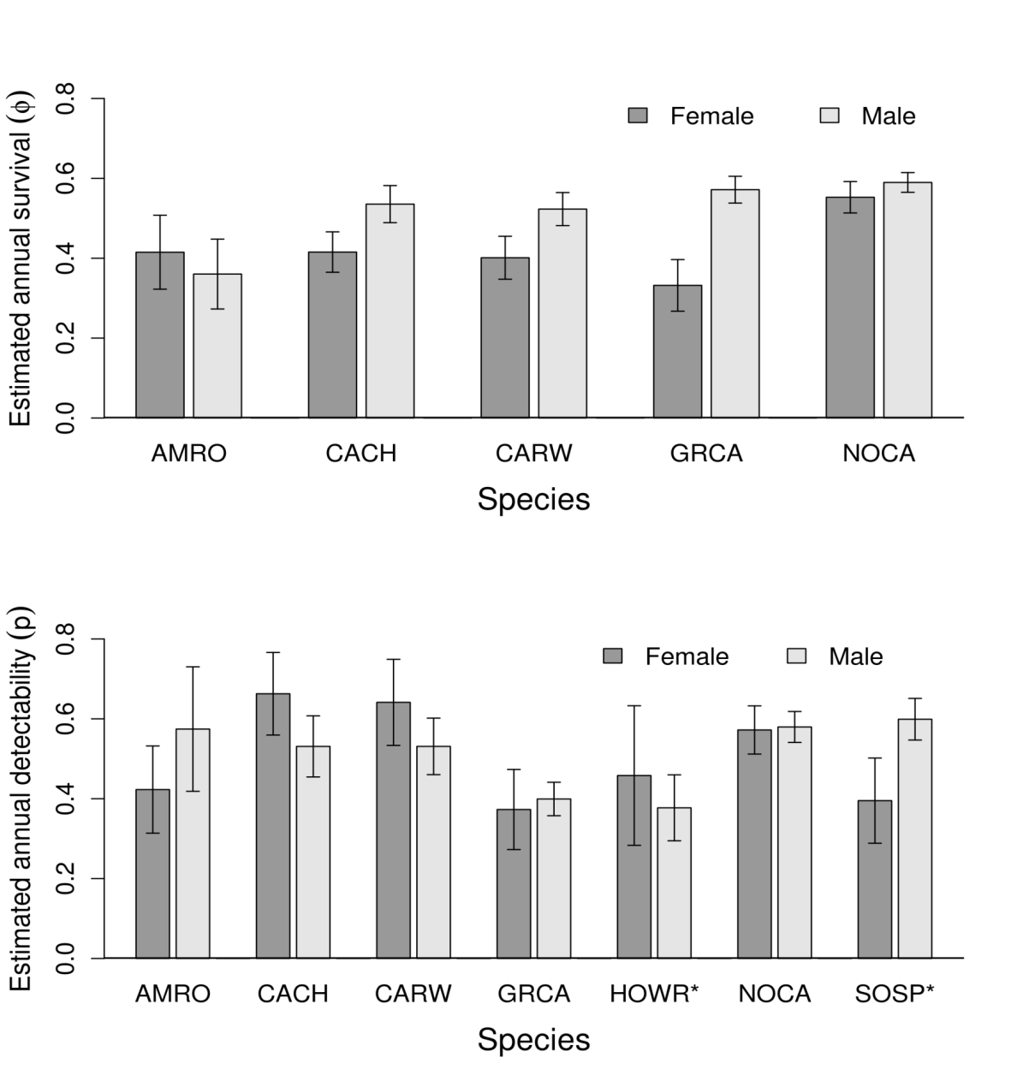

**FIGURE 3**

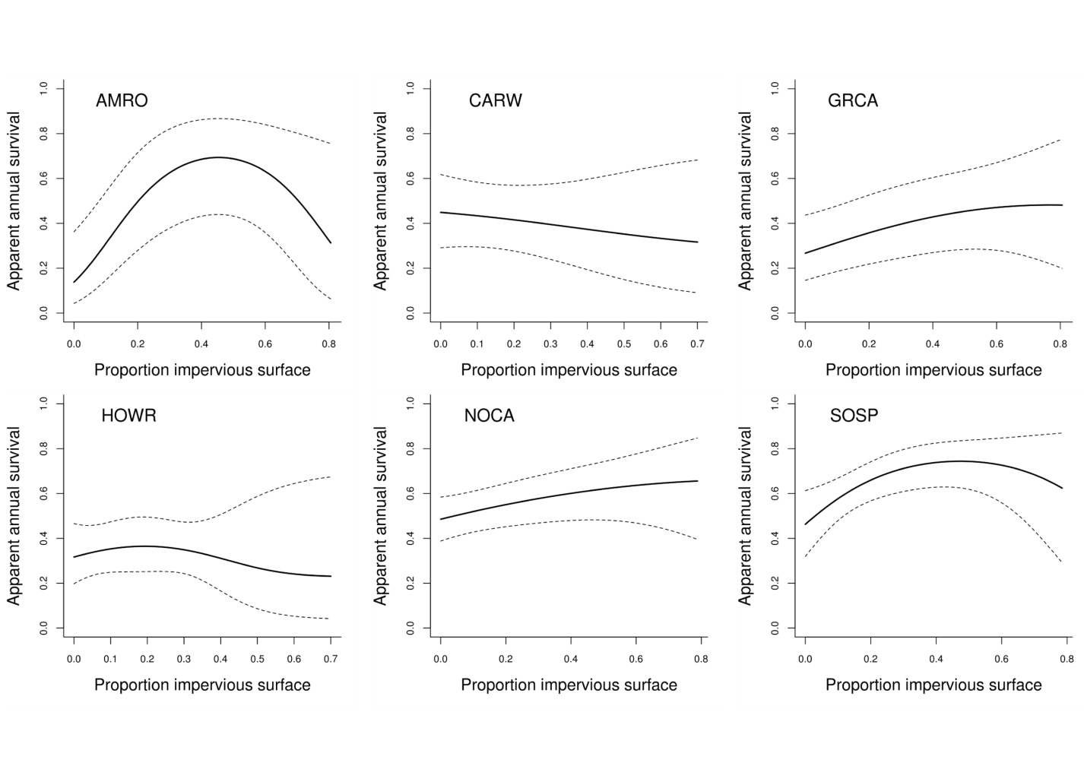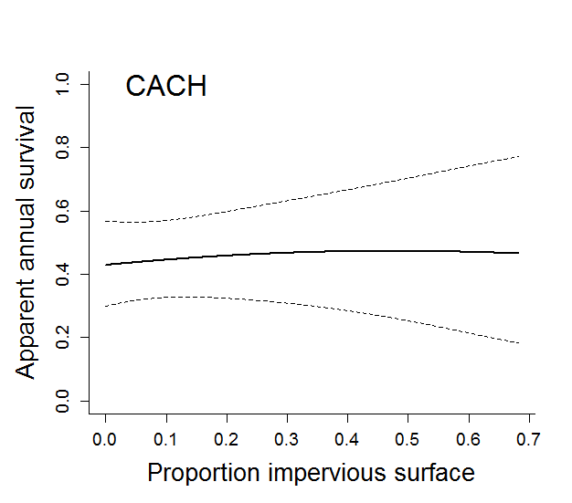

**FIGURE 4**

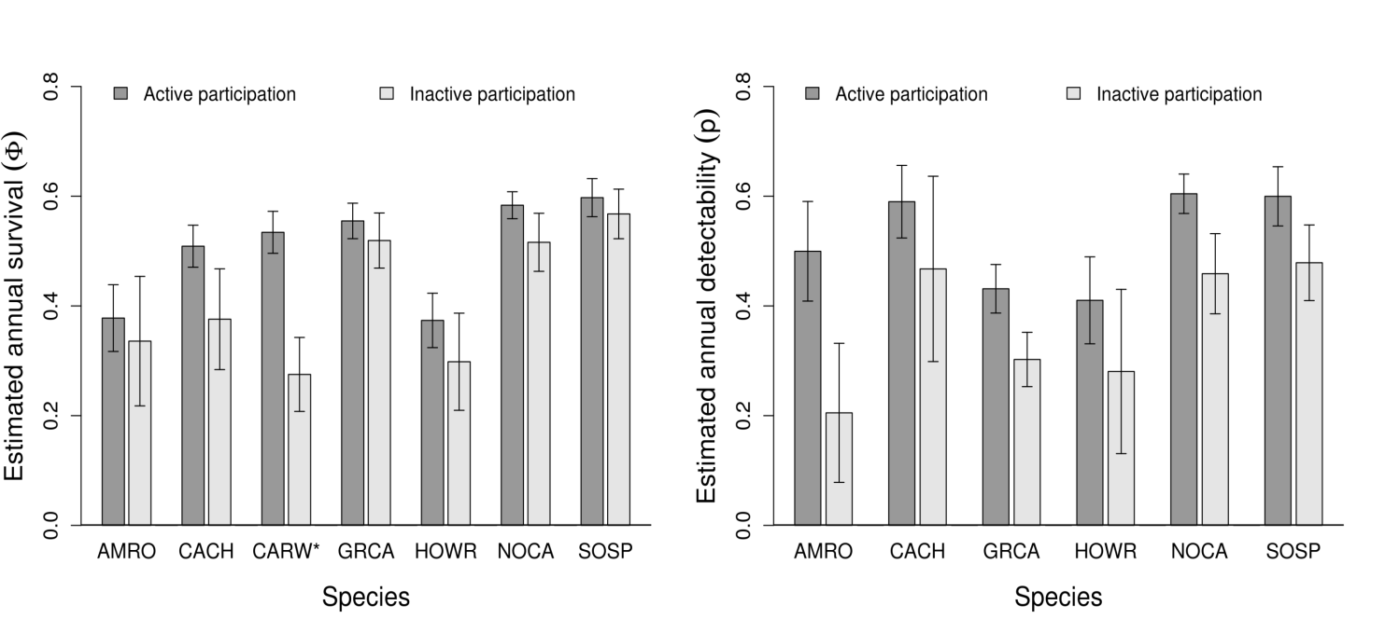

**APPENDIX I.** Summary statistics of the *a priori* model and 95% confidence set of models across species, sorted by AICc from best to worst performing models. The confidence set of models was determined as the models for which the cumulative AICc weights sum to 0.95.

|  |  |  |  |  |  |
| --- | --- | --- | --- | --- | --- |
| American robin (AMRO) | | | | | |
| **Model** | **k** | **AIC*c*** | **∆AICc** | ***w*** | **-2LogLik** |
| ɸ(*a priori* + IMP, IMP2), p(*a priori* + part) | 11 | 3184.5 | 0.00 | 0.360 | 3161.9 |
| ɸ(*a priori* + IMP, IMP2), p(*a priori* + part, sex:part) | 12 | 3186.1 | 1.60 | 0.162 | 3161.4 |
| ɸ(*a priori* + IMP, IMP2, part), p(*a priori* + part) | 12 | 3186.6 | 2.11 | 0.125 | 3161.9 |
| ɸ(*a priori* + IMP, IMP2, part), p(*a priori*) | 11 | 3186.9 | 2.44 | 0.106 | 3164.4 |
| ɸ(*a priori* + IMP, IMP2, part, part:sex), p(*a priori*) | 12 | 3187.4 | 2.86 | 0.086 | 3162.7 |
| ɸ(*a priori* + IMP, IMP2, part, part:sex), p(*a priori* + part) | 13 | 3188.2 | 3.67 | 0.057 | 3161.4 |
| *a priori:* ɸ(sex, BCI, tsm, sex:BCI, sex:tsm) p(sex) | 8 | 3214.1 | 29.60 | 0.000 | 3197.8 |
| Carolina Chickadee (CACH) | | | | | |
| ɸ(*a priori* + part), p(*a priori*) | 9 | 16212.6 | 0.00 | 0.297 | 16194.3 |
| ɸ(*a priori* + part), p(*a priori* + part) | 10 | 16214.6 | 1.96 | 0.112 | 16194.2 |
| ɸ(*a priori* + part, part:sex), p(*a priori*) | 10 | 16214.7 | 2.07 | 0.106 | 16194.3 |
| ɸ(*a priori* + IMP, part), p(*a priori*) | 10 | 16214.7 | 2.07 | 0.105 | 16194.3 |
| ɸ(*a priori*), p(*a prior +* part) | 9 | 16215.7 | 3.05 | 0.065 | 16197.3 |
| ɸ(*a priori* + IMP, IMP2, part), p(*a priori*) | 11 | 16216.2 | 3.61 | 0.049 | 16193.7 |
| ɸ(*a priori* + part, part:sex), p(*a priori* + part) | 11 | 16216.7 | 4.03 | 0.040 | 16194.2 |
| ɸ(*a priori* + IMP, part), p(*a priori* + part) | 11 | 16216.7 | 4.04 | 0.039 | 16194.2 |
| ɸ(*a priori* + IMP, part, part:sex), p(*a priori*) | 11 | 16216.8 | 4.15 | 0.037 | 16194.3 |
| ɸ(*a priori*), p(*a priori* + part, sex:part) | 10 | 16217.4 | 4.81 | 0.027 | 16197.0 |
| ɸ(*a priori* + IMP), p(*a priori* + part) | 10 | 16217.7 | 5.12 | 0.023 | 16197.3 |

|  |  |  |  |  |  |
| --- | --- | --- | --- | --- | --- |
| **APPENDIX I**, con’t |  |  |  |  |  |
| Carolina Chickadee (CACH) continued | | | | | |
| **Model** | **k** | **AIC*c*** | **∆AICc** | ***w*** | **-2LogLik** |
| ɸ(*a priori* + IMP, IMP2, part), p(*a priori* + part) | 12 | 16218.2 | 5.57 | 0.018 | 16193.6 |
| ɸ(*a priori* + IMP, IMP2, part, part:sex), p(*a priori*) | 12 | 16218.3 | 5.70 | 0.017 | 16193.7 |
| ɸ(*a priori* + IMP, IMP2, part, part:sex), p(*a priori+part*) | 12 | 16218.7 | 6.12 | 0.014 | 16202.8 |
| *a priori:* ɸ(sex, BCI, tsm, sex:BCI, sex:tsm) p(sex) | 8 | 16219.1 | 6.44 | 0.012 | 16202.8 |
| Carolina wren (CARW) | | | | | |
| ɸ(*a priori* + part), p(*a priori*) | 9 | 17650.3 | 0.32 | 0.267 | 17632.0 |
| ɸ(*a priori* + IMP, part, part:sex), p(*a priori*) | 11 | 17651.4 | 1.44 | 0.152 | 17629.0 |
| ɸ(*a priori* + IMP, part), p(*a priori*) | 10 | 17651.7 | 1.74 | 0.131 | 17631.4 |
| ɸ(*a priori* + IMP, IMP2, part, part:sex), p(*a priori*) | 12 | 17653.1 | 3.07 | 0.067 | 17628.5 |
| *a priori:* ɸ(sex, BCI, tsm, sex:BCI, sex:tsm) p(sex) | 8 | 17657.7 | 7.67 | 0.007 | 17641.4 |
| Gray catbird (GRCA) | | | | | |
| ɸ(*a priori* + IMP, IMP2), p(*a priori* + part) | 11 | 9816.5 | 0.00 | 0.192 | 9794.3 |
| ɸ(*a priori* + IMP), p(*a priori* + part) | 10 | 9816.7 | 0.17 | 0.176 | 9796.5 |
| ɸ(*a priori* + IMP, IMP2), p(*a priori* + part, sex:part) | 12 | 9818.3 | 1.79 | 0.078 | 9794.1 |
| ɸ(*a priori* + IMP, IMP2, part), p(*a priori* + part) | 12 | 9818.5 | 1.94 | 0.073 | 9794.2 |
| ɸ(*a priori* + IMP, part), p(*a priori* + part) | 11 | 9818.5 | 1.97 | 0.072 | 9796.3 |
| ɸ(*a priori* + IMP), p(*a priori* + part, sex:part) | 11 | 9818.5 | 1.97 | 0.072 | 9796.3 |
| ɸ(*a priori* + IMP, part), p(*a priori*) | 10 | 9818.8 | 2.29 | 0.061 | 9798.6 |
| ɸ(*a priori* + IMP, IMP2, part), p(*a priori*) | 11 | 9819.0 | 2.49 | 0.055 | 9796.8 |
| ɸ(*a priori* + IMP, IMP2, part), p(*a priori* + part, sex:part) | 13 | 9820.2 | 3.69 | 0.030 | 9793.9 |
| ɸ(*a priori* + IMP, part), p(*a priori* + part, sex:part) | 12 | 9820.2 | 3.70 | 0.030 | 9796.0 |
| ɸ(*a priori* + IMP, IMP2, part, part:sex), p(*a priori* + part) | 13 | 9820.4 | 3.89 | 0.027 | 9794.1 |

|  |  |  |  |  |  |
| --- | --- | --- | --- | --- | --- |
| **APPENDIX I**, con’t |  |  |  |  |  |
| Gray catbird (GRCA) continued | | | | | |
| **Model** | **k** | **AIC*c*** | **∆AICc** | ***w*** | **-2LogLik** |
| ɸ(*a priori* + IMP, part, part:sex), p(*a priori* + part) | 12 | 9820.5 | 3.97 | 0.026 | 9796.2 |
| ɸ(*a priori* + IMP, part, part:sex), p(*a priori*) | 11 | 9820.8 | 4.28 | 0.023 | 9798.6 |
| ɸ(*a priori* + IMP, IMP2, part, part:sex), p(*a priori*) | 12 | 9821.0 | 4.44 | 0.021 | 9796.7 |
| ɸ(*a priori* + IMP, IMP2), p(*a priori*) | 10 | 9821.9 | 5.33 | 0.013 | 9801.7 |
| *a priori:* ɸ(sex, BCI, tsm, sex:BCI, sex:tsm) p(sex) | 8 | 9827.6 | 11.06 | 0.001 | 9811.5 |
| House wren (HOWR) | | | | | |
| ɸ(*a priori* + part), p(*a priori*) | 6 | 6180.4 | 0.00 | 0.194 | 6168.2 |
| ɸ(*a priori* + IMP, IMP2, part), p(*a priori*) | 8 | 6181.1 | 0.70 | 0.137 | 6164.8 |
| ɸ(*a priori*), p(*a priori* + part) | 6 | 6181.5 | 1.19 | 0.107 | 6169.4 |
| ɸ(*a priori* + IMP, IMP2), p(*a priori* + part) | 8 | 6181.9 | 1.50 | 0.092 | 6165.7 |
| ɸ(*a priori* + part), p(*a priori* + part) | 7 | 6182.3 | 1.91 | 0.075 | 6168.1 |
| ɸ(*a priori* + IMP, part), p(*a priori*) | 7 | 6182.3 | 1.98 | 0.072 | 6168.2 |
| ɸ(*a priori* + IMP, IMP2, part), p(*a priori* + part) | 9 | 6183.0 | 2.60 | 0.053 | 6164.7 |
| ɸ(*a priori*), p(~part, sex:part) | 7 | 6183.4 | 3.05 | 0.042 | 6169.2 |
| ɸ(*a priori* + IMP), p(*a priori* + part) | 7 | 6183.4 | 3.10 | 0.041 | 6169.3 |
| ɸ(*a priori* + IMP, IMP2), p(~part, sex:part) | 9 | 6183.7 | 3.37 | 0.036 | 6165.5 |
| ɸ(*a priori* + part), p(~part, sex:part) | 8 | 6184.2 | 3.81 | 0.029 | 6168.0 |
| ɸ(*a priori* + IMP, part), p(*a priori* + part) | 8 | 6184.2 | 3.89 | 0.028 | 6168.0 |
| ɸ(*a priori* + IMP, IMP2), p(*a priori*) | 7 | 6184.6 | 4.29 | 0.023 | 6170.5 |
| ɸ(*a priori* + IMP, IMP2, part), p(~part, sex:part) | 10 | 6184.8 | 4.50 | 0.021 | 6164.5 |
| *a priori:* ɸ(sex, BCI, tsm, sex:BCI, sex:tsm) p(sex) | 5 | 6185.3 | 4.95 | 0.016 | 6175.2 |

|  |  |  |  |  |  |
| --- | --- | --- | --- | --- | --- |
| **APPENDIX 1,** con’t | | | | | |
| Northern cardinal (NOCA) | | | | | |
| **Model** | **k** | **AICc** | **∆AICc** | **w** | **-2LogLik** |
| ɸ(*a priori* + IMP, part), p(*a priori* + part) | 11 | 41348.9 | 0.00 | 0.159 | 41326.8 |
| ɸ(*a priori* + IMP, part), p(*a priori*) | 10 | 41349.9 | 0.94 | 0.10 | 41329.7 |
| ɸ(*a priori* + IMP, IMP2, part), p(*a priori* + part) | 12 | 41350.0 | 1.08 | 0.093 | 41325.8 |
| ɸ(*a priori* + IMP, part), p(*a priori* + part, sex:part) | 12 | 41350.3 | 1.36 | 0.081 | 41326.1 |
| ɸ(*a priori* + IMP, part, part:sex), p(*a priori* + part) | 12 | 41350.5 | 1.54 | 0.074 | 41326.3 |
| ɸ(*a priori* + IMP, IMP2, part), p(*a priori*) | 11 | 41350.9 | 2.00 | 0.059 | 41328.8 |
| ɸ(*a priori* + IMP), p(*a priori* + part) | 10 | 41351.1 | 2.16 | 0.054 | 41330.9 |
| ɸ(*a priori* + IMP, part, part:sex), p(*a priori*) | 11 | 41351.2 | 2.27 | 0.051 | 41329.0 |
| ɸ(*a priori* + IMP, IMP2, part), p(*a priori* + part, sex:part) | 13 | 41351.4 | 2.46 | 0.047 | 41325.1 |
| ɸ(*a priori* + IMP, IMP2, part, part:sex), p(*a priori* + part) | 13 | 41351.6 | 2.66 | 0.042 | 41325.3 |
| ɸ(*a priori* + IMP, IMP2), p(*a priori* + part) | 11 | 41352.2 | 3.26 | 0.031 | 41330.0 |
| ɸ(*a priori* + IMP), p(*a priori* + part, sex:part) | 11 | 41352.2 | 3.30 | 0.031 | 41330.1 |
| ɸ(*a priori* + IMP, part, part:sex), p(*a priori* + part, sex:part) | 13 | 41352.3 | 3.36 | 0.030 | 41326.0 |
| ɸ(*a priori* + IMP, IMP2, part, part:sex), p(*a priori*) | 12 | 41352.3 | 3.37 | 0.030 | 41328.1 |
| ɸ(*a priori* + part), p(*a priori* + part) | 10 | 41352.8 | 3.81 | 0.024 | 41332.6 |
| ɸ(*a priori* + IMP, IMP2), p(*a priori* + part, sex:part) | 12 | 41353.4 | 4.41 | 0.018 | 41329.1 |
| ɸ(*a priori* + IMP, IMP2, part, part:sex), p(*a priori* + part, sex:part) | 14 | 41353.4 | 4.47 | 0.017 | 41325.1 |
| *a priori:* ɸ(sex, BCI, tsm, sex:BCI, sex:tsm) p(sex) | 8 | 41369.3 | 20.36 | 0.000 | 41353.2 |

|  |  |  |  |  |  |
| --- | --- | --- | --- | --- | --- |
| **APPENDIX 1,** con’t | | | | | |
| Song Sparrow (SOSP) | | | | | |
| **Model** | **k** | **AICc** | **∆AICc** | **w** | **-2LogLik** |
| ɸ(*a priori* + IMP, IMP2), p(*a priori* + part) | 8 | 19245.2 | 0.00 | 0.298 | 19229.0 |
| ɸ(*a priori* + IMP, IMP2, part), p(*a priori*) | 8 | 19246.4 | 1.25 | 0.160 | 19230.2 |
| ɸ(*a priori* + IMP, IMP2, part), p(*a priori* + part) | 9 | 19247.0 | 1.83 | 0.119 | 19228.8 |
| ɸ(*a priori* + IMP, IMP2), p(*a priori*) | 7 | 19247.1 | 1.88 | 0.116 | 19232.9 |
| ɸ(*a priori* + IMP, IMP2), p(~part, sex:part) | 9 | 19247.1 | 1.91 | 0.115 | 19228.8 |
| ɸ(*a priori* + IMP, IMP2, part), p(~part, sex:part) | 10 | 19249.0 | 3.78 | 0.045 | 19228.7 |
| ɸ(*a priori* + IMP), p(*a priori* + part) | 7 | 19249.2 | 3.96 | 0.041 | 19235.0 |
| ɸ(*a priori* + IMP, part), p(*a priori*) | 7 | 19249.4 | 4.25 | 0.036 | 19235.3 |
| *a priori:* ɸ(BCI, tsm) p(sex) | 5 | 19256.7 | 11.47 | 0.001 | 19246.6 |

Not reencountered

Reencountered, active participant

Reencountered, inactive participant

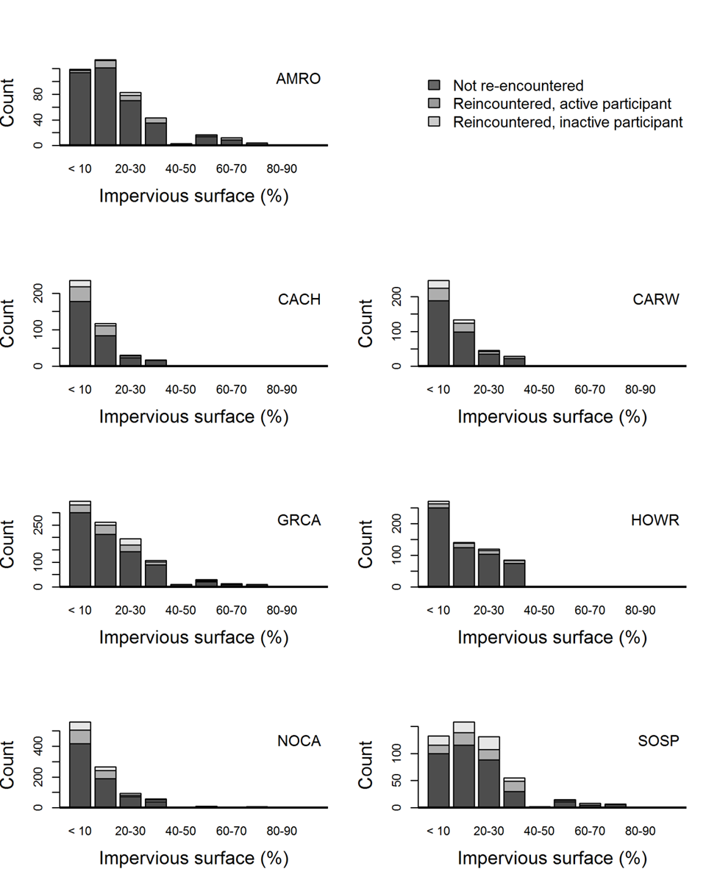

**Appendix II.** Sample size of birds captured across the rural-to-urban gradient including the counts of individuals that were captured but never reencountered, reencountered at Neighborhood Nestwatch sites in which citizen scientist participants report resight data, and sites in which only Nestwatch technicians conduct resighting.