**Phase I: Pilot program for bird banding operations at the National Zoo**

**Effective Dates: 12/01/2016 – 1/27/2017**

**Goals:** This phase of the project will test the banding component of what will become the demonstration banding program for the general public held on zoo grounds. Here, we seek to set up potential net lanes and execute banding operations in order to evaluate:

1. Catch rates and the general efficacy of selected nets
2. Interaction with keepers and general volunteers throughout the zoo
3. Interaction with the general public
4. The efficacy of training volunteers on bird extraction from nets

**Description of activity:** Banding operations will occur on Thursdays and Fridays of each week. During each banding day, 10-20 mist nets will be set up throughout the zoo grounds and will be open between the hours of 7 am and 11 am. Mist nets are 12 m long (some are 6 m) and are fastened at each end to aluminum conduit (height = 3 m). Nets visible from the path will have a sign warning onlookers that it is illegal to touch the net for any reason (go to [this link](https://github.com/bsevansunc/birdCats/blob/master/smbc/zooBandingSign.png) to view or download the sign). Potter traps (see [this link](http://www.powdermillarc.org/highlights/2013/winter.aspx) for an example of a potter trap) may be used in conjunction with netting efforts in publically inaccessible locations. Birds will be extracted during “net runs” (i.e., a circuit walked to check nets for captured birds) that occur a minimum of once every 30 minutes. A bird caught in net will be placed in a cloth bag and brought to a central location where it will be aged, sexed, measured (e.g., wing chord), banded with color bands and a USGS Aluminum band, and released. Timeline for a given sampling day:

* **0630:** SMBC staff and volunteers meet at the Science Building, discuss targets for the banding day, and gather equipment
* **0645-0715:** SMBC staff and volunteers will set up the banding station and open nets
* **0715-0930:** All nets are open
* **0930-1000:** All publicly visible nets are closed and furled
* **1000-1030:** Remaining nets are checked. Closed nets are removed.
* 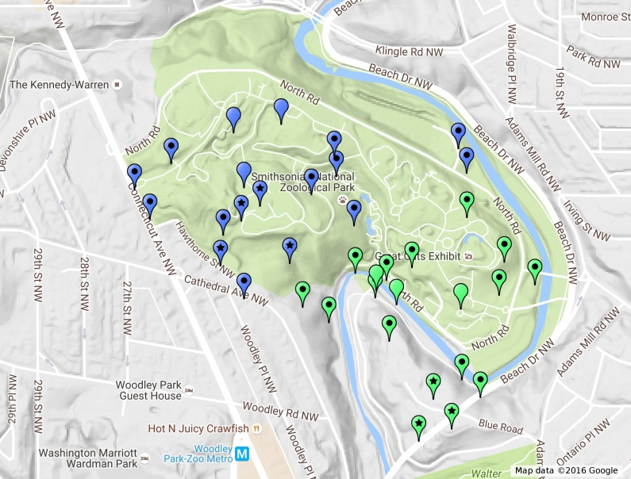**1030-1100:** All nets are closed and removed. The banding station is taken down
* **1100-1130:** SMBC staff and volunteers gather to discuss the banding day (e.g., any difficulties encountered, lessons learned)

**Locations of activity:** The map on the right displays the locations of potential banding stations (open markers), new net lanes (dot markers), and existing net lanes (star markers). Net locations and banding stations are separated into upper (blue) and lower (green) zoo grounds. The map can be explored online using [this link](https://www.google.com/maps/d/edit?hl=en&mid=1dUpGaxB929TXEXI-2Nt5hx64hu4&ll=38.92919658440485%2C-77.05010128836057&z=17) for net locations). Each section will be sampled on a separate day (e.g., the North zoo will be sampled on Thursdays and the South zoo on Fridays).

**Equipment needs:** The full banding equipment list is provided on [this spreadsheet](https://docs.google.com/spreadsheets/d/1lZfYova52vUKNAccVP1Yd8WZyTrK8EciHt9YnLnjn2U/edit#gid=0). We are requesting additional equipment for communication with the public, including: uniforms for SMBC staff and name tags for SMBC staff and volunteers. Additionally, we currently are maintaining three bird feeders on the grounds of the Science Building and request to place more feeders on zoo grounds to maximize catch rates. Finally, because some “net runs” (i.e., a circuit walked to check nets for captured birds) may be considerably long, we would like to acquire a cart to drive between nets. If available, this cart will only to be used before zoo grounds are open to the public.

**Staffing needs:** Initially, this project will require two SMBC staff members per banding day to assist with extracting birds from nets and banding. We will require 2-4 volunteers and/or interns per banding day. It is necessary that volunteers work at least one day per week. Volunteers will assist with data entry and will be trained on the extraction of birds during by SMBC staff. Training timeline:

**Week 1:** Volunteers will observe extraction and processing of birds

**Week 2:** Volunteers will observe processing of birds and learn to extract House Sparrows from nets under the guidance of SMBC staff

**Week 3:** Under the guidance of SMBC staff, volunteers will learn to process birds and extract House Sparrows from nets

**Weeks 4-7:** Volunteers will be allowed to extract House Sparrows without staff guidance. Under the guidance of SMBC staff, volunteers will learn to process birds and learn to extract other species from nets

**Week 8:** The project manager will assess volunteer skill level. After this point, volunteers may require further extraction training or be allowed to extract birds on their own

**Evaluation:** For each of the goals provided above, we will evaluate:

1. **Catch rates and the general efficacy of selected nets:** Identify net locations that minimize the distance walked on a net run while maximizing our rates of capture and the diversity of birds caught. Staff and volunteers will use handheld GPS units to record the path and path distance during a net run. We will record the net location, species captures, and time of capture and evaluate species-specific capture rates by net location.
2. **Interaction with keepers and general volunteers throughout the zoo:** TBD
3. **Interaction with the general public:** TBD
4. **The efficacy of training volunteers on bird extraction from nets:** TBD

**Phase II: Pilot program for demonstration banding for the general public**

**Effective Dates: 02/03/2017 – 03/31/2017**

**Phase III: Pilot program for demonstration banding for the groups**

**Effective Dates: 02/03/2017 – 03/31/2017**