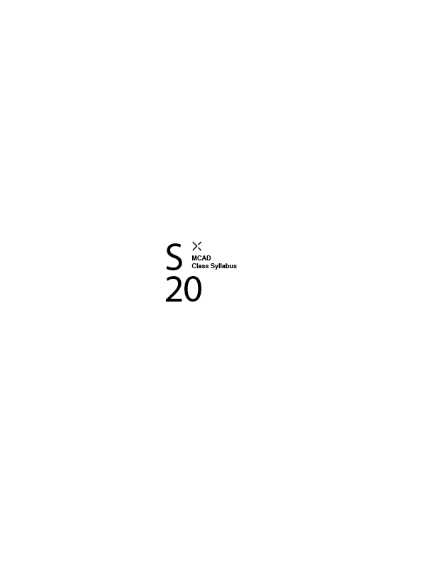

Course Name: Experimental Sound Design

Course Number: WMM 3085 01

Class Meets: MW, 9:30 AM - 12:00 PM, 04/08/20 - 05/11/20

Classroom Location: 333

Faculty Name: Severns, Benjamin

MCAD Email Address: ben_severns@mcad.edu

MCAD Telephone Number, Academic Affairs: 612-874-3694

Office Hours: Monday 1130-1230

Office Location: 316

Faculty Biography:

Ben Severns is an interdisciplinary artist whose studio work is concerned with the spectacular. His studio production in a year's time includes animation, drawing, filmmaking, music, photography, robotics, sculpture, set design/grip work, software building, and freelance writing. In addition to teaching in both Fine Arts and Media Arts at MCAD, Severns is also an adjunct at Augsburg University where he teaches a course in Web Design.  
His work has been exhibited throughout the United States and internationally, including at Boston University, the Institute of Contemporary Art (Maine), the Science Museum of Minnesota, the Minneapolis Institute of Art, Public Functionary Gallery, the Walker Art Center, and others. It is held in private collections in the United States and Brazil.

Course Description:

This hands¬-on workshop emphasizes creative practice as a way to explore the tangible properties of sound and learn a foundation of technical skills for working with it. Students complete a series of individual and collaborative projects that explore both performance and recording. The class uses digital recording tools to capture and edit work, but focus is placed on ways to physically produce and manipulate sounds outside of the computer (with bodies and an array of tools, both hand¬made and high¬-tech). Whether students are interested in music performance, sound effects for film, or sonic sculpture, this workshop introduces an array of hybrid techniques for audio investigation. Prerequisite: Media One

Outcomes:

Methodologies:

Lecture, Demonstration, Discussion, Readings, Research/Analysis, In-class Exercises, Interactive Tutoring, Individual Projects, Case Studies, Visiting Artists/Designers

Required Textbooks, Readings and Websites:

-none at this moment-

Library Reserve Information:

-none at this moment-

Materials and Tools list:

Computer with DAW you are comfortable with  
External Hard Drive to save your work  
Audio recorder [accessible via Media Center]  
Microphones  
  
--interesting things to find/work with--  
Piezo element - look in singing greeting cards or other stationary -type things or at AxMan Surplus.  
  
Toy for circuit bending - often the simpler, the better. Powered by batteries, even better. Often the toy that has the largest, most accessible circuit board is best - it takes an expert to get some of those tight spots on modern smd boards.

Blackboard:

learn.mcad.edu

Miscellaneous:

Course Calendar:

*Bullet list projects/assignments, project descriptions, and assignment due dates*

Week 1: Sound: noun  
Workshop: sampling, tape loops, experimental fundamentals, bioacoustics  
Readings&listening assigned.  
  
Week 2: Thoughts on working from home with little or no equipment  
Workshop: Software packages [MIDI, VCV Rack, Pd, Max, Abelton, etc.], Circuit Bending, Electronics/Arduino Intro  
Readings&listening assigned..  
  
Week 3: Methods of using software &&technology to improve, create, and develop sounds

Workshop: Recording/Mastering Best Practices, Contact Mics/Opamps, Image Sonification

Readings&listening assigned..

Week 4: Pattern, Poetics, Noise

Workshop: Generative music, Feedback, Music Theory, Generative Methods

Readings&listening assigned..  
  
Week 5: Showcase / Closing thoughts / A Show

SPECIAL GUEST PERFORMANCE [MURF - live via video stream] *date/time tbd*  
Workshop: Audience consideration, formal concerns, ..  
Class experimental showcase - date/time tbd

Email Usage: Email is used at MCAD as the official means of communicating with the student body. Official college announcements regarding policy, classes, registration, deadlines, etc. are delivered via email. Students are expected to check their MCAD email frequently and are held responsible for all official information communicated to them via the email system. Misuse or misrepresentation of official communications by students will result in disciplinary action.

Attendance: MCAD students are expected to attend and participate in all enrolled courses in order to complete the courses successfully. To uphold this expectation, there are no unexcused absences. Students have a responsibility to the group and for their own learning. Participation and performance are factored into the course grade. Absences and repeated tardiness have consequences that will result in lowered or failing grades. Students are responsible for obtaining class materials. Faculty are not obligated to reteach a class a student has missed. Faculty may drop a student from a course who does not attend the first class meeting. Therefore, students risk losing their spot to another student. In the case of extended illness or other legitimate absences that may keep the student from attending class, students must contact their faculty member. Faculty members will alert their department chair.

Grading Policy: Grades consider student performance of assignments listen on each course syllabus, participation in class, magnitude of improvement, attendance, level of project difficulty, timeliness of project completion, compliance with class policies, and effort/dedication. + or - may be added to letter grades at the discretion of the faculty member. The MFA program employs a pass/fail grading system and does not use letter grades.

A = Excellent work, progress far beyond expectations of effort and outcomes, full participation

B = Good work, course requirements completed, preparedness for more advanced study

C = Average work, course requirements completed, preparedness for more advanced study

D = Passing but below average work, some promise of improvement

F = Work not acceptable, or course requirements not completed

Grading Procedure / Criteria:

This course will rely heavily on in/after class production, but will be primarily interested in technical, formal exercises. Course grades will be determined by equally weighting Sketch A - Sketch D along with course participation.

Incomplete Policy: To receive a grade of Incomplete for a class a student must meet with the chair of the department or program director in which the class is taught to discuss the circumstances of the request.

Grade Notification: Midterm grades will be posted on MyMCAD between weeks 7-10 of the semester. Final grades will be posted on MyMCAD the week following commencement.

Archiving Your Work: Students are required to submit documentation of their work for each class, every semester. Please follow this naming convention: LastName_FirstName_ ProjectTitle.ext. Ex: oneill_co_DrawingA1.png

The media formats should follow MCAD archiving standards, which are found at:

<http://kb.mcad.edu/index.php?category=64>

Samples should be accompanied by a Word document containing relevant information, found at:

[http://kb.mcad.edu/index.php?article=166 - Text Listing](http://kb.mcad.edu/index.php?article=166#Text%20Listing)

Academic Deficiencies: MCAD notifies students of deficiencies in academic performance through the student alert form at any time throughout the semester. Notices are placed in student mailboxes. Students are encouraged to contact the faculty member immediately and take steps to remedy the deficiency. If a student has two or more alerts the student will be contacted by the Dean of Student Affairs. A subsequent meeting will be scheduled to help the student analyze the problem and make realistic plans to remedy the situation and succeed in school.

+ + + + + + + + + + + + + + + + + + + + + + + + + + + + + + + + + + + + + + + + + + + + + + + + + + + + + + + + + + + + + + + + + + + + + + + + + +

This information is taken from the Student Handbook. You are expected to adhere to college policy.

A. THE LEARNING CENTER: The Learning Center provides interdisciplinary support for all MCAD students, including face-to-face and online tutoring, an online writing and learning lab (OWLL), small and large group workshops and in-class presentations, as well as academic accommodation services for students with disabilities. The Learning Center works with students to make them better learners and prioritizes equal access and opportunity for all students. Tutoring areas include writing, software and technical skills, time management, and study skills. For more information on the Learning Center’s Hours, instructions for how to make an appointment, and access to the MCAD OWLL, visit [learningcenter.mcad.edu](http://learningcenter.mcad.edu/) or call (612) 874-3671.

B. TITLE IX MANDATORY REPORTING: By Federal law, faculty are mandatory reporters of sexual harassment or sexual violence. Faculty are not confidential resources for students and must report any knowledge of sexual violence to the Title IX coordinator.

C. NONBINARY PRONOUNS: It is MCAD policy to recognize self-identification within our population and it strives to accommodate.

D. LYNDA.COM: Students can access a wide variety of online tutorials at Lynda.com using their MCAD login information: <https://intranet.mcad.edu/modules/lynda/>

E. COURSE EVALUATIONS: Course evaluations are an integral part of MCAD curriculum development. Student feedback on courses are instrumental in creating a vibrant, informed, and robust learning community at MCAD. For these, and many other reasons, students are encouraged at the end of the semester to provide extensive feedback on course evaluations.

F. CELL PHONE POLICY (optional): Cell phones should be put on mute or vibrate during class. Calls can be made during breaks, as well as before or after class.

G. CREDIT HOUR DEFINITION: In lecture/discussion courses requiring outside preparation, 1 hour of credit represents 50 minutes contact time each week in class, and 2 hours of work outside of class. Therefore, a 3-credit lecture course requires 2.5 hours in class per week and approximately 6 hours outside of class.

In studio/laboratory courses, 1 hour of credit requires a minimum of 1.5 hours contact hours each week in class and approximately 1.5 hours of work outside of class. Therefore, a 3-credit studio course represents a minimum of 4.5 contact hours in class and approximately 4.5 hours of work outside of class per week.

In online courses, 1 hour of credit requires approximately 3 hours of work per week for all activities (i.e., reading, viewing, making, scanning, responding to discussion threads, collaborating, etc.). Therefore, a 3-credit online course requires approximately 9 hours per week to complete the necessary activities.

H. ATTENDANCE (ONLINE COURSES): Registration for an online course presupposes that the student will attend/fully participate in all online activities. Each student is responsible for meeting all course requirements.

I. CLASSROOM DEVICE USAGE POLICY: Participation in a classroom community has many benefits, but students will also find that along with those benefits come responsibilities:

+ Students are responsible for bringing laptops to class when scheduled to do so.

+ Student laptops should be in good working condition. If a student is experiencing problems with a laptop, it is the student’s responsibility to go to Computer Support for help: <https://intranet.mcad.edu/modules/css/?css=1>. Technical difficulties such a problems printing, uploading, saving, or retrieving files do not excuse late or missing work.

+ During classroom discussion, demonstration, or lecture, students should not be connected to network resources unless students are specifically instructed to do so.

+ Chatting, using social media, or emailing is no more acceptable than talking on a cell phone during class time. Non-class related use of a laptop during class time, including working on homework for other courses, may result in restriction of laptop use or a grade penalty.

+ Unless otherwise indicated, students should never use headphones during class time.

+ Students should always store copies of files in two backup locations. Students should never store the only copy of a paper/project on the student server space in case the server is down, and students are unable to access the paper/project.

+ Recording by instructor permission only. See the MCAD Student Handbook for the full policy.

J. ACADEMIC INTEGRITY / SCHOLASTIC DISHONESTY: Academic integrity is essential to a positive teaching and learning environment. All students enrolled in MCAD courses are expected to complete coursework responsibilities with fairness and honesty. Failure to do so by seeking unfair advantage over others or misrepresenting someone else’s work as your own can result in disciplinary action.

The MCAD Student Handbook defines academic dishonesty as follows: Submission of false records of academic achievement; cheating on assignments or examinations; altering, forging or misusing a College academic record, document or funds; taking, acquiring or using test materials without faculty permission; acting alone or in cooperation with another to falsify records to obtain grades, honors, awards or professional endorsement in a dishonest manner; plagiarizing.

+ Plagiarizing: Quoting uncited materials, visual or written; presenting the work of others as your own; using work of other MCAD students without their express permission.

+ Using the Same Work in Different Courses: Students may not submit the same work for more than one class without the knowledge and consent of all faculty.

+ Consequences for plagiarizing and double submissions may include failing the assignment or the course, or academic probation.

Within this course, a student who is responsible for scholastic dishonesty can be assigned a penalty up to an including an “F” for the course. If students have any questions regarding the expectations for a specific assignment or exam, they should consult with their professor.

Using the Same Assignment in Different Courses: Studio projects are assigned and assessed according to the specific learning objectives for each course. Occasionally students may be assigned a project in one course that shares many of the learning objectives of an assignment given in a different course. While turning in the same assignment for two courses is not encouraged, students who wish to do so are required to first notify the faculty member of each course and get permission. Faculty may assign additional requirements. Failure to notify faculty can result in failure of the assignments in both courses.

K. ACCESSIBILITY AND EQUAL ACCESS: Persons with disabilities have a right to equal opportunity as prescribed by law. MCAD is responsible for creating a barrier-free environment while empowering students to grow toward independence and self-assertion. It is the individual student’s responsibility to make their needs known and request accommodation. First-time disclosures must be made via appointment with the Learning Center or via our Disability Disclosure Form. For more information, visit [learningcenter.mcad.edu](http://learningcenter.mcad.edu/) or call (612) 874-3671.