Expense Tracker — Project Report
GROUP O
Muhammad Ibrahim Rafaat BSFT25012
Ayusha Amna BSFT25034
Hafsa Sohail BSFT25054

1. Introduction and Objectives
The Expense Tracker is a full-stack web application designed to help individuals manage their personal finances simply and effectively. Users can register, log in, record income or expenses, and instantly view their financial summary through an interactive dashboard. The main objective is to replace messy notebooks or spreadsheets with a clean, real-time tool that shows your balance, total income, and total expenses at a glance — all in one place.

2. Problem Statement
Most people struggle to track where their money goes. Without a dedicated tool, it is easy to overspend without realizing it. Existing solutions are either too complex or not private enough. This application solves that by giving each user a secure, personal space to log transactions, automatically calculate their balance, and visualize spending patterns — with zero technical knowledge required.

3. System Architecture
The application follows a three-layer client-server architecture. The frontend is built with React.js and handles all user interactions. The backend runs on Node.js with Express.js, exposing a REST API that processes requests and enforces authentication. Data is stored in MongoDB using Mongoose, where each user's transactions are saved as separate documents. The complete app is deployed and live on Vercel.

4. Features and Modules
The app is organized into five modules. The Authentication module lets users register and log in securely. The Dashboard module displays three summary cards showing Total Balance, Total Income, and Total Expense, all updated in real time. The Add Transaction module provides a simple form where users enter a title, amount, category, and type (income or expense). The Expense Report module renders a live pie chart (green for income, red for expense). Finally, the Transaction List module shows all records in a table with a Delete button on each row.

5. Database Design
MongoDB stores data in two collections. The Users collection holds each account's name, email, and hashed password. The Transactions collection stores every financial record with fields for title, amount, category, type (income or expense), a reference to the owner's user ID, and an auto-generated timestamp. This structure keeps data private per user and makes fetching or deleting records straightforward.

6. API Explanation
The backend exposes six REST endpoints. POST /api/auth/register and POST /api/auth/login handle account creation and sign-in (no auth required). POST /api/auth/logout ends the session. GET /api/transactions fetches all transactions for the logged-in user. POST /api/transactions adds a new record. DELETE /api/transactions/:id removes a specific entry. All transaction endpoints are protected and require a valid JWT token.

7. Screenshots
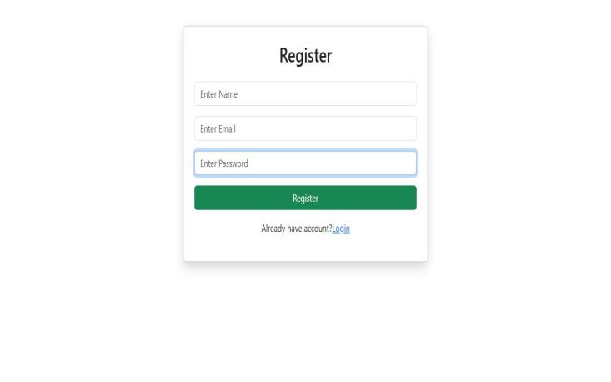
Figure 1 – Registration Page
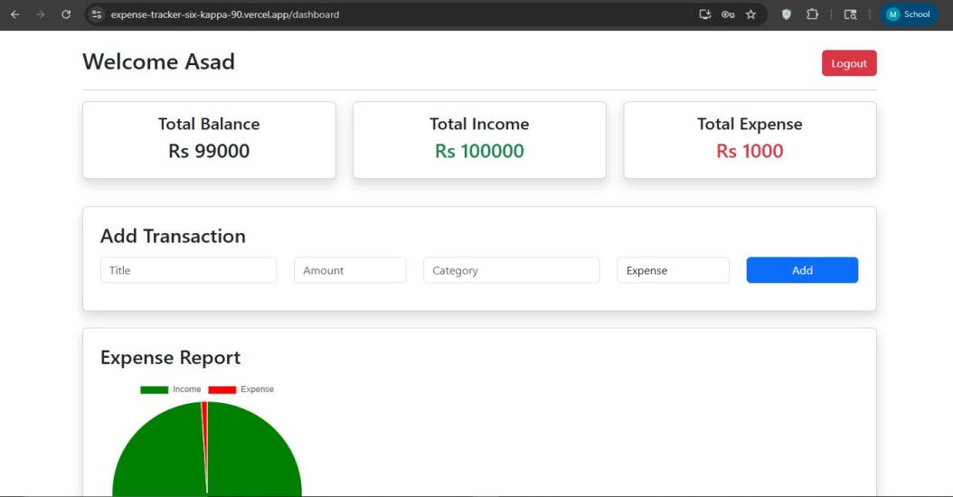
Figure 2 – Dashboard with Summary Cards and Add Transaction Form
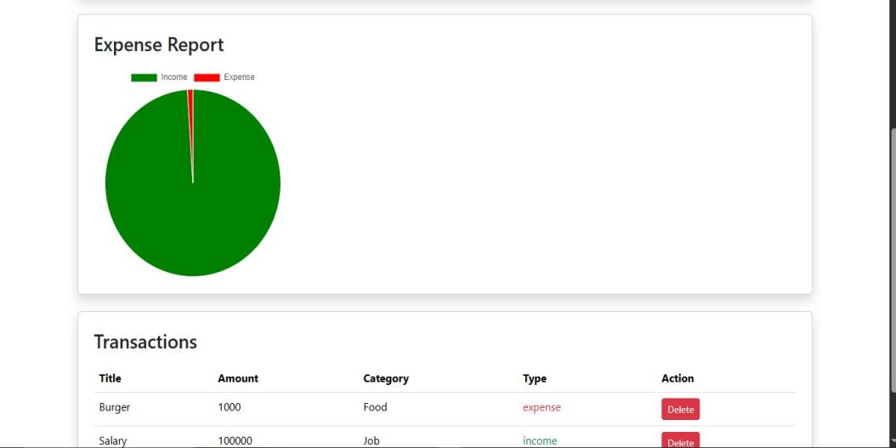
Figure 3 – Expense Report Chart and Transaction List

8. Challenges Faced
The biggest challenge was keeping the balance card accurate in real time — solved by recalculating totals from the transaction array on every update. Secure password handling required bcrypt hashing and JWT tokens stored in HTTP-only cookies. Ensuring each user only sees their own data meant adding user-ID filtering middleware to every protected route. The pie chart also needed a fallback state for when no data existed, and CORS configuration had to be set correctly for the Vercel deployment to work.

9. Conclusion and Future Improvements
The Expense Tracker successfully delivers a fast, private, and visual way to manage personal finances. The MERN stack proved reliable for this use case and the app is fully deployed and functional. Future improvements include monthly budget alerts, date-range filters, CSV or PDF export, recurring transaction automation, and a React Native mobile version for on-the-go tracking.

