**WWF**



**Description**

World Wildlife Fund's (WWF) mission is the conservation of nature. Using the best available scientific knowledge and advancing that knowledge where we can, we work to preserve the diversity and abundance of life on Earth. We are committed to reversing the degradation of our planet's natural environment and to building a future in which human needs are met in harmony with nature.

**The Nature Conservancy**

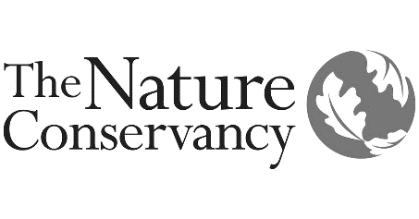

**Description**

The Nature Conservancy is a leading conservation organization working around the world to protect ecologically important lands and waters for nature and people. We address threats to conservation involving climate change, fire, fresh water, forests, invasive species, and marine ecosystems. We use a science-based approach, and we pursue non-confrontational, pragmatic solutions to conservation challenges.

**UNICEF**



**Description**

Over eight decades, the United Nations Children's Fund (UNICEF) has built an unprecedented global support system for the world's children. UNICEF works to deliver the essentials that give every child an equitable chance in life: health care and immunizations, safe water and sanitation, nutrition, education, emergency relief and more.

**Save the children**



**Description**

Save the Children believes every child deserves a future. In the United States and around the world, we work to give children a healthy start in life, the opportunity to learn and protection from harm. We ensure children's unique needs are met and their voices are heard. We deliver lasting results for millions of children, including those hardest to reach.